Project | IEEE 802.16 Broadband Wireless Access Working Group <http://ieee802.org/16>
Title | Proposed Changes to the Ranging Channel Structure for Synchronized AMSs in IEEE P802.16m/D2 (15.3.9.1.4.2)
Date Submitted | 2009-11-06
Source(s) | HyunWoo Lee, Jin Sam Kwak, HanGyu Cho, Young-Hyoun Kwon  LG Electronics | Voice: +82-31-450-7902  E-mail: camille@lge.com, samji@lge.com, hgcho@lge.com
Re: | IEEE 802.16 Working Group Letter Ballot Recirc #30a  P802.16m/D2 : 15.3.9.1.4.2
Abstract | This contribution proposes the text of ranging channel section to be included in the IEEE P802.16m Draft.
Purpose | To be discussed and adopted by TGm for the IEEE P802.16m Draft
Notice | This document does not represent the agreed views of the IEEE 802.16 Working Group or any of its subgroups. It represents only the views of the participants listed in the “Source(s)” field above. It is offered as a basis for discussion. It is not binding on the contributor(s), who reserve(s) the right to add, amend or withdraw material contained herein.
Release | The contributor grants a free, irrevocable license to the IEEE to incorporate material contained in this contribution, and any modifications thereof, in the creation of an IEEE Standards publication; to copyright in the IEEE’s name any IEEE Standards publication even though it may include portions of this contribution; and at the IEEE’s sole discretion to permit others to reproduce in whole or in part the resulting IEEE Standards publication. The contributor also acknowledges and accepts that this contribution may be made public by IEEE 802.16.
Patent Policy | The contributor is familiar with the IEEE-SA Patent Policy and Procedures:  <http://standards.ieee.org/guides/bylaws/sect6-7.html#6> and <http://standards.ieee.org/guides/opman/sect6.html#6.3>.  Further information is located at <http://standards.ieee.org/board/pat/pat-material.html> and <http://standards.ieee.org/board/pat>.
Proposed Changes to the Ranging Channel Structure for Synchronized AMSs in IEEE P802.16m/D2 (15.3.9.1.4.2)

HyunWoo Lee, Jin Sam Kwak, HanGyu Cho, and Young-Hyoun Kwon
LG Electronics

1. Introduction
This contribution proposes the modified text of ranging channel section in the IEEE P802.16m/D2 [1].

2. Proposed Changes
This contribution proposes the text of ranging channel structure for synchronized AMSs.

Reference
[1] IEEE P802.16m/D2, “Part 16: Air Interface for Broadband Wireless Access Systems : Advanced Air Interface,” October 2009.

Text proposal for inclusion in the 802.16m amendment

----------------------------------------------------------------------------------------------------------------------------------------------------------------
Black text: text in the subclause 15.3.9.1.4.2 of P802.16m/D2
Red Strike through Text: Deleted
Blue text: new text
[Bracketed Italic text]: Informative
------------------------------------------------------------------------- Text Start --------------------------------------------------------------------------

Ranging Channel Structure for synchronized AMSs
The ranging channel for synchronized AMSs is used for periodic ranging. The AMSs that are already synchronized to the target ABS are allowed to transmit the periodic ranging signal. For femtocell, the ranging channel for synchronized AMSs can be used for initial ranging, handover ranging, and periodic ranging.
The physical structure in the ranging channel for synchronized AMSs occupies 72 subcarriers by K OFDMA symbol time. K is a multiple of three, which is not larger than N_{sym}, i.e., K = 3∙floor(K/ N_{sym}), where N_{sym} is the number of OFDMA symbols in a subframe as defined in 15.3.8.1. The basic unit of ranging channel consists of 3 OFDMA symbols and a ranging channel occupies K OFDMA symbols by repeating the basic unit K/3 times from the first OFDMA symbol within a subframe.
Figure 551 illustrates the basic unit of ranging channel structure in the time domain where T_{g} and T_{b} are defined in <<<15.3.2.4.>>>
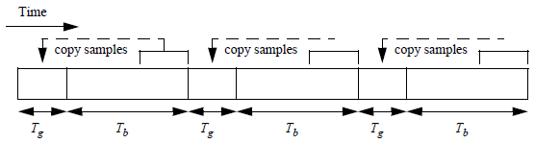
- The basic unit
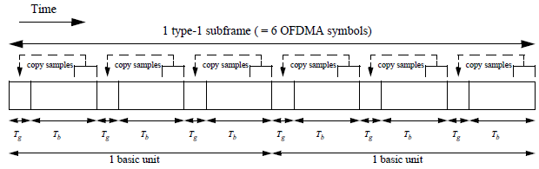
- An example in the type-1 subframe
Figure 552 – Ranging channel structure for synchronized AMSs in the time domain

Power control operation described in <<<15.3.9.4.3>>> applies to ranging signal transmission.
------------------------------------------------------------------------ Text End ---------------------------------------------------------------------------

