Project | IEEE 802.16 Broadband Wireless Access Working Group <http://ieee802.org/16>
Title | The Clarification of the Ranging Channel Code and Configuration for FDM-based UL PUSC Zone Support in IEEE P802.16m/D2 (15.3.9.2.4.3)
Date Submitted | 2009-11-06
Source(s) | HyunWoo Lee, Jin Sam Kwak, HanGyu Cho, Young-Hyoun Kwon  LG Electronics | Voice: +82-31-450-7902  E-mail: camille@lge.com, samji@lge.com, hgcho@lge.com
Re: | IEEE 802.16 Working Group Letter Ballot Recirc #30a  P802.16m/D2 : 15.3.9.2.4.3
Abstract | This contribution proposes the text of ranging channel section to be included in the IEEE P802.16m Draft.
Purpose | To be discussed and adopted by TGm for the IEEE P802.16m Draft
Notice | This document does not represent the agreed views of the IEEE 802.16 Working Group or any of its subgroups. It represents only the views of the participants listed in the “Source(s)” field above. It is offered as a basis for discussion. It is not binding on the contributor(s), who reserve(s) the right to add, amend or withdraw material contained herein.
Release | The contributor grants a free, irrevocable license to the IEEE to incorporate material contained in this contribution, and any modifications thereof, in the creation of an IEEE Standards publication; to copyright in the IEEE’s name any IEEE Standards publication even though it may include portions of this contribution; and at the IEEE’s sole discretion to permit others to reproduce in whole or in part the resulting IEEE Standards publication. The contributor also acknowledges and accepts that this contribution may be made public by IEEE 802.16.
Patent Policy | The contributor is familiar with the IEEE-SA Patent Policy and Procedures:  <http://standards.ieee.org/guides/bylaws/sect6-7.html#6> and <http://standards.ieee.org/guides/opman/sect6.html#6.3>.  Further information is located at <http://standards.ieee.org/board/pat/pat-material.html> and <http://standards.ieee.org/board/pat>.
The clarification of the Ranging Channel Code and Configuration for FDM-based UL PUSC Zone Support in IEEE P802.16m/D2 (15.3.9.2.4.3)

HyunWoo Lee, Jin Sam Kwak, HanGyu Cho, and Young-Hyoun Kwon
LG Electronics

1. Introduction
This contribution proposes the modified text of ranging channel section in the IEEE P802.16m/D2 [1].

2. Proposed Changes
This contribution proposes the text of ranging channel code and configuration for clarification.

Reference
[1] IEEE P802.16m/D2, “Part 16: Air Interface for Broadband Wireless Access Systems : Advanced Air Interface,” October 2009.

Text proposal for inclusion in the 802.16m amendment
----------------------------------------------------------------------------------------------------------------------------------------------------------------
Black text: text in the subclause 15.3.9.2.4.3 of P802.16m/D2
Red Strike through Text: Deleted
Blue text: new text
[Bracketed Italic text]: Informative
------------------------------------------------------------------------- Text Start --------------------------------------------------------------------------

15.3.9.2.4.3. Ranging Channel for FDM-based UL PUSC Zone Support

Ranging Codes
When frame structure is supporting the WirelessMAN-OFDMA MSs in UL PUSC zone by FDM manner as defined in 15.3.8.3.5, the ranging codes for WirelessMAN-OFDMA in the <<8.4.7.3>> are used for AMSs.
The binary codes are the pseudonoise codes produced by the PRBS described in Figure 559, which implements the polynomial generator . The PRBS generator shall be initialized by the seed b14...b0 = 0,0,1,0,1,0,1,1,s0,s1,s2,s3,s4,s5,s6, where s6 is the LSB of the PRBS seed, and s6:s0 = UL_PermBase, where s6 is the MSB of the UL_PermBase.

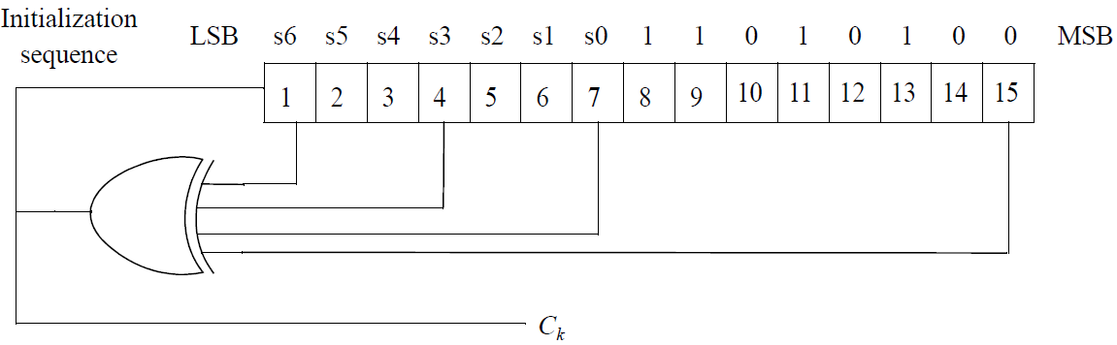
Figure 559 - PRBS generator for ranging code generation

The binary ranging codes are subsequences of the pseudonoise sequence appearing at its output C_{k}. The length of each ranging code is 144 bits. These bits are used to modulate the subcarriers in a group of six adjacent distributed LRUs, where distributed LRUs are considered adjacent if they have successive LRU numbers. The bits are mapped to the subcarriers in increasing frequency order of the subcarriers so that the lowest indexed bit modulates the subcarrier with the lowest frequency index and the highest indexed bit modulates the subcarrier with the highest frequency index. The six distributed LRUs are called a ranging LRU.

The number of available codes is 256, numbered 0, ... , 255. Each ABS uses a subgroup of these codes, where the start index of subgroup is defined by a number S, 0≤S≤255S = 16×k_{ns}+1 (=1, 17, 33, …, or 241) where k_{ns} is a cell specific value broadcased by S-SFH. The group of codes shall be between S and ((S + O + N + M) mod 256).
— The first N codes produced are for initial ranging. Clock the PRBS generator 144 × (S mod 256) times to 144 × ((S + N) mod 256) – 1 times.
— The next O codes produced are for handover ranging. Clock the PRBS generator 144 × ((S + N) mod 256) times to 144 × ((S + N + O) mod 256) – 1 times.
— The next M codes produced are for periodic ranging. Clock the PRBS generator 144 × ((S + N + O) mod 256) times to 144 × ((S + N + O + M) mod 256) – 1 times.

The start index of subgroup (S) and the number of code in each group (O, N, and M) is broadcasted by S-SFH. The number of initial, handover and periodic ranging codes is defined in Table (x.1).

Table (x.1) - Ranging preamble code partition information table for FDM-based UL PUSC Zone Support, N, O and M
Partition Index | 0 | 1 | 2 | 3 | 4 | 5 | 6 | 7 | 8 | 9 | 10 | 11 | 12 | 13 | 14 | 15
Number of initial ranging codes, N | 8 | 8 | 8 | 8 | 16 | 16 | 16 | 16 | 24 | 24 | 24 | 24 | 32 | 32 | 32 | 32
Number of handover ranging codes, O | 8 | 16 | 24 | 32 | 8 | 16 | 24 | 32 | 8 | 16 | 24 | 32 | 8 | 16 | 24 | 32
Number of periodic ranging codes, M | 8 | 8 | 8 | 8 | 16 | 16 | 16 | 16 | 24 | 24 | 24 | 24 | 32 | 32 | 32 | 32

Ranging channel configurations
The information for ranging time/frequency resource allocation is indicated by the S-SFH. The information of ranging channel allocation consists of the ranging configuration with subframe-offset (O_{SF}) for ranging resource allocation in the time domain. The lowest distributed LRU index for ranging frequency resource allocation is indicated by the S-SFH.
The periodicity of ranging channel allocation is same with non-synchronized AMSs defined in Table 878.
------------------------------------------------------------------------ Text End ---------------------------------------------------------------------------

