Project | IEEE 802.16 Broadband Wireless Access Working Group <http://ieee802.org/16>
Title | Further modifications to the specifications of the DL/UL Sub-band Assignment A-MAP IEs – Proposed Amendment Text
Date Submitted | 2009-11-06
Source(s) | Sudhir Ramakrishna, Youngbo Cho, Hyunkyu Yu, Jeongho Park, Heewon Kang, Zhouyue Pi  Samsung Electronics | sudhir.r@samsung.com
Re: | “Contribution in support of a comment on LB30”:  Category – AWD Comments  Area – Chapter 15.3.6 (DL Control)
Abstract | This contribution proposes some modifications to Sections 15.3.6.5.2.4 (DL Sub-band Assignment A-MAP IE), 15.3.6.5.2.5 (UL Sub-band Assignment A-MAP IE) and 15.3.6.5.2.2 (DL Basic Assignment A-MAP IE)
Purpose | To be discussed and adopted by TGm for the 802.16m amendment
Notice | This document does not represent the agreed views of the IEEE 802.16 Working Group or any of its subgroups. It represents only the views of the participants listed in the “Source(s)” field above. It is offered as a basis for discussion. It is not binding on the contributor(s), who reserve(s) the right to add, amend or withdraw material contained herein.
Release | The contributor grants a free, irrevocable license to the IEEE to incorporate material contained in this contribution, and any modifications thereof, in the creation of an IEEE Standards publication; to copyright in the IEEE’s name any IEEE Standards publication even though it may include portions of this contribution; and at the IEEE’s sole discretion to permit others to reproduce in whole or in part the resulting IEEE Standards publication. The contributor also acknowledges and accepts that this contribution may be made public by IEEE 802.16.
Patent Policy | The contributor is familiar with the IEEE-SA Patent Policy and Procedures:  <http://standards.ieee.org/guides/bylaws/sect6-7.html#6> and <http://standards.ieee.org/guides/opman/sect6.html#6.3>.  Further information is located at <http://standards.ieee.org/board/pat/pat-material.html> and <http://standards.ieee.org/board/pat>.

Further modifications to the specification of the DL/UL Sub-band Assignment A-MAP IEs – Proposed Amendment Text

Sudhir Ramakrishna, Youngbo Cho, Hyunkyu Yu, Jeongho Park, Heewon Kang, Zhouyue Pi
Samsung Electronics

- Introduction

There are 14 text modifications proposed in this contribution.
The first 12 modifications are related to the DL Sub-band Assignment IE section, and are numbered 1 through 12. The 12th proposed text replaces a TBD table in [1] and completes the interpretation of the RA field in the 20 MHz case, where the number of sub-bands is > 11 and a single IE is used to make an allocation.
The 13th modification refers to the UL Sub-band Assignment IE section.
Modification 14 refers to the DL Basic Assignment IE section.

- Modification 1

Note to Editor – In Section 15.3.6.5.2.4,
- Please replace all occurrences of the term SBCRU with the term SLRU.
- Please replace all occurrences of the parameter Y with Y_{SB}.

- Modification 2
The sentence on Line 26 of Page 366 of Section 15.3.6.5.2.4 is proposed to be modified as follows.
------------------------------------------------------ Begin proposed modification 2 ---------------------------------
The DL Sub-band Assignment A-MAP IE shall have an identical structure to the DL Basic Assignment A-MAP IE defined in Section 15.3.6.5.2.2.
------------------------------------------------------ End proposed modification 2 ---------------------------------

- Modification 3
The text starting from Line 48 on Page 366 and ending on Line 9 of Page 367 in Section 15.3.6.5.2.4 are proposed to be modified as follows.
------------------------------------------------------ Begin proposed modification 3 ---------------------------------
The mapping between the LRU indices and the physical PRU indices (and vice-versa) may be derived as described in Section 15.3.6.5.2.2 (“DL Basic Assignment A-MAP IE”).
Derivation of the mapping between sub-band logical resource unit (SLRU) -CRU index and the physical PRU index shall be done as follows. The total number of sub-bands over all partitions may be calculated as
For each frequency partition i, the total number of sub-band CRUs up-to and including that partition may be calculated as
Then, the sub-band SLRUs CRUs are indexed as
The sub-bands are indexed as
The mapping from the to the physical PRU indices (and vice-versa) is as specified in Section 15.3.5.
The LRU, & SBCRU, SLRU & SB indices indicated by the RA field refer to the LRU[], and the SBCRU[] SLRU[] & SB[] defined above.
------------------------------------------------------ End proposed modification 3 ---------------------------------

- Modification 4
Lines 14 through 18 on Page 367 in Section 15.3.6.5.2.4 are proposed to be modified as follows. This modification includes the insertion of Figure FIGURE_X1.
Note to Editor – Please remove Table 803 on Page 368.
------------------------------------------------------ Begin proposed modification 4 ---------------------------------
For a 5 MHz system:
- A single instance of a resource allocation shall be made using a single IE.
- It may be noted that Y_{SB} <= 4 for a 5 MHz system. The AMS shall interpret the RA field as defined below. by Table 927.
  - Each of the j bit-positions in the RA field, 0 <= j < 11, indicates the allocation or non-allocation of 2 SLRUs within a particular sub-band.
  - Position j in the RA field corresponds to the 2 SLRUs with indices k such that
  - Denoting RA[j] as the j^{th} position in the RA field, 0 <= j < 11, with j = 0 being the LSB,
    - RA[j] = 1 ➔ The 2 SLRUs with indices k such that have been allocated.
    - RA[j] = 0 ➔ The 2 SLRUs with indices k such that have not been allocated.
Figure FIGURE_X1 illustrates the interpretation of the RA field in a 5 MHz system.

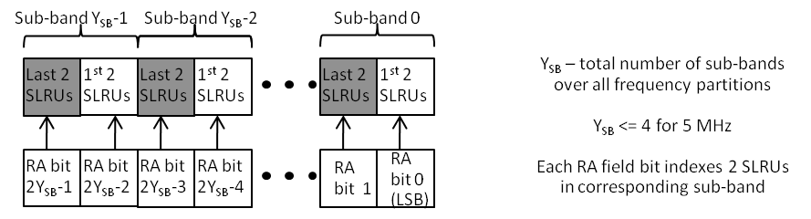
Figure FIGURE_X1: Interpretation of the RA field in a 5 MHz system
------------------------------------------------------ End proposed modification 4 ---------------------------------

- Modification 5
Lines 1 through 5 on Page 369 of Section 15.3.6.5.2.4 are proposed to be modified as follows.
------------------------------------------------------ Begin proposed modification 5 ---------------------------------
For a 10 MHz system, a single instance of a resource allocation shall be made using a single IE. It may be noted that Y_{SB} <= 10 for a 10 MHz system. For a particular value of Y_{SB}, the AMS shall interpret the bits in the Resource Allocation field as indicated by the row corresponding to that value of Y_{SB} in Table 804. Furthermore when Y (the total number of sub-bands over all frequency partitions) <= 11, the AMS shall interpret the bits in the Resource Allocation field as indicated by Table 669 (the row corresponding to the particular value of Y in that table). In the case that Y = 12, the RA field shall be interpreted as in the first row of Table 928.
------------------------------------------------------ End proposed modification 5 ---------------------------------

- Modification 6
Table 804 on Page 370 of Section 15.3.6.5.2.4 is proposed to be modified, and immediately following Table 804, Figures FIGURE_X2, FIGURE_X3, FIGURE_X4 and FIGURE_X5 are proposed to be inserted, as follows.

------------------------------------------------------ Begin proposed modification 6 ---------------------------------
Table 804: Interpretation of the RA Field in a 10 MHz or a 20 MHz system, when Y Y_{SB} <= 11 (Y Y_{SB} is the total number of sub-bands over all frequency partition)
Total # of sub-bands over all frequency partitions, Y Y_{SB} | RA Field Interpretation
Y Y_{SB} = 10 or 11 | Each of the j bit-positions in the RA field, 0 <= j < 11, indicates the allocation or non-allocation of all N1 (= 4) CRUs within a particular sub-band.  Denote RA[j] as the j^{th} bit position in the RA Field, 0 <= j < 11, with j = 0 being the LSB.
Y Y_{SB} = 6, 7, 8 or 9 | The 2 MSB bits of the RA field are denoted as the “Indication Type field” (ITF).  The Y Y_{SB} LSB bits of the RA field are denoted as the “Resource Indexing Field” (RIF).  Denote RIF[j] as the j^{th} bit position in the RIF, 0 <= j < Y Y_{SB}, with j = 0 being the LSB.
Y Y_{SB} = 6, 7, 8 or 9 | ITF == 00 | Each of the RIF[j], 0 <= j < Y Y_{SB}, indicates the allocation or non-allocation of all N1 (= 4) CRUs within a particular sub-band (out of the Y sub-bands).
Y Y_{SB} = 6, 7, 8 or 9 | ITF == 01 | Each of the RIF[j], 0 <= j < Y Y_{SB}, indicates the allocation or non-allocation of the 1st 2 CRUs within a particular sub-band.
Y Y_{SB} = 6, 7, 8 or 9 | ITF == 10 | Each of the RIF[j], 0 <= j < Y Y_{SB}, indicates the allocation or non-allocation of the last 2 CRUs within a particular sub-band.
Y Y_{SB} = 6 | The 2 MSB bits of the RA field are denoted as the “Indication Type field” (ITF).  The 9 LSB bits of the RA field are denoted as the “Resource Indexing Field” (RIF).  Denote RIF[j] as the j^{th} bit position in the RIF, 0 <= j < 9, with j = 0 being the LSB.
Y Y_{SB} = 6 | ITF == 00 | Each of the RIF[j], 0 <= j < 6, indicates the allocation or non-allocation of all N₁ (= 4) CRUs within a particular sub-band.  RIF[j] = 1The 4 CRUs with indices k such that = j have been allocated.  RIF[j] = 0The 4 CRUs with indices k such that = j have been not allocated
Y Y_{SB} = 6 | ITF == 01 | The 9 bits in the RIF index into the 9 half sub-bands (out of 12) with the higher indices. Each of the RIF[j], 0 <= j < 9, indicates the allocation or non-allocation of the 1st or last 2 CRUs within a particular sub-band.  RIF[j] = 1 The 2 CRUs with indices k such that= j +3 have been allocated.  RIF[j] = 0 The 2 CRUs with indices k such that = j+3 have not been allocated.
Y Y_{SB} = 6 | ITF == 10 | The 9 bits in the RIF index into the 9 half sub-bands (out of 12) with the lower indices. Each of the RIF[j], 0 <= j < 9, indicates the allocation or non-allocation of the 1st or last 2 CRUs within a particular sub-band.  RIF[j] = 1 The 2 CRUs with indices k such that= j have been allocated.  RIF[j] = 0 The 2 CRUs with indices k such that = j have not been allocated.
Y Y_{SB} <= 5 | Each of the j bit-positions in the RA field, 0 <= j < 11, indicates the allocation or non-allocation of 2 CRUs within a particular sub-band.  Denote RA[j] as the j^{th} bit position in the RA Field, 0 <= j < 11, with j = 0 being the LSB.

Figures FIGURE_X2, FIGURE_X3, FIGURE_X4 and FIGURE_X5 pictorially illustrate the interpretation if the RA field for the various cases, as described in Table 804.
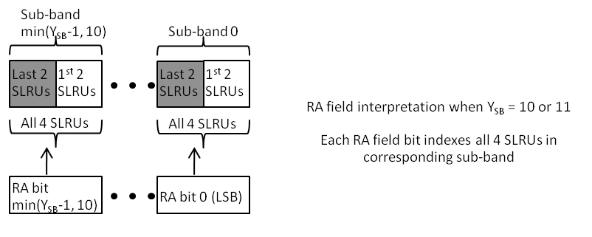
Figure FIGURE_X2: Interpretation of the RA field in Table 804, when Y_{SB} = 10 or 11

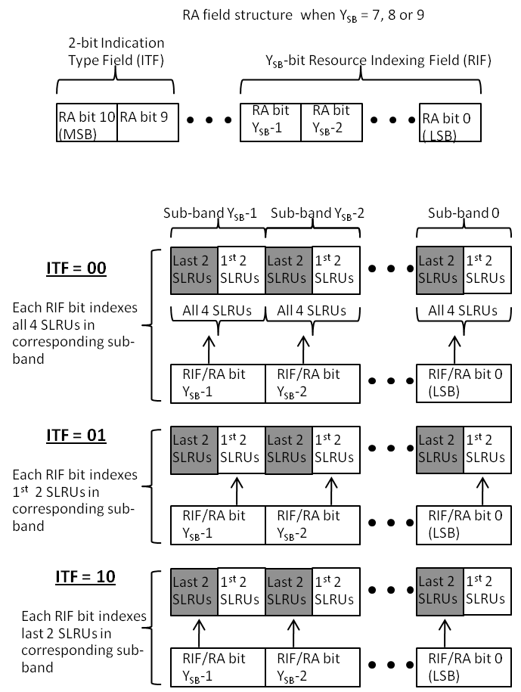
Figure FIGURE_X3: Interpretation of the RA field in Table 804, when Y_{SB} = 7, 8 or 9

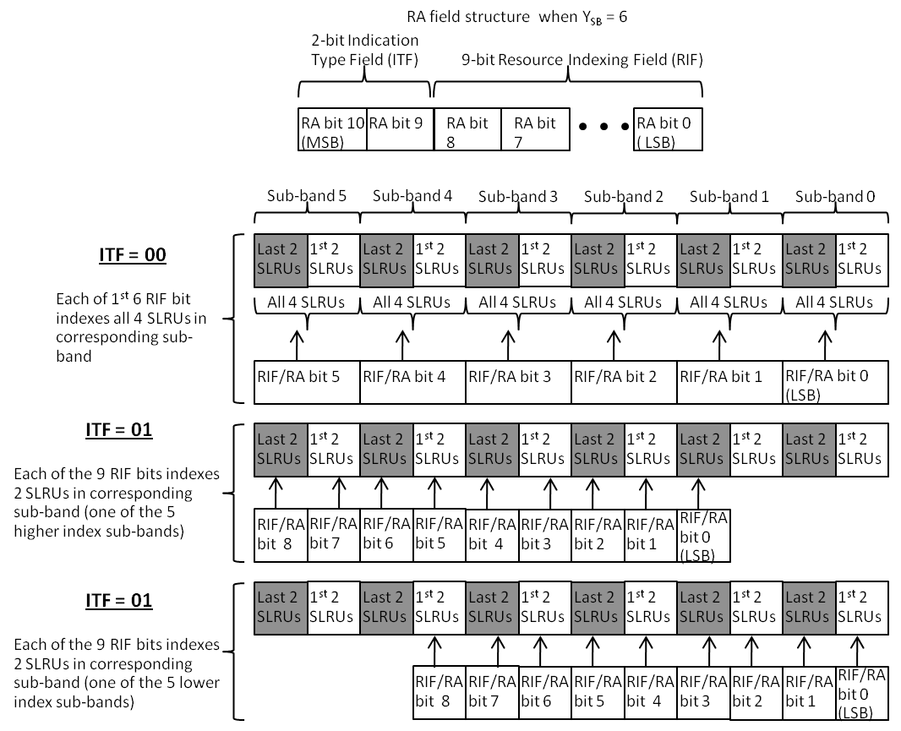
Figure FIGURE_X4: Interpretation of the RA field in Table 804, when Y_{SB} = 6
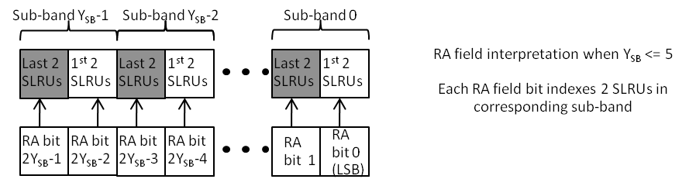
Figure FIGURE_X5: Interpretation of the RA field in Table 804, when Y_{SB} <= 5

------------------------------------------------------ End proposed modification 6 ---------------------------------

- Modification 7
Line 23 on Page 371 of Section 15.3.6.5.2.4 is proposed to be modified as follows.
------------------------------------------------------ Begin proposed modification 7 ---------------------------------
For a 20 MHz system, the following procedure shall be followed:
- It may be noted that Y_{SB} <= 21 for a 20 MHz system. When Y Y_{SB} (total number of sub-bands over all frequency partitions) <= 11, a single instance of a resource allocation shall be made using a single IE. In this case, the AMS shall interpret the bits in the Resource Allocation field as indicated by Table 669 804 (the row corresponding to the particular value of Y Y_{SB} in that table).
------------------------------------------------------ End proposed modification 7 ---------------------------------

- Modification 8
Lines 38 through 41 on Page 371 of Section 15.3.6.5.2.4 are proposed to be modified as follows. This modification includes the insertion of Figure FIGURE_X6.
------------------------------------------------------ Begin proposed modification 8 ---------------------------------
b) When an allocation is made using a single IE, the RA field shall be interpreted as in Section 15.3.6.5.2.4.1. Table 930 & Table_TBD. This section defines the mapping of the RA field to the indices of 2 or 3 sub-bands with non-contiguous indices. These tables map the value of the RA field to the indices of 2 non-contiguous sub-bands, and 3 non-contiguous sub-bands, respectively.
The overall interpretation procedure for 20 MHz as described above is pictorially illustrated in Figure FIGURE_X6.
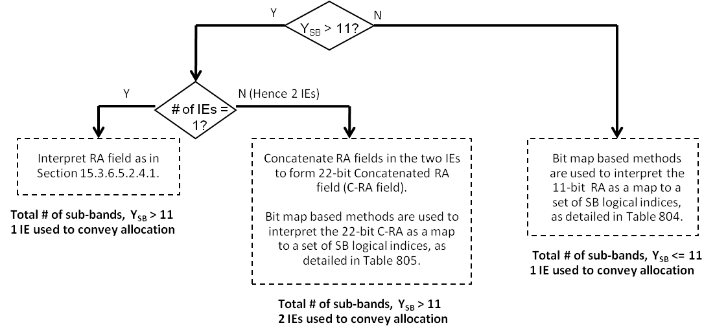
Figure FIGURE_X6: Overall RA field interpretation procedure in a 20 MHz system
------------------------------------------------------ End proposed modification 8 ---------------------------------

- Modification 9
Lines 52 through 55 on Page 371 of Section 15.3.6.5.2.4, in the 1st column, 2nd row of Table 805 are proposed to be modified as follows.
------------------------------------------------------ Begin proposed modification 9 ---------------------------------
Y Y_{SB} = 21, 22, 23, 24
----------------------------------------------------- End proposed modification 9 ---------------------------------

- Modification 10
Lines 2 through 5 on Page 372 of Section 15.3.6.5.2.4, in the 1st column of Table 805 on that page, are proposed to be modified as follows.
------------------------------------------------------ Begin proposed modification 10 ---------------------------------
20 <= Y <= 12 12 <= Y_{SB} <= 20
----------------------------------------------------- End proposed modification 10 ---------------------------------

- Modification 11

The following text and a new figure, FIGURE_X7, is proposed to be inserted starting on Line 34 of Section 15.3.6.5.2.4, immediately following Table 805.
------------------------------------------------------ Begin proposed modification 11 ---------------------------------
Figure FIGURE_X7 pictorially illustrates the interpretation of the C-RA field as detailed in Table 805.
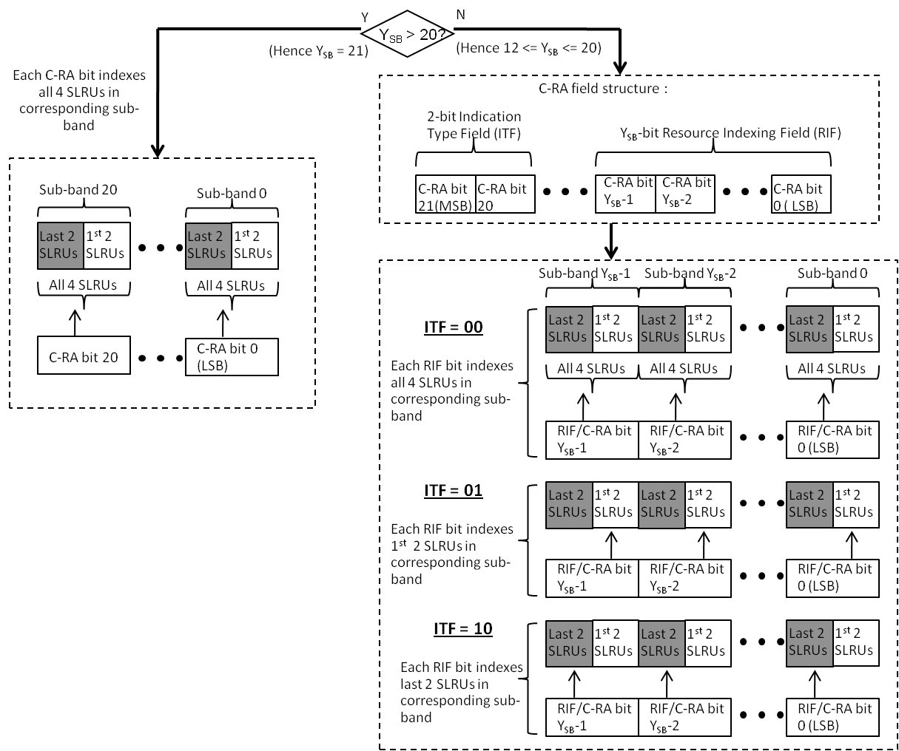
FIGURE_X7: Interpretation of the C-RA field in a 20 MHz system, as in Table 805

----------------------------------------------------- End proposed modification 11 ---------------------------------

- Modification 12
A new sub-section 15.3.6.5.2.4.1 is proposed to be added starting on Line 35 of Page 372, following Table 805. This is proposed to replace Table 806, and all the text from Line 35 on Page 372, till Line 12 on Page 373. Please note that this modification includes the insertion of 6 figures, FIGURE_X8 to FIGURE_X13.
Note to Editor – Please remove Table 806, and all the text starting from Line 35 on Page 372, and ending on Line 12 on Page 373, and replace with text below.
------------------------------------------------------ Begin proposed modification 12 ---------------------------------
15.3.6.5.2.4.1 Nominal Channel Bandwidth = 20 MHz, Y > 11, Allocation Using a Single IE
When Y (total number of sub-bands over all frequency partitions) > 11, a single IE may be used to make allocations of 2 or 3 sub-bands with arbitrary non-contiguous logical indices. This section defines the interpretation of the RA field in this case, allowing for the indication of all possible combinations of 2 or 3 sub-bands with non-contiguous logical indices.
The following definitions and associated terminology are used to make interpretations.
- A “Sub-band Pair” (SBP) contains a pair of sub-bands with contiguous indices. The indices of a sub-band pair and the corresponding sub-bands are related as follows: SBP[j] ←→ {SB[2j], SB[2j + 1]}.
  - There are a maximum of 21 sub-bands in a 20 MHz system. The corresponding 11 sub-band pairs are indexed as: SBP[0] ←→ {SB[0], SB[1]}, SBP[1] ←→ {SB[2], SB[3]}, …, SBP[9] ←→ {SB[18], SB[19]}, while SBP[10] ←→ {SB[20]}.
- The set of 11 sub-band pairs are partitioned into 2 “Pair-Groups” (PG). The pair-group with index 0 contains 5 SBPs, while the pair-group with index 1 contains 6 SBPs. The pair-group and sub-band pair indices are related as follows: PG[0] ←→ {SBP[0], SBP[1], …, SBP[4]}, PG[1] ←→ {SBP[5], SBP[6], …, SBP[10]}.
- The first 7 (MSB) bits of the RA field are referred to as the “Resource Indexing Field” (RIF), while the last 4 (LSB) bits are referred to as the “Indication Type Field” (ITF).
The mapping between the RA field and the allocated sub-band indices proceeds as follows - The Resource Indexing Field indicates the sub-band pair(s) being allocated, while the Indication Type Field further indicates the particular sub-bands within the sub-band pair that are being allocated.
Figure FIGURE_X8 pictorially depicts the definitions of sub-band pairs and pair groups, while Figure FIGURE_X9 depicts the partitioning and usage of the RA field.
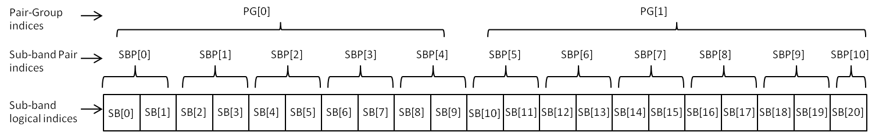
Figure FIGURE_X8: Definitions of sub-band pairs and pair groups in the 20 MHz, Y_{SB} > 11, single IE case

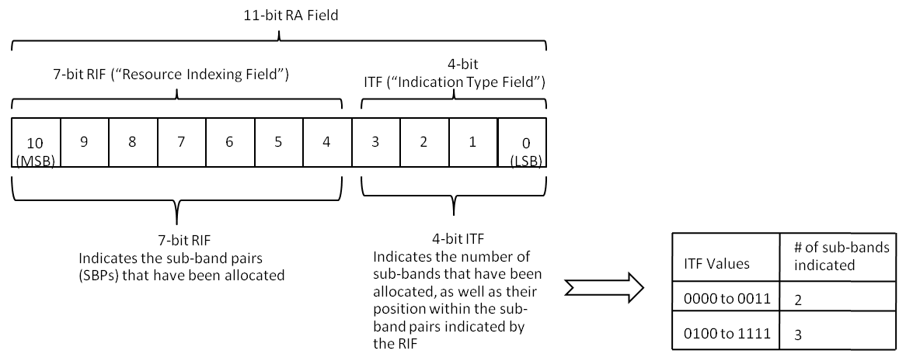
Figure FIGURE_X9: Partitioning and usage of the RA field in the 20 MHz, Y_{SB} > 11, single IE case

The interpretations of the RIF & the ITF for the 2- and 3 sub-band allocation cases are described as follow.
15.3.6.5.2.4.1.1 Allocation of 2 sub-bands
The values of the Indication Type Field (4 LSB bits of the RA field) from 0000 through 0011 indicate the assignment of 2 sub-bands. Denoting the assigned sub-bands as SB[x] and SB[y], and further denoting SB[x] ←→SBP[u] and SB[y] ←→SBP[v], the values of the ITF from 0000 through 0011 shall be interpreted as follows.
- ITF = 0000 ➔ Both SB[x] and SB[y] are the lower SB indices in SBP[u] and SBP[v], respectively.
- ITF = 0001 ➔ SB[x] and SB[y] are the higher SB indices in SBP[u] and SBP[v], respectively.
- ITF = 0010 ➔ SB[x] is the lower SB index in SBP[u], SB[y] is the higher SB index in SBP[v].
- ITF = 0011 ➔ SB[x] is the higher SB index in SBP[u], SB[y] is the lower SB index in SBP[v].
The Resource Indexing Field (7 MSB bits of the RA field) are then interpreted as in Table TABLE_X1 to indicate the SBPs allocated. As indicated in the table, the MSB and 6 LSB bits of the RIF are interpreted separately. Knowledge of the SBPs allocated, along with the information about the allocated sub-bands within the SBPs as indicated by the ITF, completes the allocation details for this case.
As an example, consider the case where RA = 11000100001, i.e., RIF = 1100010 and ITF = 0001. From the ITF, this is a 2 sub-band allocation. As above, let the two allocated sub-bands be denoted as SB[x] and SB[y], with SB[x] ←→SBP[u] and SB[y] ←→SBP[v]. From Table 1, since the MSB of the RIF is 1, this implies that the two allocated sub-band pairs are in different pair groups. The 1st 3 bits of the 6 LSB bits of the RIF (= 100) indicate SBP[u] relative to PG[0]; hence, SBP[u] = 4. The last 3 bits of the 6 LSB bits of the RIF (= 010) indicate SBP[v] relative to PG[1]; hence, SBP[v] = 7. Hence, the allocation is in SBP[4] = {SB[8], SB[9]} and SBP[7] = {SB[14], SB[15]}. The ITF (= 0001) indicates that the allocated SBs occupy the higher indices in the indicated SBPs. Hence, the allocation is {SB[9], SB[15]}.
Table TABLE_X1: Interpretation of the Resource Indexing Field (7 MSB bits of RA field) in the 2 sub-band allocation case
MSB of RIF = 0 ➔ SBP[u] & SBP[v] in same PG. | MSB of 6-bit LSB of RIF = 0 ➔ SBP[u] & SBP[v] in PG[0]. | Remaining 5 bits in 6-bit LSB of RIF used as a bit-map to indicate allocated SBPs over the 5 SBPs in PG[0] (SBP[0], SBP[1], SBP[2], SBP[3], SBP[4]), with the LSB of the 5 bit field corresponding to SBP[4].  A “1”/”0” in a particular position in the 5-bit field indicates the allocation/non-allocation of a sub-band in the corresponding SBP.
MSB of RIF = 0 ➔ SBP[u] & SBP[v] in same PG. | MSB of 6-bit LSB of RIF = 1 ➔ SBP[u] & SBP[v] in PG[1]. | Remaining 5 bits in 6-bit LSB of RIF used as a bit-map to indicate allocated SBPs over the 1st 5 of the 6 SBPs in PG[1] (SBP[5], SBP[6], SBP[7], SBP[8], SBP[9]), with the LSB of the 5-bit field corresponding to SBP[9].  A “1”/”0” in a particular position in the 5-bit field indicates the allocation/non-allocation of a sub-band in the corresponding SBP. Allocation of the 6th SBP in PG[1] (SBP[10]) is implied in the case that there is only a single “1” in the bit-map.
MSB of RIF = 1 ➔ SBP[u] & SBP[v] in different PGs. | The decimal value of the 1st 3 bits of the 6-bit LSB of the RIF indicate index SBP[u], relative to PG[0]. Hence, “000” indicates SBP[0], “001” indicates SBP[1], …, “100” indicates SBP[4].  The decimal value of the last 3 bits of 6-bit LSB of the RIF indicate index SBP[v], relative to PG[1]. Hence, “000” indicates SBP[5], “001” indicates SBP[6], …, “101” indicates SBP[10].

Figure FIGURE_X10 pictorially illustrates the usage of the RA field to make 2-sub-band assignments as detailed in Table TABLE_X1.

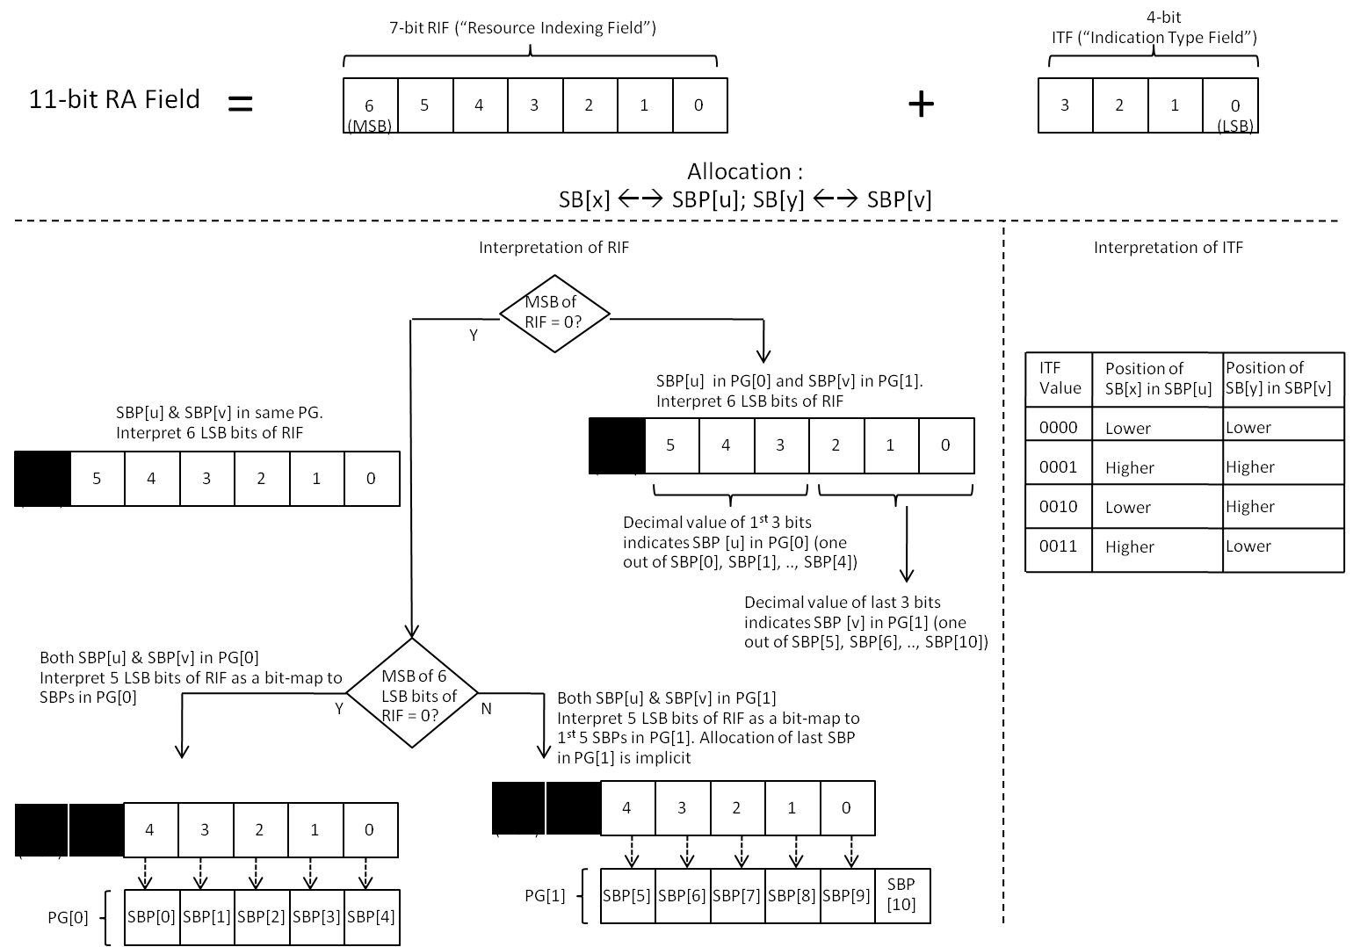
Figure FIGURE_X10: RA field usage to make an allocation of 2 sub-bands with non-contiguous indices

15.3.6.5.2.4.1.2 Allocation of 3 sub-bands
The values of the Indication Type Field (4 LSB bits of the RA field) from 0100 through 1111 indicate the assignment of 3 sub-bands. Denoting the assigned sub-bands as SB[x], SB[y] and SB[z], and further denoting SB[x] ←→SBP[u], SB[y] ←→SBP[v] and SB[z] ←→SBP[w], three sub-cases, and the interpretations of the ITF and RIF in each sub-case, are as follows.
15.3.6.5.2.4.1.2.1 Allocation of 3 sub-bands, with 2 of them in the same Sub-band Pair
In this sub-case of a 3 sub-band allocation, we have SB[x] and SB[y] belonging to the same SBP, i.e., SBP[u] = SBP[v]. The ITF values 0100 and 0101 indicate these cases, and shall be interpreted as follows.
- ITF = 0100 ➔ SB[z] is the lower SB index in SBP[w].
- ITF = 0101 ➔ SB[z] is the higher SB index in SBP[w].
The 7 bits of the Resource Indication Field shall be interpreted as in Table TABLE_X2 to indicate the three sub-band pairs SBP[u], SPB[v], SBP[w] that have been allocated. Since SBP[u] = SBP[v], the table indicates SBP[u] & SBP[w].
Table TABLE_X2: Mapping of 7 RIF bits to assignment of sub-band pairs SBP[u] (= SBP[v]) and SBP[w]
SBP[w] →  ↓ SBP[u] (= SBP[v]) | 0 | 1 | 2 | 3 | 4 | 5 | 6 | 7 | 8 | 9 | 10
0 |  | 0 |  |  |  |  |  |  | 7 |  | 9
1 | 10 |  |  |  |  |  |  |  |  |  | 19
2 | 20 |  |  |  |  |  |  |  |  |  | 29
3 | 30 |  |  |  |  |  |  |  |  |  | 39
4 | 40 |  |  |  |  |  |  |  |  |  | 49
5 | 50 |  |  |  |  |  |  |  |  |  | 59
6 | 60 |  |  |  |  |  |  |  |  |  | 69
7 | 70 |  |  |  |  |  |  |  |  |  | 79
8 | 80 |  |  |  |  |  |  |  |  |  | 89
9 | 90 |  |  |  |  |  |  |  |  |  | 99
10 | 100 | 101 | 102 | 103 | 104 | 105 | 106 | 107 | 108 | 109

In the table, the decimal values of the 7 bits of the RIF increase from left to right and from top to bottom (the first and last values in each row of the table are shown). The shaded cells are not used to make interpretations. Each particular cell in the table, corresponding to a particular decimal value of the RIF, indicates the values of the SBPs SBP[u] ( = SBP[v]) and SBP[w] that have been allocated.
Knowledge of the SBPs allocated from Table TABLE_X2, along with the information about the allocated sub-bands within the SBPs as indicated by the ITF, completes the allocation details for this sub-case.
For example, consider the case where the RA field = 00001110100, i.e., the decimal value of the RIF is 7 (= 0000111) and ITF = 0100. From the table above, the RIF maps to the 3 sub-band pairs SBP[u] = SBP[v] = 0 and SBP[w] = 8. SBP[0] ←→ {SB[0], SB[1]}, while SBP[8] ←→ {SB[16], SB[17]}. The ITF indicates that the lower SB index in SBP[8] is being allocated. Hence, the allocation is {SB[0], SB[1], SB[16]}.
This case is pictorially illustrated in Figure FIGURE_X11.

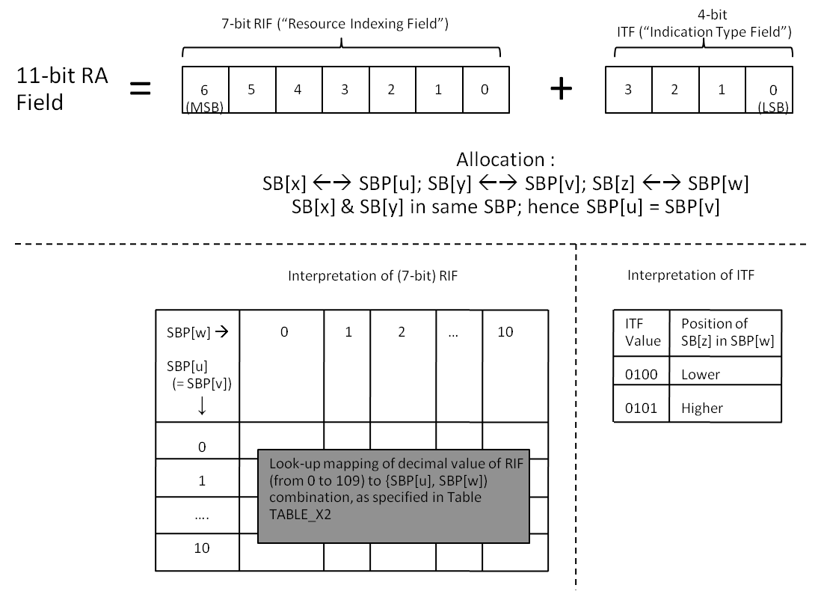
Figure FIGURE_X11: Allocation of 3 sub-bands, with 2 of them in the same sub-band pair
15.3.6.5.2.4.1.2.2 Allocation of 3 sub-bands, with all 3 in different Sub-band Pairs, not including SBP[10]
In this sub-case of a 3 sub-band allocation, we have SBP[u] ≠ SBP[v] ≠ SBP[w], and none of SBP[u], SBP[v] or SBP[w] equaling SBP[10].
The 8 ITF values from 0110 through 1101 shall indicate this sub-case, and these ITF values shall be interpreted as follows. They allow indication of all possible arrangements of the indicated 3 sub-bands SB[x], SB[y] and SB[z] within the 3 indicated sub-band pairs SBP[u], SBP[v] and SBP[w], and shall be interpreted as in Table TABLE_X3.
Table TABLE_X3: Interpretation of the ITF from 0110 through 1101 (decimal 6 through 13).
ITF value | Position of SB[x] in SBP[u]  (Higher index/Lower index) | Position of SB[y] in SBP[v]  (Higher index/Lower index) | Position of SB[z] in SBP[w]  (Higher index/Lower index)
0110 | Higher | Higher | Higher
0111 | Higher | Higher | Lower
1000 | Higher | Lower | Higher
1001 | Higher | Lower | Lower
1010 | Lower | Higher | Higher
1011 | Lower | Higher | Lower
1100 | Lower | Lower | Higher
1101 | Lower | Lower | Lower

The 7 bits of the Resource Indication Field shall be interpreted as in Table TABLE_X4 to indicate the three sub-band pairs SBP[u], SPB[v], SBP[w] that have been allocated.
Table TABLE_X4: Mapping of 7 RIF bits to assignment of 3 sub-band pairs SBP[u], SBP[v] and SBP[w]
SBP[w] →  ↓ SBP[u], SBP[v] | 2 | 3 | 4 | 5 | 6 | 7 | 8 | 9
0, 1 | 0 |  |  |  | 4 |  |  | 7
0, 2 |  | 8 |  |  |  |  |  | 14
0, 3 |  |  | 15 |  |  |  |  | 20
0, 4 |  |  |  | 21 |  |  |  | 25
0, 5 |  |  |  |  | 26 |  |  | 29
0, 6 |  |  |  |  |  | 30 |  | 32
0, 7 |  |  |  |  |  |  | 33 | 34
0, 8 |  |  |  |  |  |  |  | 35
1, 2 |  | 36 |  |  |  |  |  | 42
1, 3 |  |  | 43 |  |  |  |  | 48
1, 4 |  |  |  | 49 |  |  |  | 53
1, 5 |  |  |  |  | 54 |  |  | 57
1, 6 |  |  |  |  |  | 58 |  | 60
1, 7 |  |  |  |  |  |  | 61 | 62
1, 8 |  |  |  |  |  |  |  | 63
2, 3 |  |  | 64 |  |  |  |  | 69
2, 4 |  |  |  | 70 |  |  |  | 74
2, 5 |  |  |  |  | 75 |  |  | 78
2, 6 |  |  |  |  |  | 79 |  | 81
2, 7 |  |  |  |  |  |  | 82 | 83
2, 8 |  |  |  |  |  |  |  | 84
3, 4 |  |  |  | 85 |  |  |  | 89
3, 5 |  |  |  |  | 90 |  |  | 93
3, 6 |  |  |  |  |  | 94 |  | 96
3, 7 |  |  |  |  |  |  | 97 | 98
3, 8 |  |  |  |  |  |  |  | 99
4, 5 |  |  |  |  | 100 |  |  | 103
4, 6 |  |  |  |  |  | 104 |  | 106
4, 7 |  |  |  |  |  |  | 107 | 108
4, 8 |  |  |  |  |  |  |  | 109
5, 6 |  |  |  |  |  | 110 |  | 112
5, 7 |  |  |  |  |  |  | 113 | 114
5, 8 |  |  |  |  |  |  |  | 115
6, 7 |  |  |  |  |  |  | 116 | 117
6, 8 |  |  |  |  |  |  |  | 118
7, 8 |  |  |  |  |  |  |  | 119

In the table, the decimal values of the 7 bits of the RIF increase from left to right and from top to bottom (the first and last values in each row of the table are shown). The shaded values are not used to make interpretations. Each particular cell in the table, corresponding to a particular decimal value of the RIF, indicates the values of the SBPs SBP[u], SBP[v] and SBP[w] that have been allocated.
Knowledge of the SBPs allocated from Table TABLE_X4, along with the information about the allocated sub-bands within the SBPs as indicated by the ITF, completes the allocation details for this sub-case.
As an example. consider the case where the RA field = 00001000110, i.e., the decimal value of the RIF is 4 (= 0000100) and ITF = 0110. From the table above, the RIF maps to the 3 sub-band pairs SBP[u] = 0, SBP[v] = 1 and SBP[w] = 6. SBP[0] ←→ {SB[0], SB[1]}, SBP[1] ←→ {SB[2, SB[3]} and SBP[6] ←→ {SB[12], SB[13]}. From Table TABLE_X3, ITF = 0110 implies that the allocated sub-bands are the ones with the higher indices in SPB[u], SPB[v] and SPB[w]. Hence, the allocation is {SB[1], SB[3], SB[13]}.
This case is pictorially illustrated in Figure FIGURE_X12.
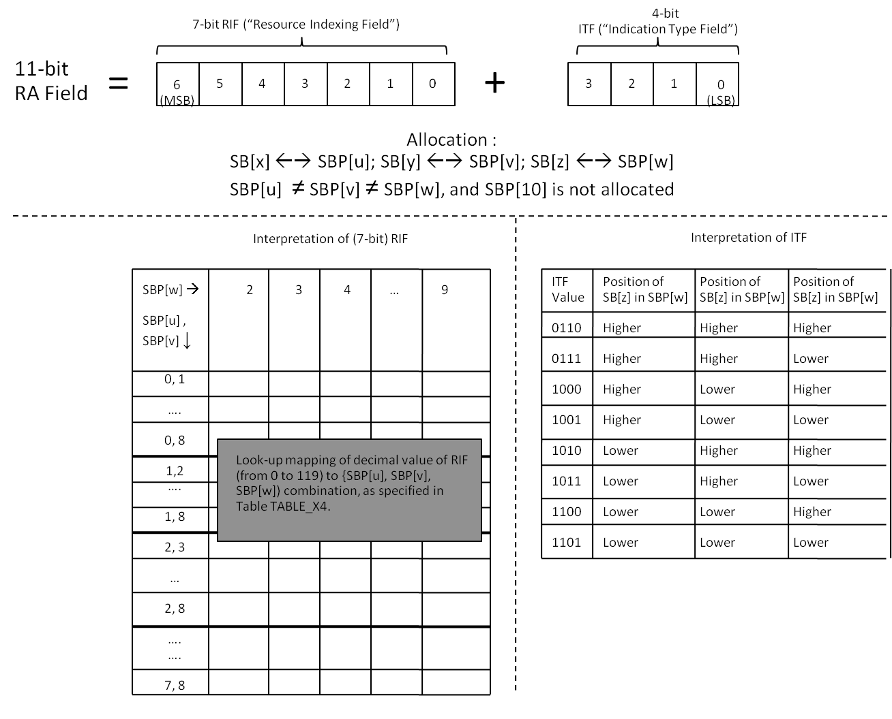
Figure FIGURE_X12: Allocation of 3 sub-bands, all in different sub-band pairs (except SBP[10])
15.3.6.5.2.4.1.2.3 Allocation of 3 sub-bands, with all 3 in different Sub-band Pairs, including SBP[10]
In this sub-case of a 3 sub-band allocation, we have SBP[u] ≠ SBP[v] ≠ SBP[w], with SBP[w] = SBP[10]. Hence, in this sub-case, we have one of the allocated sub-bands, SB[z] = SB[20].
The 2 ITF values 1110 and 1111 shall indicate this sub-case, and these ITF values shall be interpreted as follows.
- ITF = 1110 ➔ SB[x] and SB[y] are both the higher SB indices in SBP[u] and SBP[v] or both the lower indices in SBP[u] and SBP[v], respectively.
- ITF = 1111 ➔ Either SB[x] is the higher SB index in SBP[u] and SB[y] is the lower SB index in SBP[v], or SB[x] is the lower SB index in SBP[u] and SB[y] is the higher SB index in SBP[v].
The MSB bit of the RIF provides further indication about SB[x] and SB[y] as follows.
- MSB bit of RIF = 0 ➔SB[x] is the higher SB index in SBP[u].
- MSB bit of RIF = 1 ➔ SB[x] is the lower SB index in SBP[u].
The values of the ITF and the MSB bit of the RIF, taken together, complete the information about SB[x] and SB[y].
The 6 LSB bits of the Resource Indication Field shall be interpreted as in Table TABLE_X5 to indicate the sub-band pairs SBP[u] and SPB[v] that have been allocated.
Table TABLE_X5: Mapping of 6 LSB bits of the 7-bit RIF bits to assignment of sub-band pairs SBP[u] and SBP[v]
SBP[v] →  ↓ SBP[u] | 1 | 2 | 3 | 4 | 5 | 6 | 7 | 8 | 9
0 | 0 |  |  |  |  | 5 |  |  | 8
1 |  | 9 |  |  |  |  |  |  | 16
2 |  |  | 17 |  |  |  |  |  | 23
3 |  |  |  | 24 |  |  |  |  | 29
4 |  |  |  |  | 30 |  |  |  | 34
5 |  |  |  |  |  | 35 |  |  | 38
6 |  |  |  |  |  |  | 39 |  | 41
7 |  |  |  |  |  |  |  | 42 | 43
8 |  |  |  |  |  |  |  |  | 44

In the table, the decimal values of the 6 LSB bits of the RIF increase from left to right and from top to bottom (the first and last values in each row of the table are shown). The shaded values are not used to make interpretations. Each particular cell in the table, corresponding to a particular decimal value of the RIF, indicates the values of the SBPs SBP[u] and SBP[v] that have been allocated.
Knowledge of the SBPs allocated from Table TABLE_X5, along with the information about the allocated sub-bands within the SBPs as indicated by the ITF and the MSB bit of the RIF, completes the allocation details for this sub-case.
For example, consider RA field = 00001011110, with RIF = 0000101, and ITF = 1110. The 6 LSB bits of the RIF are 000101 (decimal value 5), which, from Table TABLE_X5, map to SBP[u] = 0, SBP[v] = 6. Hence, the allocated sub-bands are in SBP[0] = {SB[0], SB[1]}, SBP[6] = {SB[12], SB[13]} and SBP[10] = {SB[20]}. The value of the ITF and the MSB of the RIF indicate that allocated sub-bands are the ones with the higher indices in SBP[0] and SBP[6]. Hence, the allocation is {SB[1], SB[13], SB[20]}.
This case is pictorially illustrated in Figure FIGURE_X13.

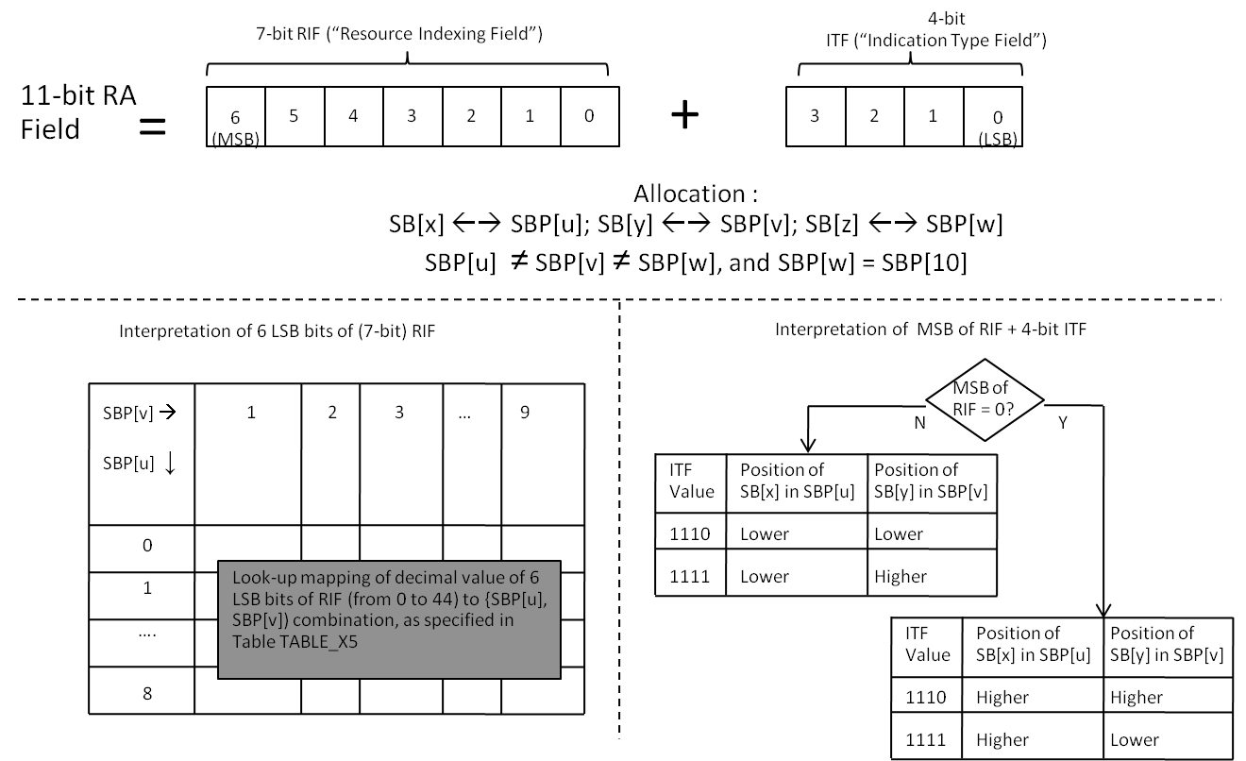
Figure FIGURE_X13: Allocation of 3 sub-bands, all in different sub-band pairs, including SBP[10]
------------------------------------------------------ End proposed modification 12 -------------------------------------

- Modification 13
The 1st sentence in Section 15.3.6.5.2.5 on Page 373 is proposed to be modified as follows.
------------------------------------------------------ Begin proposed modification 13 -------------------------------------
The UL Sub-band Assignment A-MAP IE shall have an identical structure to the UL Basic Assignment A-MAP IE defined in Section 15.3.6.5.2.3.
------------------------------------------------------ End proposed modification 13 -------------------------------------

- Modification 14
The lines starting from Line 48 on Page 361 of Section 15.3.6.5.2.2, and ending with Line 3 on Page 362 of the same section, are proposed to be modified as follows.
------------------------------------------------------ Begin proposed modification 14 -------------------------------------
- Replace all occurrences of the term “physical PRU” with the term “PRU”.
- Replace all occurrences of the term “CRU” with the term “CLRU”, and all occurrence of the term “DRU” with “DLRU”.
- In Equation(205), change the 0 <= i < 3 to 0 <= i <= 3.
------------------------------------------------------ End proposed modification 14 -------------------------------------

- References
[1] IEEE P802.16m/D2, “Part 16: Air Interface for Broadband Wireless Access Systems”, October 2009.

