Project | IEEE 802.16 Broadband Wireless Access Working Group <http://ieee802.org/16>
Title | Network Coding based E-MBS Retransmission (15.9.2)
Date Submitted | 2009-11-12
Source(s) | Hung-Yu Wei  Ching-Chun Chou  Cheng-Chih Chao  National Taiwan University  Guosen Yue,  Xiaodong Wang,  Sampath Rangarajan,  Mohammad A. (Amir) Khojastepour  NEC Labs America  Chun-Yen Wang  Frank Ren  ITRI  Xianwei Gong, Jin Xu, Robert Xu, Kaiying Lv, Bo Sun, Huiying Fang  ZTE Corporation  Chun-Yen Hsu  III | E-mail: hywei@cc.ee.ntu.edu.tw  *<http://standards.ieee.org/faqs/affiliationFAQ.html>  E-mail: yueg@nec-labs.com  amir@nec-labs.com  E-Mail: ChunYen@itri.org.tw  frank_ren@itri.org.tw  E-mail: gong.xianwei@zte.com.cn, xu.jin7@zte.com.cn,  sun.bo1@zte.com.cn  E-Mail : hcy@iii.org.tw
Re: | Proposal to standard draft P802.16m/D2, on E-MBS Retransmission
Abstract | Network coding E-MBS retransmission mechanisms and corresponding packet header format are presented. The retransmission may be triggered with or without feedback.
Purpose | For discussion and approval by IEEE 802.16m TG
Notice | This document does not represent the agreed views of the IEEE 802.16 Working Group or any of its subgroups. It represents only the views of the participants listed in the “Source(s)” field above. It is offered as a basis for discussion. It is not binding on the contributor(s), who reserve(s) the right to add, amend or withdraw material contained herein.
Release | The contributor grants a free, irrevocable license to the IEEE to incorporate material contained in this contribution, and any modifications thereof, in the creation of an IEEE Standards publication; to copyright in the IEEE’s name any IEEE Standards publication even though it may include portions of this contribution; and at the IEEE’s sole discretion to permit others to reproduce in whole or in part the resulting IEEE Standards publication. The contributor also acknowledges and accepts that this contribution may be made public by IEEE 802.16.
Patent Policy | The contributor is familiar with the IEEE-SA Patent Policy and Procedures:  <http://standards.ieee.org/guides/bylaws/sect6-7.html#6> and <http://standards.ieee.org/guides/opman/sect6.html#6.3>.  Further information is located at <http://standards.ieee.org/board/pat/pat-material.html> and <http://standards.ieee.org/board/pat>.
Network Coding based E-MBS Retransmission
Hung-Yu Wei, Ching-Chun Chou, Cheng-Chih Chao
National Taiwan University
Guosen Yue, Xiaodong Wang, Sampath Rangarajan, Mohammad A. (Amir) Khojastepour
NEC Labs America
Chun-Yen Wang, Frank Ren
ITRI
Xianwei Gong, Jin Xu, Robert Xu, Kaiying Lv, Bo Sun, Huiying Fang
ZTE Corporation

1 Introduction
SDD specifies the E-MBS operation with network coding based retransmission. In Section 13.3.3 of SDD, it states “An ABS may use a network-coding based retransmission scheme that does not require a feedback channel.”

This document conforms with SDD specification and describes the proposed AWD text on network coding based E-MBS retransmission without feedback. This harmonized document includes text from contributions C80216m-09_2539r1, and C80216m-09_2340.

2 Performance Evaluation
We compare the proposed network coding scheme with NTU-ITRI network coding scheme in [3], Motorola network coding scheme in [5], ZTE network coding scheme in [6], NTU-NEC-ITRI network coding scheme in [7].

The simulation scenario 1 is:
X-axis: retransmission overhead (redundant packets number / original packets number);
Y-axis: loss packet rate ( (original packets number – successful decoding packets ) / original packets number );

It notes that loss packet rate is ratio of error packets number, after receiver decoding the packets with network coding, to original packets number. And the erasure rate of the following table is rate of the number of lost packets over transmission packets(including first transmission packets and redundant packets ) during transmission in channel.

And the simulation condition is:
index | original packets number | erasure rate | redundant packets number | batch number
1 | 25 | 0.05 | 1, 3, 5, 7, 9, 11, 13 | 3000
2 | 25 | 0.09 | 1, 3, 5, 7, 9, 11, 13 | 3000
3 | 48 | 0.05 | 1, 2, 4, 8, 12, 24 | 3000
4 | 48 | 0.09 | 1, 2, 4, 8, 12, 24 | 3000
5 | 100 | 0.05 | 1, 3, 6, 10, 15, 20, 30 | 3000
6 | 100 | 0.09 | 1, 3, 6, 10, 15, 20, 30 | 3000

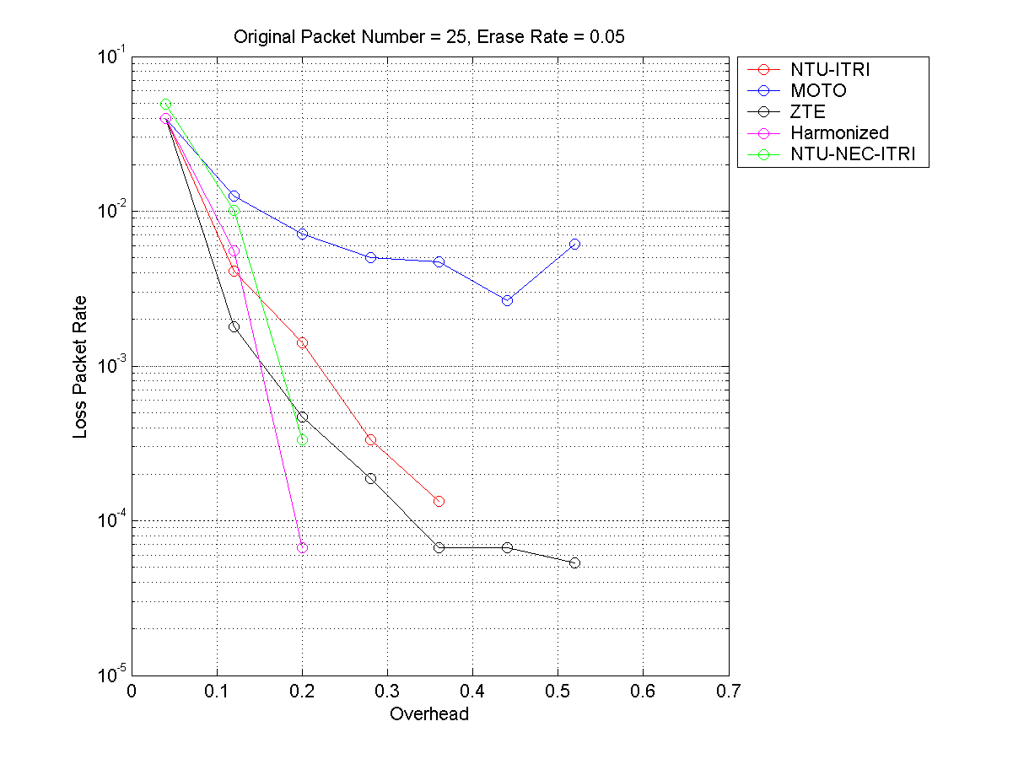
Figure 1 the result with simulation condition in index 1

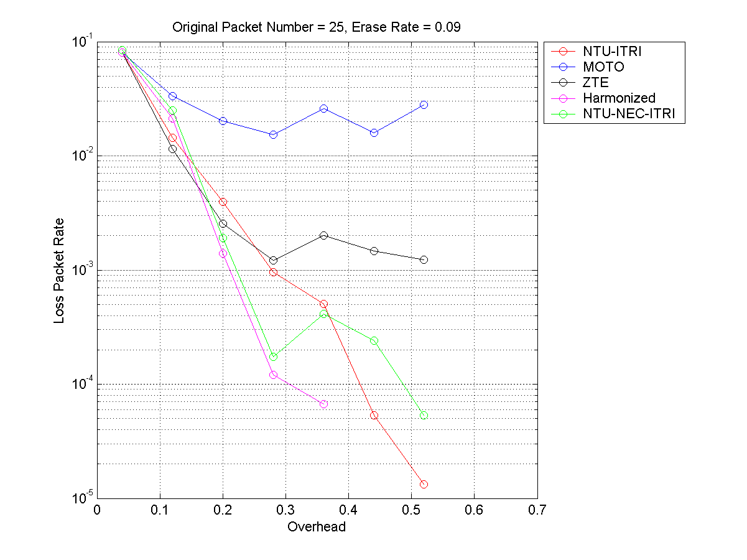
Figure 2 the result with simulation condition in index 2

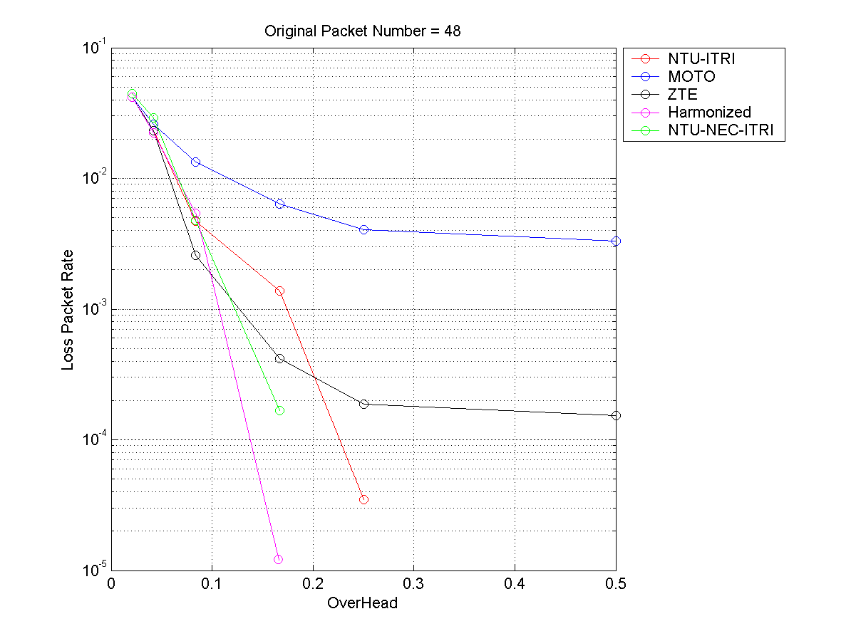
Figure 3 the result with simulation condition in index 3

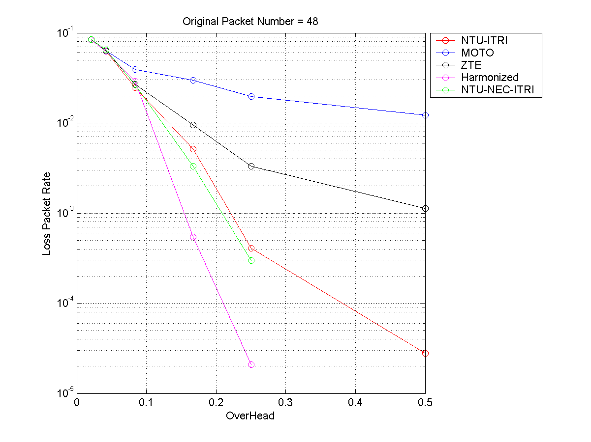
Figure 4 the result with simulation condition in index 4

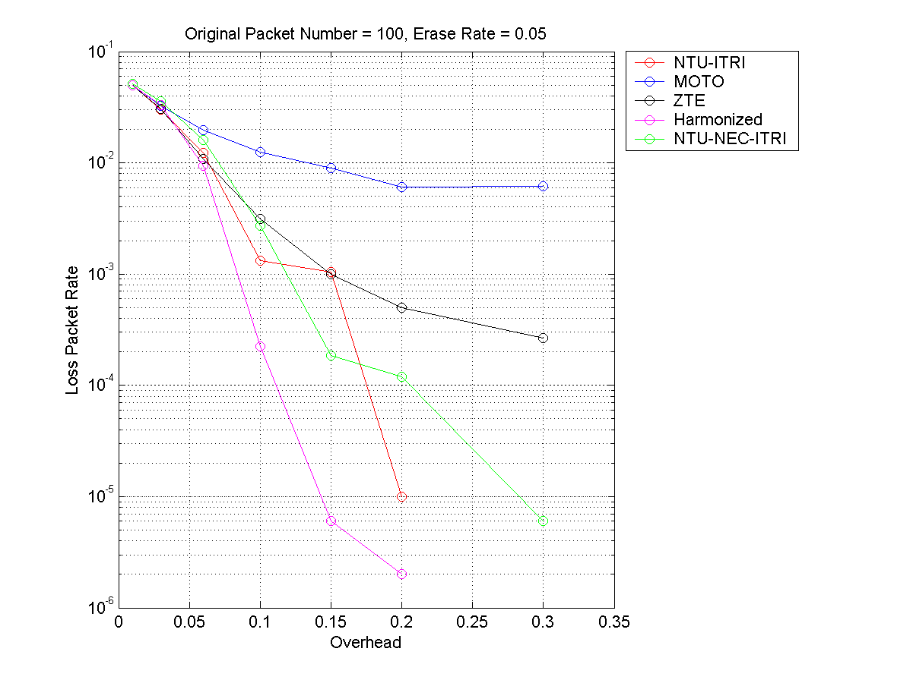
Figure 5 the result with simulation condition in index 5

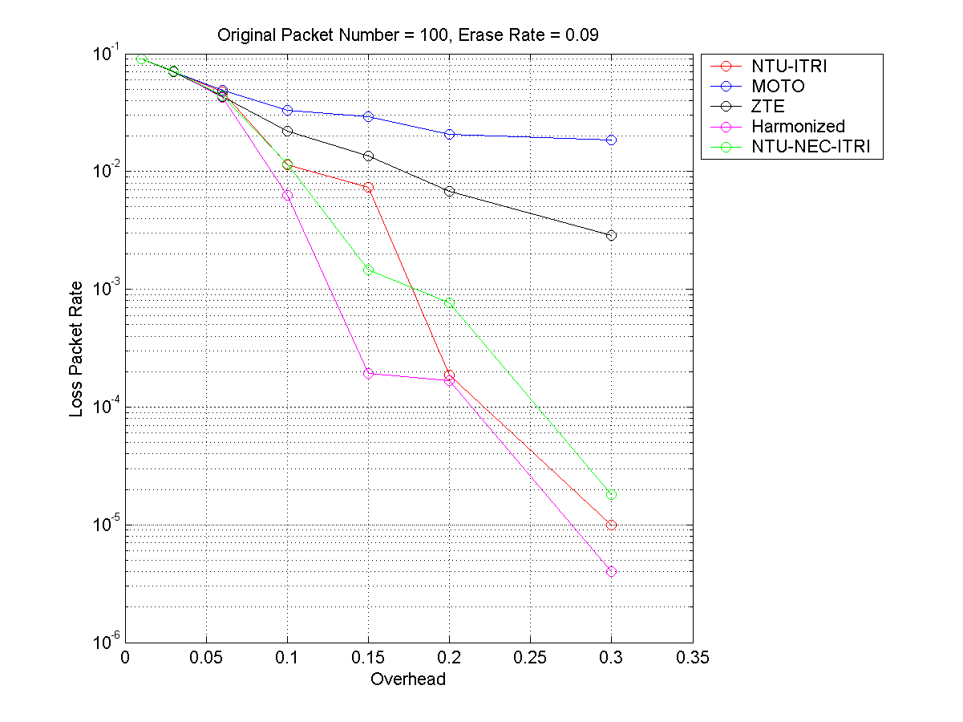
Figure 6 the result with simulation condition in index 6

The above figures show that the performance of harmonized scheme is better than others in most cases, and a little less than ZTE scheme and NTU-ITRI scheme in low overhead in Figure 1 and 2.

The simulation scenario 2 is:
X-axis: retransmission packets number;
Y-axis: a trial is successful if all AMSs decode all L packets. The all perfect ratio is the ratio of successful trials over total number of trials.
And the simulation condition is:
1, one ABS broadcast to 10 AMSs.
2, the packet loss rate is 0.05.

It notes that the erasure rate of the following table is rate of the number of lost packets over transmission packets(including first transmission packets and redundant packets ) during transmission in channel.

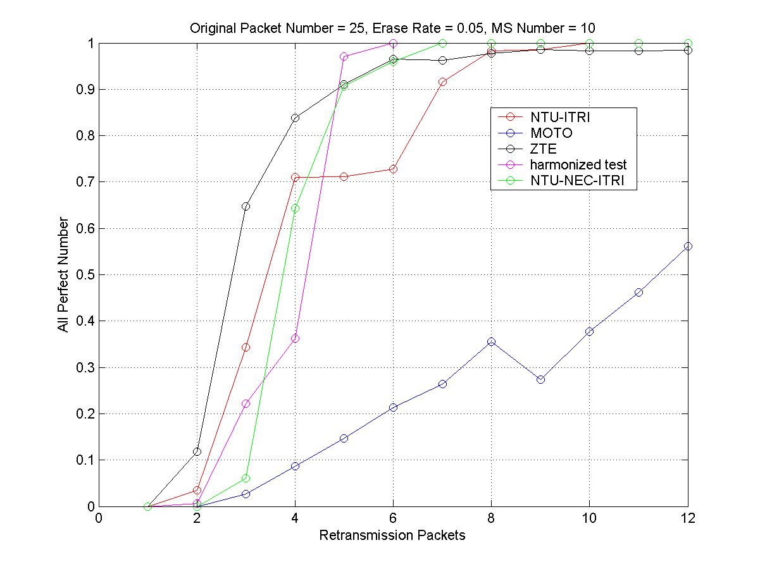
Figure 7 the simulation result in simulation scenario 2, original packets number = 25, erasure rate = 0.05, MS number = 10.

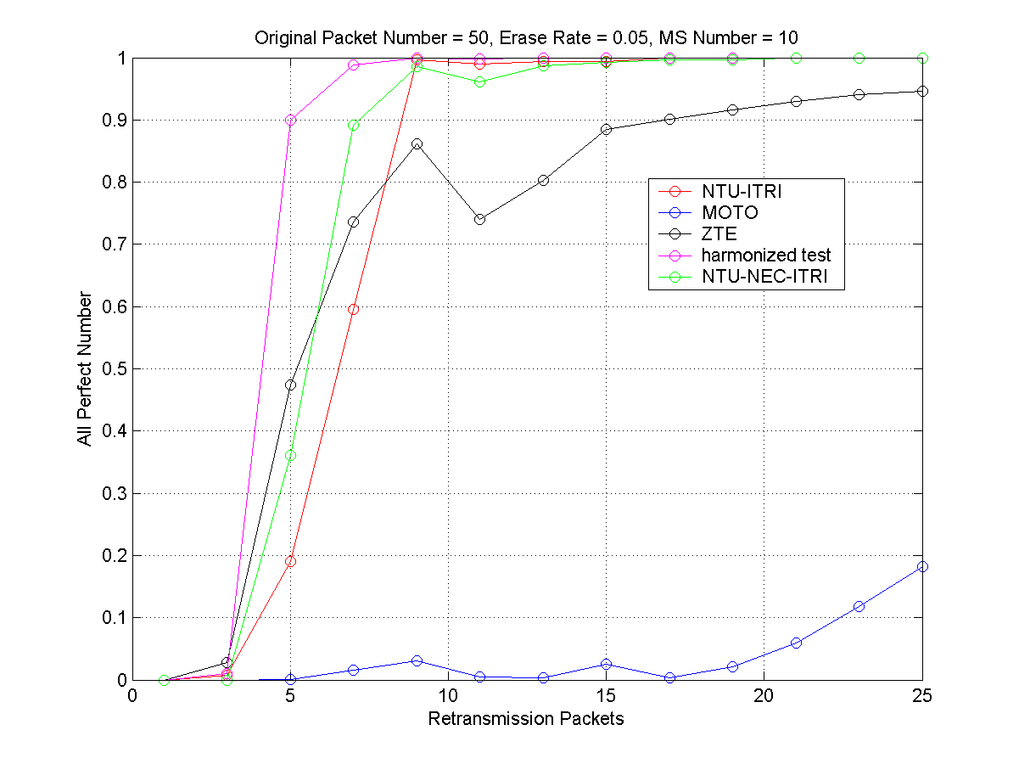
Figure 8 the simulation result in simulation scenario 2, original packets number = 50, erasure rate = 0.05, MS number = 10.
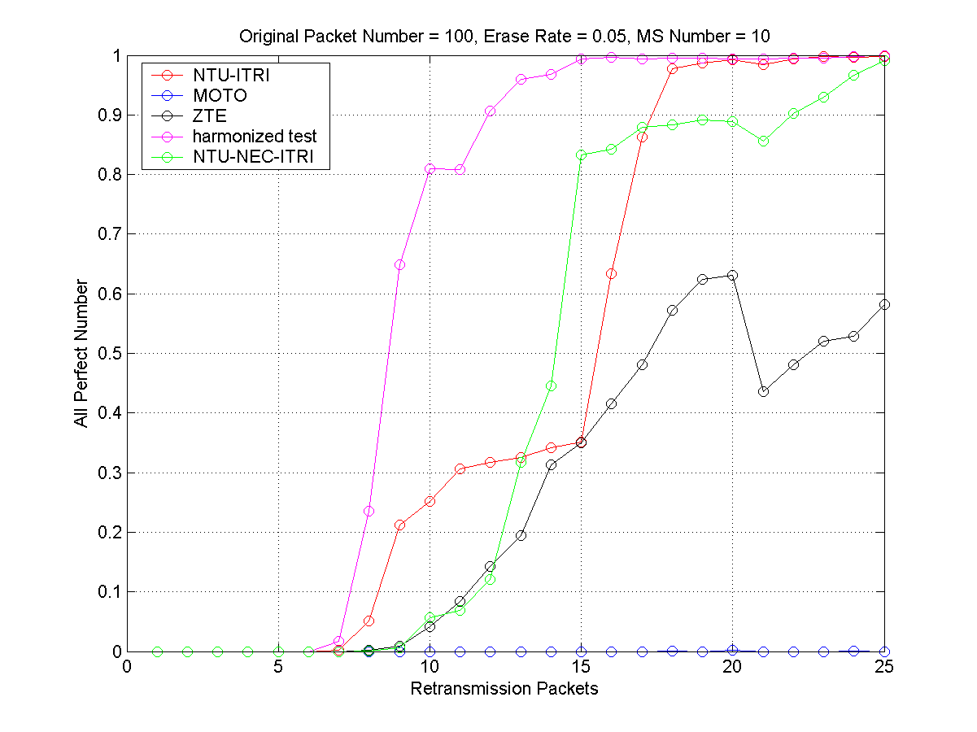
Figure 9 the simulation result in simulation scenario 2, original packets number = 100, erasure rate = 0.05, MS number = 10.

From the above 3 figures, it could be found the performance of harmonized scheme is still better than others in most cases, and a little less than ZTE scheme and NTU-ITRI scheme in low overhead in Figure 7.

Proposed Text to P802.16m Amendment Working Document
Add the following text into the amendment draft:
---------------------------------------------------Start of the proposed text------------------------------------------------------

15. 9.2.4 E-MBS Retransmission 15. 9.2.4. 1 Network Coding based E-MBS Retransmission

15. 9.2.4. 1.1 Network Coding based E-MBS Retransmission without Feedback
For E-MBS retransmission without feedback, the number of original packets and redundancies should be specified prior to the E-MBS retransmission. The pre-defined codebook is used to determine the coding coefficient for network coding transmission. The first L packets transmitted, i.e. G₁,… ,G_{L}. G_{i} (i=1,…,L) is XOR-based linear combination of the original packet sequence P₁,…, P_{L} . After the L packets are transmitted, Q packet-slots are allocated for retransmission. The packets for retransmission R₁,…,R_{Q} are binary packet encoded from the original packet sequence P₁,…, P_{L} based on the following procedures. In the E-MBS network coding subheader, Mode should be set to 01, PKT_N should be set to L, and PKT_T should be set to (L+Q).

15. 9.2.4. 2 Codebook for Network Coding Based E-MBS Retransmission

The codebook C is an L x T matrix, where L is the number of original packets, and T is the codebook size.

$$C=\left[\begin{matrix}C_{1,1} & C_{1,2} & C_{1,3} & \text{.}\text{.}\text{.} & & & & C_{1,L} \\ C_{2,1} & C_{2,2} & C_{2,3} & \text{.}\text{.}\text{.} & & & & C_{2,L} \\ C_{3,1} & C_{3,2} & C_{3,3} & \text{.}\text{.}\text{.} & & & & C_{3,L} \\ \text{.}\text{.}\text{.} & & & & & & & \\ C_{T,1} & C_{T,2} & C_{T,3} & \text{.}\text{.}\text{.} & & & & C_{T,L}\end{matrix}\right]$$

C_{i,j} : i represents the code index, j represents the index of the original packets
C_{i,j} ∈{0, 1}

Denote the original packets are P₁, P₂, P₃, … , P_{L.} One row of codebook C represents one set of coding coefficients. If C_{i,j} is 1, it means the coded packet i contains P_{j}. One row of coefficients of a codebook matrix represents one set of coding coefficient. For example, the 2nd set of coding coefficient is the 1 by N matrix [C_{2,1} C_{2,2} C_{2,3} … C_{2,L} ]. The encoded packet is the XOR-based linear combination of the (P₁C_{2,1} +P₂C_{2,2} +P₃C_{2,3} +… +P_{L}C_{2,L}). The coding coefficient index in the packet header of the encoded packet is set to 2, since the 2nd set of coding coefficient in the codebook is used.

The first L packets transmitted, i.e. Q₁,…, Q_{L}, are XOR-based linear combination of the original packet sequence P₁,…, P_{L} as following:
(1) Q₁ = P_{1;}
(2) for i = 2, …, L, Q_{i} = P_{i-1}P_{i}, where “” denotes XORing operation;
Therefore, C_{1,1} = 1, and C_{i,i-1} =C_{i,i} = 1 for i = 2,…,L.

For row L+1 to L+M, the codebook generating function is as follows. If L > 50, set M=5, else set M=4.

- Group the packets P₁,…, P_{L} to the packet sets Ω₀,…, Ω₂M₋₁ in order based on the given size of Ω_{n}, l_{n}=|Ω_{n}|, n=0,…, 2^{M}-1.
- Then retransmission packets R₁, …, R_{M} are generated as follows.
$R_{m}=\sum_{P_{j}∈V_{m}}{⊕P_{j}}$, with $V_{m}=\underset{n_{\text{bin}}(m)=1}{}Ω_{n}$
where denotes binary summation and n_{bin} (m) denotes the m-th bit of binary representation of n. In other words, R_{m} is obtained by binary XORing of the data packet P_{j} if P_{j} ∈ Ω_{n} and the m-th bit of binary representation of n. Therefore the codebook coefficients C_{ij} for i=L+1,…,L+M are given by
$C_{i,j}=\left\{\begin{matrix}1, \text{if}{\text{ P}}_{j}∈Ω_{n}{\text{, n}}_{\text{bin}}(m)=\text{1, m}=\text{i-L } \\ \text{0, otherwise}\end{matrix}\right.$

The code definition {l_{n}},can be obtained from {l'_{n}} as follows

$l_{n}=\left\{\begin{matrix}l_{n}^{'}−1, & \text{for} n=2^{0},2^{1},\text{.}\text{.}\text{.},2^{M−1}, \\ l_{n}^{'}, & \text{other} n,\end{matrix}\right.$
where l_{n}’=|Ω_{n}’| , $\sum_{n=0}^{2^{M}−1}{l_{n}^{'}}=L+M$, and {Ω_{n}’} are the packet sets including the retransmission packets, defined as
$$Ω_{n}^{'}=\left\{\begin{matrix}Ω_{n}∪\left\{R_{m}\right\}, & \text{for} n=2^{m−1}, \\ Ω_{n}, & \text{other} n\text{.}\end{matrix}\right.$$

To obtain the code {l_{n}’},
1) If L=25, 50, 75, or 100, {l_{n}’} and M are obtained from Table x.
L | T | M | { l_{n}’ : l_{n}’=|Ω_{n}’ |, n=0,…2^{M}-1}
100 | 37 | 5 | {33 6 6 3 6 3 3 1 5 3 3 1 3 1 1 1 5 3 3 2 3 1 1 0 3 1 1 0 2 0 0 1}
75 | 37 | 5 | {5 6 6 3 6 3 3 1 6 3 3 1 3 1 1 1 5 3 3 2 3 2 1 0 3 1 2 0 2 0 0 1 }
50 | 37 | 4 | {0 6 6 4 6 4 3 2 6 3 3 2 4 2 2 1};
25 | 37 | 4 | {0 3 3 2 3 2 2 1 3 2 2 1 2 1 1 1}
Table x: Code graph definition for generating first M retransmission packets.

2) For other L,
Find the minimum L* in {25,50,75,100} that is greater than L and the corresponding codebook set defined in Table x.
Then based on the following process, we remove the bit one by one from the set until $\sum_{n=0}^{2^{M}−1}{l_{n}^{'}}=L+M$:
- Find maximum l_{n}’ in the updated set and set l_{n}’ = l_{n}’ -1. If there are several l_{n}’ with the same maximum value, we set l_{n}’= l_{n}’ -1 based on the descending order of the Hamming weight of the binary expansion of n. Repeat this until $\sum_{n=0}^{2^{M}−1}{l_{n}^{'}}=L+M$.

For row i > L+M in the codebook,
The parameter a and k are positive integers$a≥2,0≤k≤a−2$, such that $i=(L+M+1)+\frac{(a−1)(a−2)}{2}+k$
$$C_{i,j}=\left\{\begin{matrix}1, \text{if}\text{ j mod a }=\text{ k } \\ \text{0, otherwise}\end{matrix}\right.$$
For example,
a = 2, k = 0, C_{L+M+1,j} = 1 if j mod 2 = 0
a = 3, k = 0, C_{L+M+2,j} = 1 if j mod 3 =0
a = 3, k = 1, C_{L+M+3,j} = 1 if j mod 3 =1
a = 4, k = 0, C_{L+M+4,j} = 1 if j mod 4 =0

15. 9.2.4. 3 Packet Header Format for Network Coding E-MBS Retransmission

Syntax | Size | Notes
Mode | 2-bit | Mode = 00 : uncoded  Mode = 01 : network coding without feedback  Mode = 10 : network coding with limited feedback  Mode = 11 : network coding with common feedback
PKT_T_Flag | 1-bit | This bit indicates that PKT_T is included in the header.  PKT_T_Flag=0: PKT_T is NOT included.  PKT_T_Flag=1: PKT_T is included.
Feedback_Info_Flag | 1-bit | This bit indicates the presence of Feedback Information.  Feedback_Info_Flag=0: No Feedback Information is contained.  Feedback_Info_Flag=1: There will be Feedback Information included in the header.
Index | 8-bit | This index indicates the row of coding coefficient in codebook C, if network coding is applied. If the packet is uncoded, this is the index of the original packet.
Batch_Sequence | TBD | Packets are encoded and decoded in the unit of batch. The batch sequence should be sent along with the header. It specifies the batch ID. Only packet within the same batch may be decoded using linear operation.
PKT_N | TBD | The number of original packet.
PKT_T(Optional) | TBD | The number of total transmitted packets in this batch. PKT_T is skipped if Feedback_Info_Flag
Feedback Information  (Optional) | TBD | Feedback Information filed is skipped if Feedback_Info_Flag=0  Specify the operation taken for the feedback signal from AMS. 3 kinds of messages may be carried here.  Feedback_Threshold:  Threshold for the number of error packet to trigger AMS feedback  Termination_of_current_batch:  Indicate the end of transmission for current batch. Next downlink radio resource block will be scheduled for packets from next batch.  Begin_of_Retransmission:  The retransmission for current batch will be scheduled for next radio resource block in E-MBS DL transmission.
Table Y: Network coding extended header format

---------------------------------------------------End of the proposed text-------------------------------------------------------

References
[1] IEEE 802.16m-09_0034.pdf, SDD text section 13.3.3
[2] IEEE C802.16m-09/1682, Proposed Text for IEEE P802.16m/D1: Network Coding based E-MBS Retransmission (E-MBS) (Ching-Chun Chou, Hung-Yu Wei, Cheng-Chih Chao, Chun-Yen Wang, Frank Ren; 2009-08-30)

[3] IEEE C802.16m-09/1684,Proposed Text for IEEE P802.16m/D1: Network Coding Codebook Design for E-MBS (E-MBS) (Cheng-Chih Chao, Hung-Yu Wei, Ching-Chun Chou, Chun-Yen Wang, Frank Ren; 2009-08-30)

[4] IEEE C802.16m-09/2111, Network Coding Based Retransmission Scheme in E-MBS for IEEE 802.16m AWD (G. Yue, X. Wang, S. Rangarajan, A. Khojasterpour; 2009-08-30)

[5] IEEE C802.16m-09/0072r1, Network coding-based retransmission schemes for E-MBS with and without MS feedback (Hua Xu, Steven Xu, Naveen Arulselvan, Suresh Kalyanasundaram; 2009-01-13)

[6] IEEE C802.16m-09/2340, Proposed text for network coding based retransmission for EMBS(Xianwei Gong, Jin Xu, Robert Xu, Kaiying Lv, Bo Sun, Huiying Fang; 2009-11-09)

[7] IEEE C802.16m-09/2539r1, Hung-Yu Wei,Ching-Chun Chou,Cheng-Chih Chao, Guosen Yue, Xiaodong Wang, Sampath Rangarajan, Mohammad A. (Amir) Khojastepour, Chun-Yen Wang, Frank Ren, 2009-11-06)

