Project | IEEE 802.16 Broadband Wireless Access Working Group <http://ieee802.org/16>
Title | Cross Layer Design for ROHC and HARQ
Date Submitted | 2009-11-06
Source(s) | Phillip Barber  Huawei Technologies Co.,Ltd. | E-mail:  pbarber@huawei.com
Re: | 802.16m amendment working document
Abstract | The cross-layer design for HARQ and ROHC is proposed. In this proposal ROHC feedback is no longer needed and instead, ROHC compressor determines its compression state based on the HARQ feedback by maintaining a context information list and interacting with HARQ. Based on the above operation, system performance in terms of transmission and decompression efficiency will be greatly enhanced.
Purpose | For review and adoption
Notice | This document does not represent the agreed views of the IEEE 802.16 Working Group or any of its subgroups. It represents only the views of the participants listed in the “Source(s)” field above. It is offered as a basis for discussion. It is not binding on the contributor(s), who reserve(s) the right to add, amend or withdraw material contained herein.
Release | The contributor grants a free, irrevocable license to the IEEE to incorporate material contained in this contribution, and any modifications thereof, in the creation of an IEEE Standards publication; to copyright in the IEEE’s name any IEEE Standards publication even though it may include portions of this contribution; and at the IEEE’s sole discretion to permit others to reproduce in whole or in part the resulting IEEE Standards publication. The contributor also acknowledges and accepts that this contribution may be made public by IEEE 802.16.
Patent Policy | The contributor is familiar with the IEEE-SA Patent Policy and Procedures:  <http://standards.ieee.org/guides/bylaws/sect6-7.html#6> and <http://standards.ieee.org/guides/opman/sect6.html#6.3>.  Further information is located at <http://standards.ieee.org/board/pat/pat-material.html> and <http://standards.ieee.org/board/pat>.

Cross Layer Design for ROHC and HARQ
Phillip Barber
Huawei Technologies Co.,Ltd.

Introduction

Present status
ROHC (Robust Header Compression) is one of the most widely used header compression technologies. In ROHC, static field information is sent only once at the beginning. By utilizing dependencies and predictability for other fields, the header size can be significantly reduced for most packets. WiMAX NWG Group has already defined related specification to support ROHC in the 1.5 release standard to improve the system throughput. It is necessary to consider ROHC in 16m system as well.
Even though the efficiency of header compression is high, ROHC should keep strict synchronization between compressor and decompressor, but this synchronization is limited in ROHC mechanism itself (such as feedback in O/R mode), which means feedback messages is required. Feedback messages firstly occupy radio resources in wireless network. Second, feedback in ROHC layer is based on k out of n principle, which may cause synchronization loss and decompression failure. The disadvantages of the current ROHC feedback mechanism may limit the improvement of system throughput.
In this proposal, we solve the above issues by proposing a fast feedback scheme to provide real-time feedback with efficient radio resource utilization. HARQ mechanism in 16m is enhanced by combining HARQ state machine, MAC ARQ state machine with MAC control messaging state machine to improve link performance. This cooperation among different functions can improve the system performance. To accommodate ROHC in WiMAX, cooperation between HARQ and ROHC also needs to be considered to improve the system performance.

The limitation of the independence of ROHC and HARQ
In current scheme, ROHC packets are transparent to HARQ functions. HARQ treats a ROHC packet as a data burst and sends a feedback according to the validation of data burst without considering the decompression status of ROHC packet, e.g. the decompression of ROHC packet may be a failure and cause ROHC decompression asynchronization, while an ACK is send to HARQ transmitter from receiver to trigger the transmission of the next packet. The following packets may also be decompressed incorrectly, and this transmission will be a waste of radio resource. The limitation of the independence of ROHC and HARQ may cause the following problems:
- Due to the independence of HARQ and ROHC, each HARQ process (re)transmits packets based solely on HARQ feedback (e.g. NACK/ACK), regardless the ROHC feedback (e.g. NACK); Therefore, although the packets transferred from the HARQ function to the ROHC function are correct, the ROHC decompressor may still not be able to decompress the packets because of the asynchronization between decompressor and compressor. If there is no IR/IR-DYN packet in the following HARQ data burst and the decompressor will not be able to decompress the data packets, it will make the radio resources waste, and decrease the decompression rate.
- The ROHC compressor transfers to another state based on the feedback from decompressor (through ROHC control signals), without considering the transmission state in HARQ. This means the compression state transfer may be not prompt and may waste radio resource. On the other hand, if interaction with the HARQ transmission state is enabled, the compressor can estimate the decompression state and determine its next compression state promptly.
- The feedback follows the k out of n principle. When k>1, the feedback is delayed which may cause the following packets incorrectly decompressed. When k=1, the feedback is so frequent which makes too many compression state transfer and may result in decreased compression efficiency.
- There are two independent feedbacks (ROHC decompressor feedback and HARQ receiver feedback), which has the potential of resource waste. In fact, only one feedback is needed, and HARQ can report HARQ feedback information to ROHC compressor for ROGC state machine transfer.
From above analysis, HARQ and ROHC should be considered to work together, which means a cross-layer design for HARQ and ROHC is needed to alleviate the above limitations.

The ROHC/HARQ cross layer design proposal

The mechanism (description)
ROHC compressor maintains related context information that includes: the compression sequence number、the header information of the packets、the transmission state in HARQ、the encapsulation information of the packets in MAC 、HARQ process information, etc.
The packets processing states in the lower layers must be reported to ROHC compressor, exp. the encapsulation information at MAC layer or the transmission state of ROHC packets.
Procedure description:
(1) HARQ transmitter reports the HARQ feedback (NACK/ACK, or analysis results of the transmission state) to ROHC compressor when it receives the feedback from the HARQ receiver;
(2) Based on the above feedback, ROHC compressor deduces which packets are transmitted incorrectly and the order of the correct packets that arrive at the decompressor. Then based on related context information, ROHC compressor deduces how many packets are decompressed incorrectly. According to the k of n principle, ROHC compressor deduces the state of decompressor.
(3) Based on the estimating decompression state and context information, ROHC compressor determines its compression state and/or other operations:
To determine the compression state transferring trend
To inform the lower layers to discard the packets in cache;
To inform the lower layer to reconstructed the packets to be transmitted
……
(4) Lower layers (MAC/PHY (HARQ)) do corresponding actions when they receive the indication from the compressor
Based on the above operation, the ROHC feedback from the decompressor is no longer needed. The expense paid is that the compressor has to maintain context information and interact with HARQ function. Simulation results shown that this scheme can enhance the system performance including the transmission and decompression efficiency.

Two scenarios
It is possible that a flow may be beard in a single HARQ process or multiple HARQ processes, which means the data packets of a certain flow can be transmitted through a single HARQ process or multi HARQ processes. The details of the two scenarios are described as shown in the following.

Scenario one: One flow mapping to a single HARQ process
Figure 1: scenario one
Figure 1 only displays the process that the compressor transfers the state from SO back to IR/FO (or from FO back to IR); the detail mechanism is showed in the following steps:
- HARQ sender transmits the HARQ date bursts of a certain flow through a single HARQ channel to the related HARQ receiver
- HARQ receiver sends feedback (NACK/ACK) when it decodes and validates the HARQ date burst
- HARQ sender receives the HARQ feedback, and reports to the ROHC compressor (or estimates the transmission state and order based on the HARQ feedback and then reports the analysis results to ROHC compressor).
- ROHC compressor infers the decompression state based on the HARQ feedback and the related context information it maintains.
- ROHC compressor determines its own compression state in order to keep synchronization with decompressor
A).According to the HARQ feedback, the compressor estimates that the decompressor transfers its state, and there are no IR/IR-DYN packets (in the HARQ data burst ) following the failed HARQ data burst transmission, then the compressor transfers to IR/FO state, and do corresponding actions (see Figure1);
B).The ROHC compressor estimates that the decompressor transfers its state, but there are IR/IR-DYN packets in following the HARQ data burst, then the compressor maintains its state without taking additional steps (see Figure1, steps (6),(7) will not be executed).
(6a) When the ROHC compressor transfers its state back to IR/FO, it will inform MAC layer to add some header information (such as SN, TS, IP-ID etc.) to the related MAC packets in the cache or inform the MAC layer to discard the related MAC packets in the cache.
(6b) When the ROHC compressor transfers its state back to IR/FO, it will inform the HARQ sender to discard the HARQ date burst in the cache
(7a) When MAC layer receives (6a), it will add some header information to the MAC packets of the related flow or discard the related MAC packets
(7b) When HARQ sender receives (6b), it will discard the HARQ date bursts of the related flow.
There are still something should be noted. When the header of a packet is transmitted successfully in wireless channel, but the payload of the packet (in another HARQ data bursts) fails to transmit, the header can be forwarded to the decompressor to assist the decompression context update. With this method, the decompressor can use the header of the packet (whose payload is not transmitted correctly) to decompress the following packets when the packets are in severe disorder and the following packets may not be decompressed correctly without the above header information .

Scenario two: One flow mapping to multiple HARQ processes

Figure 2: scenario two

The process of scenario two is similar to scenario one, and the detail mechanism is showed in the following steps:
(1) HARQ sender generates the HARQ data bursts and divides the HARQ processes based on the IR/IR-DYN packets location.
The packets of one flow may be transmitted through several HARQ processes. Therefore, the transmission failure occurred on one process may impact decompression of the packets transmitted in other HARQ processes. In order to reduce above impact, HARQ sender should try its best to make the IR/IR-DYN packets placed beginning in HARQ data burst for every process
(2) HARQ sender transmits the HARQ data bursts of one flow on multiple HARQ channels
(3) HARQ receiver sends feedback (NACK/ACK) to HARQ sender when it decodes the HARQ date bursts on several HARQ channel
(4) HARQ sender analyzes the HARQ feedback from multiple HARQ processes, estimates the transmission state and order of the related flow
(5) HARQ sender reports the HARQ feedback information (the transmission state and order) to ROHC compressor
(6) ROHC compressor infers the ROHC decompression state based on the HARQ feedback information and the related context information it maintains.
The other following steps (7), (8), (9) is the same as the steps (5), (6), (7) in scenario1.
But there is still something to be noted. HARQ receiver should try its best to transfer the packets to decompressor in order according to the schedule indication and the ACID.

Benefits of the ROHC/HARQ cross layer design proposal
In this proposal, the cross-layer design between ROHC and HARQ is proposed. No requirement of ROHC decompression feedback is needed when a feedback from the HARQ sender (the HARQ sender transfers the HARQ feedback information to ROHC compressor) can be reported to the compressor. The proposed scheme can enhance the following performances:
Reduced feedback resource utilization;
Reduced feedback delay;
Decreased decompression error rate;
Reduced (de)compression state transfer frequency;
Increased the compression efficiency;
Increased throughput, and enhanced radio resource utilization efficiency.

Simulation results
We present in what follows our simulation results based on scenario two and their underlying assumptions. The detailed simulation model is provided as follows:
(1) Uniformly distributed packet generation of one packet every 5ms. The packet length is 156 bytes and encapsulated with RTP/UDP/IP protocols;
(2) The process delay between the layers is ignored. The maximum delay of wireless transmission is 5ms;
(3) HARQ parameters: 8 HARQ processes for a user, IR mode, and retransmission delay with 10ms;
(4) ROHC parameters: R mode used for original mechanism, k of n principle (k=3, n=10), WLSB mechanism with p= -1;
(5) BER between 0.00003 and 0.0005 in the wireless channel. The channel mode is AWGN (Additive White Gaussian Noise). Through the simulation, When the BER is less than or equal to 0.0001, the BLER (Block Error Rate) is less than 0.1. And in the actual simulation, the scenario of BLER≤0.1 is used widely, so the simulation in our proposal is feasible.

The simulation results are shown as follows, where compression rate = compression packet size/packet size before compressed, and decompression rate = decompressed packet number/total packet number
Table1: Comparison of compression rate, decompression rate and resource cost
BER | Compression rate |  | Decompression rate |  | Resource cost (Bytes)
BER | Original | Improved | Original | Improved | Original | Improved | gain
0.00001 | 85.66% | 86.90% | 88.8492% | 88.882% | 4333046 | 4317344 | 0.36%
0.00005 | 80.78% | 84.66% | 82.6565% | 86.667% | 4526938 | 4487169 | 0.88%
0.0001 | 70.77% | 81.19% | 71.277% | 82.4031% | 4946696 | 4830349 | 2.35%
0.0003 | 54.87% | 76.03% | 56.6182% | 74.2756% | 6240597 | 5889829 | 5.62%
0.0005 | 51.75% | 74.56% | 55.0591% | 73.3679% | 7033114 | 6642431 | 5.55%

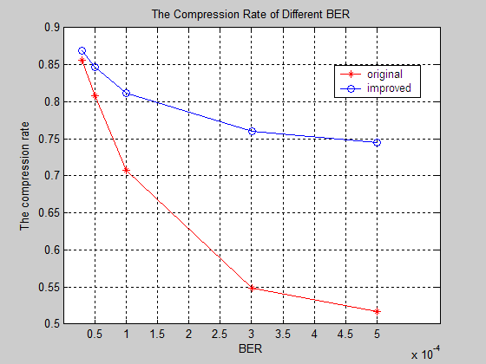
Figure 3: Comparison of the compression rate

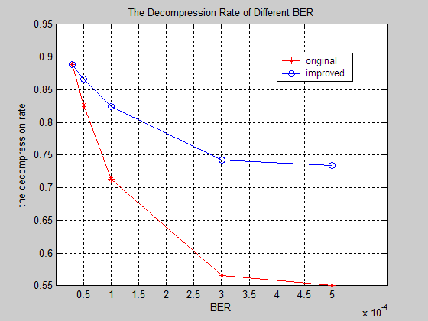
Figure 4: Comparison of the decompression rate

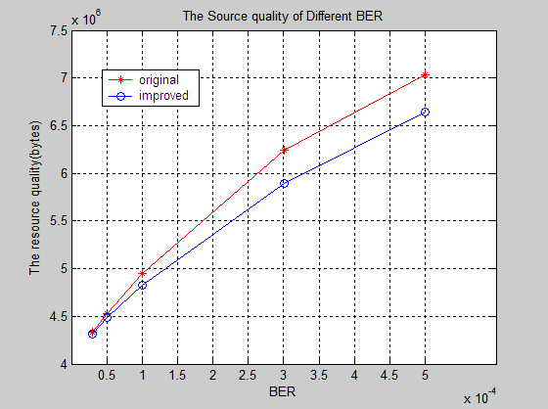
Figure 5: Comparison of the resource cost
As the BER/BLER increases, the gain including the compression rate, the decompression rate and the resources cost is increasing. Simulation results show that that the compression rate is improved by 10.42%, the decompression rate is improved by 11.126%, and the resources cost in wireless channel is reduced by 2.35% when the BER is 0.0001(which means the BLER≤0.1). Therefore, the simulation results prove the proposal about the cross layer design for HARQ and ROHC is feasible.

Text proposal
-----------------------------------------------------------Start of the Text---------------------------------------------------------
Insert the following subsection in section 15.2.14 “HARQ Functions”:
15.2.14.8 Combined feedback scheme for ROHC and HARQ
When both HARQ and ROHC are applied for a flow, the cross layer design between HARQ and ROHC (Combined feedback scheme for ROHC and HARQ) may be applied to the corresponding flow.
If the HARQ entity in the transmitter receives the feedback from the HARQ entity in the receiver, it shall report the HARQ feedback to the ROHC compressor which replaces ROHC feedback explicit feedback mechanisms.
Once the ROHC compressor receives the HARQ feedback it will estimate the decompression state; determine its own adjusted compression rate state based on the HARQ feedback information and the context of the ROHC packet transmissions. The compressor transmits ROHC packets according to the adjusted compression rate state, and at the same time informs the lower layers to do operations such as: adding header information to the MAC packets in the cache, discarding the MAC packets or HARQ data burst in the cache, etc.
Capability to support combined feedback scheme for ROHC and HARQ shall be negotiated between ABS and AMS during network entry procedure.

------------------------------------------------------------End of the Text---------------------------------------------------------

References:
[1] IEEE Std. 802.16e − Air Interface for Fixed Broadband Wireless Access Systems, Amendment 2: Physical and Medium Access Control Layers for Combined Fixed and Mobile Operation in Licensed Bands, February 2006.
[2] IEEE 802.16m-09/0034r1, “The Draft IEEE 802.16m System Description Document”.

