Project | IEEE 802.16 Broadband Wireless Access Working Group <http://ieee802.org/16>
Title | Multiple Handover Parameters for Handover to Another Type ABSs
Date Submitted | 2009-11-16
Source(s) | Youngbo Cho, Jaehee Cho, Jaehyuk Jang  Samsung Electronics.  Whai-En Chen, Shih-Yuan Cheng  National Ilan University  Shiann-Tsong Sheu, Chih-Cheng Yang  National Central University  Kanchei (Ken) Loa, Yi-Hsueh Tsai, Chun-Yen Hsu, Yung-Ting Lee,  Youn-Tai Lee, Hua-Chiang Yin, Tsung-Yu Tsai, Chiu-Wen Chen  Institute for Information Industry  Yang-Han Lee, Yih Guang Jan  Tamkang University | Voice: +82-31-9530-7093  Fax:  youngbo.cho@samsung.com
Re: | P802.16m/D2 LB30a
Abstract | This contribution proposes the mechanism for handover between different type ABSs
Purpose | To be discussed and adopted by TGm for the 802.16m Advanced Air Interface (Draft 1)
Notice | This document does not represent the agreed views of the IEEE 802.16 Working Group or any of its subgroups. It represents only the views of the participants listed in the “Source(s)” field above. It is offered as a basis for discussion. It is not binding on the contributor(s), who reserve(s) the right to add, amend or withdraw material contained herein.
Release | The contributor grants a free, irrevocable license to the IEEE to incorporate material contained in this contribution, and any modifications thereof, in the creation of an IEEE Standards publication; to copyright in the IEEE’s name any IEEE Standards publication even though it may include portions of this contribution; and at the IEEE’s sole discretion to permit others to reproduce in whole or in part the resulting IEEE Standards publication. The contributor also acknowledges and accepts that this contribution may be made public by IEEE 802.16.
Patent Policy | The contributor is familiar with the IEEE-SA Patent Policy and Procedures:  <http://standards.ieee.org/guides/bylaws/sect6-7.html#6> and <http://standards.ieee.org/guides/opman/sect6.html#6.3>.  Further information is located at <http://standards.ieee.org/board/pat/pat-material.html> and <http://standards.ieee.org/board/pat>.

Multiple Handover Parameters for Handover to Another Type ABSs
Youngbo Cho, Jaehee Cho, Jaehyuk Jang
Samsung Electronics.

Introduction
This contribution proposes the text of handover between macro ABS and another type ABS to be included in the IEEE 802.16m/D1 [5]. The technical text is inherited from the IEEE 802.16m SRD [2], SDD [3], and IEEE P802.16 Rev2/D9 [1].

Introduction

Requirement for Fast HO to micro ABS
In the hierarchical cell structure shown as Figure 1, the received signal strength level on an AMS from a micro ABS (ABS with small cell coverage such as macro hot-zone ABS, femto ABS, etc) becomes high rapidly when the AMS goes near to the microcell coverage. On the macro AMS (AMS connected with macro ABS), DL interference level from micro ABS is dramatically increased at the coverage of microcell. Moreover, as shown in Figure 2, severe uplink interference is occurred on the micro ABS due to the UL signal from macro AMS at the coverage edge of the microcell. In micro ABS, received signal power level between micro AMS and macro AMS near to microcell coverage are vastly different. Therefore, it is important that fast HO to micro ABS is carried out because seamless communication is interrupted without this fast HO.

Figure 1. DL received signal strength from macro ABS and micro ABS on an AMS

Figure 2. DL interference to AMS and UL interference to macro hot-zone ABS in hierarchical structure

In order to realize fast and accurate HO, it is important to optimize parameters in measuring received signal levels, averaging them and comparing them. If insufficient HO parameters are applied, the HO qualities such as HO delay, ping-pong effect are degraded. The physical characteristics of the received signal (such as path-loss, shadowing, etc) from micro ABS are very distinct from those from macro ABS.
Figure 3 shows the difference of received signal strength on an AMS with accordance to distance from the serving ABS. Figure 3(a) and (b) show the cases when the AMS moves from macro ABS to macro ABS and to micro ABS, respectively. When the AMS moves 20 meters from the cross point (the cross point means the point when the received signal measures from the serving ABS and target ABS are same), the difference of received signal strength from macro ABSs is 0.34dB and that between macro ABS and micro ABS is 3.52dB.

Proposed Scheme

Possible enhancement of HO process time
Proposed solution for fast HO is based on reducing HO decision delay. As shown in Figure 4, HO decision delay (cross to hysteresis margin time) consists of an averaging delay and a hysteresis margin delay. In the case of a moving average, the averaging duration with T seconds would have a constant T/2 delay because each averaged value has been made from past samples of T. On the other hand, the hysteresis margin delay depends on the hysteresis margin and variation of averaged values.

Multiple HO parameters and Preamble partitioning
From the feature of HO parameters described above, we can naturally derive a solution for HO criterion for both macro cell and microcell. As shown in Figure 5, AMS can decide HO to micro ABS rapidly by
- Reduction average duration of measured signal strength
  - The measurement from the micro ABS is robust to fast fading because signal strength increment from the micro ABS is faster than that from macro ABS.
  - Unnecessary HO due to reduction average duration can be constrained by large hysteresis margin.
- Attainment time to hysteresis margin is faster than that to macro ABS
  - Because signal strength increment from the micro ABS is faster than that from macro ABS.
For accurate and stable HO in both the macro cell and the microcell, a multiple HO parameters are required. This solution relies on the assumption that AMS can know whether the target ABS is macro or micro. If cell IDs for macro ABSs and micro ABSs are distinctive, AMS can recognize during cell search process.

- In the HO case from macro to macro ABS
- In the HO case from macro to micro ABS
Figure 3. CINR variation in accordance with averaging duration

Figure 4. HO decision delay (Cross-to-hysteresis margin time)

Figure 5. Fast HO conditions for HO to macro hot-zone

There are 2 remedies to apply this solution in IEEE 802.16m.
- The S-ABS (Serving ABS) may define trigger conditions for HO from S-ABS to T-ABS (Target ABS) which has same ABS type with S-ABS by including ‘Trigger TLV’ (type xx) encodings in AAI-SCD.
  - The offset values of trigger conditions for HO to another ABS types shall be defined in ‘Trigger TLV for another ABS type (type xy)’.
- Preamble partitioning for distinguishing the ABS type
  - This solution relies on the assumption that an AMS can distinguish the ABS type of the T-ABS.
  - Therefore, SA-Preamble sequences shall be partitioned and each partition is dedicated to specific base station type like macro ABS, macro hot-zone ABS, OSG Femto ABS, CSG Femto ABS and etc.
  - The partition information of preamble set is broadcasted in the extended system information.
  - The AMS can differentiate the ABS type of T-ABS during search process.
The S-ABS may define trigger conditions for HO from corresponding S-ABS to T-ABS which is same ABS type with S-ABS. These trigger conditions are described in ‘Trigger TLV’ (type xx) in Table 1.
The S-ABS may also define multiple trigger conditions for HO to ABS which has another ABS types and the trigger values are described in ‘Trigger TLV for another ABS type (type xy)’ in Table 2.
AMS obtains trigger conditions by combining the values from the ‘Trigger TLV’ and ‘Trigger TLV for another ABS type’ for corresponding T-ABS type. The process of obtaining HO parameters is as follow:
- S-ABS defines multiple trigger conditions.
- If the S-ABS is macro ABS,
  - ‘Trigger TLV’ contains the trigger conditions for HO from macro to macro ABSs.
  - ‘Trigger TLV for another ABS type’ contains the trigger conditions for HO from macro ABS to another type ABSs (such as macro hot-zone ABS, femto ABS, etc), respectively.
- If the S-ABS is another type ABS (for example, S-ABS is macro hot-zone ABS)
  - ‘Trigger TLV’ contains the trigger conditions for HO from macro hot-zone to macro ABSs.
  - ‘Trigger TLV for another ABS type’ contains the offset values of trigger conditions for HO from macro hot-zone to another type ABSs (such as macro ABS, femto ABS, etc), respectively..
- The AMS obtains the HO parameters from the S-ABS via AAI_SCD. It includes the ‘Trigger TLV’ and ‘Trigger TLV for another ABS type’ for difference ABS types.
  - Averaging duration for S-ABS is described in ‘Trigger TLV’.
  - If ABS type of T-ABS is same as S-ABS, trigger value and averaging duration for T-ABS are applied the values of ‘Trigger Value’ and ‘Trigger averaging duration’, which are described in ‘Trigger TLV’, respectively.
  - Else if ABS type of T-ABS is different to S-ABS, trigger value and averaging duration for T-ABS is applied the value of ‘Trigger Value’ and ‘Trigger averaging duration’, which are described in ‘Trigger TLV for another ABS type’ (which has same ‘ABS type’ with T-ABS type).

Table 1. Trigger TLV description
Name | Type | Length (Bytes) | Value
Type/Function/Action | xx.1 | 1 | See Table 3-for description
Trigger Value | xx.2 | 1 | Trigger value is the value used in comparing measured metric for determining a trigger condition from serving ABS to target ABS.
Trigger averaging duration | xx.3 | 1 | Trigger averaging duration is the time measured in number of frames over which the metric measurements are averaged.

Table 2. Trigger TLV for another ABS type description
Name | Type | Length (Bytes) | Value
ABS type | xy.1 | 1 | ABS type of target ABS for this Trigger TLV:  (Macro ABS, Macro Hot-zone ABS, Femto ABS, etc)
Type/Function/Action | xy.2 | 1 | See Table 3-for description
Trigger Value | xy.3 | 1 | Trigger value is the value used in comparing measured metric for determining a trigger condition from serving ABS to target ABS (which is defined in ABS type).
Trigger averaging duration | xy.4 | 1 | Trigger averaging duration for target ABS (which is defined in ABS type) is the time measured in number of frames over which the metric measurements are averaged.
The Type/function/action byte field of the trigger description in Table 1 and 2 is described in Table 3.

Table 3. Type/Function/Action Description
Name | Length (Bits) | Value
Type | 2(MSB) | Trigger metric type:  0x0: CINR metric  0x1: RSSI metric  0x2: RTD metric  0x3: Number of missed frames metric
Function | 3 | Computation defining trigger condition:  0x0: Reserved  0x1: Metric of neighbor BS is greater than absolute value  0x2: Metric of neighbor BS is less than absolute value  0x3: Metric of neighbor BS is greater than serving BS metric by relative value  0x4: Metric of neighbor BS is less than serving BS metric by relative value  0x5: Metric of serving BS greater than absolute value  0x6: Metric of serving BS less than absolute value  0x7: Reserved  NOTE-0x1-0x4 not applicable for RTD trigger metric  NOTE-When type 0x1 is used together with function 0x3 or 0x4, the threshold value shall range from -32 dB (0x80) to +31.75 dB (0x7F). When type 0x1 is used together with function 0x1, 0x2, 0x5 or 0x6, the threshold value shall be interpreted as an unsigned byte with units of 0.25 dB, such that 0x00 is interpreted as -103.75 dBm and 0xFF is interpreted as -40 dBm  NOTE-Type 0x3 can only be used together with function 0x1 or function 0x2
Action | 3(LSB) | Action performed upon reaching trigger condition:  0x0: Reserved  0x1: Respond on trigger with AAI_SCN-RSP  0x2: Respond on trigger with AAI_HO-REQ  0x3: Respond on trigger with AAI_SCN-REQ  0x4: Declare ABS unreachable: If this ABS is the serving ABS, AMS sends AAI_HO-IND with code 0x03 to the serving ABS. If this ABS is a target ABS, the AMS needs not take immediate action when this trigger condition is met for a single ABS. The AMS shall act only when this condition is met for all target ABSs included in AAI-HO-CMD during HO execution.  0x5: Cancel HO  0x6 and 0x7: Reserved  NOTE-0x3 is not applicable when neighbor BS metrics are defined (i.e., only Function values 0x5 or 0x6 are applicable).

The process of AMS is described in Figure 6. The AMS obtains the trigger condition for each ABS type and the preamble partitioning information via S-SFH SP3 and extended system information, respectively. If the AMS detects the preamble during cell search process, the AMS measures the signal strength for S-ABS and T-ABS.
For S-ABS, the received signal strength is averaged with the value of ‘Trigger averaging duration’ in ‘Trigger TLV’. For T-ABS, the received signal strength is averaged with the value of ‘Trigger averaging duration’ in ‘Trigger TLV’ (if ABS type of T-ABS is same as S-ABS) or ‘Trigger TLV for corresponding target ABS type’ (if ABS type of T-ABS is different to S-ABS).
The AMS decides HO to T-ABS when the Trigger condition which is described in ‘Trigger TLV’ (if ABS type of T-ABS is same as S-ABS) or ‘Trigger TLV for corresponding target ABS type’ (if ABS type of T-ABS is different to S-ABS) is met.

Figure 6. Flow of process on AMS

Simulation Results
Simulation result of HO was evaluated in terms of the probability of unnecessary HO and HO decision delay (which is the summation of averaging delay and hysteresis margin delay). Figure 7 shows the simulation environment (Figure 7 (a) shows the HO from macro ABS to macro ABS and Figure 7 (b) shows the HO from macro ABS to macro hot-zone ABS). The AMS connected with serving macro ABS moves to macro ABS or macro hot-zone ABS on a straight line. Table 4 shows simulation parameters. The path-loss model and shadowing factor are referred from 802.16m EMD document [6].

Table 4. Simulation parameters
Parameters | Value | Parameters | Value
Cell radius of macro ABS (R) | 866 m | Location of macro hot-zone ABS | 0.75R
Transmit power of macro ABS | 46 dBm | Transmit power of macro hot-zone ABS | 3 dBm
Shadowing std. dev. Of macro ABS | 8.0 dB [6] | Shadowing std. dev. Of macro hot-zone ABS | 4.0 dB [6]
ABS shadowing correlation | 0.5 | MS speed | 100 km/h
Path loss model (macro) | 130.19+37.6log10(R) [6]
Path loss model (macro hot-zone) | Urban micro cell model [6]

- Simulation environment of HO from macro ABS to macro ABS

- Simulation environment of HO from macro ABS to macro hot-zone ABS
Figure 7. Simulation environment

HO from macro ABS to macro ABS
The average durations of RSSI (Received Signal Strength Indication) from S-ABS and T-ABS are same and values of 50, 200, 500 ms are used. Hysteresis margin varies from 0.5 to 7.5 dB. Figure 7 shows simulation results in accordance with averaging durations and hysteresis levels. To evaluate throughput HO performance, the probability of unnecessary HO and cross-to-hysteresis margin time (HO decision delay) is considered. After proper HO from the serving macro to the target macro hot-zone ABS, additional HO attempts can be occurred unnecessarily due to ping-pong effect. The unnecessary HO means these additional HO attempts. As shown in Figure 4, cross-to-hysteresis margin time is the delay from the time when the path-loss of S-ABS and T-ABS are crossed to the time when the trigger condition is met. When the probability of unnecessary HO is limited to 0.1, adequate HO parameters is selected as averaging duration of 500 ms and hysteresis level of 6.5 dB.
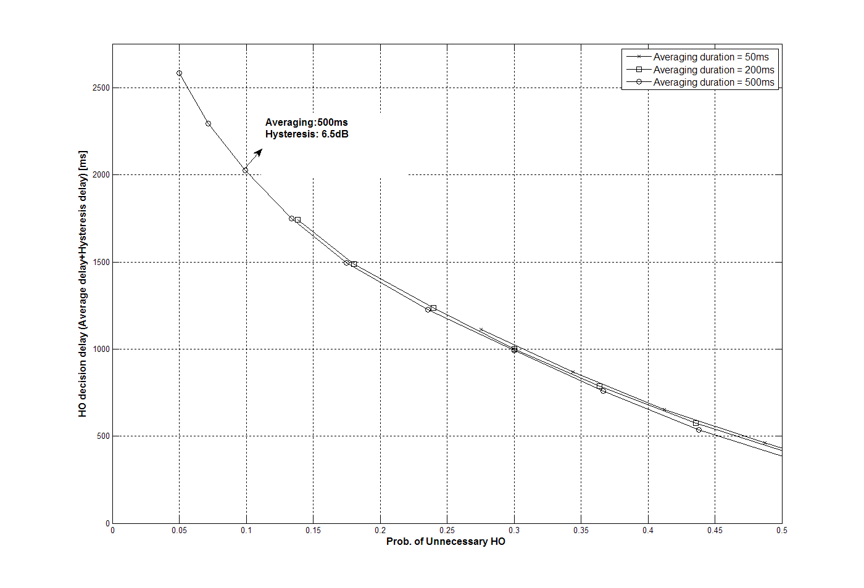
Figure 7. Simulation result for HO from macro ABS to macro ABS

HO from macro ABS to macro hot zone ABS
The average duration of RSSI from serving macro ABS is fixed to 500 ms and values of 50, 200, 500 ms are used for T-ABS. Hysteresis margin varies from 0.5 to 7.5 dB. Figure 8 shows simulation results in accordance with averaging durations and hysteresis levels.
When the probability of unnecessary HO is limited to 0.1, adequate averaging durations of T-ABS and S-ABS are selected to 50 ms and 500 ms, respectively, hysteresis level is selected to 6 dB. When those parameters are used, the cross-to-hysteresis margin time is 490 ms on average. We designate the location of the AMS at this time to ‘HO decision point A’.
When the same HO parameters for HO from macro ABS to macro ABS (averaging duration of 500 ms, hysteresis margin of 6.5 dB, which is described in previous section) are used, cross-to-hysteresis margin time is delayed about 220ms (the location of the AMS at this time to ‘HO decision point B’).
If cross-to-hysteresis margin time is delay from HO decision point A (when HO parameters optimized for HO to macro hot-zone are used) to HO decision point B (when HO parameters are same as HO to macro case), the CINR of serving ABS is degraded about 1.2 dB as shown in Figure 9. It causes the severe degradation of channel quality and may interrupt seamless communication.
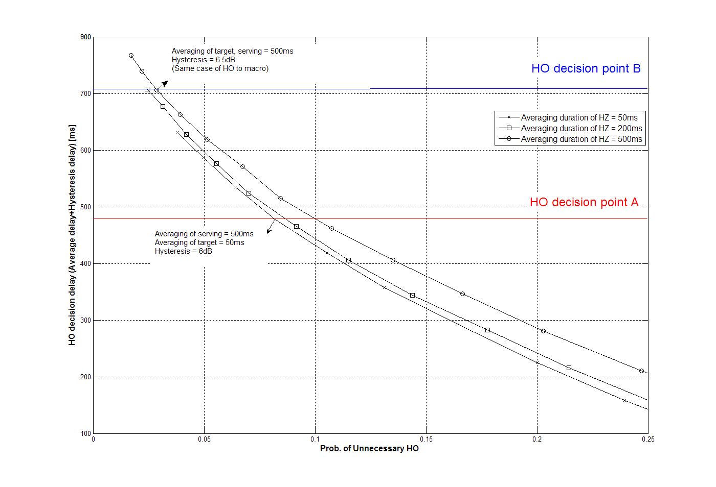
Figure 8. Simulation result for HO from macro ABS to macro hot-zone ABS

Figure 9. DL CINR degradation when HO decision is delayed

Text Proposal
---------------------------------------------------------Start of the Text----------------------------------------------------------

[Modify Table 721 in line 5, page 122 in P802.16m/D2]

Table 721-Trigger TLV Description
Name | Type | Length (Bytes) | Value
Type/Function/Action | xx.1 | 1 | See Table YY-for description
Trigger Value | xx.2 | 1 | Trigger value is the value used in comparing measured metric for determining a trigger condition
Trigger averaging duration | xx.3 | 1 | Trigger averaging duration is the time measured in number of frames over which the metric measurements are averaged.

Table 722-Trigger TLV for another ABS type Description
Name | Type | Length (Bytes) | Value
ABS type | xy.1 | 1 | ABS type of target ABS for this Trigger TLV: (Macro Hot-zone ABS, Femto ABS, etc)
Type/Function/Action | xy.2 | 1 | See Table YY-for description
Trigger Value | xy.3 | 1 | Trigger value is the value used in comparing measured metric for determining a trigger condition from serving ABS to target ABS (which is defined in ABS type).
Trigger averaging duration | xy.4 | 1 | Trigger averaging duration for target ABS (which is defined in ABS type) is the time measured in number of frames over which the metric measurements are averaged.

---------------------------------------------------------End of the Text----------------------------------------------------------

Reference
[1] IEEE P802.16 Rev2/D9, “Draft IEEE Standard for Local and Metropolitan Area Networks: Air Interface
for Broadband Wireless Access,” Jan. 2009.
[2] IEEE 802.16m-07/002r8, “802.16m System Requirements”
[3] IEEE 802.16m-08/0034, “The Draft IEEE 802.16m System Description Document”
[4] IEEE 802.16m-08/043, “Style guide for writing the IEEE 802.16m amendment”
[5] IEEE 802.16m/D1, “Part 16: Air Interface for Broadband Wireless Access Systems – Advanced Air Interface”
[6] IEEE 802.16m-08/004r5, “IEEE 802.16m Evaluation Methodology Document (EMD)”

