Project | IEEE 802.16 Broadband Wireless Access Working Group <http://ieee802.org/16>
Title | Proposal to correct the uplink 3-stream pilot pattern (15.3.8.4)
Date Submitted | 2009-11-15
Source(s) | David Mazzarese, Hokyu Choi  Samsung Electronics | d.mazzarese@samsung.com
Re: | P802.16m/D2 LB30a
Abstract | The contribution proposes text to correct the uplink 3-stream pilot pattern.
Purpose | To be discussed and adopted by TGm for the 802.16m Advanced Air Interface (Draft 2)
Notice | This document does not represent the agreed views of the IEEE 802.16 Working Group or any of its subgroups. It represents only the views of the participants listed in the “Source(s)” field above. It is offered as a basis for discussion. It is not binding on the contributor(s), who reserve(s) the right to add, amend or withdraw material contained herein.
Release | The contributor grants a free, irrevocable license to the IEEE to incorporate material contained in this contribution, and any modifications thereof, in the creation of an IEEE Standards publication; to copyright in the IEEE’s name any IEEE Standards publication even though it may include portions of this contribution; and at the IEEE’s sole discretion to permit others to reproduce in whole or in part the resulting IEEE Standards publication. The contributor also acknowledges and accepts that this contribution may be made public by IEEE 802.16.
Patent Policy | The contributor is familiar with the IEEE-SA Patent Policy and Procedures:  <http://standards.ieee.org/guides/bylaws/sect6-7.html#6> and <http://standards.ieee.org/guides/opman/sect6.html#6.3>.  Further information is located at <http://standards.ieee.org/board/pat/pat-material.html> and <http://standards.ieee.org/board/pat>.

Proposal to correct the uplink 3-stream pilot pattern (15.3.8.4)

David Mazzarese, Hokyu Choi
Samsung Electronics

- Introduction
The 3-streams pilot pattern of Fig 532 is not correct. The tones of the pilot positions of the 4th stream should not be marked with an X, which indicates a null tone, but they should be blank, indicating a data tone.

The proposed remedy of comment A1215 is also included in this proposal, because Figures 534, 536, 538, 540, 542, 544, 546 and 548 for UL pilot patterns are duplicated with 531, 532 and 533. These duplicated figures should be deleted.

Proposed AWD text has been underlined in blue, AWD text that has been deleted has been marked in red and struck through and existing AWD text is shown in black.

- References
[1] P802.16m DRAFT Amendment to IEEE Standard for Local and metropolitan area networks, P80216m/D2, Oct 2009.

- Text proposal for inclusion in the 802.16m AWD

Instructions to the editor:
- Delete the pilot pattern figures 534, 536, 538, 540, 542, 544, 546 and 548.
- Modify the text starting on page 466 line 28 as shown in text proposal below.

------------------------------- Start of text proposal -------------------------------------------

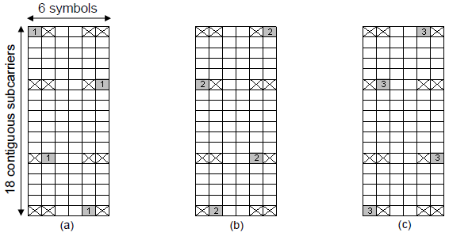
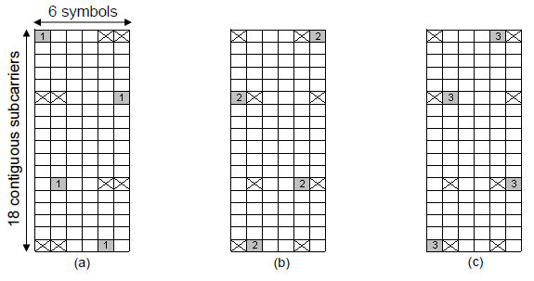
Figure 532—Pilot patterns for contiguous LRUs for 3 Tx streams

For 3 streams MIMO transmissions, the first three of the four pilot streams will be used and the unused pilot stream is allocated for data transmission.

------------------------------- End of text proposal --------------------------------------------

