Project | IEEE 802.16 Broadband Wireless Access Working Group <http://ieee802.org/16>
Title | Physical CINR feedback for 802.16m (16.3.9)
Date Submitted | 2009-01-07
Source(s) | Avia Yachil  Alvarion | Avia.Yachil@Alvarion.com
Re: | Letter Ballot #30b on the Draft Amendment (IEEE P802.16m/D3)
Abstract | This contribution proposes physical CINR feedback
Purpose | Propose to be discussed and adopted by TGm for the 802.16m Amendment
Notice | This document does not represent the agreed views of the IEEE 802.16 Working Group or any of its subgroups. It represents only the views of the participants listed in the “Source(s)” field above. It is offered as a basis for discussion. It is not binding on the contributor(s), who reserve(s) the right to add, amend or withdraw material contained herein.
Release | The contributor grants a free, irrevocable license to the IEEE to incorporate material contained in this contribution, and any modifications thereof, in the creation of an IEEE Standards publication; to copyright in the IEEE’s name any IEEE Standards publication even though it may include portions of this contribution; and at the IEEE’s sole discretion to permit others to reproduce in whole or in part the resulting IEEE Standards publication. The contributor also acknowledges and accepts that this contribution may be made public by IEEE 802.16.
Patent Policy | The contributor is familiar with the IEEE-SA Patent Policy and Procedures:  <http://standards.ieee.org/guides/bylaws/sect6-7.html#6> and <http://standards.ieee.org/guides/opman/sect6.html#6.3>.  Further information is located at <http://standards.ieee.org/board/pat/pat-material.html> and <http://standards.ieee.org/board/pat>.

Physical CINR feedback for 802.16m (16.3.9)
Avia Yachil
Alvarion

- Introduction
In current IEEE 802.16m specification [1], the feedback allocation A-MAP IE (16.3.6.5.2.4.5) defines:
- The channel resource allocation
- The periodicity of the feedback and its duration
- The MIMO-feedback mode and its corresponding parameters.

The standard defines 7 MIMO-feedback modes (16.3.7.2.5.4) where all modes enable a feedback content of Channel Quality Indicator (i.e. CQI) (table 839).

The CQI definition (16.3.9.3.1.3) composes of a spectral-efficiency recommendation from the AMS, based on some pre-defined criteria:
- Assuming 4 LRUs in type-1 AAI subframe as a resource allocation.
- Target block-error rate that do not exceed 10% for the first HARQ transmission
- For MU-MIMO modes with code-book based feedback it is assumed the interfering users are scheduled using rank-1 pre-coders orthogonal to each other and orthogonal to the rank-1 precoder represented by the reported PMI.
It is also expected from the ABS to adjust the spectral-efficiency based on delay and mobility conditions.
“The CQI feedback together with the rank feedback (when applicable) composes the spectral efficiency value reported by the AMS. This value corresponds to the measured block error rate which is the closest, but not exceeding, a specific target error rate.
The AMS reports the CQI by selecting a nominal MCS index from Table 901. MCS index should be selected assuming 4 LRUs in type-1 AAI subframe as a resource allocation, and 10% as a target error rate for the first HARQ transmission. In order to allocate the AMS with MCS level and rank appropriate for the actual requirements, the ABS should make adjustments to the AMS reported spectral efficiency, by considering parameters values different from the reference ones and by adapting to delay and mobility conditions.”

We find this CQI definition to be insufficient as it strongly depends on the CPE translation of the above criteria to a quantized MCS table (table 901) which is not known to the ABS. Moreover the above criteria may not be optimal for the spectral-efficiency for all QoS and scheduling schemes. Therefore the current CQI definition limits the ABS to adjust the spectral-efficiency to delay and mobility is limited.

In this contribution we suggest to support additional CQI feedback that is based on DL physical CINR measurements that the AMS provides the ABS over the feedback channel.
The physical CINR measurement is not subjected to predefined criteria and provides flexibility for the ABS to optimize the rate-selection.

In addition, the standard specifies ‘DL CINR Report Operation’ (16.2.8.2.8) where it states:
“An ABS may assign FastFeedback channels to each carrier of an AMS. When FastFeedback channel is assigned, the AMS reports CINR for a carrier over the assigned FastFeedback channel of the corresponding carrier. ABS may also direct AMS to report CINRs of active carriers through FastFeedback channel(s) on the primary carrier at the feedback region as defined in Section 15.3.8.3.3. …“
Unfortunately the standard does not specify the mechanism of the CINR report over the feedback channel, nor over the MAC-messages.

More sections relate to the CQI as a feedback of SINR as it is stated in (16.3.5.4) Pilot Structure:
“The transmission of pilot subcarriers in the downlink is necessary for enabling channel estimation, measurements of channel quality indicators such as the SINR, frequency offset estimation, etc. “

Therefore, we are motivated to define physical CINR reports as a channel-quality indicator (CQI) and utilize the feedback-channel for it.

Proposed text:
Insert the following text into section 16.3.6.5.2.4.5 ‘Feedback Allocation A-Map IE’

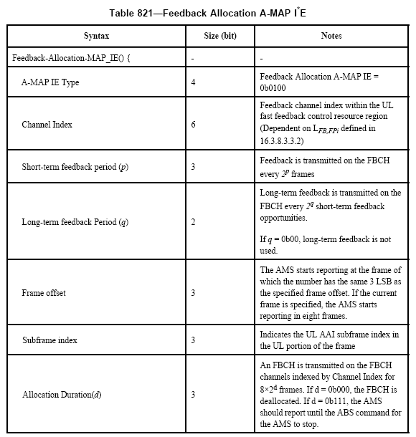

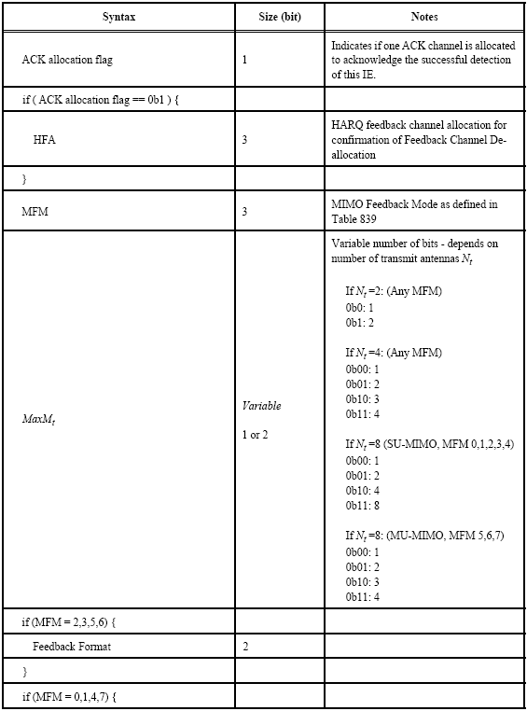
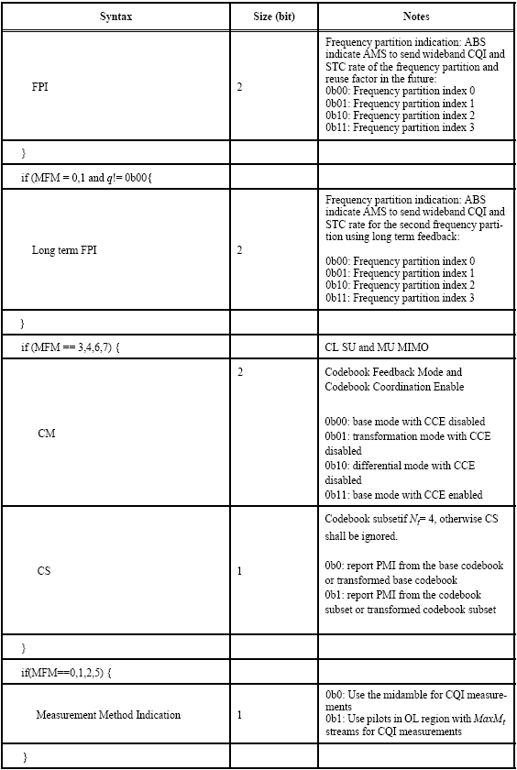
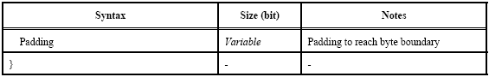

Add the following entries to table 821: (page427, lines 1-9 ):
------------------------------------------------ Start of text------------------------------------------------------------

Syntax | Size (bit) | Notes
CQI type | 1 | Indicates which CQI type is required to be reported in this feedback-channel:  0b0: use MCS recommendation as CQI information: table 901  0b1: use physical CINR measurement as CQI information.
If(CQI type == 0b1)
short term CINR | 3 | Determines the required CINR calculation for the short-term reports based on the bellow MIMO encoding format:  0b000: use physical CINR measurement over A-preamble as CQI information  0b001: use physical CINR measurement over pilots of data: SFBC as CQI information  0b010: use physical CINR measurement over pilots of data: VE as CQI information  0b011: use physical CINR measurement over pilots of data: HE as CQI information  0b101: use physical CINR measurement over pilots of data: CDR as CQI information  0b110: use physical CINR measurement over MIMO midamble as CQI information
long term CINR | 3 | Determines the required CINR calculation for the long-term reports based on the bellow MIMO encoding format:  0b000: use physical CINR measurement over A-preamble as CQI information  0b001: use physical CINR measurement over pilots of data: SFBC as CQI information  0b010: use physical CINR measurement over pilots of data: VE as CQI information  0b011: use physical CINR measurement over pilots of data: HE as CQI information  0b101: use physical CINR measurement over pilots of data: CDR as CQI information  0b110: use physical CINR measurement over MIMO midamble as CQI information
}
Padding | Variable
}

------------------------------------------------ End of text------------------------------------------------------------

Change the following text into section 16.3.9.3.1.5 ’Feedback Format’
------------------------------------------------ Start of text------------------------------------------------------------
Feedback format for MFM 0,1,4,7
Feedback formats for MFM 0, 1, 4, and 7 are listed in Table 902. Short term report happens in every reporting period as defined in feedback allocation A-MAP IE, long term report will puncture short term report according to long term feedback period in feedback allocation A-MAP IE. The long period report shall start by puncturing the first short period report if MFM = 4 or 7, or by puncturing the 2q-th short period report if MFM = 0 or 1, where q is defined in the feedback allocation A-MAP IE. The wideband CQI is classified by the ‘CQI type’ defined in the feedback allocation A-MAP IE:
- If the CQI type is a recommended MCS (0b0) then wideband CQI is one average CQI corresponding to the MIMO mode signaled by the combination MFM and STC rate, with averaging over the whole band. In the case where the number of DL frequency partitions FPCT > 1, the wideband CQI is one average CQI over the corresponding frequency partition.
- If the CQI type is a physical CINR (0b1), then the wideband CQI is determined by short-term and long-term CINR determined in short-term CINR and long-term CINR respectively.
Table 902 shows feedback formats for MIMO feedback mode 0, 1, 4, and 7 when Measurement Method Indication = 0b0 in Feedback Allocation A-MAP IE (operation outside the open-loop region):
…
Table 903 shows feedback formats for MIMO feedback mode 0 and 1 when Measurement Method Indication = 0b1 in Feedback Allocation A-MAP IE (operation inside the open-loop region). The ABS shall not assign a feedback channel on the short periods. The ABS will

Feedback format for MFM 2:
The detailed format is listed in Table 904. Short term report happens in every reporting period as defined in feedback allocation A-MAP IE, long term report will puncture short term report according to long term feedback period in feedback allocation A-MAP IE. The long period report shall start by puncturing the first short period report. If the PFBCH indicator in SFBCH is set to '1', PFBCH is transmitted by puncturing SFBCH in the next feedback opportunity regardless of short-term and long-term feedback using encoding type 0.
The subband CQI is classified by the ‘CQI type’ defined in the feedback allocation A-MAP IE:
- If the CQI type is a recommended MCS (0b0) then the CQI of subband m shall be computed as follows: (Subband m CQI index) = (Subband avg CQI index) +Subband m differential CQI), using the latest available reports of Subband avg CQI and Subband differential CQI. Subband avg CQI index is an average measure of the CQI over the M reported subbands. The possible differential CQI values are {-1, 0, +1, +2}. The AMS shall ensure that the reported differential CQI will produce a value of subband m CQI in the range of 0 to 15.
- For PFBCH reports, if the CQI type is a physical CINR (0b1) then the subband CQI is the avg CINR calculated over the subband indexes only.
….

Feedback format for MFM 3:
The detailed format is listed in Table 906. Short term report happens in every reporting period as defined in feedback allocation A-MAP IE, long term report will puncture short term report according to long term feedback period in feedback allocation A-MAP IE. The long period report shall start by puncturing the first short period report. For feedback format 0 with 3 reports using the PFBCH, Subband PMI shall be transmitted first after every report of Best_subbands_ index. Subband CQI and subband PMI are then transmitted alternately and Best_subbands_index is transmitted in the long term period. If the PFBCH indicator in SFBCH is set to '1', PFBCH is transmitted using encoding type 0 by puncturing SFBCH in the next feedback opportunity regardless of short-term and long-term feedback.
The subband CQI is classified by the ‘CQI type’ defined in the feedback allocation A-MAP IE:
- If the CQI type is a recommended MCS (0b0) then the CQI of subband m shall be computed as follows for the first short period report following a long period report: (Subband m CQI index) = (Subband avg CQI index) + (Subband m differential CQI). Subband avg CQI index is an average measure of the CQI over the M reported subbands. The possible differential CQI values are {-1, 0, +1, +2}. The AMS shall ensure that the reported differential CQI will produce a value of subband m CQI in the range of 0 to 15.
- For PFBCH reports, if the CQI type is a physical CINR (0b1) then the subband CQI is the avg CINR calculated over the subband indexes only.
….

Feedback format for MFM 6:

The detailed format is listed in Table 909. Short term report happens in every reporting period as defined in feedback allocation A-MAP IE, long term report will puncture short term report according to long term feedback period in feedback allocation A-MAP IE. The long period report shall start by puncturing the first short period report. For feedback format 0 with 3 reports using the PFBCH, Subband PMI shall be transmitted first after every report of Best_subbands_index. Subband CQI and subband PMI are then transmitted alternately and Best_subbands_index is transmitted in the long term period. If the PFBCH indicator in SFBCH is set to '1', PFBCH is transmitted using encoding type 0 by puncturing SFBCH in the next feedback opportunity regardless of short-term and long-term feedback.
The subband CQI is classified by the ‘CQI type’ defined in the feedback allocation A-MAP IE:
- If the CQI type is a recommended MCS (0b0) then the CQI of subband m shall be computed as follows: (Subband m CQI index) = (Subband avg CQI index) + (Subband m differential CQI), using the latest available reports of Subband avg CQI and Subband differential CQI. Subband avg CQI index is an average measure of the CQI over the M reported subbands. The possible differential CQI values are {-1, 0, +1, +2}. The AMS shall ensure that the reported differential CQI will produce a value of subband m CQI in the range of 0 to 15.
- For PFBCH reports, if the CQI type is a physical CINR (0b1) then the subband CQI is the avg CINR calculated over the subband indexes only.
…
------------------------------------------------ End of text------------------------------------------------------------

Add the following text into section 16.3.9.3.1.3 ’Channel Quality Indicator (CQI) definition’:
------------------------------------------------ Start of text------------------------------------------------------------
16.3.9.3.1.3 Channel quality indicator (CQI) definition
The CQI feedback can be classified as follows:
- A nominal MCS index (along with rank feedback when applicable) that composes the spectral efficiency value that is recommneded by the AMS: MCS-based CQI
- A DL CINR measurement reported by the AMS: CINR-based CQI

The ABS instructs the AMS which CQI feedback is required via the feedback Allocation A-Map IE (16.3.6.5.2.4.5) using the CQI_Type field.

The following sections specifies the two report schemes.
16.3.9.3.1.3.1 MCS-based CQI definition
Copy the current 16.3.9.3.1.3 content into this sub-section:
“The CQI feedback together with the rank feedback (when applicable) composes the spectral efficiency value reported by the AMS. This value corresponds to the measured block error rate which is the closest, but not exceeding, a specific target error rate. ….”
…

16.3.9.3.1.3.2 CINR-based CQI definition
There are three CINR measurements types.
- CINR that is based on A-Preamble (16.3.9.3.1.3.2.xx)
- CINR that is based on MIMO midamble (16.3.9.3.1.3.2.xx)
- CINR that is based on pilots of data (16.3.9.3.1.3.2.xx)

For the CINR measurement that is based on pilots of data, we distinguish between four CINR formulations, based on the transmitted MIMO Encoding Formats (MEF): SFBC, VE, HE and CDR. The required MEF is instructed to the AMS via: DL Basic Assignment A-Map IE (16.3.6.5.2.4.1), DL Subband Assignment A-Map IE and DL Persistent A-Map IE. The MEF and further DL MIMO control-parameters (Table 840) (e.g. Mt, Nt) are needed for the AMS to calculate the CINR over the pilots of data.

The ABS instructs the AMS which of the three CINR feedbacks is required via the feedback Allocation A-Map IE (16.3.6.5.2.4.5) using the short/long term CINR field.

The AMS measurs the DL CINR and reports the DL CINR via one of the code-word in the range [0:50]. The mapping of the code-word ‘CQI’ to ‘CINR’ is as follows:

$$\text{CINR}=\text{CQI}−\text{10}$$
Equation 1: CQI code-word mapping to CINR
The CINR report is quantized in steps of 1 dB in the range: -10 to 40.

------------------------------------------------ End of text------------------------------------------------------------

Add the following text into section 16.3.5.4.3 ’Usage of Downlink Pilots’

------------------------------------------------ Start of text------------------------------------------------------------
“Channel estimation for demodulation of data burst and CINR calculation at AMS should be performed as follows:
- In DLRU:
the 2 streams non-adaptively precoded common pilots across the DLRU should be used for channel estimation and CINR calculation by all AMSs allocated a burst in the DLRU. Within each frequency partition, all pilots are shared by all AMSs for demodulation in DLRU.
- In CLRU:
The AMS should use its dedicated pilot streams for channel estimation and CINR calculation in the allocation. Pilots are not shared by AMSs for demodulation in CLRU, whether they are non-adaptively or adaptively precoded.”
------------------------------------------------ End of text------------------------------------------------------------

Reference
[1] IEEE 802.16m/D3, Part 16: Air Interface for Broadband Wireless Access Systems, Advanced Air Interface

