Project | IEEE 802.16 Broadband Wireless Access Working Group <http://ieee802.org/16>
Title | DL MIMO Mode 2 analysis in N-LRU (Section 16.3.7 of the IEEE 802.16m/D3)
Date Submitted | 2009-12-30
Source(s) | Apostolos Papathanassiou  Alexei Davydov  Srinivasan Roshni  Huaning Niu  Yuan Zhu | aposotolos.papathansiou@intel.com  alexei.davydov@intel.com
Re: | Category: LB30b / Area: Chapter 16.2.3
Abstract | The contribution proposes modification to te maximum to broadcast parameters for sounding channel
Purpose | To be discussed and adopted by TGm for the 802.16m Advanced Air Interface (Draft 4)
Notice | This document does not represent the agreed views of the IEEE 802.16 Working Group or any of its subgroups. It represents only the views of the participants listed in the “Source(s)” field above. It is offered as a basis for discussion. It is not binding on the contributor(s), who reserve(s) the right to add, amend or withdraw material contained herein.
Release | The contributor grants a free, irrevocable license to the IEEE to incorporate material contained in this contribution, and any modifications thereof, in the creation of an IEEE Standards publication; to copyright in the IEEE’s name any IEEE Standards publication even though it may include portions of this contribution; and at the IEEE’s sole discretion to permit others to reproduce in whole or in part the resulting IEEE Standards publication. The contributor also acknowledges and accepts that this contribution may be made public by IEEE 802.16.
Patent Policy | The contributor is familiar with the IEEE-SA Patent Policy and Procedures:  <http://standards.ieee.org/guides/bylaws/sect6-7.html#6> and <http://standards.ieee.org/guides/opman/sect6.html#6.3>.  Further information is located at <http://standards.ieee.org/board/pat/pat-material.html> and <http://standards.ieee.org/board/pat>.
DL MIMO Mode 2 analysis in N-LRU
Apostolos Papathanassiou, Alexei Davydov, Srinivasan Roshni, Huaning Niu, Yuan Zhu
Intel Corporation

Introduction
In C802.16m-09/2533r1 it has been found that usage of more than one data stream for DL MIMO 2 in N-LRU allocations provides gains in reuse-3 scenario. Based on the simulation results it was recommended to remove rate-one-only restriction for DL MIMO mode 2 in N-LRU.

In this contribution we validate the conclusions conducted in C802.16m-09/2533r1 using system level simulations. The link level simulations are also provided for analysis of the higher STC rate performance of DL MIMO 2 in N-LRU allocations in realistic scenarios that account impact of ICI noise due to mobility and channel estimation errors.

Simulation Results
A system simulation was carried out in accordance to IMT-Advanced evaluation methodology for UMa test environment. Two reuse cases were tested: 1x3x1 (reuse-1) and 1x3x3 (reuse-3). 10 MHz channel bandwidth per sector was used. TDD DL:UL ratio was equal to 29:18. Long-term covariance matrix reporting period was equal to 20 ms.
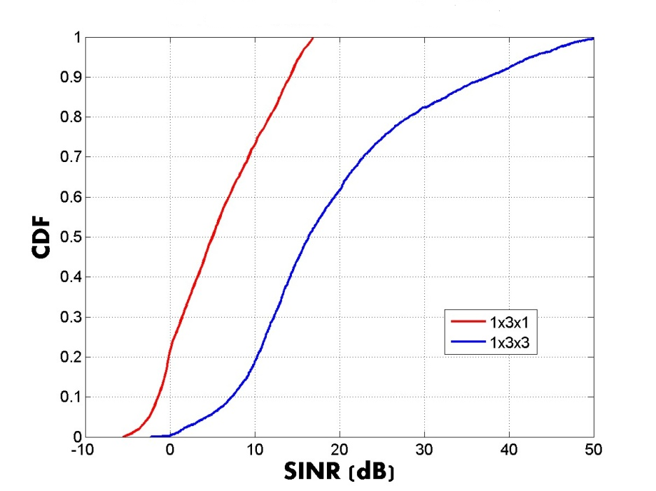
Figure 1. DL geometry SINR distribution for resue-1 and resue-3 UMa environment
DL SINR geometry distributions are shown on Figure 1 for two considered reuse cases. It can be seen from the figure that in 1x3x3 scenario the DL SINR are substantially higher than DL SINR in reuse 1x3x1. From the provided figures it is expected that spatial multiplexing mode with STC rate more than one (usually requiring high SINR values) will be selected in reuse 1x3x3.

Three MIMO schemes were investigated and compared: SU-MIMO maximum number of streams 1, SU -MIMO maximum number of streams 2 and MU-MIMO maximum number of streams 4. Average system level simulation results are provided in Tables 1 and Table 2.
In Table 1 average sector throughput and average cell edge user throughput are provided. It can be seen from the table that in case of reuse 1x3x1 the performance of SU-MIMO schemes with maximum STC rate of 1 and maximum STC rate of 2 shows similar performance for both sector and cell edge throughputs. This is explained by low SINR of AMS in reuse 1x3x1 scenario. On the other hand, in case of reuse 1x3x3 the advantage due to usage of higher STC rates is clearly seen. It should be noted that MU-MIMO with maximum 4 streams outperforms all other schemes both in reuse 1x3x1 and 1x3x3 scenarios.
Table 1. Average throughput performance
 | Reuse-1 |  | Reuse-3
 | Sector throughput (Mbps) | Cell-edge user throughput (Kbps) | Sector throughput (Mbps) | Cell-edge user throughput (Kbps)
SU-rank1 | 10.86 | 389 | 15.94 | 901
SU-rank1-2 | 10.43 | 382 | 22.78 | 937
MU-rank4 | 15.78 | 400 | 25.46 | 958

The same conclusions can be drawn from Table 2 where average spectral efficiency (SE) are presented for all considered DL MIMO schemes and reuse scenarios.
Table 2. Average spectral efficiency performance
 | Reuse-1 | Reuse-3
 | SE(b/s/Hz/site) | SE (b/s/Hz//site)
SU-rank1 | 5.28 | 2.58
SU-rank1-2 | 5.07 | 3.69
MU-rank4 | 7.67 | 4.13

In the same UMa test environment a link level simulations were carried out. A performance for SU-MIMO mode with different maximum number of streams is presented in Figure 2 where MCS spectral efficiencies versus SNR are shown. A red curve with square markers represents hull spectral efficiency vs. SNR for SU MIMO mode in N-LRU with MCS of STC rate one only. A green curve with circle markers shows hull spectral efficiencies versus SNR for SU MIMO mode in N-LRU with MCS of STC rate one and two.

The following conclusions can be drawn form Figure 2. For SNR region corresponding to reuse 1x3x1, there is no difference between two considered SU MIMO schemes. For SNRs region corresponding to reuse 1x3x3 substantial improvement can be obtained by using MCSs with STC rate 2 in addition to MCSs with STC rate 1. It fully confirms the conclusions of system level simulation results discussed above.

Mt=1+Mt=2
Mt=1
SNR range of reuse-3
SNR range of reuse-1
Figure 2. Link level performance of SU MIMO in NLRU

Text proposal for inclusion in the 802.16m/D4
-------------------------------------------------- Text Start #1 ------------------------------------------------
{Modify contents of Table 835 specified on page 453, line 46, section 16.3.7.2.4 as follows}
Table 835 – Supported Permutation for each DL MIMO mode outside the OL region
 | DLRU | NLRU | SLRU
MIMO mode 0 | Yes | Yes | No
MIMO mode 1 | Yes, with M_{t}=2 | Yes, with M_{t}≤4 | Yes
MIMO mode 2 | No | Yes, with M_{t}=1≤4 | Yes
MIMO mode 3 | No | No | Yes
MIMO mode 4 | No | Yes | Yes
MIMO mode 5 | No | No | No

-------------------------------------------------- Text End #1 ------------------------------------------------
-------------------------------------------------- Text Start #2 ------------------------------------------------
{Modify contents of Table 839 specified on page 457, line 2, section 16.3.7.2.5.5 as follows}

MIMO Feedback mode | Description and type of RU | Feedback content | Supported  MIMO transmission mode outside the OL region (when Measurement Method Indication = 0b0) | Supported  MIMO transmission mode inside the OL region (when Measurement Method Indication = 0b1)
…
3 | CL SU MIMO (localized: SLRU) | 1. STC Rate  2. Subband CQI  3. Subband PMI  4.Subband selection  5. Wideband correlation matrix | MIMO mode 2  1 ≤ STC Rate ≤ 8 | N/A
4 | CL SU MIMO (Diversity: NLRU) | 1. Wideband CQI  2. Wideband PMI  3. Wideband correlation matrix | MIMO mode 2 ( M_{t} =1≤4) | N/A
...
-------------------------------------------------- Text End #2 ------------------------------------------------

