Project | IEEE 802.16 Broadband Wireless Access Working Group <http://ieee802.org/16>
Title | Boolean function description of DL MIMO Midamble and UL Sounding sequences
Date Submitted | 2009-12-30
Source(s) | Ying Li  Yen-Wen Huang  Yi-Chan Kao  Yuan Ze University | eeyli@saturn.yzu.edu.tw
Re: | Text Addition on 802.16m Draft Amendment, IEEE P802.16m/D3
Abstract | The contribution proposes to add the Boolean function description of the length 2048 binary Golay sequence used for downlink MIMO midamble and uplink sounding in 802.16m
Purpose | To be discussed and adopted by TGm for the 802.16m amendment Session #65
Notice | This document does not represent the agreed views of the IEEE 802.16 Working Group or any of its subgroups. It represents only the views of the participants listed in the “Source(s)” field above. It is offered as a basis for discussion. It is not binding on the contributor(s), who reserve(s) the right to add, amend or withdraw material contained herein.
Release | The contributor grants a free, irrevocable license to the IEEE to incorporate material contained in this contribution, and any modifications thereof, in the creation of an IEEE Standards publication; to copyright in the IEEE’s name any IEEE Standards publication even though it may include portions of this contribution; and at the IEEE’s sole discretion to permit others to reproduce in whole or in part the resulting IEEE Standards publication. The contributor also acknowledges and accepts that this contribution may be made public by IEEE 802.16.
Patent Policy | The contributor is familiar with the IEEE-SA Patent Policy and Procedures:  <http://standards.ieee.org/guides/bylaws/sect6-7.html#6> and <http://standards.ieee.org/guides/opman/sect6.html#6.3>.  Further information is located at <http://standards.ieee.org/board/pat/pat-material.html> and <http://standards.ieee.org/board/pat>.
Boolean function description of midamble and sounding sequence
Ying Li, Yen-Wen Huang, Yi-Chan Kao
Yuan Ze University

Introduction
This contribution proposes to add the Boolean function description of the length 2048 binary Golay sequence used for downlink MIMO midamble and uplink sounding in 802.16m. The sequence is currently given in Table 786 and Table 886. Adding the Boolean function description does not change the sequence or the signaling mechanism, but would provide a simple description and generation method of the Golay sequence and may prevent errors. Note that the original table of the length 2048 binary Golay sequence used for sounding in IEEE P802.16e-2005 (Table 315e) was corrupted. It was corrected in C802.16maint-06/003 and updated in IEEE Std. 802.16-2009.

Proposed Text addition for the 802.16m draft amendment
Insert text in the section 16.3.5.4.2 MIMO midamble on page 343 at the end of the section “Comment to Table 786: hexadecimal sequence should be read as…”, and in the section 16.3.9.2.3.1 Sounding sequence on page 530 at the end of the section below Table 886 “Note: hexadecimal series should be read as…”.
-------------------------------------------------------------------------- Start of the text ------------------------------------------------------------------------
(Table 786 starts on page 342, IEEE P802.16m D3)
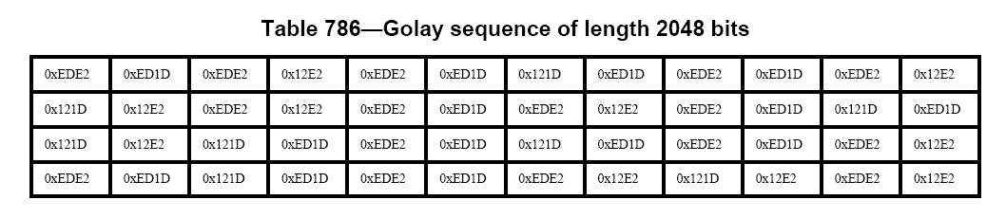
(Table 786 is continued on IEEE P802.16m D3 page 343)
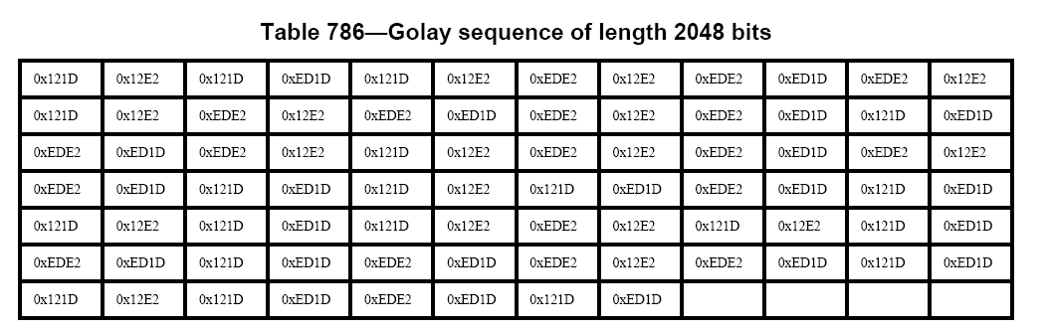

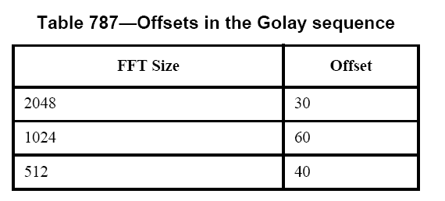
Comment to Table 786: hexadecimal series should be read as a sequence of bits where each 16 bit word is started at the MSB and ends at the LSB where the second word MSB follows. The first bit of the sequence is referenced as offset 0. The sequence G(x), 0 ≤ x ≤ 2047 can also be generated from the Boolean function below:

(Table 886 starts on page 529, IEEE P802.16m D3) 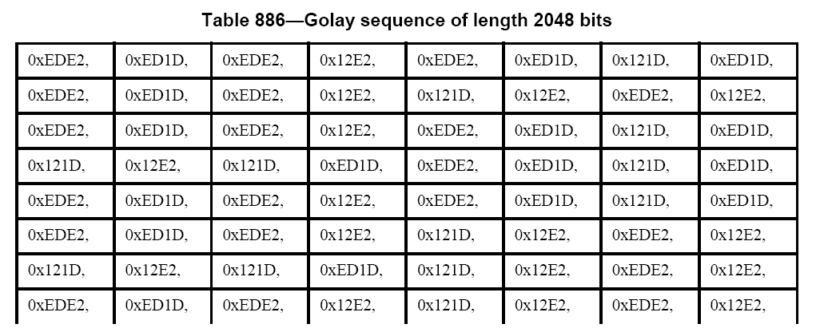
(Table 886 is continued on page 530, IEEE P802.16m D3)
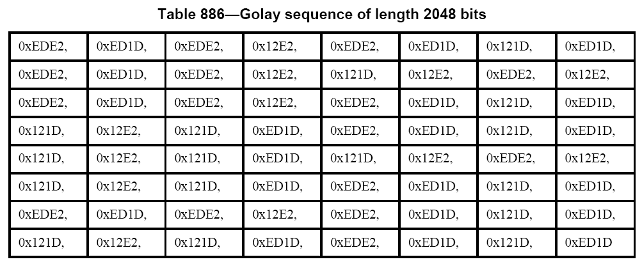

Note: hexadecimal series should be read as a sequence of bits where each 16 bit word is started at the MSB and ends at the LSB where the second word MSB follows. First bit of sequence is referenced as offset 0. The sequence G(x), 0 ≤ x ≤ 2047 can also be generated from the Boolean function below:

-------------------------------------------------------------------------- End of the text ------------------------------------------------------------------------

