Project | IEEE 802.16 Broadband Wireless Access Working Group <http://ieee802.org/16>
Title | Clarification of Idle Mode Initiation (16.2.17)
Date Submitted | 2009-12-31
Source(s) | Giwon Park, Kiseon Ryu, Ronny Yongho Kim and Jin Sam Kwak  LG Electronics | gwpark@lge.com
Re: | Category: LB30b / Area: Chapter 16.2.17.1
Abstract | This contribution proposes changes to the Section 16.2.17.1 of IEEE P802.16m/D3
Purpose | Discussion and adoption by TGm
Notice | This document does not represent the agreed views of the IEEE 802.16 Working Group or any of its subgroups. It represents only the views of the participants listed in the “Source(s)” field above. It is offered as a basis for discussion. It is not binding on the contributor(s), who reserve(s) the right to add, amend or withdraw material contained herein.
Release | The contributor grants a free, irrevocable license to the IEEE to incorporate material contained in this contribution, and any modifications thereof, in the creation of an IEEE Standards publication; to copyright in the IEEE’s name any IEEE Standards publication even though it may include portions of this contribution; and at the IEEE’s sole discretion to permit others to reproduce in whole or in part the resulting IEEE Standards publication. The contributor also acknowledges and accepts that this contribution may be made public by IEEE 802.16.
Patent Policy | The contributor is familiar with the IEEE-SA Patent Policy and Procedures:  <http://standards.ieee.org/guides/bylaws/sect6-7.html#6> and <http://standards.ieee.org/guides/opman/sect6.html#6.3>.  Further information is located at <http://standards.ieee.org/board/pat/pat-material.html> and <http://standards.ieee.org/board/pat>.
Clarification of Idle Mode Initiation (16.2.17)
Giwon Park, Kiseon Ryu, Ronny Yongho Kim and Jin Sam Kwak
LG Electronics

Introduction
This contribution proposes a clarification on the idle mode entry procedure with the following point:

- Current action code (0x05, to allow AMS to transmit AMS-initiated idle mode request) of DREG-RSP message does not resolve the following problem.
Case (Msg from the ABS is not received at the AMS)
ABS → AMS (0x05): This message gets lost
AMS → ABS (0x01): AMS sends the AAI_DREG-REQ message with action code 0x01 (AMS initiated idle mode entry)
ABS → AMS (0x05): Although AMS expects to receive the DREG-RSP (0x07) but ABS sends the AAI_DREG-RSP with action code 0x05.

In WiMAX Forum TWG, the TWG Inter-Operability Problem Report [1] which is related to mentioned problem was submitted in May 22, 2009 and accepted.
Therefore, in case ABS initiated idle mode entry, based on TWG IOPR [1] we propose to use new Action Code in AAI_DREG-RSP message for ABS-initiated idle mode entry.

- REQ-Duration
- In case ABS initiated idle mode entry, if the AMS receives the AAI_DREG-RSP (to allow AMS to transmit AMS-initiated idle mode request) from the ABS, the AMS just can transmit the AAI_DREG-REQ with De-registration_Request_Code 0x01 without REQ-Duration. We propose that REQ-Duration is only used when the ABS sends the AAI_DREG-RSP message with action code 0x06 (to reject AMS-initiated idle mode request).

Proposed text
======================== Start of Proposed Text ========================
[Modify the paragraph (in line 30 on page 81) of P802.16m/D3 as follows]
16.2.3.21 AAI_DREG-REQ message
0x01: request for AMS deregistration from serving ABS and initiation of AMS idle mode.
0x02: response for the unsolicited AAI_DREG-RSP message with action code 0x05 by the ABS.
0x032: reject for the unsolicited AAI_DREG-RSP message with action code 0x05 or 0x07 by the ABS. This code is applicable only when an AMS has a pending UL data to transmit.
0x043: request for AMS deregistration from servinng ABS to enter DCR mode
0x054-0x07: reserved

[Modify the paragraph (from line 21 to line 30 on page 82) of P802.16m/D3 as follows]
16.2.3.22 AAI_DREG-RSP message
0x05: AMS shall begin idle mode initiation: a) to signal AMS to begin idle mode in unsolicited manner or b) to allow AMS to transmit AMS-initiated idle mode request at the REQ-Duration expiration to allow AMS-initiated idle mode request
0x06: This option is valid only in response to a AAI_DREG-REQ message with De-Registration Code 0x01: a) to reject AMS-initiated idle mode request or b) to allow AMS to transmit AMS-initiated idle mode request at the REQ-Duration expiration
0x07: This option is valid only in response to an AAI_DREG-REQ message with De-Registration Request Code 0x01 to allow AMS-initiated idle mode request AMS shall send AAI_DREG-REQ with action 0x01 to request the ABS to initiate idle mode

[Modify the paragraph (in line 38 on page 82) of P802.16m/D3 as follows]
When the action code is set to 0x05 or 0x07, the following parameters shall be included in AAI_DREG-RSP message.
[Delete the paragraph (from line 64 to line 65on page 82, in line 01 on page 83) of P802.16m/D3 as follows]
When the action code is set to 0x05 or 0x06 or 0x07, the following parameter may be included in the AAI_DREG-RSP message.
REQ-Duration

[Modify the paragraph (in line 61 on page 255) of P802.16m/D3 as follows]
16.2.17.1.1 AMS initiated
When the ABS decides to allow AMS-initiated idle mode request, the ABS shall send a AAI_DREG-RSP with action code 0x075 in response to the AAI_DREG-REQ message.
[Modify the paragraph (in line 06 on page 256 ) of P802.16m/D3 as follows]
Also, the ABS shall start Management_Resource_Holding_Timer to maintain connection information with the AMS as soon as it sends the AAI_DREG-RSP message with action code 0x075 to the AMS. If Management_Resource_Holding_Timer has been expired, the ABS shall release connection information with the AMS.

[Replace the Figure 439 (in line 18 on page 256) of P802.16m/D3 to the following figure]
Figure 439 – Call for AMS initiated idle mode entry
[Modify the paragraph (line 53 on page 257) of P802.16m/D3 as follows]
16.2.17.1.2 ABS initiated
Using ABS initiated idle mode entry, a serving ABS may signal for an AMS to begin idle mode by sending an AAI_DREG-RSP message with action code 0x05 in unsolicited manner. This unsolicited AAI_DREG-RSP may include REQ-Duration TLV. When an AMS receives an unsolicited AAI_DREG-RSP without REQ_Duration TLV, the AMS shall immediately start the idle mode initiation procedures. In this case of ABS-initiated idle mode, after sending the AAI_DREG-RSP message with action code 0x05, the serving ABS shall start T46 timer as well as Management_Resource_Holding_Timer at the same time. If the ABS does not receive the AAI_DREG-REQ message with the De-registration_Request_Code parameter = 0x02 or the AAI_DREG-REQ message with the De-registration_Request_Code parameter = 0x03 from the AMS in response to the unsolicited AAI_DREG-RSP message with action code 0x05 within T46 timer expiry, the ABS shall retransmit the AAI_DREG-RSP message with action code 0x05 in unsolicited manner as long as DREG command retry count has not been exhausted. When the AMS sends the AAI_DREG-REQ message with the De-registration_Request Code parameter = 0x02 in response to the unsolicited AAI_DREG-RSP message with action code 0x05, the AMS shall send AAI_DREG-REQ message with polling bit set to 1 in FEH. The AMS shall not enter idle mode immediately after sending a message indicating that it will enter idle mode, because that message could get lost in the air link. Rather, the AMS shall wait for AAI_MSG-ACK message from the ABS. If the AMS detects the AAI_MSG-ACK message, the AMS shall enter idle mode. Otherwise, the AMS shall send the same AAI_DREG-REQ message with the request for the AAI_MSG-ACK message again. If the AMS has a pending UL data to transmit, it shall send AAI_DREG-REQ message with De-registration_Request Code parameter = 0x03 in response to the unsolicited AAI_DREG-RSP message with action code 0x05 by the ABS. These procedures are illustrated in Type 1 in Figure 441, Figure 442 and Figure 443.

[Modify the paragraph (line 37 on page 258) of P802.16m/D3 as follows and move the paragraph into the line 14 on page 258 (before Figure 441)]
As another In case of ABS initiated Idle Mode, the serving ABS may also include a REQ-duration TLV sends the AAI_DREG-RSP message with an Action Code = 0x057 in the AAI_DREG-RSP, signaling for an AMS to initiate an Idle Mode request through a AAI_DREG-REQ with De-Registration_Request Code = 0x01, request for AMS De-Registration from serving ABS and initiation of AMS Idle Mode, at REQ-duration expiration. In this case, ABS shall not start T46 timer as well as Management_resource_Holding_Timer at the same time. AMS may shall include Idle Mode Retain Information TLV with in AAI_DREG-REQ message with De-Registration_Request Code = 0x01 transmitted at the REQ-duration expiration within T46 timer expiry. In this case, ABS shall transmit another AAI_DREG-RSP message with Action Code=0x05 including Idle Mode Retain Information TLV. If the AMS has a pending UL data to transmit, it shall send AAI_DREG-REQ message with De-registration_Request Code parameter = 0x03 in response to the unsolicited AAI_DREG-RSP message with action code 0x07 by the ABS. These procedures are illustrated in Type 2 in Figure 441, Figure 444 442 and Figure 445 443.

[Replace Figure 441(on page 258) of P802.16m/D3 to the following figure]
Type 1 ABS initiated idle mode entry Type 2 ABS initiated idle mode entry

Figure 441 – Call flow for ABS initiated idle mode entry

[Delete Figure 442 (on page 259) of P802.16m/D3]
Figure 442- ABS procedures during Type 1 ABS initiated idle mode entry

[Delete Figure 443 (on page 260) of P802.16m/D3]

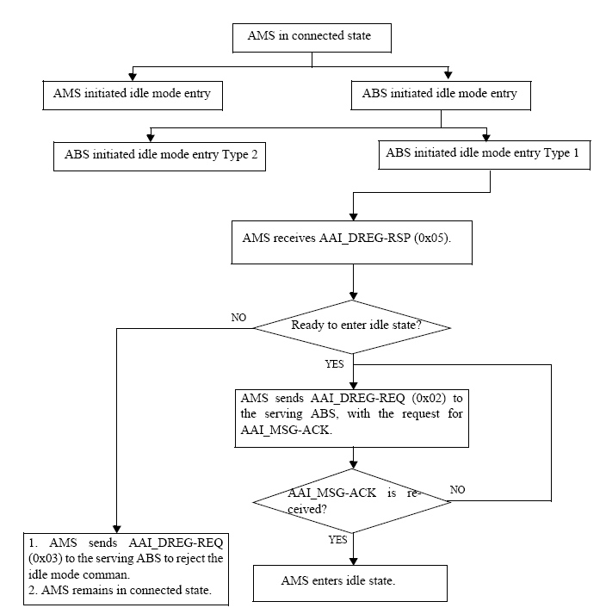
Figure 443- AMS procedures during Type 1 ABS initiated idle mode entry

[Replace Figure 444(on page 261) of P802.16m/D3 to the following figure]

Figure 444 442 – AMS Procedures during Type 2 ABS initiated idle mode entry

[Replace Figure 445(on page 262) of P802.16m/D3 to the following figure]

Figure 445 443 – ABS Procedures during Type 2 ABS initiated idle mode entry

======================== End of Proposed Text ========================

Reference
[1] IEEE L802.16-09/0058, TWG Inter-Operability Problem Reports (IOPRs 41111, 41164, 41762), May 22, 2009

