Project | IEEE 802.16 Broadband Wireless Access Working Group <http://ieee802.org/16>
Title | Proposed Modification of Ranging Signal Transmission for Amendment Working Document Draft 3 on Ranging Channel for Non-synchronized AMSs
 | 2009-12-30
Source(s) | Chao-Wang Huang, Jia-Hao Wu, Ping-Heng Kuo, Yu-Tao Hsieh, Pang-An Ting | Voice:  E-mail: ythsieh@itri.org.tw
Re: | IEEE P80216m_D3, “IEEE 802.16m Amendment Working Document.”
Abstract | This contribution proposes some modifications to the transmitted ranging signal of non-synchronized AMSs in Section 16.3.9.2.4.1
Purpose | Discussion and adoption by TG m.
Notice | This document does not represent the agreed views of the IEEE 802.16 Working Group or any of its subgroups. It represents only the views of the participants listed in the “Source(s)” field above. It is offered as a basis for discussion. It is not binding on the contributor(s), who reserve(s) the right to add, amend or withdraw material contained herein.
Release | The contributor grants a free, irrevocable license to the IEEE to incorporate material contained in this contribution, and any modifications thereof, in the creation of an IEEE Standards publication; to copyright in the IEEE’s name any IEEE Standards publication even though it may include portions of this contribution; and at the IEEE’s sole discretion to permit others to reproduce in whole or in part the resulting IEEE Standards publication. The contributor also acknowledges and accepts that this contribution may be made public by IEEE 802.16.
Patent Policy | The contributor is familiar with the IEEE-SA Patent Policy and Procedures:  <http://standards.ieee.org/guides/bylaws/sect6-7.html#6> and <http://standards.ieee.org/guides/opman/sect6.html#6.3>.  Further information is located at <http://standards.ieee.org/board/pat/pat-material.html> and <http://standards.ieee.org/board/pat>.

Proposed Modification of Ranging Signal Transmission for Amendment Working Document Draft 3 on Ranging Channel for Non-synchronized AMSs
Chao-Wang Huang, Ping-Heng Kuo, Yu-Tao Hsieh and Pang-An Ting
ITRI

Introduction
In this contribution, we would like to modify the ranging channel for non-synchronized AMSs in Section 16.3.9.2.4.1 of the AWD [1]. In order to further improve the performance of ranging channel in 100 km cell, 350 km/h, the transmitted ranging signal is better to have the capability of ICI self-cancellation. The performance of present ranging channel format 1 in 100 km cell when the mobility is 350 km/h is shown in the following figure. Obviously, the performance is not good enough for non-synchronized AMSs to do initial network entry and association and for ranging against a target BS during handover. So, we suggest, the transmitted ranging signal should modified to employ the ICI self-cancellation algorithm.

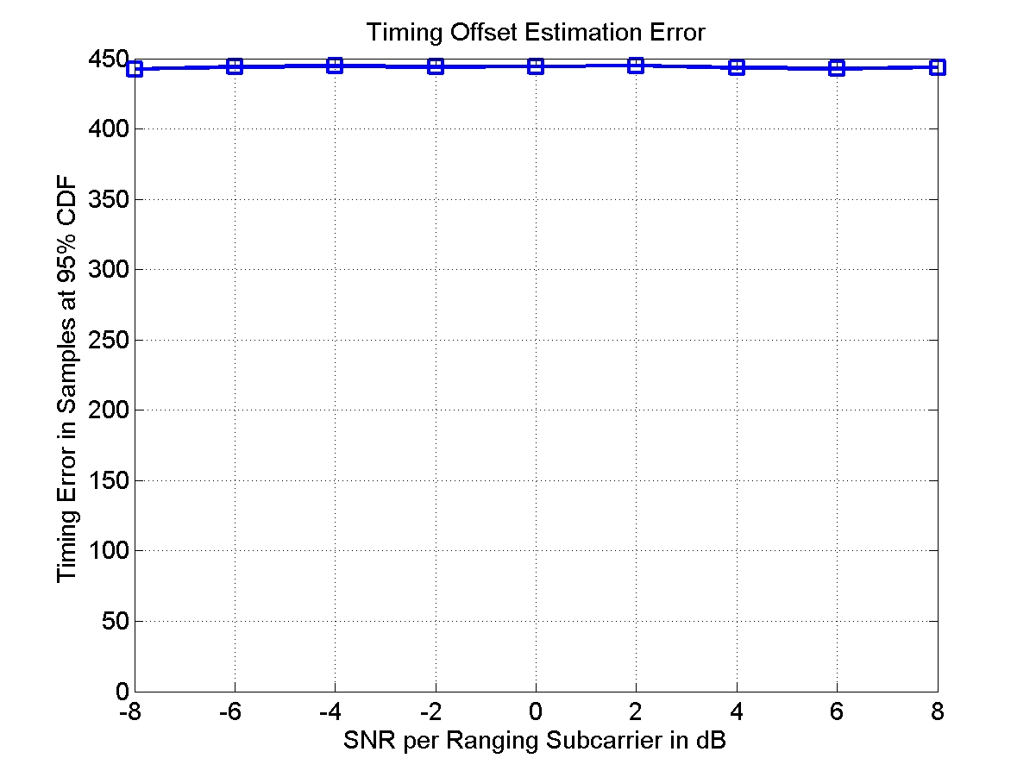

Text Proposal

---------------------------------------------------------Start of the Text--------------------------------------------------------
16.3.9.2.4.1 Ranging channel for non-synchronized AMSs

Ranging signal transmission

Equation (262) specifies the transmitted signal voltage to the antenna, as a function of time, during ranging channel format 0 or 1.

(262)
Step 1: According equation 258, construct 2 sequences xp,1(k) and xp,2(k). xp,2(k) is the cyclic shift and antipodal version of xp,1(k). In other words,
(xxx)
Step 2: Combine the two weighted Zadoff-Chu sequences to obtain x’_{p}(k).
(yyy)
Step 3: Modulate x’_{p}(k) to the assigned ranging channel subband to obtain the ranging preamble signal.
(262)

---------------------------------------------------------End of the Text---------------------------------------------------------

References

[1] IEEE P802.16m/D3, “IEEE 802.16m Amendment Working Document.”

