Project | IEEE 802.16 Broadband Wireless Access Working Group <http://ieee802.org/16>
Title | Clarification on Sub-Carrier Alignment Support for Mixed Deployment (16.3.3)
Date Submitted | 2010-01-10
Source(s) | I-Kang Fu, Kelvin Chou, Pei-Kai Liao, Paul Cheng  MediaTek Inc. | IK.Fu@mediatek.com
Re: | P802.16m/D3
Abstract | This contribution aims to clarify 1) some detail to be considered for mixed deployment and 2) the sub-carrier alignment support for mixed deployment. The proposed text modification aims to ensure the AMS can work well under various deployment scenarios.
Purpose | For TGm discussion and adoption into P802.16m/D3
Notice | This document does not represent the agreed views of the IEEE 802.16 Working Group or any of its subgroups. It represents only the views of the participants listed in the “Source(s)” field above. It is offered as a basis for discussion. It is not binding on the contributor(s), who reserve(s) the right to add, amend or withdraw material contained herein.
Release | The contributor grants a free, irrevocable license to the IEEE to incorporate material contained in this contribution, and any modifications thereof, in the creation of an IEEE Standards publication; to copyright in the IEEE’s name any IEEE Standards publication even though it may include portions of this contribution; and at the IEEE’s sole discretion to permit others to reproduce in whole or in part the resulting IEEE Standards publication. The contributor also acknowledges and accepts that this contribution may be made public by IEEE 802.16.
Patent Policy | The contributor is familiar with the IEEE-SA Patent Policy and Procedures:  <http://standards.ieee.org/guides/bylaws/sect6-7.html#6> and <http://standards.ieee.org/guides/opman/sect6.html#6.3>.  Further information is located at <http://standards.ieee.org/board/pat/pat-material.html> and <http://standards.ieee.org/board/pat>.
Clarification on Sub-Carrier Alignment Support for Mixed Deployment

I-Kang Fu, Kelvin Chou, Pei-Kai Liao, Paul Cheng
MediaTek Inc.

- Executive Summary

IEEE 802.16m is in general a multi-carrier system. This contribution aims to clarify two issues: 1) more details on how 16m zone will coexist with 16e zone when multi-carrier and 2) sub-carrier alignment support when 16e zone and 16m zone are co-deployed on multiple carriers.
For the issue 1), the proposed text request two adjacent carriers need to configure its FRAME_OFFSET be the same over adjacent carriers and inform AMS the location of 16m DL frame boundary in each carrier by a new parameter MC_FRAME_OFFSET. Otherwise AMS will have difficulty to perform efficient scanning over different carriers.
For the issue 2), the proposed text will allow the sub-carrier alignment not be performed between two carriers where both of them contain 16e zone. In order to support this condition, some clarification on the way to configure existing AAI_MC-ADV parameters will be necessary with additional multi-carrier configuration for single carrier cases.

- IEEE 802.16m Multi-Carrier Network Deployment Scenarios

There are three possible deployment scenarios have been identified from service provider perspective [1]: Greenfield Deployment, Mixed Deployment Carrier Reuse and Mixed Deployment Frequency Overlay. The basic concepts are redrawn as following, where the AAIF (Advanced Air InterFace) zone (aka 16m zone) and WirelessMAN-OFDMA zone (aka 16e zone) are both considered.
Figure 1 Multi-carrier deployment example

Consider the general deployment scenarios during the network migration depicted in Figure 2, there may be a period of time that both 16e and 16m MS need to be supported by the network.

Figure 2 Example on IEEE 802.16m network upgrade roadmap

Therefore, it is necessary to make more clarification on how the 16e zone will be coexist with 16m zone under the multi-carrier deployment. Section III will discuss and clarify more details on how 16e and 16m will coexist under multi-carrier deployment. One problem on AMS scanning due to this deployment is also identified for clarification. In Section IV, the issue on sub-carrier alignment support under multi-carrier 16e/16m deployment is also discussed for resolution.

- AMS Scanning Problem under Multi-Carrier Mixed Deployment

If the frame structure applied over one carrier contains both 16e and 16m zone, while the frame structure applied over another carrier only contain 16m zone, the DL frame boundary for 16m zone in these two carriers will be different. However, there is no information to inform AMS where the DL frame boundary of another carrier under this situation. This will result in AMS difficult to perform scanning over the 16m A-Preamble in different carriers when 16e and 16m zone are mixed deployed over some carriers.
Similar as the FRAME_OFFSET parameter to inform AMS where the 16e or 16m Preamble located, it is necessary to have parameter to inform AMS the location of A-Preamble in another carrier to facilitate AMS scanning. Therefore, it is recommended to have another parameter MC_FRAME_OFFSET in AAI_MC-ADV message to notify AMS this information. The basic definition of MC_FRAME_OFFSET is depicted in Figure 3.

Figure 3 Definition of MC_FRAME_OFFSET

In the example shown in Figure 3, the DL frame boundary of 16e zone in Carrier 2 is assumed to be aligned with the DL frame boundary of 16m zone in Carrier 1. In this case, the value of MC_FRAME_OFFSET will be the same as the FRAME_OFFSET between 16e preamble and 16m A_Preamble on Carrier 2. In current P802.16m/D3, there is no description on how to configure the timing of DL frame boundary of the 16e zone. It is recommended to align the 16e frame boundary in one carrier with the 16m frame boundary in another carrier where it only contains 16m zone. But this part will need further discussion with the TGm members.
In addition, the current text in P802.16m/D3 does not preclude the mixed deployment scenario depicted in Figure 4, some detail of this configuration will need more clarification. The first issue is that whether the FRAME_OFFSET value applied in Carrier 1 and Carrier 2 will be different, which was not described in current standard. It is recommended to apply the same FRAME_OFFSET value over different carriers for those carriers contain both 16e and 16m zone. Otherwise the location of 16m A-Preamble among those carriers will be misaligned.

Figure 4 Multiple carriers deployed with both 16e and 16m zones

- Sub-Carrier Alignment Support under Multi-Carrier Mixed Deployment

There are two typical transceiver architectures for multi-carrier AMS considered by TGm members [2-4]. The first one is shown in Figure 5, which utilize single RF to support multi-carrier operations.

Figure 5 Multi-carrier AMS transceiver architecture Type 1

Type 1 architecture has the benefit on lower hardware cost and complexity, which can also lead to lower power consumption. The benefit comes from the nature of OFDM, where multiple OFDM waveforms with different bandwidth (e.g. 2×10MHz) can be easily generated by a larger size FFT (e.g. 2048). This is something that multi-carrier CDMA systems (e.g. DC-HSPA) cannot achieve, which can increase the competiveness of the system developed base on IEEE 802.16m standard.
This architecture will be desired especially by mobile handheld device (e.g. smart phone) which requires low power consumption while supporting the higher transmission rate by multi-carrier aggregation. But Type 1 architecture will need sub-carrier alignment support and is only able to process contiguous carriers, because the legacy center frequency separation between adjacent frequency channels (e.g. 10MHz) cannot be fully divided by existing sub-carrier spacing (i.e. 10.9375kHz). This is also the reason to have mandatory requirement on sub-carrier alignment for most deployment scenario in order to allow this implementation.
Another typical architecture is shown in Figure 6, which utilize multiple RF to support multi-carrier operations.

Figure 6 Multi-carrier AMS transceiver architecture Type 2

This architecture has higher flexibility to support all kinds of multi-carrier configuration, with or without sub-carrier alignment. But it consumes higher hardware complexity and generally higher power consumption. This architecture will be desired to be considered by CPE, wireless gateway and possibly laptop based MS devices. This architecture is actually complementary with the architecture 1 and can be integrated in various different ways.
General speaking, both Type 1 and Type 2 are important architectures need to be supported by IEEE 802.16m network, so as to allow vendors develop various solutions for MS device in the future. From standard development perspective, it is very important to ensure either one will NOT be precluded by the standard. This is very important.
Because Type 2 is obviously more flexibly than Type 1, the major problem is how to ensure Type 1 architecture can be generally supported by the IEEE 802.16m standard. Since the major bottleneck to support Type 1 architecture lies on sub-carrier alignment, therefore, the major problem is on whether sub-carrier alignment can be generally supported in all scenarios.
However, it will be difficult to apply sub-carrier alignment under the deployment scenario as shown in Figure 4, where two adjacent carriers both contain 16e and 16m zone. The reason is because the legacy 16e MS cannot decode the Table 770 in P802.16m/D3, so it cannot understand the small frequency offset (i.e. < 1/2 sub-carrier spacing) applied over either one carrier for sub-carrier alignment. Although the 16e MS can easily compensate this small frequency offset as the way they resolve general frequency offset due to Doppler effect, it is true that the performance of legacy 16e MS may be slightly degraded by applying sub-carrier alignment under this special case.
Therefore, the recommendation is to allow the overlapped sub-carriers not aligned under this deployment condition. In order to implement this in P802.16m/D3 draft standard, some clarification on the way to configure multi-carrier configuration need to be clarified. The simplest way to allow this case is configure each 16e/16m carrier as individual carrier group follow the same way for non-contiguous carriers, either there are adjacent or not. This will be the easiest way to incorporate this configuration with minimal standard text change while align with existing messaging design philosophy.
Under this situation, the MS implemented with Type 1 architecture cannot enable multi-carrier operation due to the sub-carrier misalignment under the deployment scenario depicted in Figure 4. But it may still activate multi-carrier operation once the sub-carriers are aligned in other scenario.
Because the ABS may configure the sub-carrier be aligned or misaligned under different deployment scenario, it is important to mandate AMS to be capable of supporting necessary signaling for decoding all the multi-carrier configurations indicated by AAI_MC-ADV message and make corresponding frequency offset adjustment for sub-carrier alignment. Otherwise standard will actually preclude Type 1 architecture, because the ABS cannot configure the sub-carriers be aligned under the risk that some AMS (e.g. Type 2 architecture) cannot support this.

- Text Proposal
---------------------------------------------------------Start of the Text-----------------------------------------------------------

[Adopt the following text modification started from line#46, page#309 in P802.16m/D3]

16.3.3.6.1 Frame structure to support WirelessMAN-OFDMA with multicarrier operation
In the multicarrier mode supporting WirelessMAN-OFDMA, each carrier can have either a basic frame structure (16.3.3.1) or a basic frame structure configured to support the WirelessMAN-OFDMA (16.3.3.5). Figure 478 illustrates an example of the frame structure in the multicarrier mode supporting WirelessMAN-OFDMA. In the multicarrier mode, to support WirelessMAN-OFDMA, the uplink can be also configured as TDM as defined 16.3.3.5.

Multicarrier operation is only performed between Advanced Air Interface AAI subframes. No multicarrier operation is defined between the Advanced Air Interface frames and WirelessMAN-OFDMA frames.

When two adjacent carriers both contain AAIF zone and WirelessMAN-OFDMA zone (e.g. RF Carrier 2 in Figure 478), the FRAME_OFFSET and UL support configuration (i.e. TDM or FDM) applied in each of these two carriers shall be the same. The MC_FRAME_OFFSET will be broadcast in AAI_MC-ADV to inform AMS the frame boundary of the AAIF zone applied in different carrier groups.

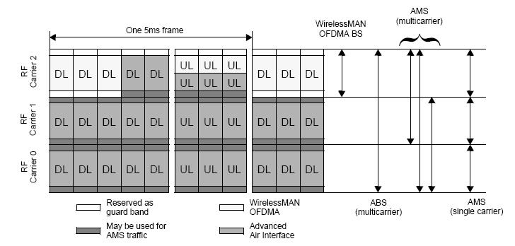
Figure 478 Example of the frame structure to support WirelessMAN-OFDMA with multi-carrier operation

[Adopt the following text modification started from line#31, page#310 in P802.16m/D3]

16.3.3.6.2 Subcarrier alignment for multicarrier operation

When contiguous carriers only contain AAIF zone and are involved in multicarrier operation, the overlapped guard sub-carriers shall be aligned in frequency domain. In order to align the overlapped sub-carriers of the OFDMA signals transmitted over adjacent carriers, a permanent frequency offset (Δf’) will be applied over the original center frequency. The basic principle is shown by the example in Figure 479. The subcarrier alignment shall be achieved without affecting legacy support. In mixed mode operation, the legacy channel raster shall be maintained.

When one carrier contains both AAIF zone and WirelessMAN-OFDMA zone while its adjacent carrier only contain AAIF zone, the overlapped sub-carriers shall be aligned. The center frequency of the carriers which contain both AAIF zone and WirelessMAN-OFDMA zone will exactly locate on the channel raster grid. When two adjacent carriers both contain AAIF zone and WirelessMAN-OFDMA zone, the overlapped sub-carriers may not be aligned.

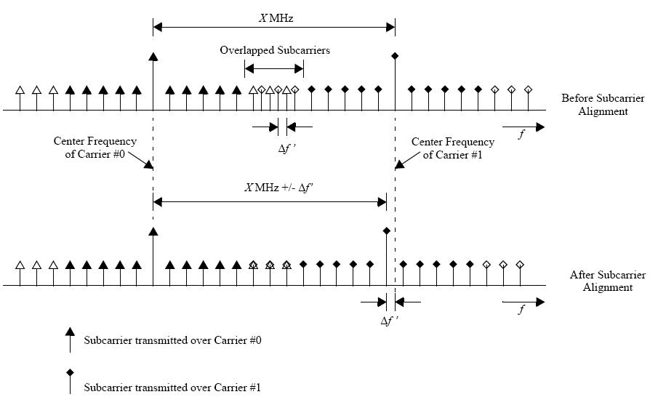
Figure 479 Example of sub-carrier alignment of adjacent carriers

During the network entry procedure (defined in 16.2.1516.2.8.2.3), the ABS will notify the AMS of the frequency offset to be applied over each carrier for sub-carrier alignment through AAI_MC-ADV message. According to the multicarrier configuration index and the Physical Carrier Index of Current Carrier broadcasted by ABS, AMS can derive the center frequency of the available carriers by the associated frequency offset using Table 770. Note that the frequency offset is smaller than the sub-carrier spacing value depicted in Figure 479.

In Table 770, a lookup table is defined to indicate the configurations of for a group of contiguous carriers. If the systemnetwork supports multiple groups of contiguous carriers, AAI_MC-ADV message will separately indicate each group of the contiguous carriers by referring to the index of this table. For example, the multicarrier configuration { 5 , 10 } indicates two contiguous carriers are supported. The first one is a 5MHz carrier and another one is a 10MHz carrier, where the order in this configuration is sorted from lower frequency to higher frequency. In addition, the reference carrier index indicates the index of physical carrier which carrier within the configuration information is the one where the AMS received this configuration information sent through.

Based on the center frequency of the reference carrier that AMS received the AAI_MC-ADV message and the bandwidth of each carrier, the center frequency of each carrier before sub-carrier alignment can be derived. Then the AMS can obtain the frequency offset to be applied over each carrier based on the multicarrier configuration
index, the reference carrier index Physical Carrier Index of Current Carrier and Table 770. So that AMS can obtain the correct center frequency of each carrier including the sub-carrier alignment effect.

When two adjacent carriers both contain AAIF zone and WirelessMAN-OFDMA zone, they will be treated as two non-contiguous carriers and be indicated by different carrier group in AAI_MC-ADV message. The overlapped sub-carriers of the radio signals transmitted over these two adjacent carriers will not be aligned under this condition.

ABS may choose different multi-carrier configuration according to the available spectrum resources and the restriction due to support of WirelessMAN-OFDMA zone. But AMS shall be capable to decode each multi-carrier configuration depicted in Table 770 and apply the corresponding frequency offset before activating multi-carrier operations. If AMS cannot support carrier aggregation due to hardware restriction under sub-carrier misalignment configuration, the AMS shall inform ABS the carriers it can simultaneously process through AAI_MC-REQ message.

Table 770 Center frequency offset for sub-carrier alignment and bandwidth of each adjacent carriers within a carrier group with sub-carrier alignment
Index | Multi-Carrier Configuration (MHz) | Frequency Offset Δf (kHz)
1 | {5} | {0}
2 | {7} | {0}
3 | {8.75} | {0}
4 | {10} | {0}
5 | {20} | {0}
6 TBD | {10, 10} | {0, -3.1248}

----------------------------------------------------------End of the Text-----------------------------------------------------------

Reference
[1] “Requirements for WiMAX Air Interface System Profile Release 2,” WiMAX Forum Service Provider Working Group (SPWG), June 2009.
[2] I-Kang Fu et al., “Multi-Carrier Configurations supported by IEEE 802.16m,” IEEE C802.16m-09/0964, April 2009.
[3] Hujun Yin et al., “Virtual Multi-Carrier Operation for IEEE 802.16m,” C802.16m-08/364, May 2008.
[4] Jaehee Choet al., “Contribution to support MC comments resolution,” C802.16m-Multicarrier-08/042, November 2008.

