Project | IEEE 802.16 Broadband Wireless Access Working Group <http://ieee802.org/16>
Title | Proposed Text changes for Feedback Allocation A-MAP IE
Date Submitted | 2009-12-30
Source(s) | Rajni Agarwal, Kevin Power  Fujitsu | Rajni.agarwal@uk.fujitsu.com  Kevin.power@uk.fujitsu.com
Re: | IEEE 802.16 Working Group Letter Ballot #30b (Area: Chapter 16.3.6.5.2.4.5 – Feedback Allocation A-MAP IE)
Abstract | The contribution proposes modification to Feedback Allocation A-MAP IE which allows reduction of DL Control overhead during FFR operation
Purpose | To be discussed and adopted by TGm for the 802.16m draft amendment.
Notice | This document does not represent the agreed views of the IEEE 802.16 Working Group or any of its subgroups. It represents only the views of the participants listed in the “Source(s)” field above. It is offered as a basis for discussion. It is not binding on the contributor(s), who reserve(s) the right to add, amend or withdraw material contained herein.
Release | The contributor grants a free, irrevocable license to the IEEE to incorporate material contained in this contribution, and any modifications thereof, in the creation of an IEEE Standards publication; to copyright in the IEEE’s name any IEEE Standards publication even though it may include portions of this contribution; and at the IEEE’s sole discretion to permit others to reproduce in whole or in part the resulting IEEE Standards publication. The contributor also acknowledges and accepts that this contribution may be made public by IEEE 802.16.
Patent Policy | The contributor is familiar with the IEEE-SA Patent Policy and Procedures:  <http://standards.ieee.org/guides/bylaws/sect6-7.html#6> and <http://standards.ieee.org/guides/opman/sect6.html#6.3>.  Further information is located at <http://standards.ieee.org/board/pat/pat-material.html> and <http://standards.ieee.org/board/pat>.

Proposed Text changes for Feedback Allocation A-MAP IE
Rajni Agarwal, Kevin Power
Fujitsu

Introduction
In the current version of the IEEE 802.16m draft amendment text [1], using the Feedback Allocation A-MAP IE during FFR operation, the ABS is capable of requesting CQI measurements from two frequency partitions. This is achieved by defining Long Term FPI and Short Term FPI for long and short term reporting, respectively. However, if the ABS changes the current FPI for the AMS based on the CQI reports from Long Term FPI, then a new Feedback Allocation IE will have to be issued in order to maintain accurate link adaptation. This can be avoided by defining a new parameter in the Feedback Allocation A-MAP IE that implicitly allows the AMS to update its short term feedback report based on the latest data allocation, thereby reducing DL control overhead.
Figure 1 illustrates an example where the parameter “Long-Short FPI Switch Flag” is introduced in the Feedback Allocation A-MAP IE.
Feedback Allocation A-MAP IE Parameters:
FPI for Short term Period report = A
FPI for Long term Period report = B
Long-Short FPI Switch Flag = 1
When the FPI changes for latest data allocation, the Long-Short switch takes effect in the immediate "Long-term" FFB opportunity after sending the ACK/NACK response to the data allocation.
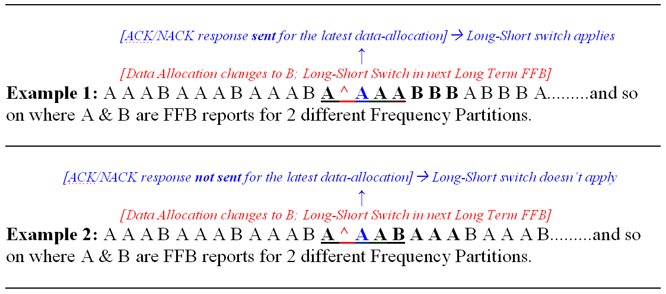
Figure 1 Fast Feedback Reporting when “Long-Short FPI Switch” set to 1

If the Long-Short term flag is set to 0, the AMS shall feed back Short and Long term period reports as initially defined in the A-MAP IE irrespective of the data allocation until the Feedback Allocation A-MAP IE is re-issued or de-allocated.
In order to support the above feature, a “Long-Short FPI Switch Flag” is required in the Feedback Allocation A-MAP IE therefore we are proposing to adopt the text below.

References
[1] P802.16m Draft Amendment, IEEE P802.16m/D3, December 2009.

Proposed Text:
Adopt the following modification to Table 821:

------------------------------------ Start of Proposed Text -------------------------------------------

Syntax | Size in bits | Description/Notes
Feedback-Allocation-MAP_IE() { | - | -
A-MAP IE Type | 4 | Feedback Allocation A-MAP IE = 0b0010
Channel Index | 6 | Feedback channel index within the UL fast feedback control resource region  (Dependent on L_{FB,FPi} defined in section 16.3.8.3.3.2)
Short-term Feedback Period (p) | 3 | A feedback is transmitted on the FBCH every $2^{p}$frames
Long-term Feedback Period (q) | 2 | A long-term feedback is transmitted on the FBCH every $2^{q}$ short-term feedback opportunities.  If q = 0b00, long-term feedback is not used.
Frame offset | 3 | The AMS starts reporting at the frame of which the number has the same 3 LSB as the specified frame offset. If the current frame is specified, the AMS starts reporting in eight frames
Allocation Duration(d) | 3 | A FBCH is transmitted on the FBCH channels indexed by Channel Index for 8×$2^{d}$ frames. If d = 0b000, the FBCH is deallocated. If d=0b111, the AMS should reports until the ABS command for the AMS to stop.
ACK Allocation Flag | 1 | Indicates if one ACK channel is allocated to acknowledge the successful detection of this IE.
If (ACK Allocation Flag == 0b1){
HFA | 3 | HARQ feedback channel allocation for confirmation of Feedback Channel Deallocation
}
MFM | 3 | MIMO Feedback Mode as defined in Table 839
MaxMt | Variable  1-2 | Variable number of bits - depends on number of transmit antenna Nt  If Nt=2 (Any MFM):  0b0: 1  0b1: 2  If Nt=4 (Any MFM):  0b00: 1  0b01: 2  0b10: 3  0b11: 4  If Nt=8 (SU-MIMO, MFM 0, 1, 2, 3, 4):  0b000: 1  0b001: 2  0b011: 4  0b111: 8  If Nt=8 (MU-MIMO, MFM 5, 6, 7):  0b00: 1  0b01: 2  0b10: 3  0b11: 4
If (MFM = 2, 3, 5, 6) {
Feedback Format | 2
}
If(MFM=0,1,4,7){
FPI | 2 | Frequency partition indication: ABS indicate AMS to send wideband CQI and STC rate of the frequency partition and reuse factor in the future:  0b00: Frequency partition index 0  0b01: Frequency partition index 1  0b10: Frequency partition index 2  0b11: Frequency partition index 3
}
If (MFM = 0,1 & q != 0b00){
Long term FPI | 2 | Frequency partition indication: ABS indicate AMS to send wideband CQI and STC rate for the second frequency partition using long term feedback:  0b00: Frequency partition index 0  0b01: Frequency partition index 1  0b10: Frequency partition index 2  0b11: Frequency partition index 3
Long-Short FPI Switch Flag | 1 | Used to inform the AMS to switch Short and Long term reporting based on the FPI of the latest data allocation.  0b0: FPI for Long & Short Term Period report remains constant for the Allocation Duration (d)  0b1: FPI for Long & Short Term Period interchange after every update of FPI of latest data allocation at the subsequent Long Term Feedback Opportunity.
}
If (MFM == 3,4,6,7) { |  | CL SU and MU MIMO
CM | 2 | Codebook Feedback Mode and Codebook Coordination Enable  0b00: base mode with CCE disabled  0b01: transformation mode with CCE disabled  0b10: differential mode with CCE disabled  0b11: base mode with CCE enabled
CS | 1 | Codebook subset if Nt= 4, otherwise CS shall be ignored.  0b0: report PMI from the base codebook or transformed base codebook  0b1: report PMI from the codebook subset or transformed codebook subset
}
If(MFM=0, 1, 2, 5){
Measurement Method Indication | 1 | 0b0: Use the midamble for CQI measurements  0b1: Use pilots in OL region with MaxMt streams for CQI measurements
}
Padding | Variable | Padding to reach byte boundary
} | - | -
*A 16 bit CRC is generated based on the contents of the Feedback Allocation A-MAP IE. The CRC is masked by the Station ID.
Channel Index: Uniquely identifies a fast feedback channel on which an AMS can transmit fast feedback information. With this allocation, a one-to-one relationship is established between channel index and the AMS.
ACK Allocation Flag: The ABS may set ACK Allocation Flag to 0b1 if Allocation Duration equals 0b00. ABS may set ACK Allocation Flag to 0b1 if Allocation Duration is not equal to 0b00 and the channel index of the newly allocated FBCH is the same as the channel index of the deallocated FBCH.
Short-term Feedback Period (p): Short-term feedback is transmitted on the FBCH every 2p frames
Long-term Feedback Period (q): Long-term feedback is transmitted on the FBCH every 2q short-term feedback reports are transmitted. If q = 0b00, long-term feedback is not used.
Allocation duration (d): A FBCH is transmitted on the FBCH channels indexed by Channel Index for 8×2dframes. If d = 0b000, the FBCH is deallocated. If d = 0b111, the AMS shall report until the ABS command for the AMS to stop.
MFM: MIMO feedback mode, defined in Table 839.
Feedback Format: This field specifies the feedback format index when reporting fast feedback information in the FBCH. Feedback format definitions for different MIMO feedback modes are described in 16.3.9.3.1.4.
FPI: The frequency partition over which the short term period report shall be measured by the AMS.
Long term FPI: The frequency partition over which the long term period report shall be measured by the AMS.

Long-Short FPI Switch Flag: This field indicates whether AMS switches Short and Long term reporting based on the FPI of the latest data allocation.
If set to 0, the Long & Short term feedback reports do not change during fast feedback allocation duration.
If set to 1, FPI for Long & Short Term Period interchange after every update of FPI of data allocation. The Long-Short interchange takes effect in the immediate "Long-term" FFB opportunity after sending the HARQ response to the data allocation.
MaxMt: This field specifies the maximum rank to be fed back by the AMS if MFM=0,1,2,3,4 (which indicates a SU MIMO feedback mode for SM), or it specifies the maximum number of users scheduled on each RU at the ABS if MFM=5,6,7 (which indicates a MU MIMO feedback mode)
CCE: Codebook Coordination Enable. When CCE is enabled, AMS finds PMI within whole broadcasted codebook type entry; when the CM field is set to 0b11, it means AMS finds rate-1 PMI within broadcasted codebook entries indicated by BC_SI and codebook subset indication CS.
CM: this field specifies codebook feedback mode.
Measurement Method Indication: This field indicates the use of midamble or pilots for CQI measurement.
For SU MIMO feedback modes, the AMS should apply an additional constraint in the choice of its STC rate feedback: M_{t}≤min(N_{t},N_{r},MaxM_{t}), where Nt is the number of transmit antennas at the ABS, Nr is the number of receive antennas at the AMS, and MaxMt is indicated in the Feedback Allocation A-MAP IE.
The DL Basic Assignment A-MAP IE sent by the ABS can indicate any value of Mt as long as it complies with M_{t}≤min(N_{t},N_{r}). There is no constraint on the assigned Mt relative to MaxMt for an allocation outside the open-loop region. Mt shall be equal to MaxMt for an allocation in the open-loop region with MaxMtstreams.
MaxMt should be interpreted as a function of Measurement Method Indication and the MIMO Feedback Mode.
If Measurement Method Indication == 0b0:
- With an MFM supporting MU MIMO operation, MaxMt indicates the maximum number of users the AMS should assume will be scheduled in future MU MIMO allocations. Based on this information, the AMS may make a better estimation of the multiuser interference in the CQI. If MaxMt is set to one, then the AMS shall assume it will be paired with no other AMSs when it calculates CQI. If MFM 5 is indicated in the Feedback Allocation A-MAP IE, MaxMt indicates the unitary matrix from which the AMS should feedback its preferred stream index on a given physical subband.
- With an MFM supporting SU MIMO operation, MaxMt indicates the maximum STC rate allowed in the feedback report of the AMS. The ABS also uses MaxMt to make sure that the STC rate feedback is in accordance to STC rate ≤min(N_{t},N_{r}) for the AMS. For an MFM requesting OL MIMO feedback for operation with a diversity allocation, setting MaxMt = 2 enforces feedback for DLRU, otherwise the AMS may feedback STC rate up to 4.
If Measurement Method Indication == 0b1:
- MaxMt indicates the rank of the open-loop region for which the feedback shall be provided. The open-loop region type can be deduced from MaxMt and MFM. MaxMt indicates the pilot pattern used in the OL region in which CQI measurements should be taken by the AMS.

------------------------------------ End of Proposed Text -------------------------------------------

