Project | IEEE 802.16 Broadband Wireless Access Working Group <http://ieee802.org/16>
Title | Proposed change to RAID and CDMA allocation A-MAP IE (16.2.11.2)
Date Submitted | 2009-12-30
Source(s) | Youngkyo Baek  Hyunkyu Yu  Jaehyuk Jang  Hyunjeong Kang  Jaejeong Shim  Jonghyun Won  Jaeweon Cho  Heewon Kang  Samsung Electronics | E-mail: youngkyo.baek@samsung.com  Phone : +82-31-279-7321  *<http://standards.ieee.org/faqs/affiliationFAQ.html>
Re: | Call for LB #30b on “ P802.16m/D3”:  Target topic: “16.2.11.2”
Abstract | This contribution proposes RAID definition and transmission scheme for CDMA allocation A-MAP IE.
Purpose | To be discussed and adopted by WG LB
Notice | This document does not represent the agreed views of the IEEE 802.16 Working Group or any of its subgroups. It represents only the views of the participants listed in the “Source(s)” field above. It is offered as a basis for discussion. It is not binding on the contributor(s), who reserve(s) the right to add, amend or withdraw material contained herein.
Release | The contributor grants a free, irrevocable license to the IEEE to incorporate material contained in this contribution, and any modifications thereof, in the creation of an IEEE Standards publication; to copyright in the IEEE’s name any IEEE Standards publication even though it may include portions of this contribution; and at the IEEE’s sole discretion to permit others to reproduce in whole or in part the resulting IEEE Standards publication. The contributor also acknowledges and accepts that this contribution may be made public by IEEE 802.16.
Patent Policy | The contributor is familiar with the IEEE-SA Patent Policy and Procedures:  <http://standards.ieee.org/guides/bylaws/sect6-7.html#6> and <http://standards.ieee.org/guides/opman/sect6.html#6.3>.  Further information is located at <http://standards.ieee.org/board/pat/pat-material.html> and <http://standards.ieee.org/board/pat>.

Proposed change to RAID and CDMA allocation AMAP IE (16.2.11.2)
Youngkyo Baek, Hyunkyu Yu, Jaehyuk Jang, Hyunjeong Kang, Jaejeong Shim,
Jonghyun Won, Jaeweon Cho, Heewon Kang

Samsung Electronics

1. Introduction
BW allocation using CDMA allocation A-MAP IE is based on RAID for identification.
Without STID message transactions or BR header transmission, which uses CDMA allocation A-MAP IE, should be done under uniqueness of RAID. CDMA allocation AMAP IE is required for AAI_RNG-REQ/RSP transaction during initial NW entry or AAI_RNG-REQ/RSP/confirmation message for SMS during idle mode.
Per D3, however, 12-bit RAID (including 4-bit frame index) is too short to guarantee uniqueness during those message transactions.
We suggest longer RAID and body of CDMA allocation AMAP IE.

2. Text Proposal

2.1 Text Proposal #1
Modify the subclause 16.2.11.2 at line 11, page 209 and table 743 and 744 move to other sections(see Text proposal #2 and #3) as follows
======================== Start of Proposed Text =====================

16.2.11.2 Grant

In the contention-based random access bandwidth request procedure, the grant for BW-REQ message BR header is allocated by CDMA Allocation A-MAP IE, which is shown in Table xxx743. CDMA Allocation A-MAP IE is used for UL allocation of bandwidth to a user that requested bandwidth using a ranging preamble code or BR preamble code. AMS decodes the IE and checks the MCRC field by its specific 152-bit RA-ID and 14-bit Masking prefixIndicator. The RA-ID is derived from calculated by a hash function with the AMS' random access attributes (i.e., superframe number (LSB 5bits), frame_number index (42 bits), ranging preamble code/BR preamble code index (6 bits) and opportunity index (2 bits)) as defined below:
RA-ID = (LSB 5bits of superframe number | frame_index | preamble ranging_code_index | opportunity_index)

Masking indicator indicates the identifier used for CRC masking, as shown in Table 744. The allocation shall be in the first UL AAI subframe relevant to the A-MAP region regardless of DL/UL ratio and N _{AAI subframe}, A-MAP. The maximum number of the HARQ retransmission is TBD. same as that for UL HARQ burst , and control information cannot be changed during retransmission process. HARQ process for BR header is performed with one UL HARQ channel that is separate from general UL HARQ channels described in 16.2.14.2.1.2.

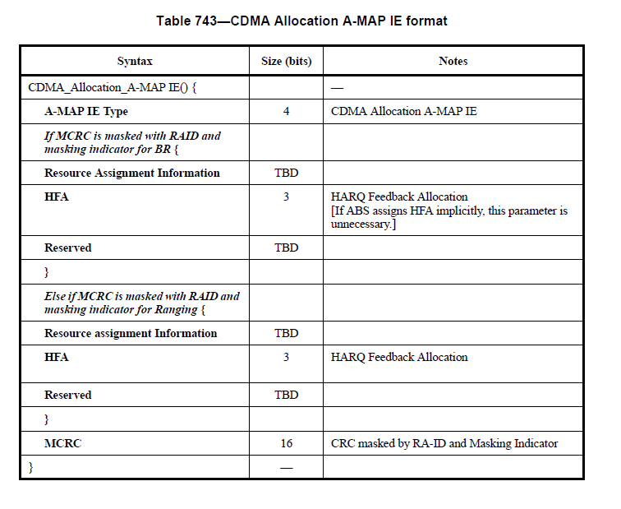
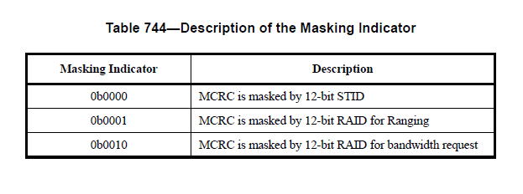

2.2 Text Proposal #2
Insert the following table in the subclasue 16.3.6.5.2.4.7 CDMA Allocation A-MAP IE at line 57, page 429 as follows.
======================== Start of Proposed Text =====================

16.3.6.5.2.4.7 CDMA Allocation A-MAP IE
The CDMA allocation A-MAP IE is specified in Table xxx.

Table xxx—CDMA Allocation A-MAP IE*
Syntax | Size (bits) | Notes
CDMA_Allocation_A-MAP IE() { |  | —
A-MAP IE type | 4 | CDMA Allocation A-MAP IE
CDMA allocation indication | 1 | 0: Bandwidth allocation for bandwidth request.  1: Bandwidth allocation for ranging
Resource Index | 11 | 5 MHz: 0 in first 2 MSB bits + 9 bits for resource index  10 MHz: 11 bits for resource index  20 MHz: 11 bits for resource index  Resource index includes location and allocation size.
Long TTI Indicator | 1 | Indicates number of AAI subframes spanned by the allocated resource.  0b0: 1 AAI subframe (default)  0b1: 4 UL AAI subframes for FDD or all UL AAI subframes for TDD  If number of DL AAI subframes, D, is less than number of UL AAI subframes, U, Long TTI Indicator= 0b1
I_{SizeOffset} | 5 | Offset used to compute burst size index
HFA | 3 | HARQ Feedback Allocation
Reserved | 15 | Reserved bits
} |  | —
*A 16 bit CRC is generated based on the contents of the CDMA allocation A-MAP IE. The CRC is masked by the RAID.

============================== End of Proposed Text ===============

2.3 Text Proposal #3
Insert the following table at line 36, page 395 as follows.
======================== Start of Proposed Text =====================
16.3.6.5.2.4 Assignment A-MAP IE
Assignment A-MAP IE types
Table 811 describes Assignment A-MAP IE Types.
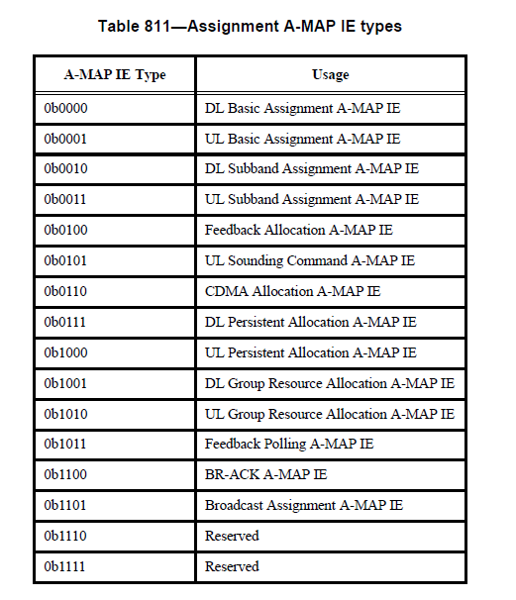
CRC Mask
A 16 bit CRC is generated based on the contents of assignment A-MAP IE and is masked by 16 bit CRC mask using the bitwise XOR operation.

Table yyy—Description of CRC Mask
Masking prefix | Description
0b0 | CRC is masked by 1 bit Masking prefix, 3 bit message type indicator, and 12 bit Masking Code  The 3-bit type indicator shall be set/interpreted as follows.  000: 12 bit Masking Code refers to an STID (i.e. CRC mask = 0000| Masking Code)  001: 12 bit Masking Code used to mask broadcast assignment A-MAP IE, BR-ACK A-MAP IE, and group resource allocation A-MAP IE, which is described in Table zzz (i.e. CRC mask = 0001| Masking Code).
0b1 | CRC is masked by 1 bit Masking prefix, and 15 bit RAID (i.e. CRC mask = 1|RAID)

Table zzz—Description of the Masking Code for type indicator 001
Decimal value | Description
0 | Used to mask broadcast assignment A-MAP IE
1 | Used to mask BR-ACK A-MAP IE
2 – 64 | Used to mask group resource allocation A-MAP IE (group ID)

============================== End of Proposed Text ===============

2.4 Text Proposal #4
Modify sentences at line 51, page 243 as follows.
======================== Start of Proposed Text =====================
The RA-ID is used until AAI_RNG-REQRSP tranmission is completed, but if AMS does not receive UL bandwidth allocation in T3(TBD) or the AAI_RNG-REQ/RSP transmission transaction is not completed in 64 128frames, it sends ranging code to perform ranging procedure again.
============================== End of Proposed Text ===============

2.5 Text Proposal #5
Modify the text at line 5, page 41 as follows.
======================== Start of Proposed Text =====================
In response to the additional UL bandwidth request, ABS should provide UL bandwidth by CDMA Allocation A-MAP IE still masked with the RA-ID and masking prefixindicator for the ranging code (refer to Table yyy 15.2.15.3.1).
============================== End of Proposed Text ===============

2.6 Text Proposal #6
Modify the text at line 23, page 206 as follows.
======================== Start of Proposed Text =====================
The ABS shall limit the maximum HARQ retransmission of the BR header to TBD through the BR ACK A-MAP IE or CDMA Allocation A-MAP IE is same as that of UL HARQ burst.
============================== End of Proposed Text ===============

2.7 Text Proposal #7
Modify the text at line 44, page 441 as follows.
======================== Start of Proposed Text =====================
The maximum number of the HARQ retransmissions is TBD same as that of UL HARQ burst.
============================== End of Proposed Text ===============

4. References
- IEEE P802.16m/D3. DRAFT Amendment to IEEE Standard for Local and metropolitan area networks—Part 16: Air Interface for Broadband Wireless Access Systems—Advanced Air Interface, Dec 2009.
- IEEE 802.16m-08/003r9a. The Draft IEEE 802.16m System Description Document, May 2009.
- IEEE 802.16m-07/002r9. IEEE 802.16m System Requirements Document, Sep 2009.

