Project | IEEE 802.16 Broadband Wireless Access Working Group <http://ieee802.org/16>
Title | Proposed change to clean up the network entry and initialization section (16.2.15)
Date Submitted | 2009-12-30
Source(s) | Youngkyo Baek  Hyeonjeong Kang  Sungjin Lee  JaeJeong Shim  Rakesh Taori  Jungje Son  Kyeong-Tae Do  Samsung Electronics  Kiseon Ryu  LG Electronics | E-mail: youngkyo.baek@samsung.com  Phone : +82-31-279-7321  *<http://standards.ieee.org/faqs/affiliationFAQ.html>
Re: | Call for LB #30b on “ P802.16m/D3”:  Target topic: “16.2.15”
Abstract | This contribution provides to clean up the network entry and initialization section
Purpose | To be discussed and adopted by WG LB
Notice | This document does not represent the agreed views of the IEEE 802.16 Working Group or any of its subgroups. It represents only the views of the participants listed in the “Source(s)” field above. It is offered as a basis for discussion. It is not binding on the contributor(s), who reserve(s) the right to add, amend or withdraw material contained herein.
Release | The contributor grants a free, irrevocable license to the IEEE to incorporate material contained in this contribution, and any modifications thereof, in the creation of an IEEE Standards publication; to copyright in the IEEE’s name any IEEE Standards publication even though it may include portions of this contribution; and at the IEEE’s sole discretion to permit others to reproduce in whole or in part the resulting IEEE Standards publication. The contributor also acknowledges and accepts that this contribution may be made public by IEEE 802.16.
Patent Policy | The contributor is familiar with the IEEE-SA Patent Policy and Procedures:  <http://standards.ieee.org/guides/bylaws/sect6-7.html#6> and <http://standards.ieee.org/guides/opman/sect6.html#6.3>.  Further information is located at <http://standards.ieee.org/board/pat/pat-material.html> and <http://standards.ieee.org/board/pat>.
Proposed change to clean up the network entry and initialization section (16.2.15)
Youngkyo Baek,Hyeonjeong Kang, Sungjin Lee, JaeJeong Shim,Rakesh Taori, Jungje Son, Kyeong-Tae Do
Samsung Electronics
Kiseon Ryu
LG Electronics

Introduction
This contribution suggests a clean-up text for the Network entry and initialization section 16.2.15.
We suggest fixing up words/sentences to keep consistency over the sections and remove ambiguous points to make readers understand easily the text.

Proposed Text #1
[For consistency and readiblity]
Replace the figure 435, page 239 with the following figure as follows.
----------------------------------------------------- Start of Proposed Text #1---------------------------------------------------
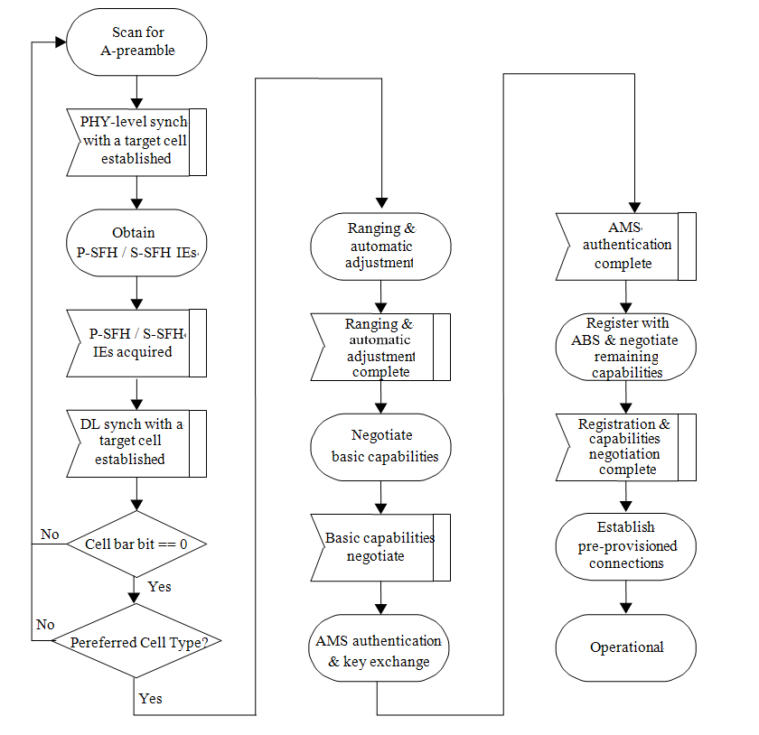
----------------------------------------------------- End of Proposed Text #1---------------------------------------------------

Proposed Text #2
[For consistency and readiblity]
Modify sentences, line 48,page 239 as follows.
----------------------------------------------------- Start of Proposed Text #2---------------------------------------------------
Systems shall support the applicable procedures for entering and registering a new AMS or a new node to the network. The procedure for initialization of an AMS shall be divided into the following stepsphases:
a) Scan for DL channel and establish DL PHY synchronization with the ABS
b) Obtain DL/UL parameters (from P-SFH/S-SFH IEs etc.SuperFrameHeader) and establish DL synchronization
c) Perform ranging and automatic adjustment
d) Negotiate basic capability
e) Authorize AMS and perform AMS authorization and key exchange
f) Perform Capability exchange and registration, and setup default service flows(i.e. pre-provisioned service flows).
----------------------------------------------------- End of Proposed Text #2---------------------------------------------------

Proposed Text #3
[For consistency and readiblity]
Modify subclauses, line 31, page 242 as follows.
----------------------------------------------------- Start of Proposed Text #3---------------------------------------------------
16.2.15.1 AMS DL PHY synchronization.
On initialization or after signal loss, the AMS shall acquire the DL PHY synchronization by A-PreamblePREAMBLE. The detailed procedure for DL PHY synchronization is reporteddescribed in section 16.3.6.1.
The AMS shall have nonvolatile storage in which the last operational parameters are stored and, when the AMS needs to acquire DL PHY synchronization, it may at first try to reacquire synchronization using the stored DL channel information. But, i If the trial aforementioned process fails, the AMS shall begin to scan the possible channels of the DL frequency band of operation until it finds a valid DL signal.

16.2.15.2 AMS obtaining DL/UL parameters
For initial network entry, once the AMS has achieved DL PHY synchronization with an particular ABS, the AMS shall decode the P-SFH and S-SFH in order to obtain the necessary system information containing the DL and UL parameters for the initial network entry. Based on the network information such as NSP list which may be obtained from AAI_SII-ADV message, the AMS shall decide whether to continue the network entry process with this ABS or to scan for other ABSs. If the AMS reads cell_bar=1 in SFH, this means this cell does not allow access of new AMS and the AMS shall select a different cell to restart network entry procedure.
If the AMS succeeds to decode the essential system information, the AMS is DL synchronized with the ABS.
The procedure to determine the loss of DL synchronization is TBD.
After DL synchronization, the AMS shall attempt to perform initial ranging with the ABS. If the ranging procedure is successfully completed, the AMS is UL synchronized with the ABS.

16.2.15.3 Initial ranging and automatic adjustments
After DL synchronization, the AMS shall attempt to perform initial ranging with the ABS. If the ranging procedure is successfully completed, the AMS is UL synchronized with the ABS and obtains TSTID from the ABS. The TSTID is used until the ABS assigns the AMS an STID through registration procedure.
Ranging is the process of acquiring the correct timing offset, frequency offset and power adjustments so that the AMS's transmissions are aligned with the ABS, and they are received within the appropriate reception thresholds.
16.2.15.3.1 Contention-based initial ranging and automatic adjustments
An AMS that wishes to perform initial ranging shall take the following steps:
• The AMS, after acquiring downlink synchronization and uplink transmission parameters, shall select one Ranging Slot ranging opportunity based on the random backoff. The random backoff shall use a binary truncated exponent algorithm. After selecting the Ranging Slot ranging opportunity, the AMS shall choose a ranging sequence preamble code (from the Initial Ranging domain) using a uniform random process. The AMS shall send the selected ranging sequence preamble code to the ABS in the selected Ranging Slot ranging opportunity.
• The ABS should respond with an AAI_RNG-ACK message in a predefined, subsequent DL AAI subframe as define in 16.2.3.316.2.3.19. The AAI_RNG-ACK message provides responses to all the successfully received and decoded IR requests ranging preamble codes in initial ranging slots all the ranging opportunities in a previous UL AAI subframe. If all the decoded ranging preamble codes prove ‘success’ status and the ABS provides UL BW allocation for each ranging preamble codes before the predefined DL AAI subframe that AAI_RNG-ACK is to be transmitted , the AAI_RNG-ACK may be omitted. If the AMS finds in the RNG-ACK bitmap that no initial ranging sequence preamble code has been successfully decoded in the ranging slot ranging opportunity selected by the AMS, or it does not find either a response in the AAI_RNG-ACK message or UL BW allocation to its IR access attempt ranging preamble code, the AMS considers its initial ranging request is failed and restarts the initial ranging procedure.
• After successfully receive an IR request, t There are three possible ranging status responses from ABS to AMS provided in the AAI_RNG-ACK message:
– 1)IR continue: the ABS provides the needed adjustments (e.g., time, power, and possibly frequency corrections) and a status notification of "continue".
– a) IR success: the ABS provides a status notification of "success", and but may have has no adjustment suggestions to the AMS if necessary. With IR status success In this case, the ABS shall provide the AMS an UL BW allocation for the AMS to send AAI RNG-REQ message.
– a) IR abort: the ABS requests the AMS to abort the ranging process.
• Based on the received response of ranging status, the AMS performs the followings.
– Upon receiving a Continue status notification and parameter adjustments in the AAI_RNG-ACK message, the AMS shall adjust its parameters accordingly and continue the ranging process as done on the first entry (using random selection rather than random backoff) with ranging sequence preamble code randomly chosen from the initial ranging domain sent on the initial ranging region.
• – Upon receiving a Success status notification, the AMS shall wait for the ABS to provide UL BW allocation. If the AMS has not received CDMA Allocation A-MAP IE for UL BW allocation by T3 after sending a ranging preamble code, it restarts the initial ranging procedure or, if ‘ranging retries’ is exhausted, it retries DL PHY synchronization. When receiving an UL BW allocation, the AMS shall send the AAI_RNG-REQ message. If the granted BW allocation cannot accommodate the entire AAI_RNG-REQ message, the AMS may fragment the AAI_RNG-REQ message to fit the provided BW allocation, and requests additional UL bandwidth through either BR without STID header(refer to 16.2.2.1.3.2) or PBREH(refer to 16.2.2.2.8) as defined in 15.2.2.2.9 for the remaining fragments. In response to the PBREH, the ABS shall provide UL BW allocation through CDMA Allocation A-MAP IE, which is identified by the same RA-ID used for the previous BW allocation. The RA-ID is used until AAI_RNG-REQ tranmission is completed, but if AMS does not receive UL bandwidth allocation in T3(TBD) or the AAI_RNG-REQ transmission is not completed in 64 frames, it sends ranging code to perform ranging procedure again.
• ABS assigns and transfers a TSTID by AAI_RNG-RSP message when ranging status is success. Initial ranging process is over after receiving the AAI_RNG-RSP message, which includes a The TSTID (temporary station ID) to be is used until STID is newly assigned and received at successful registration. If the AMS has not received AAI_RNG-RSP by T3 after sending an AAI_RNG-REQ, it restarts the initial ranging procedure or, if ‘ranging retries’ is exhausted, it retries DL PHY synchronization.
• The timer required for AMS to wait for AAI_RNG-RSP or CDMA Allocation A-MAP IE, is defined by T3 (TBD).
----------------------------------------------------- End of Proposed Text #3---------------------------------------------------

Proposed Text #4
[For readiblity]
Modify sentences, line 3, page 245 as follows.
----------------------------------------------------- Start of Proposed Text #4---------------------------------------------------
If PKM authorization support is enabled in basic capability negotiation, the ABS and AMS shall perform authorization and key exchange through EAP-based authentication(IETF RFC 3748) and key agreement procedure(see 16.2.5.2.1.4) as described in 15.2.3. If this procedure completes successfully, all parameters for TEK generation are shared, and TEKs are derived at each side of AMS and ABS. If authorization support is disabled, the step of AMS authorization and key exchange shall be skipped.
----------------------------------------------------- End of Proposed Text #4---------------------------------------------------

Proposed Text #5
[For consistency and readiblity]
Modify sentences, line 9, page 245 as follows.
----------------------------------------------------- Start of Proposed Text #5---------------------------------------------------
16.2.15.6 Capability exchange and r Registration
Registration is the process by which the AMS is allowed to enter into the network.
After authorization and key exchange are finished, the AMS informs the ABS of its capabilities and requests the registration for entry into the network by AAI-_REG-REQ. If an ABS receives an AAI-_REG-REQ, the ABS shall respond with AAI-_REG-RSP.
In AAI-_REG-REQ, the AMS informs the ABS of its capabilitiesy parameters to be negotiated, except those capabilities already negotiated with the ABS through AAI_SBC-REQ/RSP messages, with its capabilities set to "on". In AAI-_REG-RSP, the ABS responds with the accepted capability parameters intersection of the AMS's and the ABS's capabilities set to "on". Among the parameters for capability from AMS, if AMS follows default value, the AMS may omit those parameters from AAI-_REG-REQ. If the AMS omits some capability parameters in AAI_REG-REQ, the ABS considers AMS follows the default values for those parameters and, if acceptable, ABS may omit those parameters applying default value in its AAI-_REG-RSP.
----------------------------------------------------- End of Proposed Text #5---------------------------------------------------

Proposed Text #6
[For consistency and readiblity]
Modify sentences, line 36, page 245 as follows.
----------------------------------------------------- Start of Proposed Text #6---------------------------------------------------
During the capability exchange and registration procedure, the AMS and the ABS shall negotiate IP versions and may negotiate host configuration parameters. The AMS shall inform the supported IP version(s), (for example, IPv4, IPv6 or both) to the network through the ABS by including the Supported-IP-Versions IE in the AAI_REG-REQ message. After the network selects one of the supported IP version(s) among one of IP versions which the network supports and its allowed policy allows, the ABS shall inform the AMS of the selected IP service type (for example, IPv4 only, IPv6 only or IPv4/IPv6 dual mode) for the AMS by including the IP-Service-Type IE in the AAI_REG-RSP message.
----------------------------------------------------- End of Proposed Text #6---------------------------------------------------

Proposed Text #7
[Due to duplication with the subclause 16.2.3.8, line 46, page 55]
Delete the sublcause 16.2.15.6.1, line 6, page 246 as follows.
----------------------------------------------------- Start of Proposed Text #7---------------------------------------------------
16.2.15.6.1 AAI-REG-REQ Message contents
16.2.15.6.1.1 AMS Scanning Capability
This field indicates properties of the AMS that the ABS needs to know for scanning purposes:
-Number of Center Frequencies AMS can scan during one scan iteration.
-Maximum number of preambles per Center Frequency AMS can scan during one iteration.
-Number of frames required to complete scanning of all preambles for a given frequency.
The length of the field is 3 Bytes, which are divided as follows:
•Bit 0-4: Indicates the maximum number of preambles using the same center frequency that AMS can scan within one frame
•Bit 5-7: Number of sub-frames the AMS requires to switch from the serving ABS to the first center frequency. This value is measured from the end of the last frame during which the AMS is connected to the S-ABS (and may have to receive/send data) until the beginning of the first frame in which a measurement of a neighboring ABS in a different center frequency can be performed.
•0b000 = 0 sub-frames
•0b111 = 7 sub-frames)
•Bits 8-10: The number of sub-frames the AMS requires to switch between center frequencies. This is the time duration (in sub-frames) between a sub-frame in which a center frequency was scanned until the beginning of a sub-frame in which a new center frequency can be scanned.
•0b000 = 0 sub-frames
•0b111 = 7 sub-frames)
•Bits 11-13: The number of sub-frames the AMS requires to switch from the last center frequency back to the serving ABS. This is the time duration (in sub-frames) between a frame in which a center frequency was scanned until the beginning of the first frame in which the AMS is available at the S-ABS and may receive/transmit data.
•0b000 = 0 sub-frames
•0b111 = 7 sub-frames)
•Bit 14-15: Minimum supported scan duration
•(0b000 = no limit, 0b001= 1 sub-frame, 0b111= 7 sub-frames)
•Bit 16-23: Maximum supported scan duration
•(0x0 = no limit
•All other values: maximum scan duration in number of sub-frames))
----------------------------------------------------- End of Proposed Text #7---------------------------------------------------

Proposed Text #8
[For consistency and readiblity]
Modify the table 674(AAI_RNG-REQ), line 59, page 44 as follows.
----------------------------------------------------- Start of Proposed Text #8---------------------------------------------------
Name | Value | Usage
……. | ……….. | ……….
Ranging Purpose Indication | The presence of this item in the message indicates the following AMS action:  If Bit#0 is set to 1, it indicates that the AMS is currently attempting HO reentry, or, in combination with a Paging Controller ID, indicates that the MS is attempting network reentry from idle mode to the BS. In this case, Bit#1 shall be 0..  If Bit#1 is set to 1, it indicates that the AMS is initiating the idle mode location update process. In this case, Bit#0 shall be 0  If Bit#2 is set to 1, ranging request for emergency call setup. When this bit is set to 1, it indicates AMS action of Emergency Call process.  If Bit#4 is set to 1, it indicates that the AMS is attempting to perform location update due to a need to update service flow management encodings for E-MBS flows.  If bit #5 is set to 1, it indicates that the AMS is initiating location update for transmission to DCR mode from idle mode.  If bit #6 is set to 1 in combination with ID of the network entity that assigns/retains the context, it indicates that the AMS is currently attempting reentry from DCR mode.  If Bit#7 is set to 1, it indicates that the AMS is currently attempting network reentry after experiencing a coverage loss.  <<<Editor’s note: reserved bits below are invalid>>>  Bit#3-7 : reserved. | It shall be included when the AMS is attempting to perform reentry, HO or location update
…… | ……….. | ……….
Previous STID | The STID which the AMS uses in the previous serving ABS. | It shall be included when the AMS is attempting to perform HO reentry
…… | ……….. | ……….
NONCE_AMS | A freshly generated 64-bit random number used for PMK derivation | It shall be included when PMK is updated zone switching from LZone to MZone occurs.
NONCE_ABS | A 64-bit number transferred from ABS and used for PMK derivation | It shall be included when PMK is updated zone switching from LZone to MZone occurs.
…… | ……….. | ……….

----------------------------------------------------- End of Proposed Text #8---------------------------------------------------

Proposed Text #9
[For consistency and readiblity]

Modify the table 675(AAI_RNG-RSP), line 5, page 47 as follows.
----------------------------------------------------- Start of Proposed Text #9---------------------------------------------------
Name | Value | Usage
…… | ……. | ………
Temporary STID | ……. | It shall be included in the AAI_RNG-RSP message in response to the AAI_RNG-REQ message, which is not CMAC protected, when the AMS is not assigned its STID/DID yet
AMID* | …….
…… | ……. | ………
STID | AMS identification to be used in the target ABS | It shall be included in the AAI_RNG-RSP message during uncontrolled HO, NW reentry or Zone switching in case that the AAI_RNG-RSP is encrypted
…… | ……. | ………
NONCE_AMS | The 64-bit NONCE_AMS transferred by AAI_RNG-REQ | It shall be included when PMK is updated zone switching from LZone to MZone occurs.
NONCE_ABS | The 64-bit NONCE_ABS transferred by AAI_RNG-REQ | It shall be included when PMK is updated zone switching from LZone to MZone occurs.
…… | ……. | ………

----------------------------------------------------- End of Proposed Text #9---------------------------------------------------

