Project | IEEE 802.16 Broadband Wireless Access Working Group <http://ieee802.org/16>
Title | Mismatch between described flows and diagrams for sleep mode in the std
Date Submitted | 2009-12-31
Source(s) | Jon Labs, Wavesat
Re: | IEEE 802.16-2009 Change request 0022
Abstract | Mismatch between described flows and diagrams in the std could lead to different interpretation and interoperability problems.
Purpose | Formatting this contribution for incorporating the CR into P802.16m/D3
Notice | This document does not represent the agreed views of the IEEE 802.16 Working Group or any of its subgroups. It represents only the views of the participants listed in the “Source(s)” field above. It is offered as a basis for discussion. It is not binding on the contributor(s), who reserve(s) the right to add, amend or withdraw material contained herein.
Release | The contributor grants a free, irrevocable license to the IEEE to incorporate material contained in this contribution, and any modifications thereof, in the creation of an IEEE Standards publication; to copyright in the IEEE’s name any IEEE Standards publication even though it may include portions of this contribution; and at the IEEE’s sole discretion to permit others to reproduce in whole or in part the resulting IEEE Standards publication. The contributor also acknowledges and accepts that this contribution may be made public by IEEE 802.16.
Patent Policy | The contributor is familiar with the IEEE-SA Patent Policy and Procedures:  <http://standards.ieee.org/guides/bylaws/sect6-7.html#6> and <http://standards.ieee.org/guides/opman/sect6.html#6.3>.  Further information is located at <http://standards.ieee.org/board/pat/pat-material.html> and <http://standards.ieee.org/board/pat>.
Mismatch between described flows and diagrams for sleep mode in the std

Jon Labs, Wavesat
Problem Statement
[From Annex A.2 of IEEE L802.16-09/0123:]

Mismatch between described flows and diagrams in the std could lead to different interpretation and interoperability problems.
It is described in the standard that Sleep windows are interleaved with windows of fixed duration. This means that the sleep window follows the Listening window. Figure D8 is therefore incorrect. The arrow labeled with “Sleep mode, 2*N1 frames *” should only start from the end of the listening window.

Figure D.8—Example sleep mode—BS-initiated for the case of TRF_IND = 1 andTraffic_triggering_wakening_flag = 1

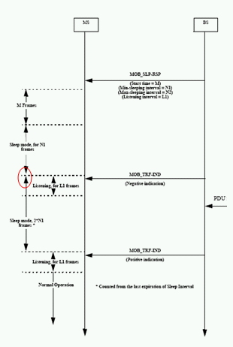
Proposed Solution
[Insert the following change language text at the end of page 648 of P802.16m/D3:]:

Annex D

D.2 Sleep mode MSCs

[Modify figures D7 and D8 as follows:]
1) The arrow for the sleep interval in figure D8 should be modified. Figure D7 contains the same arrow and there it is correct:
In figure D8 (page 1937) shorten the upper end of the arrow labeled with “Sleep mode, 2*N1 frames. It should only start from the end of the listening window. See red corrections in the figure below:

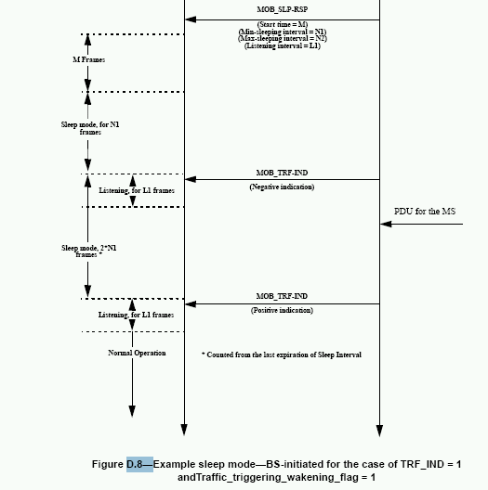

2) In addition the following confusing sentence “Counted from the last expiration of Sleep interval” should be removed from both figures D7 and D8. “Counted from the last expiration of Sleep interval”

3) In both D7 and D8, change the arrow labels from “Sleep mode 2*N1 frames” to “Sleep Window 2*N1 frames”

4) In both D7 and D8, change the MOB_SLP-REQ/RSP parameters as follows:
Change Min-sleeping interval to Initial sleep window
Change Max-sleeping interval to Final sleep window
Change Start time to Start_frame_number

5) In both D7 and D8, change Listening for L1 frames to Listening window (L1 frames)

6) In both D7 and D8, change the arrow labels from “Sleep mode, for N1 frames” to “Sleep Window for N1 frames”

