Project | IEEE 802.16 Broadband Wireless Access Working Group <http://ieee802.org/16>
Title | Advanced ARQ for Relays (16.6.2.8)
Date Submitted | 2010-01-04
Source(s) | Gauri Joshi, Nirbhay Rane, Srinadh B, Abhay Karandikar, Prateek Kapadia  TICET, IIT Bombay  Shantidev Mohanty, Muthaiah Venkatachalam  Intel Corp. | Voice: +91-9820347269  E-mail: karandi@ieee.org
Re: | IEEE 802.16m-09/0058r4: Letter Ballot Recirc #30b  Target Topic: IEEE P802.16m/D3: Section 16.6.2.8
Abstract | Modifications to the ARQ protocol to ensure seamless handover with relays.
Purpose | Propose inclusion of additional text for Relay ARQ operation in Section 16.6.2.8
Notice | This document does not represent the agreed views of the IEEE 802.16 Working Group or any of its subgroups. It represents only the views of the participants listed in the “Source(s)” field above. It is offered as a basis for discussion. It is not binding on the contributor(s), who reserve(s) the right to add, amend or withdraw material contained herein.
Release | The contributor grants a free, irrevocable license to the IEEE to incorporate material contained in this contribution, and any modifications thereof, in the creation of an IEEE Standards publication; to copyright in the IEEE’s name any IEEE Standards publication even though it may include portions of this contribution; and at the IEEE’s sole discretion to permit others to reproduce in whole or in part the resulting IEEE Standards publication. The contributor also acknowledges and accepts that this contribution may be made public by IEEE 802.16.
Patent Policy | The contributor is familiar with the IEEE-SA Patent Policy and Procedures:  <http://standards.ieee.org/guides/bylaws/sect6-7.html#6> and <http://standards.ieee.org/guides/opman/sect6.html#6.3>.  Further information is located at <http://standards.ieee.org/board/pat/pat-material.html> and <http://standards.ieee.org/board/pat>.

Advanced ARQ for Relays
Gauri Joshi, Nirbhay Rane, Srinadh B, Abhay Karandikar, Prateek Kapadia
TICET, IIT Bombay, India
Shantidev Mohanty, Muthaiah Venkatachalam
Intel Corp. USA

INTRODUCTION

Section 16.6.2.8 of P802.16m/D3 states that ARS performs ARQ operation separately with ABS on the relay link, and AMS on access link. In this protocol, the ABS is unaware of the ARQ state on the access link. Due to this, the current protocol has the following drawbacks:

- When an AMS handover takes place from the serving ARS to the ABS (or another ARS in the same cell), the downlink ARQ blocks pending for transmission in serving ARS queue are dropped. Also, the ABS has already cleared these ARQ blocks after receiving the corresponding ACKs from the ARS. Thus, ARQ blocks pending for transmission, in the serving ARS queue, are lost.
- For a downlink transmission, the ARS may send ACK to ABS for an ARQ block, before sending the ARQ block successfully on the access link. Thus, there may be a large number of ARQ blocks successfully transmitted on the relay link, but pending transmission to the AMS. Since the ABS is unaware of this scenario, it may flood the ARS with ARQ blocks to forward to the AMS.

Thus, the ABS must receive feedback about the ARQ state on the link from the ARS to the AMS. We propose an advanced ARQ (A-ARQ) protocol that will solve the problems described above. This new method gives a significant advantage by ensuring seamless intra-cell handover without any packet loss. It also enables the ABS to use flow control measures to schedule future downlink transmissions according to the ARQ state of the access link.

PROPOSED A-ARQ PROTOCOL

Fig. 1 describes ARQ operation as in D3:
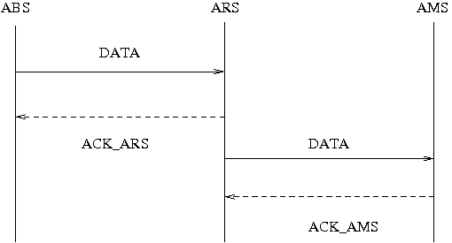

Fig. 1- Current ARQ protocol described in Section 16.6.2.8

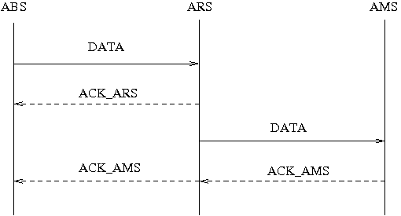
Fig. 2- Proposed A-ARQ protocol

In the proposed protocol shown in Fig. 2, the ACK or NACK information sent by the AMS to the ARS is also forwarded to the ABS. ABS will clear the ARQ blocks from its buffer only on receiving ACK from AMS, via relay.

ABS maintains two pointers for the ARQ states on relay link and access link. Thus ABS tracks the state information of ARQ of both these links. In scenarios such as handover from ARS to another ARS, the ABS can set the relay link pointer equal to the access link pointer. It will then start transmission of ARQ blocks to the target ARS from the new relay pointer position. Thus packet loss during handover is averted.

The proposed protocol gives the following advantages:

- Seamless handover: With the A-ARQ protocol, ABS will not clear ARQ blocks from its buffer until it receives the ACK_AMS (ACK of AMS). When a handover takes place from the ARS, to the ABS or another ARS, a copy of the ARQ blocks pending for transmission at ARS queue will also be present at the ABS. These blocks can be forwarded to the handover target ARS and then to the AMS. Thus, the proposed scheme ensures a seamless handover with no packet loss.
- Efficient scheduling by the ABS: When the ABS is aware of the state of access link ARQ, it can intelligently schedule future transmissions to the AMS. Thus, ABS will use its resources more efficiently. Intelligent scheduling will also ensure that the buffer at ARS does not overflow.

IMPLEMENTATION

The proposed protocol is compatible with both L2 and L3 relay architectures. For example, in L3 relays, the ARQ feedback can be sent of the R8 interface.

PROPOSED TEXT
-----------------------------------------Start of the Text (Page 619, Line 60)---------------------------------------------

In the downlink, the ABS generates and sends an ARQ block to ARS in the relay link. If the ARQ block is corrupted in the relay link, ARS shall send a NACK to ABS, and then ABS shall prepare and perform retransmission. If ARS receives the ARQ block correctly in the relay link, ARS shall send an ACK to ABS and forward the ARQ block to the AMS in the access link. In the access link, if the ARQ block is corrupted and the ARS receives a NACK from AMS, ARS shall prepare and perform retransmission to AMS. If the AMS receives the ARQ block correctly in the access link, it sends an ACK to the ARS. The ARS will forward the AMS ACK/NACK to ABS. This forwarding need not happen for every ACK. If the ABS decides to trade-off between packet loss and delay, it may forward the last received ACK before a handover.

16.6.2.8.1 ARQ state machine variables

16.6.2.8.1.1 ARQ_TX_WINDOW_BEGIN

ARQ_TX_WINDOW_BEGIN is used in the transmitter ARQ state machine and represents the lowest edge of ARQ window on the access link. The ABS maintains this pointer for the least SN of ARQ blocks unacknowledged by the AMS.

16.6.2.8.2 ARQ transmitter state machine at ABS

ABS follows a modified version of ARQ transmitter state machine in Figure 427, Section 16.2.13.5.2.
ACK: Relay ACK

ACK_AMS : AMS ACK forwarded to ABS by ARS

An ARQ block may be in one of the following six states: not-sent, outstanding, waiting-for-retransmission, discard, ARS receive and done state.

“ARS receive” state: At ABS, ARQ block state transits to this state on reception of ACK. If the transmitter receives ACK_AMS in this state, it transits to “done” state.

“Done” state: ARQ block state transits to this state on reception of ACK_AMS. The ABS shall flush the ARQ block and remove the timers and state variables associated with the flushed ARQ block .

ARQ_SYNC: The ARQ_SYNC trigger condition is generated by the ABS when a handover of the AMS from the serving ARS to another ARS/ABS within the cell occurs. It is also generated if the ARS requests ABS for synchronization of ARQ states for a flow.

When ARQ_SYNC trigger occurs, the ABS synchronizes its ARQ states with the AMS as follows:
- ARQ blocks in outstanding” and “ARS receive” states transit to “waiting for retransmission” state.
- ARQ_TX_WINDOW_START and ARQ_TX_NEXT_SN are made equal to ARQ_TX_WINDOW_BEGIN.
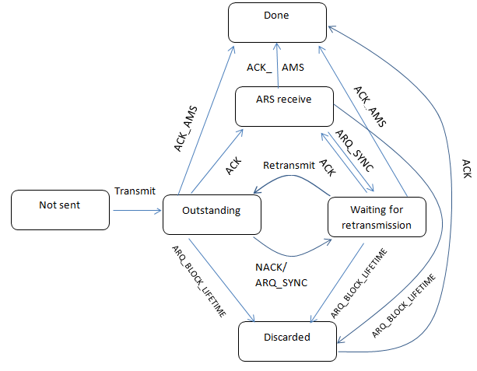

Figure xxx. ARQ transmitter state machine at ABS

16.6.2.8.3 ARQ feedback processing

The ARQ_TX_WINDOW_BEGIN is updated on reception of ARQ feedback IE of access link, in the same way as ARQ_TX_WINDOW_START in section 16.2.13.4.

-----------------------------------------End of the Text-----------------------------------------------

