Project | IEEE 802.16 Broadband Wireless Access Working Group <http://ieee802.org/16>
Title | Updates to DL/UL subchannelzation (D4 Draft -- Section 16.3.5 & 16.3.8)
Date Submitted | 2010-03-05
Source(s) | Jong-Kae (JK) Fwu, Tom Harel, Jonathan Kosloff, Hujun Yin,  Intel Corporation | E-mail: jong-kae.fwu@intel.com  *<http://standards.ieee.org/faqs/affiliationFAQ.html>
Re: | Change Request on 802.16m Draft Amendment, IEEE P802.16m/D4  Section 16.3.5 & 16.3.8
Abstract | This contribution corrects errors in the DL/UL permutation equations and figures.
Purpose | To be discussed and adopted by WG LB
Notice | This document does not represent the agreed views of the IEEE 802.16 Working Group or any of its subgroups. It represents only the views of the participants listed in the “Source(s)” field above. It is offered as a basis for discussion. It is not binding on the contributor(s), who reserve(s) the right to add, amend or withdraw material contained herein.
Release | The contributor grants a free, irrevocable license to the IEEE to incorporate material contained in this contribution, and any modifications thereof, in the creation of an IEEE Standards publication; to copyright in the IEEE’s name any IEEE Standards publication even though it may include portions of this contribution; and at the IEEE’s sole discretion to permit others to reproduce in whole or in part the resulting IEEE Standards publication. The contributor also acknowledges and accepts that this contribution may be made public by IEEE 802.16.
Patent Policy | The contributor is familiar with the IEEE-SA Patent Policy and Procedures:  <http://standards.ieee.org/guides/bylaws/sect6-7.html#6> and <http://standards.ieee.org/guides/opman/sect6.html#6.3>.  Further information is located at <http://standards.ieee.org/board/pat/pat-material.html> and <http://standards.ieee.org/board/pat>.
Updates to DL/UL subchannelzation (D4 Draft -- Section 16.3.5 & 16.3.8)

Jong-Kae (JK) Fwu, Tom Harel, Jonathan Kosloff, Hujun Yin
Intel Corporation

Introduction
There are some errors in the permutation equations of D4 draft, which were original proposed in IEEE C802.16m-09/2828 to fix a miniband diversity issue when most of the BW is used as subbands. The proposal proposes corrections to the equations and provides updated permutation figures for the next release of D5 draft. A separate FrameMaker format file is also provided in (C80216m-10_0045) for the editor to import those figures directly.

Proposed Text
----------------------------------------------------- Start of Proposed Text -----------------------------------------------------

============= << Text Change #1 >> =============
[Adopt the following changes in the section 16.3.5.2.1 on page 375 (line 42), equation 176 & 177 as shown below. The change is to replace K_{SB to (}N_{Sub -}K_{SB}) in the two equations]

============= << Text Change #2 >> =============
[Replace the permutation figure Fig 486 – Fig 490 in D4 draft with the following figures]
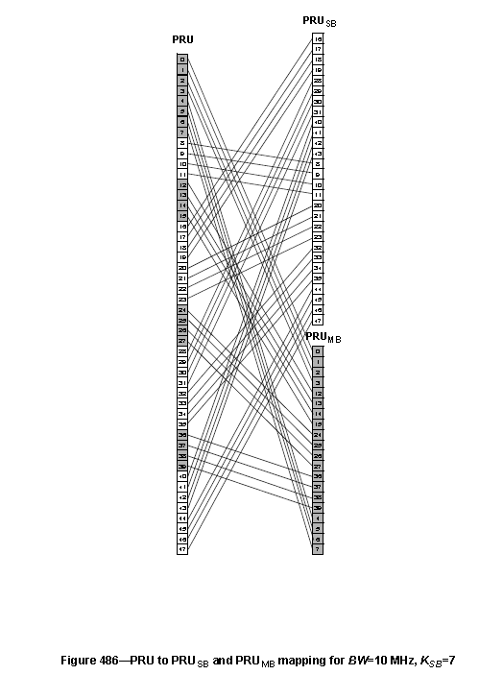

============= << Text Change #3 >> =============
[Adopt the following changes in the section 16.3.8.2.1 on page 580 (line 52), equation 252 & 253 as shown below. The change is to replace K_{SB to (}N_{Sub -}K_{SB}) in the two equations]

============= << Text Change #4 >> =============
[Replace the permutation figure Fig 539 – Fig 542 in D4 draft with the following figures]

------------------------------------------------------ End of Proposed Text ------------------------------------------------------

