Project | IEEE 802.16 Broadband Wireless Access Working Group <http://ieee802.org/16>
Title | Guard Band Usage in Frame structure supporting WirelessMAN-OFDMA with Multicarrier Operation (16.3.3.6.1)
Date Submitted | 2010-03-16
Source(s) | Jinyoung Chun, Jin Sam Kwak  LG Electronics | jiny.chun@lge.com  *<http://standards.ieee.org/faqs/affiliationFAQ.html>
Re: | IEEE 802.16 Working Group Letter Ballot Recirc #31
Abstract | This contribution provides the guard band usage in frame structure to support WirelessMAN-OFDMA with multicarrier operation.
Purpose | To be discussed and adopted by TGm for the 802.16m draft.
Notice | This document does not represent the agreed views of the IEEE 802.16 Working Group or any of its subgroups. It represents only the views of the participants listed in the “Source(s)” field above. It is offered as a basis for discussion. It is not binding on the contributor(s), who reserve(s) the right to add, amend or withdraw material contained herein.
Release | The contributor grants a free, irrevocable license to the IEEE to incorporate material contained in this contribution, and any modifications thereof, in the creation of an IEEE Standards publication; to copyright in the IEEE’s name any IEEE Standards publication even though it may include portions of this contribution; and at the IEEE’s sole discretion to permit others to reproduce in whole or in part the resulting IEEE Standards publication. The contributor also acknowledges and accepts that this contribution may be made public by IEEE 802.16.
Patent Policy | The contributor is familiar with the IEEE-SA Patent Policy and Procedures:  <http://standards.ieee.org/guides/bylaws/sect6-7.html#6> and <http://standards.ieee.org/guides/opman/sect6.html#6.3>.  Further information is located at <http://standards.ieee.org/board/pat/pat-material.html> and <http://standards.ieee.org/board/pat>.
Guard Band Usage in Frame structure supporting WirelessMAN-OFDMA with multicarrier operation (16.3.3.6.1)
Jinyoung Chun, Jin Sam Kwak
LG Electronics

- Introduction
In P802.16m/D4, there is some description about guard band usage in multicarrier operation. But when frame structure is supporting the WirelessMAN-OFDMA in PUSC zone by FDM manner, the guard band usage is unclear. Therefore I suggest the method of guard band usage.

- Problem statement
When frame structure is supporting the WirelessMAN-OFDMA in PUSC zone by FDM manner, the subframe consists of DLRUs. But it’s difficult to use the guard subcarriers in UL frame to support WirelessMAN-OFDMA PUSC FDM mode to DLRUs because PUSC tile permutation is not applied in the guard subcarriers. And it’s inefficient to apply new tile permutation rule to distribute the tiles made of guard subcarriers.

- Text proposal in the P802.16m/D4
Proposed text has been underlined in blue and deleted text has been struck through in red. Existing draft text is shown in black.

------------------------------------------------ Text Start -----------------------------------------------------------
[Add the text and modify the figure as below in line 14 of page 365]

When two adjacent carriers both contain AAI zone and WirelessMAN-OFDMA zone, the guard subcarriers in UL frame structure to support WirelessMAN-OFDMA PUSC FDM mode shall not be used.

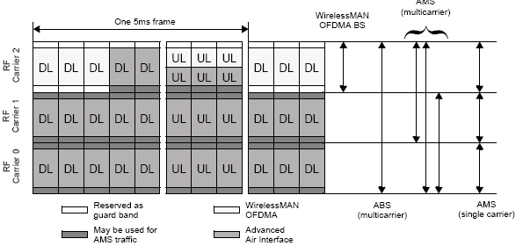

----------------------------------------------- Text End -----------------------------------------------------------

