Project | IEEE 802.16 Broadband Wireless Access Working Group <http://ieee802.org/16>
Title | Proposed Text for E-MBS dynamic multicast in Section 16.9
Date Submitted | 2010-03-05
Source(s) | Yongjoo Tcha and Kyung-ah Kim  KT | Email :  yjtcha@kt.com  kka1@kt.com
Re: | Contribution in support of a comment on P802.16m/D4 currently under LB#31
Abstract | This contribution defines the text and format for E-MBS dynamic Multicast support.
Purpose | For review and adoption by IEEE 802.16m TGm
Notice | This document does not represent the agreed views of the IEEE 802.16 Working Group or any of its subgroups. It represents only the views of the participants listed in the “Source(s)” field above. It is offered as a basis for discussion. It is not binding on the contributor(s), who reserve(s) the right to add, amend or withdraw material contained herein.
Release | The contributor grants a free, irrevocable license to the IEEE to incorporate material contained in this contribution, and any modifications thereof, in the creation of an IEEE Standards publication; to copyright in the IEEE’s name any IEEE Standards publication even though it may include portions of this contribution; and at the IEEE’s sole discretion to permit others to reproduce in whole or in part the resulting IEEE Standards publication. The contributor also acknowledges and accepts that this contribution may be made public by IEEE 802.16.
Patent Policy | The contributor is familiar with the IEEE-SA Patent Policy and Procedures:  <http://standards.ieee.org/guides/bylaws/sect6-7.html#6> and <http://standards.ieee.org/guides/opman/sect6.html#6.3>.  Further information is located at <http://standards.ieee.org/board/pat/pat-material.html> and <http://standards.ieee.org/board/pat>.

Proposed Text for E-MBS dynamic multicast in Section 16.9
Yongjoo Tcha and Kyung-ah Kim
KT

- Problem definition
In current E-MBS, the contents are always transmitted through one or more MBS connections that would have been pre-established prior to the user(s) join and leave a MBS session at one or more MBS zone. It is defined as Static multicast service by WiMAX Forum. The Static multicast has strong points for mobility and macro diversity gain. But it is not efficient to manage radio resource; because the radio resources for MBS are pre-allocated and are always transmitted over the air regardless of existence of MS in a cell.
Figure 1 shows the static multicasting with one MBS zone. All cells in the MBS zone transmit their MBS bursts even though the numbers of MBS users are small and they are distributed in 4 of total 24 cells.

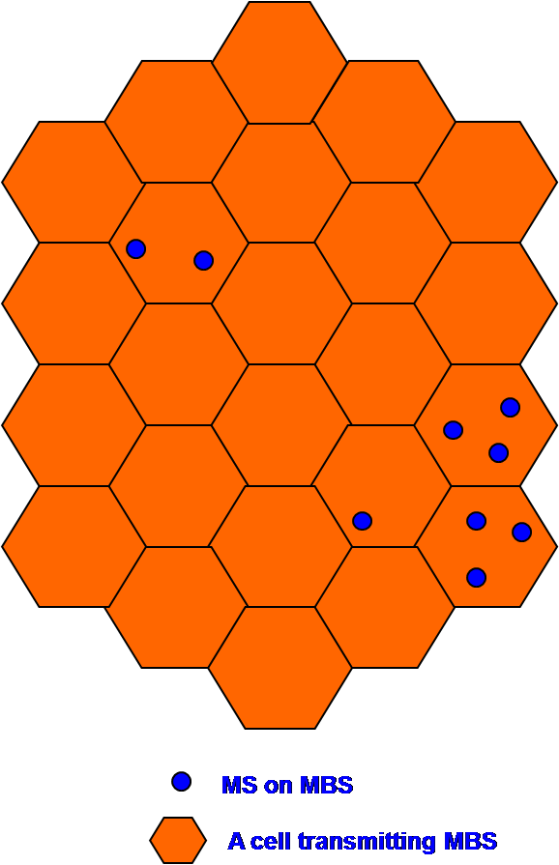
Figure 1 Example of static multicasting in an MBS zone

As compared with Static multicast, the contents are only transmitted through one or more MBS connections that would have been joined by the user(s) after user’s subscription at one or more MBS zone in Dynamic multicast environment. The Dynamic multicast has an advantage point for radio resource management for MBS. But it has some problems to support user’s mobility and macro-diversity among cells in an MBS zone. And in addition, inter cell interference might be happen if a neighbor cell does not transmit MBS bursts or allocates the MBS bursts to other unicast traffics. Figure 2 illustrates some problem in existing dynamic multicast service. Even though 4 cells out of total 24 cells transmit MBS bursts, it might be difficult to support mobility and macro diversity.
Therefore, some mechanism to solve the problems happening in dynamic multicast is needed.

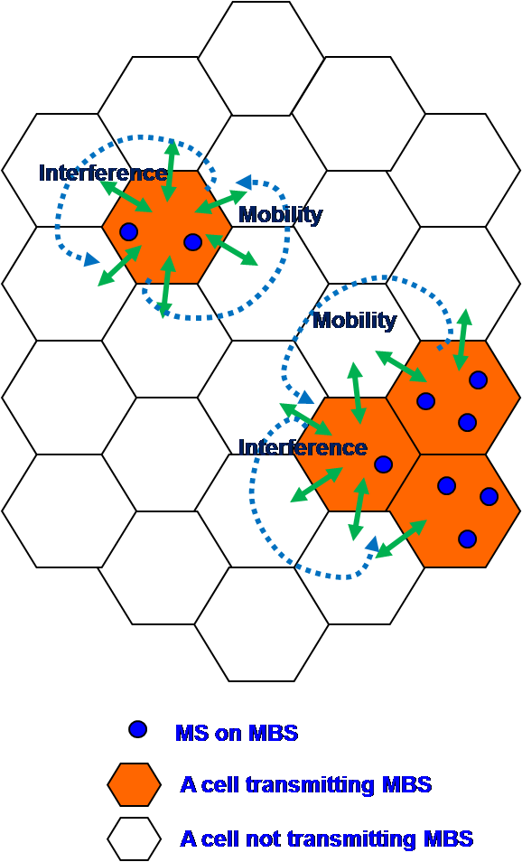
Figure 2 Example of existing dynamic multicasting in an MBS zone

- Dynamic multicast depending on MBS status of neighboring cells
In this contribution, we propose the dynamic multicasting method which a cell decides whether it’s transmitting MBS or not in accordance with the MBS status of its neighbor cells.
In traditional dynamic multicast, a BS that is transmitting MBS bursts monitors whether there are MSs receiving MBS in its cell or not. If there is no MS receiving MBS, the BS will stop transmitting MBS burst. But, in the proposed dynamic multicast, a BS that is transmitting MBS bursts monitors the existence of MS receiving MBS in its neighbor cells as well as in its own cell. Figure 3 is a state diagram for a BS that is transmitting MBS bursts. If there is no MS that is receiving MBS in its cell, then the BS has to check up the existence of MS in its neighbor cells before it stops MBS transmitting. If there is no MS in its neighbor cells regardless of transmitting MBS in neighbor cells, the BS and its neighbor BSs should broadcast the paging message to find out idle mode MSs that is receiving MBS. If there is no reply, the BS can stop its MBS burst and allocate the resource to unicast traffic in the cell.
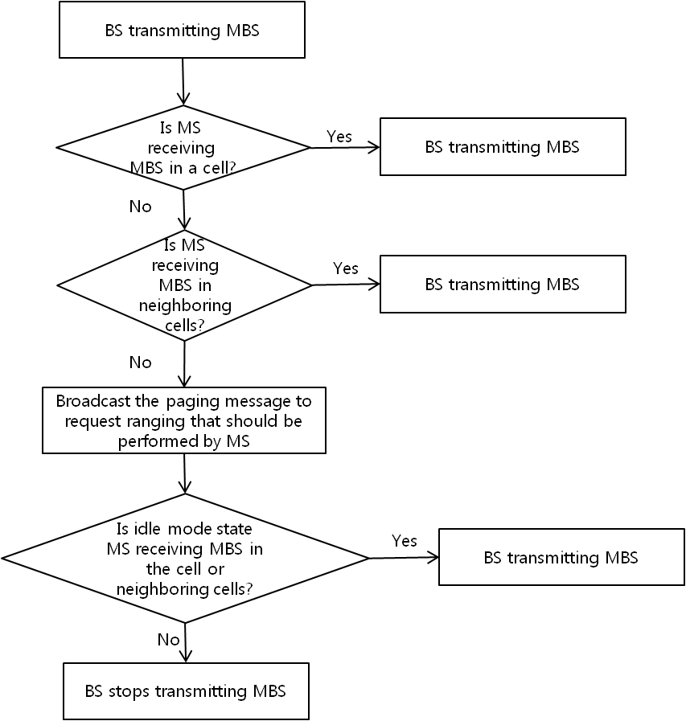
Figure 3 State Diagram of BS transmitting MBS

In case of BS that is not transmitting MBS, if there is an MS moving into one of its neighboring cells or an MS powering on in the cell, the BS has to re-start transmitting MBS burst immediately as Figure 4. To support Idle Mode, BS should broadcast the paging message to find out MS receiving MBS in idle mode state.

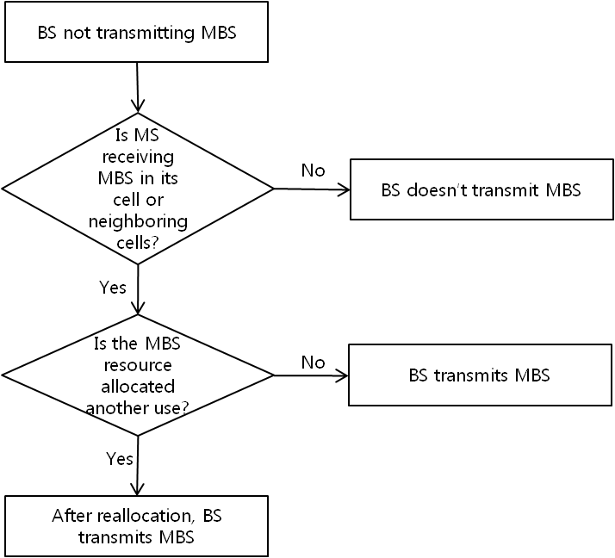
Figure 4 State Diagram of BS not transmitting MBS

Figure 5 illustrates the effect of proposed dynamic multicast.

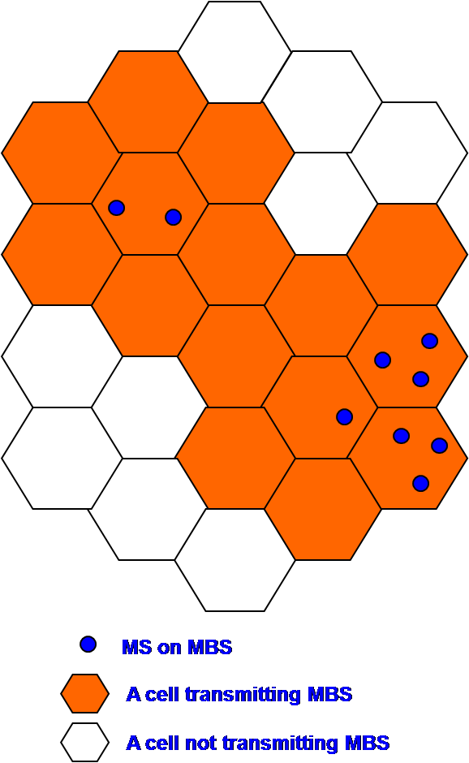
Figure 5 An example to illustrate proposed dynamic multicasting effect

We can save 9 cells out of total 24 cells (37.5%) using dynamic multicast considering neighbor cells’ service status. In addition to the effect of radio resource, the proposed dynamic multicast can support mobility and macro diversity like static multicast does. And there is no interference among cell edges within MBS zone also.

- Idle Mode support for the proposed dynamic multicast scheme
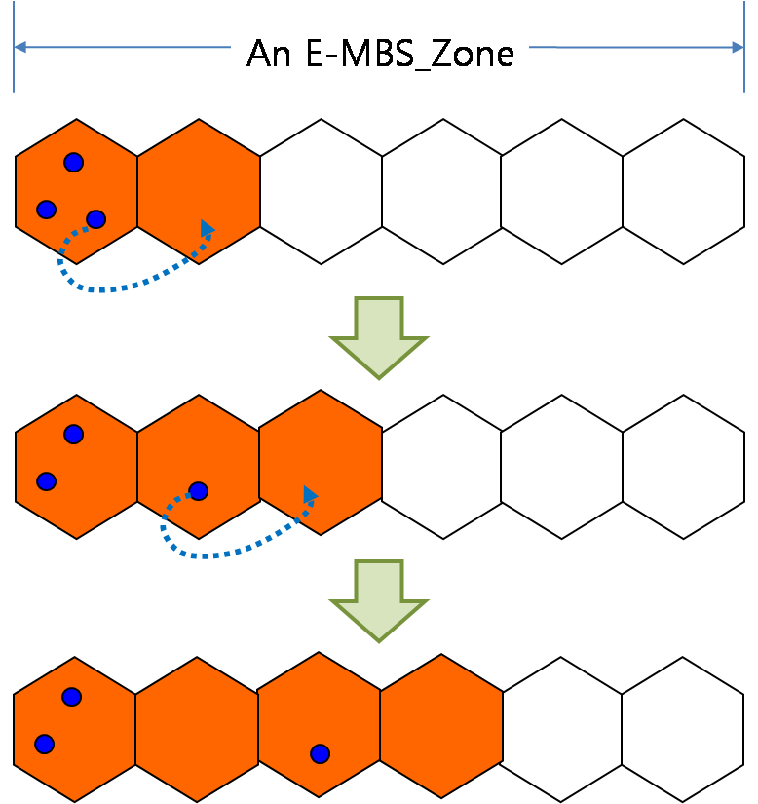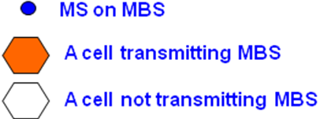
Figure 6. An illustration of ABS’s retransmitting E-MBS data by an MS moving into a cell

To allow seamless E-MBS service between one ABS transmitting E-MBS data and another ABS without transmitting E-MBS data, MS should perform location-update in order to let the neighbor ABS retransmit the E-MBS data.

To adopt the method, BS has to monitor the existence of MS for MBS in neighboring cells as well as in the cell. BS can also calculate the number of MS receiving MBS from handover or location update process in the cell and maintain it, but we suggest some messages to monitor;
MSTID and FID Mapping List in AAI_E-MBS-CFG_Message is modified to indicate what the neighbor ABS isn’t transmitting the E-MBS data.
Message to inform of MBS status to its neighbor BSs is performed through the backhaul network.

---------------------------------------------------- Proposed Text ------------------------------------------------

16.9 Support for Enhanced Multicast Broadcast Service

Enhanced Multicast and Broadcast Service (E-MBS) provides an efficient method for concurrent transport of DL data common to a group of users, using a common multicast STID (MSTID) and a FID. E-MBS service is offered in the downlink only and may be coordinated and synchronized among a group of ABS to allow macro-diversity.
Each multicast/broadcast connection is associated with a service flow provisioned with the QoS and traffic parameters for that service flow.
Service flows to carry E-MBS data are instantiated on individual AMSs participating in the service while in normal operation. During such instantiation the AMS learns the parameters that identify the service and associated service flows.
Each ABS capable of providing E-MBS belongs to a certain E-MBS Zone and one ABS can belong to multiple E-MBS zones. An E-MBS zone defined as a set of ABSs where the same MSTID and FID is used for transmitting the content of certain service flow(s). Each E-MBS Zone is identified by a unique E-MBS_Zone_ID.
To ensure proper multicast operation on networks of ABS employing E-MBS, the MSTIDs and FIDs used for common E-MBS content and service shall be the same for all ABSs within the same E-MBS Zone. This allows the AMS which has already registered with a service to be seamlessly synchronized with E-MBS transmissions within an E-MBS Zone without communicating in the UL or re-registering with other ABS within that E-MBS Zone. The E-MBS_Zone_IDs shall not be reused across any two adjacent E-MBS Zones.

Remedy 1
On the IEEE P802.16m/D4, Page 747 Line 31 add following texts: These texts moves from “16.9.1 E-MBS Transmission Modes” Page 747 Line 41
-----------------------------------------------------------Start of the Text---------------------------------------------------------
An ABS may provide the AMS with E-MBS content locally within its coverage and independently of other ABSs. The single ABS provision of E-MBS is therefore a configuration where an E-MBS Zone is configured to consist of a single ABS only. This configuration may be provided as one of the possible cases of E-MBS. In this case, the ABS may use any MSTID and FID for providing the E-MBS service, independently of other ABSs, so the AMS receives the E-MBS data from its serving ABS, and the AMS should not expect the service flow for this E-MBS connection to continue when the AMS leave the serving ABS. However, if the AMS moves to an ABS that is transmitting the same E-MBS flows in another E-MBS Zone and updates its Service Flow management encodings, the AMS may continue to receive the same E-MBS flows.
-------------------------------------------------------------End of the Text---------------------------------------------------------

16.9.1 E-MBS Transmission Modes
Continuous reception of E-MBS transmissions within an E-MBS Zone rely on some coordination among ABS's in that E-MBS Zone. Such coordination is applied to achieve frame level synchronization of E-MBS in non-macro diversity transmission mode or to achieve symbol level synchronization with macro diversity transmission mode as described below.

--------------Page 747 Line 41, remove following texts --------------------
An ABS may provide the AMS with E-MBS content locally within its coverage and independently of other ABSs. The single ABS provision of E-MBS is therefore a configuration where an E-MBS Zone is configured to consist of a single ABS only. This configuration may be provided as one of the possible cases of E-MBS. In this case, the ABS may use any MSTID and FID for providing the E-MBS service, independently of other ABSs, so the AMS receives the E-MBS data from its serving ABS, and the AMS should not expect the service flow for this E-MBS connection to continue when the AMS leave the serving ABS. However, if the AMS moves to an ABS that is transmitting the same E-MBS flows in another E-MBS Zone and updates its Service Flow management encodings, the AMS may continue to receive the same E-MBS flows.

16.9.2 E-MBS Operation
Remedy 2
On the IEEE P802.16m/D4, Page 749 Line 4 add following texts
-----------------------------------------------------------Start of the Text---------------------------------------------------------
The ABS may not transmit the E-MBS data when there is no AMS participating in the E-MBS connection in the coverage. The ABS may update the list of AMSs participating in the E-MBS connection by AAI_DSA, AAI_DSD, AAI_DREG, HO message transactions for Normal or Sleep Mode AMSs and E-MBS Location Update for Idle Mode AMS. The ABS shall transmit E-MBS MAP to provide available E-MBS information to the AMS entering from another ABS even if it does not transmit the E-MBS data.
In order to support mobility, some ABSs may be cooperated to transmit E-MBS data. The ABSs may be configured by the number of the AMSs. The messages among ABSs may be exchanged through the backhaul network. The messages and procedures are out of scope of this specification.
-------------------------------------------------------------End of the Text---------------------------------------------------------

16.9.2.1 E-MBS Connection Establishment
Remedy 3
On the IEEE P802.16m/D4, Page 750 Line 4 add following texts
-----------------------------------------------------------Start of the Text---------------------------------------------------------
In addition to allowing seamless transition from one E-MBS Zone to another without any interruption of E-MBS data service and operation, it is necessary to allow seamless transition from one ABS that is transmitting E-MBS data to another ABS that isn’t transmitting E-MBS data in case of dynamic multicast. If the AMS in the idle mode receives AAI_E-MBS-CFG_Message set ‘MSTID and FID of neighbor E-MBS Zones’ part of ‘MSTID and FID Mapping List’ to all ‘0’, then the AMS knows that the neighbor ABS isn’t transmitting multicast and broadcast service flow corresponding to MSTID and FID and is required to make the neighbor ABS start transmitting the E-MBS data by performing location-update.
-------------------------------------------------------------End of the Text---------------------------------------------------------

16.9.2.3 E-MBS Operation in Idle State
Remedy 4
On the IEEE P802.16m/D4, Page 750 Line 47 add following texts
-----------------------------------------------------------Start of the Text---------------------------------------------------------
When an AMS in Idle mode moves to an ABS which does not belongs to AMS' previous E-MBS Zone or receives AAI_E-MBS-CFG_Message set ‘MSTID and FID of neighbor E-MBS Zones’ part of ‘MSTID and FID Mapping List’ to all ‘0’, the AMS is expected to update the E-MBS service flow management encodings at that ABS to provide continuous reception of E-MBS content. The AMS may obtain the E-MBS information in the target E-MBS zone through broadcast messages in the E-MBS-Zone of the serving ABS. If the idle AMS has not received such information from the serving E-MBS Zone, the AMS shall use location update procedure to acquire updated E-MBS service flow management encodings. In order to perform the MBS location update process, the AMS shall transmit AAI_RNG-REQ message with Ranging Purpose Indication Bit # 4 set to 1. In response to the request for MBS location update, the ABS shall transmit AAI_RNG-RSP message which may include the E-MBS zone identifier, MSTID, FID, and E-MBS Zone Identifier Assignment parameter and etc. to provide update service flow management encodings for any affected E-MBS flow(s).
-------------------------------------------------------------End of the Text---------------------------------------------------------

16.9.3 E-MBS Protocol Features and Functions
16.9.3.1 E-MBS Configuration Indicators
Remedy 5
On the IEEE P802.16m/D4, Page 751 Line 20 add following texts to Table 949
-----------------------------------------------------------Start of the Text---------------------------------------------------------

Table 949—AAI_E-MBS-CFG_Message format

Syntax | Size (bits) | Notes
AAI-E-MBS-CFG_Message_Format() {
MAC Control Message Type | 8 | AAI_E-MBS-CFG
E-MBS_CFG_LIFETIME (m) | 4 | Indicates the duration of E-MBS_CFG_LIFETIME for which the E-MBS configuration information of the zone do not change.  Duration of E-MBS_CFG_LIFETIME:  16 (m+1) superframes
Zone_Allocation Bit-MAP | variable | Indicates the zone configuration. The size is as below.  20 bits for 20 MHz  9 bits for 10MHz  3 bits for 5 MHz
ZF | 1 | Zone Flag bit. Indicates the use of the last zone.  0b0: Unicast  0b1: E-MBS
for (i = 0; i< Num_E-MBS_Zones; i++) {
E-MBS_Zone_ID | 7 | The E-MBS_Zone_ID to which this E-MBS MAP applies.
MSI Length (N_{MSI}) | 2 | The length of an MSI in units of the number of superframes  0b00: 2 superframes, 40 ms (N_{MSI} = 2)  0b01: 4 superframes, 80 ms (N_{MSI} = 4)  0b10: 8 superframes, 160 ms (N_{MSI} = 8)  0b11: 16 superframes, 320 ms (N_{MSI} = 16)
E-MBS MAP Resource Index | 11 | Resource index includes location and allocation size.
E-MBS MAP ISizeOffset | 5
MSTID and FID Mapping List inclusion | 1 | Indicates whether MSTID and FID Mapping list is included or not  0b0: No Zone boundary or Zone boundary but no inter-zone service continuity in neighbor ABS  0b1: No Zone boundary and no AMS receiving E-MBS data or Zone boundary and inter-zone service continuity
if (MSTID and FID Mapping List inclusion == 1) {
MSTID and FID Mapping List | variable | MSTID and FID Mappings List between serving and neighbor E-MBS Zones.  For support Dynamic Multicast, if MSTID and FID of neighbor E-MBS Zones set all ‘0’, it means that the neighbor ABS isn’t transmitting the E-MBS data corresponding to the MSTID and FID.
}
}
}
-------------------------------------------------------------End of the Text---------------------------------------------------------

