Project | IEEE 802.16 Broadband Wireless Access Working Group <http://ieee802.org/16>
Title | ABS-Initiated Sleep Mode and Idle Mode (16.2.16)
Date Submitted | 2010-03-05
Source(s) | Ming-Hung Tao, Ying-Chuan Hsiao  ITRI | Voice: +886-3-5914629  E-mail: MHTao@itri.org.tw
Re: | Category: LB31 / Area: Chapter 16.2.16 (Sleep Mode)
Abstract | This contribution proposes changes to the Section 16.2.16 of IEEE P802.16m/D4
Purpose | To be discussed and adopted by TGm
Notice | This document does not represent the agreed views of the IEEE 802.16 Working Group or any of its subgroups. It represents only the views of the participants listed in the “Source(s)” field above. It is offered as a basis for discussion. It is not binding on the contributor(s), who reserve(s) the right to add, amend or withdraw material contained herein.
Release | The contributor grants a free, irrevocable license to the IEEE to incorporate material contained in this contribution, and any modifications thereof, in the creation of an IEEE Standards publication; to copyright in the IEEE’s name any IEEE Standards publication even though it may include portions of this contribution; and at the IEEE’s sole discretion to permit others to reproduce in whole or in part the resulting IEEE Standards publication. The contributor also acknowledges and accepts that this contribution may be made public by IEEE 802.16.
Patent Policy | The contributor is familiar with the IEEE-SA Patent Policy and Procedures:  <http://standards.ieee.org/guides/bylaws/sect6-7.html#6> and <http://standards.ieee.org/guides/opman/sect6.html#6.3>.  Further information is located at <http://standards.ieee.org/board/pat/pat-material.html> and <http://standards.ieee.org/board/pat>.

ABS-Initiated Sleep Mode and Idle Mode (16.2.16)

Ming-Hung Tao, Ying-Chuan Hsiao
ITRI

- Introduction

Either Sleep Mode or Idle Mode can be initiated by the ABS or AMS. In case of the mode initiation is triggered by the AMS, the different design for each AMS will raise the fairness issue and may result in huge amounts of request overheads (the AMS may frequently request to enter Sleep/Idle Mode without considering the system capacity or the request cost). It may have many advantages if entering Sleep/Idle Mode is initiated by the ABS, since ABS is able to make decision from all aspects. By this way, lots of unnecessary attempts for entering the Sleep/Idle Mode can be avoided. In this contribution, we suggest that Sleep/Idle Mode initiation should be mainly triggered by the ABS, and the AMS should provide at least its battery level information to the ABS to facilitate Sleep/Idle Mode initiation.

We compared the performance of ABS-initiated mode transition (with battery level report) and AMS-initiated mode transition (without battery level report) in terms of control overheads. The results are shown in Figure 1 and Figure 2. We can observe that the unicast cost for the AMS-initiated mode transition is extremely high, this high cost is the result of having too many unsuccessful idle/sleep mode request attempts generated by AMSs.

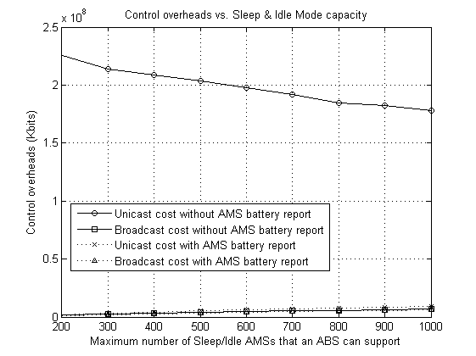
Figure 1. Control overheads comparison.

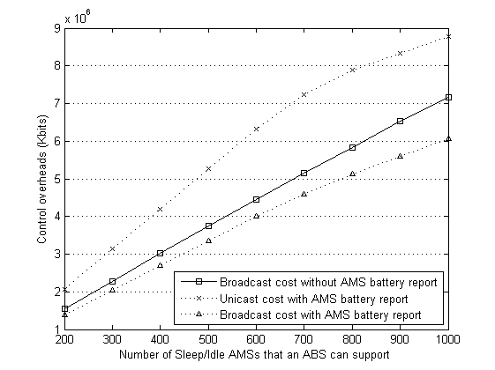
Figure 2. Control overheads comparison (parts of Figure 1).

In addition, AMS lifetime distributions are also recorded and shown in Table 2. We can observe that the diversity of AMS lifetime in ABS-initiated mode transition is smaller than the diversity in AMS-initiated mode transition, which means the AMS applied in the ABS-initiated mode transition system can have more predictable lifetime.

Table 2. Mobile client lifetime distributions.
 | Maximum number of clients allowed in Sleep (Idle) Mode
 | MS-initiated Mode Transition |  |  | BS-initiated Mode Transition
MS lifetime (hrs) | 200 | 500 | 800 | 200 | 500 | 800
< 16.67 hrs | 0 | 0 | 0 | 0 | 0 | 0
16.67~18 hrs | 101 | 0 | 0 | 5 | 0 | 0
18~19.44 hrs | 9377 | 0 | 0 | 10854 | 0 | 0
19.44~20.83 hrs | 2105 | 6 | 0 | 932 | 22 | 0
20.83~22.22 hrs | 309 | 6117 | 0 | 0 | 10179 | 0
22.22~23.61 hrs | 0 | 3642 | 0 | 0 | 598 | 646
23.61~25 hrs | 0 | 715 | 6858 | 0 | 481 | 8722
25~26.39 hrs | 0 | 444 | 1614 | 0 | 81 | 469
26.39~27.78 hrs | 0 | 133 | 723 | 0 | 0 | 489
27.78~29.17 hrs | 0 | 0 | 416 | 0 | 0 | 335
29.17~30.56 hrs | 0 | 0 | 405 | 0 | 0 | 0
30.56~31.94 hrs | 0 | 0 | 326 | 0 | 0 | 0

In conclusions, ABS-initiated mode transition mechanism has the following advantages.
- This mechanism can avoid unnecessary attempts of Sleep/Idle Mode Request made by AMSs.
- This mechanism can help the ABS to adjust the Sleep/Idle Mode parameters for an AMS.
- The implementation cost for the AMS decreases because the ABS-initiated mechanism allows the AMS being designed without implementing the triggers for entering either Sleep Mode or Idle Mode.
- The AMS will have more predictable lifetime.

- Proposed Text for IEEE P802.16m/D4
================================= Remedy 1 =======================================
[Accept the following modifications marked in blue from line 64 on page 298.]

16.2.16 Sleep Mode

16.2.16.1 Sleep Mode Initiation

The AMS may initiate the negotiation by sending an AAI_SLP-REQ message and shall expect an AAI_SLP-RSP message from the serving ABS in response. Alternatively, the ABS may initiate the negotiation by sending an unsolicited AAI_SLP-RSP message to the AMS. In this case, the ABS should request the AMS to send acknowledgment(i.e., AAI_MSG-ACK) to the AAI_SLP-RSP. If an AMS is able to report its detailed battery level, the AMS shall enter Sleep Mode through only ABS-initiated procedure.

[Accept the following modifications marked in blue from line 56 on page 308.]

16.2.17 Idle Mode

16.2.17.1.2 ABS initiated

Using ABS initiated idle mode entry, a serving ABS may signal for an AMS to begin idle mode by sending an AAI_DREG-RSP message with action code 0x05 in unsolicited manner. This unsolicited AAI_DREG-RSP may include REQ-Duration TLV. When an AMS receives an unsolicited AAI_DREG-RSP without REQ_Duration TLV, the AMS shall immediately start the idle mode initiation procedures. If an AMS is able to report its detailed battery level, the AMS shall enter Idle Mode through only ABS-initiated procedure.

References
- IEEE P802.16m/D4. DRAFT Amendment to IEEE Standard for Local and metropolitan area networks—Part 16: Air Interface for Broadband Wireless Access Systems—Advanced Air Interface, Feb 2010.
- IEEE 802.16m-08/0034r2. IEEE 802.16m System Description Document, Sep 2009.
- IEEE 802.16m-07/002r9. IEEE 802.16m System Requirements Document, Sep 2009.

