Project | IEEE 802.16 Broadband Wireless Access Working Group <http://ieee802.org/16>
Title | Support of Resource Scheduling across Frequency Partitions
Date Submitted | 2010-03-5
Source(s) | Yanfeng Guan, Ding Ning, Xianming Chen, Bo Sun, Huiying Fang  ZTE Corporation | guan.yanfeng@zte.com.cn
Re: | Comment on “DRAFT Amendment to IEEE Standard for Local and metropolitan area networks, P802.16m/D4”  16.3.6.5.2.4.1 DL Basic Assignment A-MAP IE
Abstract | The contribution proposes modification to resource indexing in the DL Basic Assignment A-MAP IE (16.3.6.5.2.4.1)
Purpose | To be discussed and adopted by TGm for the 802.16m amendment.
Notice | This document does not represent the agreed views of the IEEE 802.16 Working Group or any of its subgroups. It represents only the views of the participants listed in the “Source(s)” field above. It is offered as a basis for discussion. It is not binding on the contributor(s), who reserve(s) the right to add, amend or withdraw material contained herein.
Release | The contributor grants a free, irrevocable license to the IEEE to incorporate material contained in this contribution, and any modifications thereof, in the creation of an IEEE Standards publication; to copyright in the IEEE’s name any IEEE Standards publication even though it may include portions of this contribution; and at the IEEE’s sole discretion to permit others to reproduce in whole or in part the resulting IEEE Standards publication. The contributor also acknowledges and accepts that this contribution may be made public by IEEE 802.16.
Patent Policy | The contributor is familiar with the IEEE-SA Patent Policy and Procedures:  <http://standards.ieee.org/guides/bylaws/sect6-7.html#6> and <http://standards.ieee.org/guides/opman/sect6.html#6.3>.  Further information is located at <http://standards.ieee.org/board/pat/pat-material.html> and <http://standards.ieee.org/board/pat>.
Support of Resource Scheduling across Frequency Partitions
Yanfeng Guan, Ding Ning, Xianming Chen, Bo Sun, Huiying Fang
ZTE Corporation

- Introduction
In current 802.16m D4, DL/UL Basic Assignment A-MAP IEs are designed to support the contiguous logical resource allocation. The allocated resource location and number are indicated by the “Resource Index” field.

- Problem

2.1) Resource Indexing in Basic Assignment A-MAP IE
RI (Resource Index) field indicates the location and size of one instance of a resource allocation for an AMS. Although some good design considerations in [2] were taken into account, but there are still some other issues needed to be considered.
For RA field in DL/UL Basic Assignment A-MAP IEs, the pre-processing is derivation of the mapping between LRU index and physical PRU index. Mapping CRU/DRU to LRU is defined as:

Obviously, the derivate LRU index is according to the order of the Frequency Partition Number, not the SLRU, NLRU and DLRU, as a result of that, all the same type of logical resource units (for example DLRU) are non-contiguous in logical index, and then some restrictions on ABS scheduler will be present.
1) The system can’t assign the DLRUs or NLRUs across mutiple frequency partitions, especially for two deboosted frequency partitions. However, scheduling LRUs across frequency partitions is possible and important in some cases.
The following figure in D4 is a general instance for the downlink resource mapping.
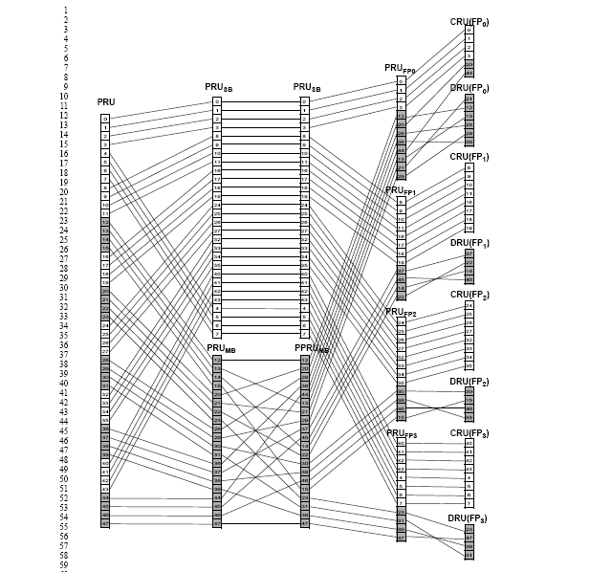
Figure Frequency Partition for 10MHz System

For 4 frequency partitions, each frequency partition maybe has different transmission power. Assuming that FP0 is Reuse 1 Region and FP1 is high boosted Reuse 3 Region, the power used in FP2 is same or similar to FP3 because both they are low boosted Reuse 3 Regions. For a given AMS which has registered in Cell 1, the CQIs on FP2 and FP3 sometimes are same or similar, and the resources in FP2 and FP3 can be used together in principle.In addition, although FP0 and FP1 has different transmission power, the interference from other BSs may also be different in some cases. AMS still has some possibility to use the resources in FP0 and FP1.
Figure 2 The Basic Concept of Frequency Partition Reuse.
However, ABS can’t assign the resources (for example DLRUs) in FP2 and FP3 or FP0 and FP1 simultaneously in one Basic Assignment A-MAP IE because the resource index in the fields indexing method only supports the contiguous allocation by the Basic Assignment A-MAP IE. So the function of Resource Indexing has to support using one kind of resources across mutiple frequency partitions.
This problem is not only a special case, actually, it will be present for many resource mapping configurations in DL/UL Resource Mapping Configurations.

2）To use DLRUs, NLRUs and CLRUs together in same one FP is not possible and necessary.
Since the MIMO mode of DLRUs, NLRUs and CLRUs are different, the CQI feedback is seriously inaccurate if we use one kind of MIMO mode for both DLRUs and CLRUs. It is hard to use DLRUs, NLRUs and CLRUs together even in one Frequency partition. So the function of Resource Indexing in Basic Assignment A-MAP IE do not have to support using the all kinds of resources in one frequency partition.

In this contribution, we propose to modify the preprocess for Resource Indexing in the DL/UL Basic Assignment A-MAP IE.

- References
[1] "DRAFT Amendment to IEEE Standard for Local and metropolitan area networks Part 16: Air Interface for Broadband Wireless Access Systems Advanced Air Interface", P802.16m/D4 Feb 2010.
[2] IEEE 802.16m-07/002r8, “IEEE 802.16m System Requirements Document”
[3] IEEE 802.16m-08/003r7, “IEEE 802.16m System Description Document”
[4] IEEE 802.16m-08/043, “Style guide for writing the IEEE 802.16m amendment”
[5] IEEE 802.16m-09/1327r1, “Proposed Changes to the DL and UL A-MAP Information Element Types in AWD ”
[6] IEEE 802.16m-09/1331r2, “Proposed AWD text specifying the “Resource Allocation” field in the A-MAP IEs AWD ”
[7] IEEE 802.16m-09/1334r1, “AWD Proposal for DL/UL Resource Indexing in IEEE 802.16m ”
[8] IEEE 802.16m-09/1516 “Proposed Resource Allocation” Field in Basic Assignment A-MAP IE in IEEE802.16m ”
[9] IEEE 802.16m-09/1814r1 “Proposed Resource Allocation” Field in Assignment A-MAP IE in IEEE802.16m ”
[10] IEEE 802.16m-09/2814r3 “Proposed Modification on Resource Indexing in the DL Basic Assignment A-MAP IE in P802.16m/D3 (16.3.6.5.2.4.1) ”

- Proposed Text
Proposed Text for Remedy 1:
Modify “Derivation of the mapping between LRU index and physical PRU index” part on page 465 line 31 in the 16.3.6.5.2.4.1 DL basic assignment A-MAP IE as followed:
----------------------------------------------------- Proposed Text Starts --------------------------------------------------

For each frequency partition i, TC_{LRU, i} , the total number of CLRUs & DLRUs up to and including that partition is calculated as
(221)

(222)

(221)
(221a)
(221b)
(221c)
(221d)
(221e)

(222)
with

------------------------------------------------------ Proposed Text Ends --------------------------------------------------

