Project | IEEE 802.16 Broadband Wireless Access Working Group <http://ieee802.org/16>
Title | Proposed Text for Pilot Boosting Level of SFBCH (16.3.9.2.1.2)
Date Submitted | 2010-03-05
Source(s) | Min-Ho Jang, Hwasun Yoo, Heewon Kang  Samsung Electronics Co., Ltd. | minho78.jang@samsung.com  hwasun.yoo@samsung.com hkang@samsung.com
Re: | IEEE 802.16-10/0011, “IEEE 802.16 Working Group Letter Ballot#31”  Target topic: “IEEE P802.16m/D4, section 16.3.9.2.1.2”.
Abstract | The contribution proposes the text changes to Pilot Boosting Level of SFBCH of the 802.16m draft amendment, IEEE P802.16m/D4.
Purpose | To be discussed and adopted by TGm for the 802.16m amendment.
Notice | This document does not represent the agreed views of the IEEE 802.16 Working Group or any of its subgroups. It represents only the views of the participants listed in the “Source(s)” field above. It is offered as a basis for discussion. It is not binding on the contributor(s), who reserve(s) the right to add, amend or withdraw material contained herein.
Release | The contributor grants a free, irrevocable license to the IEEE to incorporate material contained in this contribution, and any modifications thereof, in the creation of an IEEE Standards publication; to copyright in the IEEE’s name any IEEE Standards publication even though it may include portions of this contribution; and at the IEEE’s sole discretion to permit others to reproduce in whole or in part the resulting IEEE Standards publication. The contributor also acknowledges and accepts that this contribution may be made public by IEEE 802.16.
Patent Policy | The contributor is familiar with the IEEE-SA Patent Policy and Procedures:  <http://standards.ieee.org/guides/bylaws/sect6-7.html#6> and <http://standards.ieee.org/guides/opman/sect6.html#6.3>.  Further information is located at <http://standards.ieee.org/board/pat/pat-material.html> and <http://standards.ieee.org/board/pat>.
Proposed Text for Pilot Boosting Level of SFBCH (16.3.9.2.1.2)

Min-Ho Jang, Hwasun Yoo, and Heewon Kang
Samsung Electronics Co., Ltd.

- Introduction
The contribution proposes the text clean-up on pilot boosting level of secondary fast feedback channel. In current draft, there is no description of pilot boosting level of SFBCH. This contribution proposes the 3dB pilot boosting based on simulation results. Simulation results show that there is little performance gain more than 3dB pilot boosting.

- Text proposal
--------------------------------------------------- Text Start ---------------------------------------------------
[Remedy: Modify the text on page 618 line 28-30 as following text]
The SFBCH is comprised of 3 distributed FMTs with 2 pilots allocated in each FMT. Pilot sequence are modulated as [1 1 1 1 1 1] with 3dB pilot boosting.

--------------------------------------------------- Text end ---------------------------------------------------

- Appendix

Simulation conditions
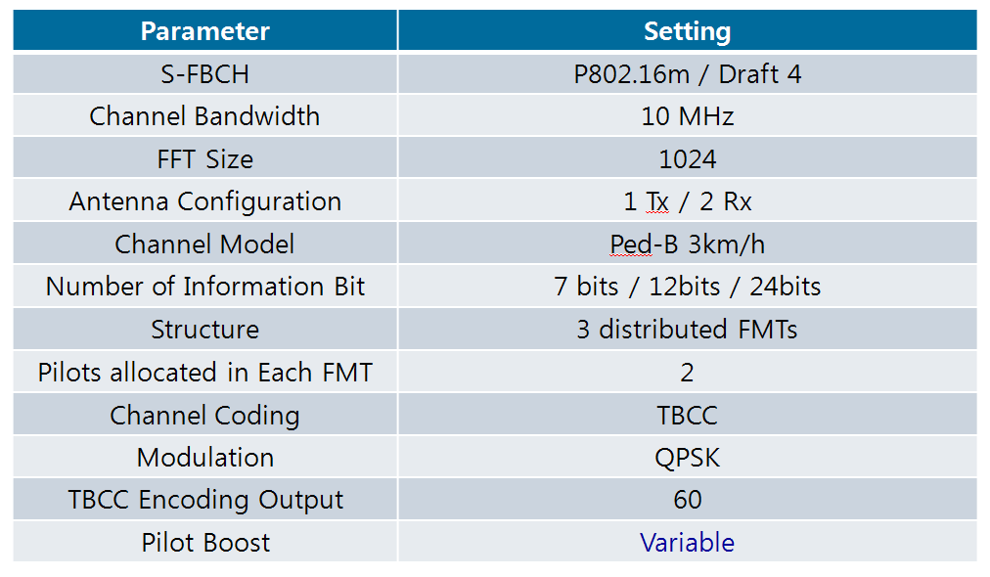

Simulation results

