Project | IEEE 802.16 Broadband Wireless Access Working Group <http://ieee802.org/16>
Title | CSG cell type change in Femto ABS (16.4.11)
Date Submitted | 2010-03-05
Source(s) | Jin Lee, Kiseon Ryu, Ronny Yongho Kim, Youngsoo Yuk, JinSam Kwak  LG Electronics, Inc. | +82-31-450-2067  [jins978, ksryu, ronnykim, sixs, samji] @lge.com  *<http://standards.ieee.org/faqs/affiliationFAQ.html>
Re: | IEEE 802.16 Working Group Letter Ballot #31
Abstract | This contribution is to clarify CSG cell type change for interference mitigation.
Purpose | Update P802.16m/D4 by discussion and adoption
Notice | This document does not represent the agreed views of the IEEE 802.16 Working Group or any of its subgroups. It represents only the views of the participants listed in the “Source(s)” field above. It is offered as a basis for discussion. It is not binding on the contributor(s), who reserve(s) the right to add, amend or withdraw material contained herein.
Release | The contributor grants a free, irrevocable license to the IEEE to incorporate material contained in this contribution, and any modifications thereof, in the creation of an IEEE Standards publication; to copyright in the IEEE’s name any IEEE Standards publication even though it may include portions of this contribution; and at the IEEE’s sole discretion to permit others to reproduce in whole or in part the resulting IEEE Standards publication. The contributor also acknowledges and accepts that this contribution may be made public by IEEE 802.16.
Patent Policy | The contributor is familiar with the IEEE-SA Patent Policy and Procedures:  <http://standards.ieee.org/guides/bylaws/sect6-7.html#6> and <http://standards.ieee.org/guides/opman/sect6.html#6.3>.  Further information is located at <http://standards.ieee.org/board/pat/pat-material.html> and <http://standards.ieee.org/board/pat>.

CSG cell type change in Femto ABS (16.4.11)
Jin Lee, Kiseon Ryu, Ronny Yongho Kim, Youngsoo Yuk, Jin Sam Kwak
LG Electronics, Inc.

- Introduction

The current draft defines that CSG-Closed Femto ABS may convert to a CSG-Open Femto ABS temporarily for IM. To do so, AMS should send ‘Femto Interference’ indication via AAI_RNG-REQ to the CSG-Closed Femto ABS regardless of its membership or AMS may report the result of channel measurement to overlay macro ABS if the AMS is connected to the overlay macro ABS. For a latter case, the macro ABS is able to recommend for CSG-Closed Femto ABS to convert into a CSG-Open Femto ABS upon receiving the measurement report (i.e. The AMS notifies the overlay macro ABS of interference level by the measurement report). However, D4 does not clearly describe the aforementioned contexts.

- Coordination between overlay macro ABS and CSG-Closed Femto ABS for IM

Case A : connection to overlay macro ABS

Case B : no connection to overlay macro ABS/Femto ABS

In case of A, AMS may send the result of signal strength measurement to overlay macro ABS and the macro ABS may direct Femto ABS to mitigate interference

In case of B, AMS may send “Femto Interference” indication to the CSG-Closed Femto ABS

Upon receiving the aforementioned signal, the CSG-Closed Femto ABS may perform the following procedures
- Reducing transmission power and/or,
- Blocking resource regions and/or,
- Converting to a CSG-Open Femto ABS
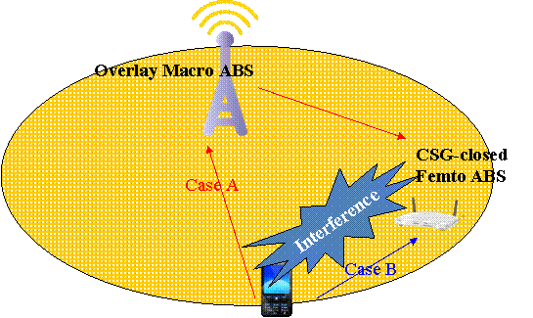

- Proposed Texts
---------------------------------------------------------------Text Start ----------------------------------------------------------
Remedy 1 :
[Modify texts as suggested below: Page 704, Line 9]

An AMS may initiate or be requested to report the signal strength measurement of its neighbor ABSs to its serving ABS. The reported information can be used by the serving ABS to coordinate interference mitigation (e.g., reducing transmission power and/or blocking resource regions and/or converting CSG-Closed Femto ABS to CSG-Open Femto ABS) with its neighbor ABSs.

Remedy 2 :
[Modify texts as suggested below: Page 704, Line 14]

If an AMS is placed into outage by a CSG-closed Femto ABS of which it is not a member and only if the AMS has no connection with neighbor macro ABS, it can may indicate this problem to that Femto ABS by sending an AAI_RNG-REQ with the “Femto Interference” bit set to 1 based on configured trigger conditions.

If the AMS is connected to macro ABS and the AMS is interfered by a CSG-Closed Femto ABS where it is not a member, it may indicate this problem to the macro ABS by reporting the signal strength measurement of its neighbor ABSs

Remedy 3 :
[Delete texts as suggested below (Duplicate): Page 704, Line 43]

AMS sends AAI_RNG-REQ with the “Femto Interference” bit set to 1 based on configured trigger conditions.

Remedy 4 :
[Delete texts as suggested below: Page 704, Line 47]

Upon CSG-Closed Femto ABS receiving an AAI_RNG-REQ with the “Femto Interference” bit set to 1 or receiving the interference notification sent by the overlay macro ABS , it may either reduce its transmit power locally or communicate with the network entity

---------------------------------------------------------------Text End -----------------------------------------------------------

