Project | IEEE 802.16 Broadband Wireless Access Working Group <http://ieee802.org/16>
Title | Proposed Text on Power Control of Initial Network Entry/Reentry (16.3.9.4)
Date Submitted | 2010-03-05
Source(s) | Dongcheol Kim, Wookbong Lee, Jin Sam Kwak, HanGyu Cho  LG Electronics | Voice : +82-31-450-7919  E-mail: dongcheol.kim@lge.com,wookbong.lee@lge.com
Re: | Call for LB #31 on “ P802.16m/D4”  Proposed text to P802.16m/D4
Abstract | This contribution includes proposed text on 16m power control of initial network entry/reentry.
Purpose | For member’s review and adoption into P802.16m D5 Draft
Notice | This document does not represent the agreed views of the IEEE 802.16 Working Group or any of its subgroups. It represents only the views of the participants listed in the “Source(s)” field above. It is offered as a basis for discussion. It is not binding on the contributor(s), who reserve(s) the right to add, amend or withdraw material contained herein.
Release | The contributor grants a free, irrevocable license to the IEEE to incorporate material contained in this contribution, and any modifications thereof, in the creation of an IEEE Standards publication; to copyright in the IEEE’s name any IEEE Standards publication even though it may include portions of this contribution; and at the IEEE’s sole discretion to permit others to reproduce in whole or in part the resulting IEEE Standards publication. The contributor also acknowledges and accepts that this contribution may be made public by IEEE 802.16.
Patent Policy | The contributor is familiar with the IEEE-SA Patent Policy and Procedures:  <http://standards.ieee.org/guides/bylaws/sect6-7.html#6> and <http://standards.ieee.org/guides/opman/sect6.html#6.3>.  Further information is located at <http://standards.ieee.org/board/pat/pat-material.html> and <http://standards.ieee.org/board/pat>.
Proposed Text on Power Control of Initial Network Entry/Reentry (16.3.9.4)
Dongcheol Kim, Wookbong Lee, Jin Sam Kwak, HanGyu Cho
LG Electronics

Introduction
In the current power control section in IEEE 802.16m/D4, power control mechanism during initial entry is unclear. This contribution tries to address this issue based on the following observations and design consideration points:

- During initial network entry, an AMS needs to transmit UL MAC control message such as AAI_RNG-REQ, AAI_SBC-REQ, and AAI_REG-REQ. Also, an AMS may transmit UL control channels such as HARQ and Bandwidth request channel during initial network entry. Please refer to the Fig. 1 for more details.
- During initial network entry, AMS may not receive the power control-related parameters transmitted in AAI_SCD message, AAI_UL Noise and Interference Level Broadcast Message, and S-SFH SP3 IE within the time requirement for initial network entry.
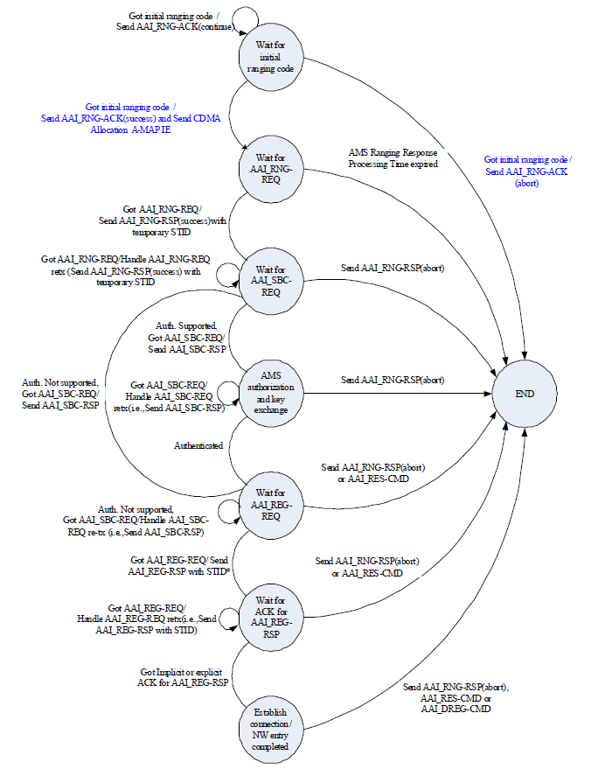

Fig. 1-State machine of the ABS for the initial NW entry process

References
[1] IEEE P802.16m/D4, “Draft Amendment to IEEE Standard for Local and metropolitan area network: Air Interface for Fixed and Mobile Broadband Wireless Access Systems”.

Text proposal
Instruction to editor;
Black text: existing D4 text
Red and strike out text: for deletion
Blue and underline text: for addition
Remedy #1. Line 15, page 659, include following texts;
============================== Start of Proposed Text #1 =============================

For initial network entry and reentry , after AMS got CDMA Allocation A-MAP IE, the transmit power level for data channel shall be calculated by
P_{DATA} (dBm) = P_{last_RANGING}+delta_power_data (xx1)
And the transmit power level for control channel shall be calculated by
P_{CONTROL} (dBm) = P_{last_ RANGING} +delta_power_control (xx2)
Where d P_{last_ RANGING} is latest Ranging channel’s power level. And delta_power_data and delta_power_control are transmitted via CDMA Allocation A-MAP IE.

If AMS got AAI_UL_POWER_ADJUST message masked by temporary STID or STID, then the transmit power level shall be calculated by
P_{DATA} (dBm) = P_{last,} _{DATA} +Offset_{Data} (xx3)
And the transmit power level for control channel shall be calculated by
P_{CONTROL} (dBm) = P_{last,} _{Control} +Offset_{Control} (xx4)
Where Offset_{Data} and Offset_{Control} are transmitted via AAI_UL_POWER_ADJUST message.

After AMS decodes AAI_SCD and AAI_NI message successfully, then the transmit power level shall be determined by equation (287) with zero Offset_{Data} and Offset_{Control}.

============================== End of Proposed Text #1 ===============================

Remedy #2. Line 16, page 504, modify table as follows;
============================== Start of Proposed Text #2 =============================
delta_power_data | 6 | delta_power_data is the transmit power adjustment value transmitted by the ABS. It has 6bits to represent the value among -15.5 to 16dB with 0.5dB step.
delta_power_control | 6 | delta_power_control is the transmit power adjustment value transmitted by the ABS. It has 6bits to represent the value among -15.5 to 16dB with 0.5dB step.
Reserved | 153 | Reserved bits

============================== End of Proposed Text =================================

