Project | IEEE 802.16 Broadband Wireless Access Working Group <http://ieee802.org/16>
Title | Proposed Text on the UL FFR Section(16.2.20.2)
Date Submitted | 2010-03-05
Source(s) | Dongcheol Kim, Jinyoung Chun, Wookbong Lee, Jin Sam Kwak, HanGyu Cho  LG Electronics | Voice : +82-31-450-7919  E-mail: dongcheol.kim@lge.com, jiny.chun@lge.com, wookbong.lee@lge.com
Re: | Call for LB #31 on “ P802.16m/D4”  Proposed text changes to P802.16m/D4 16.2.20.2
Abstract | This contribution includes the proposed text and modification on the UL FFR section (16.2.20.2)
Purpose | To be discussed and adopted by TGm for the 802.16m D5 Draft
Notice | This document does not represent the agreed views of the IEEE 802.16 Working Group or any of its subgroups. It represents only the views of the participants listed in the “Source(s)” field above. It is offered as a basis for discussion. It is not binding on the contributor(s), who reserve(s) the right to add, amend or withdraw material contained herein.
Release | The contributor grants a free, irrevocable license to the IEEE to incorporate material contained in this contribution, and any modifications thereof, in the creation of an IEEE Standards publication; to copyright in the IEEE’s name any IEEE Standards publication even though it may include portions of this contribution; and at the IEEE’s sole discretion to permit others to reproduce in whole or in part the resulting IEEE Standards publication. The contributor also acknowledges and accepts that this contribution may be made public by IEEE 802.16.
Patent Policy | The contributor is familiar with the IEEE-SA Patent Policy and Procedures:  <http://standards.ieee.org/guides/bylaws/sect6-7.html#6> and <http://standards.ieee.org/guides/opman/sect6.html#6.3>.  Further information is located at <http://standards.ieee.org/board/pat/pat-material.html> and <http://standards.ieee.org/board/pat>.
Proposed text on the UL FFR Section (16.2.20.2)
Dongcheol Kim, Jinyoung Chun, Wookbong Lee, Jin Sam Kwak, HanGyu Cho
LG Electronics

Introduction
This contribution includes the proposed text and modification on the UL FFR section (16.2.20.2) of the IEEE 802.16m/D4 for commonality with DL FFR section in terms of terminology and concept.

References
[1] IEEE P802.16m/D4, “Draft Amendment to IEEE Standard for Local and metropolitan area network: Air Interface for Fixed and Mobile Broadband Wireless Access Systems”.

Text proposal
Instruction to editor;
Black text: existing D4 text
Red and strike out text: for deletion
Blue and underline text: for addition
Line 61, page 333, include following texts;
============================== Start of Proposed Text =================================
16.2.20.2 UL FFR
UL FFR allows the system to designate a different UL IoT control parameter, i.e., per frequency partition. Note that the UL frequency partition is defined in 16.3.8.2.3.
For UL FFR, the ABSs shall be capable to measure the interference statistics over each frequency partition. In order to support UL FFR, the ABS transmits necessary information. UL FFR configuration including the number of frequency partitions and size of each frequency partition is broadcasted through S-SFH. The S-SFH SP2 IE related to UL FFR is given in 16.3.6.5.1.2. The UL frequency partition configuration (UFPC) information is given in 16.3.8.2.3. Also, UL IoT control parameter for each frequency partition is broadcasted as shown in 16.2.3.29 through ABI AAI_SCD message.
UL IoT control parameter,, signalled through ABI AAI_SCD message, is used in ULPC based on cell-specific FFR pattern. When UL FFR is applied in the cell (i.e., UFPCT>1), the different FFR pattern is used by different cells. When UFPCT=4, for example, each cell chooses one of the three FFR patterns (sectorpattern 1, sectorpattern 2 and sector pattern 3pattern) as shown in Figure 463 (when UFPCT=3 and FPS₃>0, the same FFR patterns shown in Figure 463 are used only excluding FP₀FP0). The index of FFR pattern is set by a particular cell with its Segment IDCell. That is, each cell adopts the FFR pattern corresponding to the pattern k decided by the following equation:
k = Segment_ID + 1

Figure 463 shows an illustration of UL FFR when UPFPCT is four. Power-boosted reuse 3 partition (or power-boosted reuse 2 partition) in UL is defined as the partition with the UL FFR pattern index, i.e., if UL FFR pattern index is i, power-boosted reuse 3 partition (or power-boosted reuse 2 partition) in UL is FP_{i}.
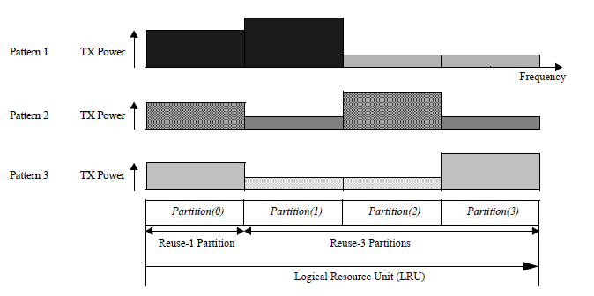
Figure 463-The basic concept of UL FFR

Figure 463-The basic concept of UL FFR for reuse-3 scenario

Figure xxx- Basic concept of fractional frequency reuse for reuse-2 scenario
When FPCT=3 and FPS₃=0, for example, each ABS chooses one of the two FFR patterns (pattern 1 and pattern 2) as shown in Figure xxx (when FPCT=2, the same FFR patterns exists only excluding FP₀). The index of FFR pattern is set by a particular ABS with its Segment ID. That is, each ABS adopts the FFR pattern corresponding to the pattern k in Figure xxx and k is decided by the following equation:

k = Segment_ID + 1

============================== End of Proposed Text =================================

