Project | IEEE 802.16 Broadband Wireless Access Working Group <http://ieee802.org/16>
Title | Clarification of Constellation rearrangement (section 16.3.11.4.2)
Date Submitted | 2010-03-10
Source(s) | Seunghyun Kang, Sunam Kim and Jin Sam Kwak  LG Electronics  Huaning Niu  Intel Corporation  Lei Huang  Panasonic Singapore Laboratories  Isamu Yoshii  Panasonic Corporation | seunghyun.kang@lge.com  huaning.niu@intel.com  lei.huang@sg.panasonic.com  yoshii.isamu@jp.panasonic.com
Re: | Call for IEEE 802.16 Working Group Letter Ballot #31  Target topic: 16.13.11.4.2
Abstract | This contribution provides the proposed text for 16.3.11.4.2 Constellation rearrangement
Purpose | To be discussed and adopted into P802.16m/D4 by Working Group Letter Ballot
Notice | This document does not represent the agreed views of the IEEE 802.16 Working Group or any of its subgroups. It represents only the views of the participants listed in the “Source(s)” field above. It is offered as a basis for discussion. It is not binding on the contributor(s), who reserve(s) the right to add, amend or withdraw material contained herein.
Release | The contributor grants a free, irrevocable license to the IEEE to incorporate material contained in this contribution, and any modifications thereof, in the creation of an IEEE Standards publication; to copyright in the IEEE’s name any IEEE Standards publication even though it may include portions of this contribution; and at the IEEE’s sole discretion to permit others to reproduce in whole or in part the resulting IEEE Standards publication. The contributor also acknowledges and accepts that this contribution may be made public by IEEE 802.16.
Patent Policy | The contributor is familiar with the IEEE-SA Patent Policy and Procedures:  <http://standards.ieee.org/guides/bylaws/sect6-7.html#6> and <http://standards.ieee.org/guides/opman/sect6.html#6.3>.  Further information is located at <http://standards.ieee.org/board/pat/pat-material.html> and <http://standards.ieee.org/board/pat>.

Clarification of Constellation rearrangement (section 16.3.11.4.2)

Seunghyun Kang, Sunam Kim, Jin Sam Kwak
LG Electronics
Huaning Niu
Intel Corporation
Lei Huang
Panasonic Singapore Laboratories
Isamu Yoshii
Panasonic Corporation
- Introduction
This contribution discusses some ambiguities on the current CoRe(Constellation Rearrangement) (Section 16.3.11.4.2) in P802.16m/D4 [1] and proposes the modified text of CoRe for further clarification.

- CRV(CoRe Version) indication method in P802.16m/D4
In the current CoRe section [1], two kinds of CoRe mapping rules have been defined according to the number of MIMO streams. For k^{th} FEC block, N_{CTC,k} coded bits (or subpacket bits) are mapped onto N_{QAM} QAM symbols while applying CoRe mapping rules. Especially, in the case that the number of MIMO stream is larger than 1, the CoRe mapping rule is defined as bit interleaving within the coded bits which are mapped onto a pair of two adjacent QAM symbols.
Also, in the CoRe section, there have been the descriptions how to use CoRe considering the bit selection and repetition method (Section 16.3.11.1.6 in [1]) as follows.
CoRe Description 1:
“In DL HARQ operation, CRV (Constellation Rearrangement Version) is signaled for each subpacket to an AMS as a starting value for CRV. In UL HARQ operation, the information on CRVs is implicitly known at AMS and ABS and the starting value for CRV of the subpacket i shall be . The CRV shall be changed to the other version of CoRe whenever the transmitted bits wraparound at the end of circular buffer per SPID.”
CoRe Description 2:
“In DL and UL HARQ operation, the CRV is determined assuming N_{shift,i} is 0 for all subpacket i.”

However, in the current description of CoRe, there have been some ambiguities between the CoRe mapping rule and the CRV indication when the number of MIMO stream is larger than 1. The following examples show that there exist a QAM symbol pair having different values of CRV depending on a subpacket size, a starting position of the IR HARQ (16.3.11.4.1 in [1]) and a shift value N_{shift,i} of the bit selection and repetition.

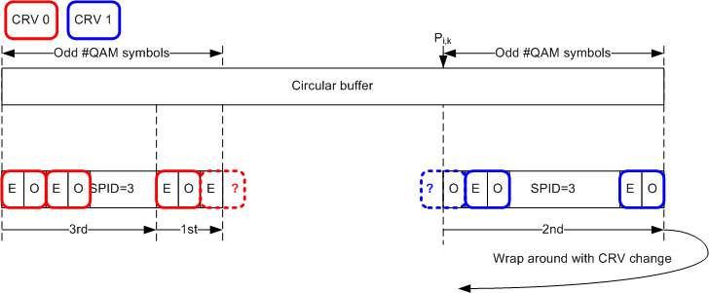
(a) Example #1: DL-HARQ, SPID = 3 and odd number of QAM symbols before/after wraparound

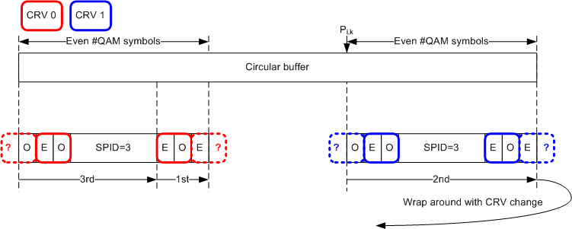
(b) Example #2: DL/UL-HARQ, SPID mod 2 = 1 and even number of QAM symbols before/after wraparound
Figure 1— CRV Examples considering the bit selection when MIMO stream>1

In Figure 1, there are three parts of subpacket bits considering the order of mapping subpacket bits onto QAM symbols after data modulation.
1st part of subpacket: N_{shift,i} bits which are mapped onto the first SPID QAM symbols after data modulation.
2nd part of subpacket: The subpacket bits before wraparound in the circular buffer.
3rd part of subpacket: The subpacket bits after wraparound in the circular buffer excluding the 1st part.

Also, in the figure, the bit selection procedure is described by the unit of a QAM symbol (NOT a bit) and ‘E’ represents a QAM symbol having an even index (j mod 2) = 0 and ‘O’ represents a QAM symbol having an odd index (j mod 2) = 1, where j = 0, 1, …, N_{QAM,k}-1.
According to the current description ‘CoRe Description 2’, the first QAM symbol in the 2nd part of subpacket has to be the starting value of CRV (as described in [2]). In the examples, the starting value of CoRe version CRV_{starting,k} has been set to 1.
In the example #1, the last QAM symbol of the 1st part has an even index with CRV=0 and the first QAM symbol in 2nd part has an odd index with CRV=1. In the example #2, the last QAM symbol of the 1st part has an even index with CRV=0 and the first QAM symbol in 2nd part has an odd index with CRV=1. Also, the last QAM symbol of the 2nd part has an even index with CRV=1 and the first QAM symbol in 3rd part has an odd index with CRV=0. Since the CRV is determined assuming that N_{shift,i} is 0 for all subpakcet i (,where i=SPID) and the two adjacent QAM symbols are located in the different parts of the subpacket demarcated by the wraparound point, they cannot be paired.
These examples cannot be fully covered by the current CRV indication method.

- Proposed CRV indication method
In this section, we propose new CRV indication method as follows.

${\text{CRV}}_{j,k}=\left({\text{CRV}}_{\text{starting},k}+\left\lfloor \frac{\left\lfloor \frac{{P_{i,k}}/{N_{\text{mod}}}}{m}\right\rfloor ⋅m+n}{{N_{{\text{FB}}_{\text{Buffer}},k}}/{N_{\text{mod}}}}\right\rfloor \right)\text{mod}2$
where:
$$n=\left(N_{\text{QAM},k}−\left\lfloor \frac{\text{SPID}}{m}\right\rfloor ⋅m+j\right) \text{mod} N_{\text{QAM},k }$$
$m=\left\{\begin{matrix}1 \text{if} \text{MIMO stream }=\text{ 1} \\ 2 \text{otherwise } \end{matrix}\right.$.

As a function of QAM symbol index j, the CRV of j-th QAM symbol CRV_{j,k} is defined. Also, it is assumed that a starting value of CRV CRV_{starting,k} is already defined by the current CoRe description in D4. In order to avoid the ambiguities between the CoRe mapping rule and the current CRV indication, the proposed method makes a pair of two adjacent QAM symbols to have the same value of CRV always. Figure 2 shows the examples of the proposed method under the same conditions in Figure 1.

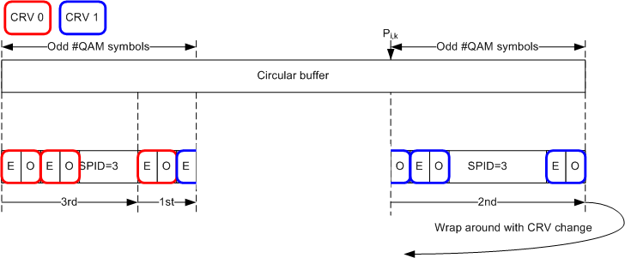
(a) Example #1: DL-HARQ, SPID = 3 and odd number of QAM symbols before/after wraparound

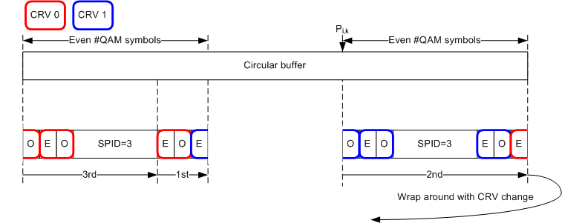
(b) Example #2: DL/UL-HARQ, SPID mod 2 = 1 and even number of QAM symbols before/after wraparound
Figure 2— Examples of new CRV indication method when MIMO stream>1

The proposed CRV indication method works well with the CoRe mapping rules regardless of the number of MIMO stream consistently. Furthermore, the proposed method determines the same values of CRV for each QAM symbols compared to the current CRV indication method under the most cases other than the cases we have discussed.

- References
[1] IEEE P802.16m/D4, “Draft Amendment to IEEE standard for local and metropolitan area networks: Air Interface for Fixed and Mobile Broadband Wireless Access Systems,” Feb. 2010.
[2] IEEE C802.16m-09/2421, “Proposed Changes to Constellation rearrangement (15.3.11.4.2)” Nov. 2009.

- Text proposal for inclusion in P802.16m/D4

[Modify the text line 14~ 45 in page 692 as follows]
-------------------------------------------------------- Text Start --------------------------------------------------------
Table 941—Constellation rearrangement version (MIMO stream >1)

Constellation | Ncbps  N_{mod} | CRV | Mapping rule
Constellation | Ncbps  N_{mod} | CRV | Even symbol |  |  |  |  |  | Odd symbol
16 QAM | 4 | 0 | b₀ | b₁ | b₂ | b₃ | - | - | b₄ | b₅ | b₆ | b₇ | - | -
16 QAM | 4 | 1 | b₁ | b₄ | b₃ | b₆ | - | - | b₅ | b₀ | b₇ | b₂ | - | -
64 QAM | 6 | 0 | b₀ | b₁ | b₂ | b₃ | b₄ | b₅ | b₆ | b₇ | b₈ | b₉ | b₁₀ | b₁₁
64 QAM | 6 | 1 | b₂ | b₇ | b₀ | b₅ | b₁₀ | b₃ | b₈ | b₁ | b₆ | b₁₁ | b₄ | b₉

For k^{th} FEC block, N_{CTC,k} coded bits are mapped onto N_{QAM} QAM symbols applying CoRe mapping rule in Table 940 and 941. In Table 941, a pair of two QAM symbols uses the same value of CRV(Constellation Rearrangement Version) when the number of MIMO stream is larger than 1. For a QAM symbol index j, an ‘Even symbol’ has its index j mod 2 =0 and an ‘Odd symbol’ has its index j mod 2 =1 where j = 0, 1, 2, …, N_{QAM,k} -1.
In DL HARQ operation, CRV(Constellation Rearrangement Version) is signaled for each subpacket to an AMS as a starting value for CRV. For data initially transmitted using persistent allocated resources, the value of the CRV indicated by DL Persistent Allocation A-MAP IE shall be zero. In UL HARQ operation, the information on CRVs is implicitly known at AMS and ABS and the starting value for CRV of the subpacket i shall be $\left\lfloor (i⋅N_{\text{CTC},k})/{N_{{\text{FB}}_{\text{Buffer}},k}}\right\rfloor \text{mod} 2$.
In DL and UL HARQ operation, the CRV is determined assuming N_{shift,i} is 0 for all subpacket i.
The CRV shall be changed to the other version of CoRe in DL and UL HARQ operation whenever the transmitted bits wraparound at the end of circular buffer per SPID.
In DL and UL HARQ operation, the CRV is determined assuming N_{shift,i} is 0 for all subpacket i.
Let CRV_{j,k} be the value of CRV for j^{th} QAM symbol for the k^{th} FEC block. The value CRV_{j,k} is calculated by Equation (xxx).
$\begin{aligned}{\text{CRV}}_{j,k}=\left({\text{CRV}}_{\text{starting},k}+\left\lfloor \frac{\left\lfloor \frac{{P_{i,k}}/{N_{\text{mod}}}}{m}\right\rfloor ⋅m+n}{{N_{{\text{FB}}_{\text{Buffer}},k}}/{N_{\text{mod}}}}\right\rfloor \right)\text{mod}2 \\ \end{aligned}$ (xxx)
where:
CRV_{starting,k} : The starting value for the CRV
$$n=\left(N_{\text{QAM},k}−\left\lfloor \frac{\text{SPID}}{m}\right\rfloor ⋅m+j\right) \text{mod} N_{\text{QAM},k }$$
$m=\left\{\begin{matrix}1 \text{if} \text{MIMO stream }=\text{ 1} \\ 2 \text{otherwise } \end{matrix}\right.$.
-------------------------------------------------------- Text End --------------------------------------------------------

