Project | IEEE 802.16 Broadband Wireless Access Working Group <http://ieee802.org/16>
Title | Idle mode modification for the smooth evolution from 16e to 16m
Date Submitted | 2009-03-11
Source(s) | Lin Chen,  Feng Xie,  Yang Liu,  Yuqin Chen,  ZTE Corporation | E-mail:  {chen.lin23, xie.feng2, liu.yang8, chen.yuqin, }@zte.com.cn
Re: | Call for LB #31b on “ P802.16m/D4”:  Target topic: “16.2.17”
Abstract | This contribution proposes the texts for the idle mode modification for the smooth evolution from 16e to 16m (16.2.17)
Purpose | To be discussed and adopted
Notice | This document does not represent the agreed views of the IEEE 802.16 Working Group or any of its subgroups. It represents only the views of the participants listed in the “Source(s)” field above. It is offered as a basis for discussion. It is not binding on the contributor(s), who reserve(s) the right to add, amend or withdraw material contained herein.
Release | The contributor grants a free, irrevocable license to the IEEE to incorporate material contained in this contribution, and any modifications thereof, in the creation of an IEEE Standards publication; to copyright in the IEEE’s name any IEEE Standards publication even though it may include portions of this contribution; and at the IEEE’s sole discretion to permit others to reproduce in whole or in part the resulting IEEE Standards publication. The contributor also acknowledges and accepts that this contribution may be made public by IEEE 802.16.
Patent Policy | The contributor is familiar with the IEEE-SA Patent Policy and Procedures:  <http://standards.ieee.org/guides/bylaws/sect6-7.html#6> and <http://standards.ieee.org/guides/opman/sect6.html#6.3>.  Further information is located at <http://standards.ieee.org/board/pat/pat-material.html> and <http://standards.ieee.org/board/pat>.

Idle mode modification for the smooth evolution from 16e to 16m

Lin Chen, Feng Xie, Yang Liu, Yuqin Chen
ZTE Corporation

1. Introduction
Due to the deployment requirement, the smooth evolution from 16e to 16m network SHOULD be supported. However, the first release of Wimax profile supporting 16m will be lack of network support. That is, the Rel1.x ASN-GW is used for not only the 16e BS/MS but also the 16m ABS/AMS as shown in Figure 1.

Figure 1 The first phase deployment for WiMAX (from 16e to 16m)

In this deployment scenario, the idle mode is impacted and has to be modified. The ABS has to bridge the gap between the legacy ASN-GW and the 16m AMS/ABS. As shown in Table 1, the major differences include:
  - Identification
    - 16m use 10 bit DID together with paging cycle, paging offset to identify the AMS within the paging group,
    - 16e use the 24 bit MAC address hash to identify the AMS.
  - Paging groups:
    - 16m AMS could belong to multiple paging groups
    - 16e AMS could only belong to one paging groups
  - Paging listening interval:
    - 16m use the number of superframe to calculate the start of the paging listening interval
    - 16e use the number of frame to calculate the start of the paging listening interval
  - Emergency alert
    - 16m AMS support the paging for emergency indication
    - 16e does not support it.
  - DCR
    - 16m AMS may terminate the idle mode due to the entering of DCR mode
    - 16e AMS does not support it.

Table 1 Detailed Idle mode Comparison between 16e and 16m
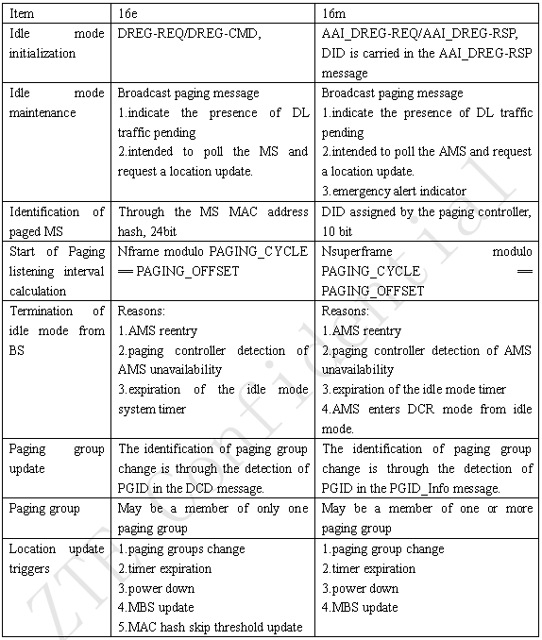

As we all know, the DID used to identify an AMS during paging in 16m is generally regarded as being assigned by the paging controller. Since the legacy ASN-GW does not support the updated paging controller, the DID could not be assigned by the paging controller any more. So the DID has to be removed.

Also the paging controller in the legacy ASN-GW regard all the paging groups as the same type, that is, it does not know which paging groups are for 16e BS and which paging groups are for 16m ABS. Since the numbering of frame and synchronization is different for 16e and 16m, for the ease of processing, when design the paging group,16e BS and mixed mode ABS may be in the same paging group, 16m only ABS and mixed mode ABS may be in the same paging group. The 16e BS and 16m only ABS should not be in the same paging group. So it is natural to consider that the idle initialization and the paging identification should happen within the same zone. That is, the AMS only listens to the same zone that it enters the idle mode until the paging group changes.

Except the identifier and paging zone, the emergency alert and DCR mode is not supported in the legacy ASN-GW. And the legacy ASN-GW only assigns one paging group to one AMS.

Based on the aforementioned analysis, the following solution is proposed.

2. Proposed Solution
For the Paging group, 16e BS and mixed mode ABS (LZone) could be in the same paging group, 16m only ABS and mixed mode ABS (MZone) could be in the same paging group. The 16e BS and 16m only ABS should not be in the same paging group. The PGID for the LZone BS or MZone ABS should be differentiated. For example, the first MSB of PGID could be used to distinguish the paging group from LZone or MZone.

For the ABS, ABS sends the Identifier type indication (1 bit) in the SFH. If the Identifier type = 1, then use advanced paging identifier, DID. If the Identifier type = 0, then use legacy paging identifier, mac address hash. According to the paging identifier type indication, the AAI_PAG-ADV message contains the DID or mac address hash info respectively. The ABS decides whether to page the AMS in LZone or MZone according to the PGID that the AMS belongs to. Since the paging offsets and paging cycles defined in paging controller of legacy ASN is in terms of frame whereas 16m specification is in terms of superframe, the ABS should do a mapping between these parameters for the paging groups of MZone.

For the AMS, if the AMS receive the Identifier type =1, it parse the DID from the AAI_DREG-RSP and the AAI_PAG-ADV message and use the DID to identify whether it is paged or not. If the AMS receive the Identifier type =0, it directly use the mac address hash to identify whether it is paged or not.

The advantage of this solution is that it works in each smooth evolution phase. Also the benefit of lower DID overhead (DID is 10 bit, MAC address hash is 24 bit) is maintained in 16m when advanced paging identifier is utilized. The paging identifier type indication could be further reused with the network entry identifier type indications.

3. Proposed text with change marks

Adopt the following modification in section 16.2.17.2.1 “Broadcast paging message”

Table 767 –Parameters for AAI_PAG-ADV message format
Name | Value | Usage
Paging_Group_IDs bitmap | Each bit in the bitmap indicates:  0: the paging information for the corresponding PGID is not included1: the paging informationfor the corresponding PGID is included | The size of Paging_Group_IDs bitmap equals to the number of paging group IDs in the PGID_Info message.
Num_AMSs | Number of paged AMSs in a particular paging group | For each non-zero bit in the Paging_Group_IDs bitmap, there shall be one Num_AMSs.
Deregistration Identifier | 0~1023 | Deregistration Identifier and Paging Cycle are used to identify each paged AMS when advanced identifier is used.
MAC address hash | 24bit | MAC address hash are used to identify each paged AMS when legacy identifier is used.

Adopt the following modification in section 16.3.6.5.1.2 “S-SFH IE

Table 813 – S-SFH SP3 IE format
Bandwidth request backoff start | 4 | Initial backoff window size for contention BRs, expressed as a power of 2. Values of n range 0-15 (the highest order bits shall be unused and set to 0)
Bandwidth request backoff end | 4 | Final backoff window size for contention BRs, expressed as a power of 2. Values of n range 0-15
fpPowerConfig | 4 | The power boosting/de-boosting values are listed in Table 814
Identifier type Indication | 1 | 1: advanced identifier shall be used  0: legacy identifier shall be used
Reserved | TBD
}

Adopt the following modification in line 53 of page 102 of section 16.2.3.22 “AAI_DREG-RSP message”

When the action code is set to 0x05 or 0x07, the following parameters shall be included in AAI_DREG-RSP message. Only if the advanced paging identifier is indicated could the Deregistration identifier be included.
Paging information
Paging cycle
Paging offset (4bits)
0x00: 0 superframe
0x01: 8 superframes
0x02: 16 superframes
0x03: 32 superframes
0x04-0x0f: reserved
Paging group ID
Paging controller ID
Idle Mode Retain Information
Deregistration Identifier

Adopt the following modification in line 17 of page 103 of section 16.2.3.22 “AAI_DREG-RSP message”

When the action code is set to 0x08, the following parameters shall be included in AAI_DREG-RSP message. Only if the advanced paging identifier is indicated could the Deregistration identifier be included.
Idle Mode Retain Information
Deregistration identifier (DID)

Adopt the following modification in line 61 of page 306 of section 16.2.17 “Idle mode”

To adapt to the smooth evolution, the ABS may use advanced identifier or legacy identifier for paging AMS. The identifier type shall be indicated in the S-SFH. For example, if the advanced identifier is indicated, the ABS shall contain the DID in the AAI_DREG-RSP message and use the DID in the AAI_PAG-ADV message for paging AMS. On the other hand, if the legacy identifier is indicated, the ABS shall use the MAC address hash for paging AMS. When the AMS receive the identifier indication bit in S-SFH, it shall use the corresponding identifier to check whether it is paged or not.

The LZone and MZone of ABS should be divided into different paging groups and could not be mixed into one paging group. Through the differentiated PGID of the paging groups that the AMS belongs to, the ABS decides where to page the AMS, in LZone or MZone. On the other hand, the paging offsets and paging cycles defined in paging controller of legacy ASN is in terms of frame whereas WirelessMAN-OFDMA Advanced system is in terms of superframe, the ABS should do a mapping between these parameters for the paging groups composed by the MZone of ABS.

