Project | IEEE 802.16 Broadband Wireless Access Working Group <http://ieee802.org/16>
Title | Text Proposal for Transformation Codebook Refinement and Tracking on Section 16.3.7.2.5.5.1
Date Submitted | 2010-3-5
Source(s) | Jiann-An Tsai, Jerry Pi,  Sudhir Ramakrishna  Samsung Electronics Co., Ltd. | jtsai@sta.samsung.com
Re: | Contribution in support of a comment on LB31B  Section 16.3.7.2.5.5.1 Transformation codebook feedback mode
Abstract | The contribution proposes the text of transformation codebook to be included in the 802.16m AWD (P802.16m/D4).
Purpose | To be discussed and adopted by TGm for the 802.16m AWD (P802.16m/D4).
Notice | This document does not represent the agreed views of the IEEE 802.16 Working Group or any of its subgroups. It represents only the views of the participants listed in the “Source(s)” field above. It is offered as a basis for discussion. It is not binding on the contributor(s), who reserve(s) the right to add, amend or withdraw material contained herein.
Release | The contributor grants a free, irrevocable license to the IEEE to incorporate material contained in this contribution, and any modifications thereof, in the creation of an IEEE Standards publication; to copyright in the IEEE’s name any IEEE Standards publication even though it may include portions of this contribution; and at the IEEE’s sole discretion to permit others to reproduce in whole or in part the resulting IEEE Standards publication. The contributor also acknowledges and accepts that this contribution may be made public by IEEE 802.16.
Patent Policy | The contributor is familiar with the IEEE-SA Patent Policy and Procedures:  <http://standards.ieee.org/guides/bylaws/sect6-7.html#6> and <http://standards.ieee.org/guides/opman/sect6.html#6.3>.  Further information is located at <http://standards.ieee.org/board/pat/pat-material.html> and <http://standards.ieee.org/board/pat>.

AWD Text Proposal for Transformation Codebook Refinement and Tracking on Section 16.3.7.2.5.5.1

Jiann-An Tsai, Jerry Pi, Sudhir Ramakrishna
Samsung Electronics Co., Ltd.

- Introduction
The contribution proposes the text of transformation codebook refinement and tracking (TCRT) to be included in the 802.16m/D4 ([4]). The proposed text is developed so that it can be readily combined with IEEE P802.16 Rev2/D8 ([1]), it is compliant to the 802.16m SRD ([2])).

- References
[1] IEEE P802.16 Rev2/D8, “Draft IEEE Standard for Local and Metropolitan Area Networks: Air Interface
for Broadband Wireless Access,” Dec. 2008.
[2] IEEE 802.16m-07/002r7, “IEEE 802.16m System Requirements Document”
[3] IEEE 802.16m-08/003r8, “IEEE 802.16m System Description Document”
[4] IEEE 802.16m/D4, “802.16m Amendment Working Document (AWD)”

- Text proposal for inclusion in the 802.16m AWD/D4

Black: current text in D4
Blue: text to be added in D4
Insert the following text on page 564, line 61, of section 16.3.7.2.5.5.1:
------------------------------- Text Start ---------------------------------------------------------------
The total number of bits of feedback is 6 bits for 2 transmit antennas, 28 bits for 4 transmit antennas, and 120 bits for 8 transmit antennas. The AMS and ABS shall use the same transformation based on the correlation matrix fed back by the AMS. In the case that the ABS has eight transmit antennas, the AMS and the ABS shall further follow the procedure described below, in order to provide further information about the transmit correlation matrix, in addition to the information provided by the wideband correlation matrix R. The objective of this procedure is to provide a method for the AMS and ABS to correlation matrix, denoted below as R_{t} . The following procedure applies to each ABS-AMS pair.

- Reset of the estimate of R_{t}:
When the AMS transmits the wideband correlation matrix R to the ABS, it shall set R_{t} = R. The ABS shall do likewise, i.e., upon receiving a wideband correlation matrix R reported by the AMS, it shall set R_{t} = R.

- Update of R_{t}:
Between two long-term feedback reports of the wideband correlation matrix R, both the AMS and the ABS shall simultaneously track and update/refine the correlation matrix R_{t}. R_{t} shall be updated each short reporting period, which is as defined in the Feedback Allocation A-MAP IE. The update is performed using the equations below. In these equations, the index n is in units of the short reporting period, and R_{t} [n] represents the update of R_{t} after receiving the PMI information for the n^{th} short reporting period. n = 0 corresponds to the reset event as defined in Step 1 above. The update equation is as

$$R_{t}[n]={αR}_{t}[n−1]+(1−α)\sum_{s=1}^{M}{\frac{1}{M}{\tilde{v}}_{s}[n]{\tilde{v}}_{s}^{H}[n]}$$
--- Equation xxxx
where
- n is the PMI feedback period index,
- α is the forgetting factor, which is designed to track the mobility of mobile channel
- ${\tilde{v}}_{s}[n]$is the PMI for subband s based on transformed codebook at time instant n

------------------------------- Text End -----------------------------------------------------------------

Appendix: SLS Simulation Results

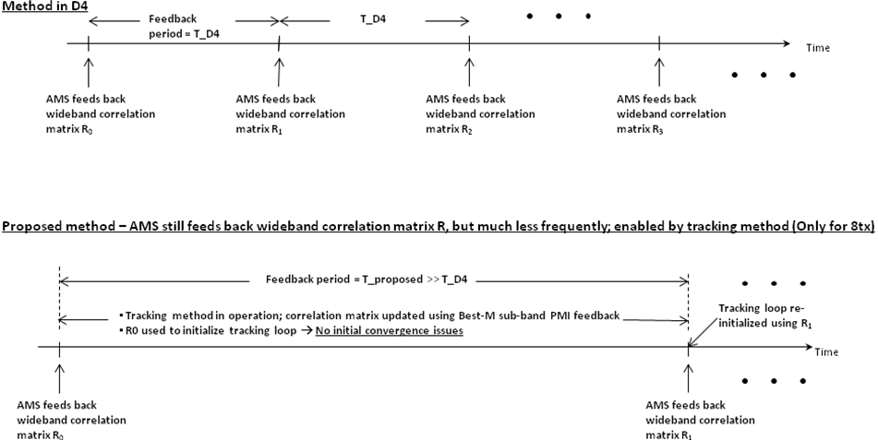

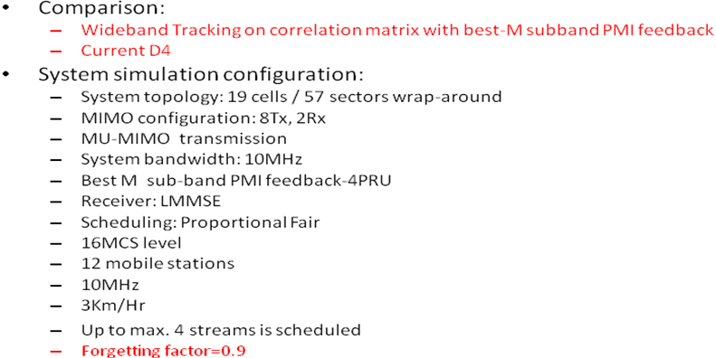
Case 1
System Throughput | Long Term D4’s R Feedback (200ms) ) | Long term D4’s R feedback (400ms)
D4/Baseline | 100% | 100%
Tracking method  10ms subband PMI  feedback | 102.2% | 103.9%
Tracking method  5 ms subband PMI  feedback | 104.1% | 107.2%

Cell EdgeThroughput | Long Term D4’s R Feedback (200ms) ) | Long term D4’s R feedback (400ms)
D4/Baseline | 100% | 100%
Tracking method  10ms subband PMI  feedback | 101.3% | 103.0%
Tracking method  5 ms subband PMI  feedback | 102.8% | 104.5%

System Throughput | Long Term D4’s R Feedback (200ms) ) | Long term D4’s R feedback (400ms)
D4/Baseline | 100% | 100%
Tracking method  10ms subband PMI  feedback | 100.2% | 100.3%
Tracking method  5 ms subband PMI  feedback | 100.4% | 100.9%

