Project | IEEE 802.16 Broadband Wireless Access Working Group <http://ieee802.org/16>
Title | Clarifications of Zone Switch based Handover (16.2.6.4.1.2.1)
Date Submitted | 2010-03-05
Source(s) | Sungcheol Chang, Eunkyung Kim, Soojung Jung, Jaesun Cha, Hyun Lee , Chulsik Yoon  ETRI  138 Gajeongno, Yuseong-gu, Daejeon, 305-700, KOREA | Voice: +82-42-860-5456  E-mail: scchang@etri.re.kr  *<http://standards.ieee.org/faqs/affiliationFAQ.html>
Re: | “P802.16m/D4,” in response to the IEEE 802.16 Working Group Letter Ballot Recirc #31: Announcement, IEEE 802.16-10/0011
Abstract | This provides clarifications of Zone Switch based Handover on the IEEE 802.16m Amendment Draft Standard
Purpose | To discuss and adopt the proposed text in the next revision of 802.16m draft
Notice | This document does not represent the agreed views of the IEEE 802.16 Working Group or any of its subgroups. It represents only the views of the participants listed in the “Source(s)” field above. It is offered as a basis for discussion. It is not binding on the contributor(s), who reserve(s) the right to add, amend or withdraw material contained herein.
Release | The contributor grants a free, irrevocable license to the IEEE to incorporate material contained in this contribution, and any modifications thereof, in the creation of an IEEE Standards publication; to copyright in the IEEE’s name any IEEE Standards publication even though it may include portions of this contribution; and at the IEEE’s sole discretion to permit others to reproduce in whole or in part the resulting IEEE Standards publication. The contributor also acknowledges and accepts that this contribution may be made public by IEEE 802.16.
Patent Policy | The contributor is familiar with the IEEE-SA Patent Policy and Procedures:  <http://standards.ieee.org/guides/bylaws/sect6-7.html#6> and <http://standards.ieee.org/guides/opman/sect6.html#6.3>.  Further information is located at <http://standards.ieee.org/board/pat/pat-material.html> and <http://standards.ieee.org/board/pat>.

Clarifications of Zone Switch based Handover (16.2.6.4.1.2.1)
Sungcheol Chang, Eunkyung Kim, Soojung Jung, Jaesun Cha, Hyun Lee, Chulsik Yoon
ETRI

Introduction
In last meeting there was an update of zone switch based handover procedure to correct ‘Ranging purpose indicator’ in the RNG-REQ management message for zone switch request. The update is done only in the text description in the section 16.2.6.4.1.2.1. The D4 document contains still Figure 415 with ‘Ranging purpose indicator’ not updated yet.

This contribution provides a clarification of ‘Ranging purpose indicator’ in the RNG-REQ management message in IEEE 802.16m Amendment Draft Standard [1] as followings:
- Figure 415
- Description update of ‘Ranging purpose indicator’ bit #5

Text Proposal for the IEEE 802.16m Amendment Draft Standard
Note:
The text in BLACK color: the existing text in the 802.16m Amendment Draft Standard
The text in RED color: the removal of existing 802.16m Amendment Draft Standard Text
The text in BLUE color: the new text added to the 802.16m Amendment Draft Standard Text

--------------Start of Proposed Text---------------------------------------------------------------------

16.2.6.4.1.2.1 Zone Switch based Handover Procedure

[Modify the text of "Ranging Purpose Indication" in Figure 415 as indicated:]

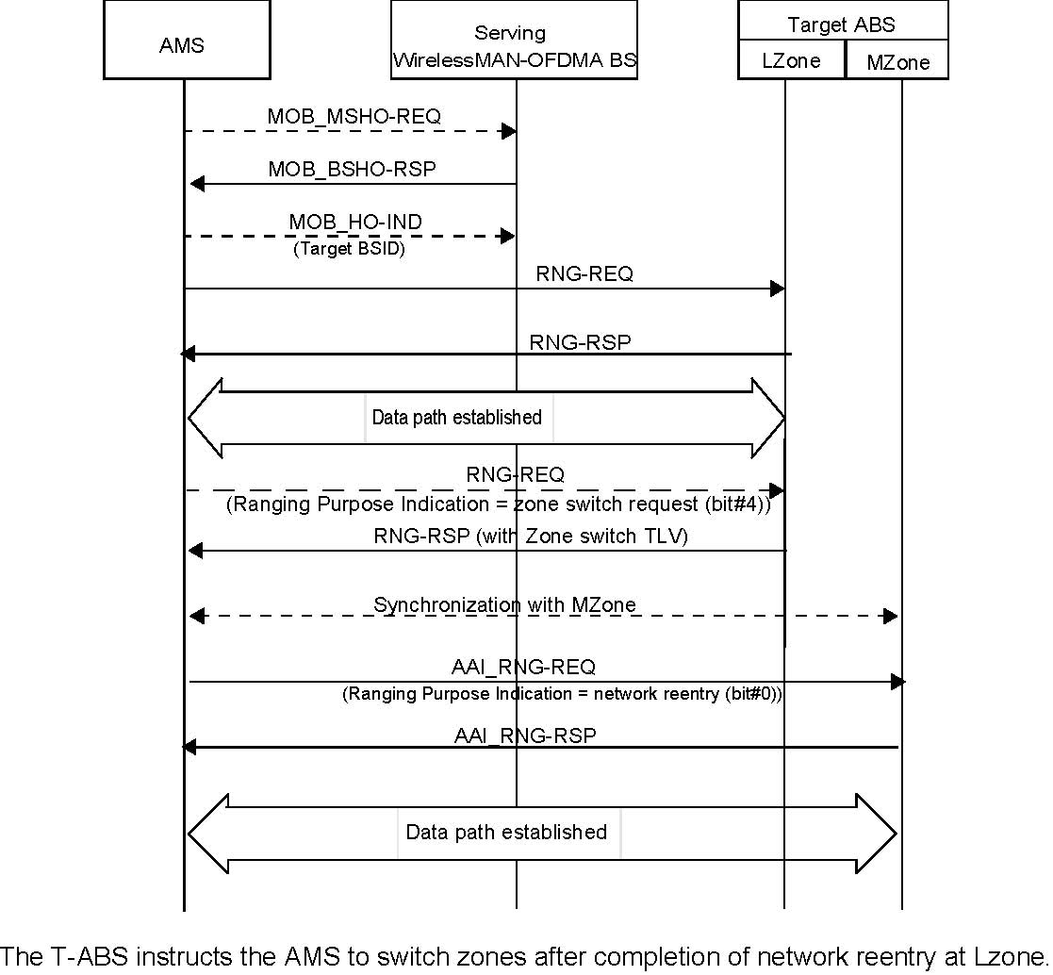
(bit#5)

Figure 415—Handover procedure from WirelessMAN-OFDMA BS to ABS

The Zone Switch parameters shall include the followings and are coded as TLV tuples as defined in 16.10.2.1:
- MZone A-Preamble index.
- Time offset between LZone and MZone
- Action Time: Action time of zone switch from LZone to MZone. AMS performs zone switch at Action Time. If HO_Reentry_Mode Zone Switch Mode=0, ABS stops all resource allocation for the AMS at LZone.
- Zone Switch Mode: If set to 1, the AMS maintains its data communication with the ABS in LZone while performing network reentry in MZone; otherwise it breaks data communication in LZone before performing network reentry in MZone.
- NONCE_ABS: It is used to derive a new PMK to be used in Mzone.

6.3.2.3.5 RNG-REQ (ranging request message)

[Modify section 6.3.2.3.5 as indicated:]
The following TLV parameter shall be included in the RNG-REQ message when the MS is attempting to
perform reentry, HO, or location update:

Ranging Purpose Indication
The presence of this item in the message indicates the following MS action:

If Bit 0 is set to 1, in combination with a serving BSID, it indicates that the MS is currently attempting to HO or reentry; or, in combination with a Paging Controller ID, indicates that the MS is attempting network reentry from idle mode to the BS.
If Bit 1 is set to 1, it indicates that the MS is initiating the idle mode location update
process.
Bit 2: Seamless HO indication. When this bit is set to 1 in combination with other included
information elements, it indicates the MS is initiating ranging as part of seamless HO
procedure.
Bit 3: Ranging Request for Emergency Call Setup. When this bit is set to 1, it indicates
MS action of Emergency Call Process.
Bit 4: MBS update. When this bit is set to 1, the MS is currently attempting to perform
location update due to a need to update service flow management encodings for MBS
flows.
Bit 5: Zone Switch Request. When this bit is set to 1, it indicates the AMS requests Zone Switch based Handover.
Bits 56–7: Reserved

11.5 RNG-REQ management message encodings

[Modify the text of the "Raning Purpose Indication" row in Table 582 as indicated:]

Ranging Purpose  Indication | 6 | 1 | Bit 0: HO indication (when this bit is set to 1 in combination with other included information elements indicates the MS is currently attempting to HO or network reentry from idle mode to the BS)  Bit 1: Location update request (when this bit is set to 1, it indicates MS action of idle mode location update process)  Bit 2: Seamless HO indication (when this bit is set to 1 in combination with other included information elements indicates the MS is currently initiating ranging as part of the seamless HO procedure)  Bit 3: Ranging Request for Emergency Call Setup (when this bit is set to 1, it indicates MS action of Emergency Call Process)  Bit 4: MBS update. When this bit is set to 1, the MS is currently attempting to perform location update due to a need to update service flow management encodings for MBS flows.  Bit 5: Zone Switch Request. When this bit is set to 1, it indicates the AMS requests Zone Switch based Handover.  Bits 56–7: Reserved

--------------End of Proposed Text ---------------------------------------------------------------------

References
- IEEE P802.16m/D4, “DRAFT Amendment to IEEE Standard for Local and metropolitan area networks; Part 16: Air Interface for Broadband Wireless Access systems; Advanced Air Interface,” February 2009

