Project | IEEE 802.16 Broadband Wireless Access Working Group <http://ieee802.org/16>
Title | Proposed Modifications to CDMA based Handover Procedure (16.2.6.3.5.1)
Date Submitted | 2010-03-05
Source(s) | Sungcheol Chang, Eunkyung Kim, Soojung Jung, Jaesun Cha, Hyun Lee , Chulsik Yoon  ETRI  138 Gajeongno, Yuseong-gu, Daejeon, 305-700, KOREA | Voice: +82-42-860-5456  E-mail: scchang@etri.re.kr  *<http://standards.ieee.org/faqs/affiliationFAQ.html>
Re: | “P802.16m/D4,” in response to the IEEE 802.16 Working Group Letter Ballot Recirc #31: Announcement, IEEE 802.16-10/0011
Abstract | This provides proposed modifications to CDMA based handover procedure on the IEEE 802.16m Amendment Draft Standard
Purpose | To discuss and adopt the proposed text in the next revision of 802.16m draft
Notice | This document does not represent the agreed views of the IEEE 802.16 Working Group or any of its subgroups. It represents only the views of the participants listed in the “Source(s)” field above. It is offered as a basis for discussion. It is not binding on the contributor(s), who reserve(s) the right to add, amend or withdraw material contained herein.
Release | The contributor grants a free, irrevocable license to the IEEE to incorporate material contained in this contribution, and any modifications thereof, in the creation of an IEEE Standards publication; to copyright in the IEEE’s name any IEEE Standards publication even though it may include portions of this contribution; and at the IEEE’s sole discretion to permit others to reproduce in whole or in part the resulting IEEE Standards publication. The contributor also acknowledges and accepts that this contribution may be made public by IEEE 802.16.
Patent Policy | The contributor is familiar with the IEEE-SA Patent Policy and Procedures:  <http://standards.ieee.org/guides/bylaws/sect6-7.html#6> and <http://standards.ieee.org/guides/opman/sect6.html#6.3>.  Further information is located at <http://standards.ieee.org/board/pat/pat-material.html> and <http://standards.ieee.org/board/pat>.

Proposed Modifications to CDMA based Handover Procedure (16.2.6.3.5.1)
Sungcheol Chang, Eunkyung Kim, Soojung Jung, Jaesun Cha, Hyun Lee, Chulsik Yoon
ETRI

Introduction
During network reentry procedure AMS may follow CDMA-based handover procedure or RNG message transaction, which are indicated by CDMA_RNG_FLG in the AAI_HO-CMD management message. The CDMA-based handover procedure may have procedural variations by conditions: ranging code or opportunity type, seamless handover indication, and Ranging Initiation Deadline. However Figure 411 does not show CDMA based handover procedure correctly and have wrong information. According to 16m/D3, after Ranging_Initiation_Deadline timer expired a target ABS consider a handover procedure fails. Also in the case of no seamless handover Ranging_Initiation_Deadline timer works.
For seamless handover procedure there are two points in the figure 411. The one is that network reentry procedure should are forced to use dedicated ranging code or opportunity instead of random ranging code or opportunity. The other is that AMS and target ABS may exchange traffic data after AAI_RNG-ACK.

This contribution provides modifications of CDMA based handover procedure in IEEE 802.16m Amendment Draft Standard [1] as followings:
- Figure 411

Text Proposal for the IEEE 802.16m Amendment Draft Standard
Note:
The text in BLACK color: the existing text in the 802.16m Amendment Draft Standard
The text in RED color: the removal of existing 802.16m Amendment Draft Standard Text
The text in BLUE color: the new text added to the 802.16m Amendment Draft Standard Text

--------------Start of Proposed Text---------------------------------------------------------------------

16.2.6.3.5.1 CDMA-based Handover Procedure

[Modify Figure 411 and the text as indicated:]

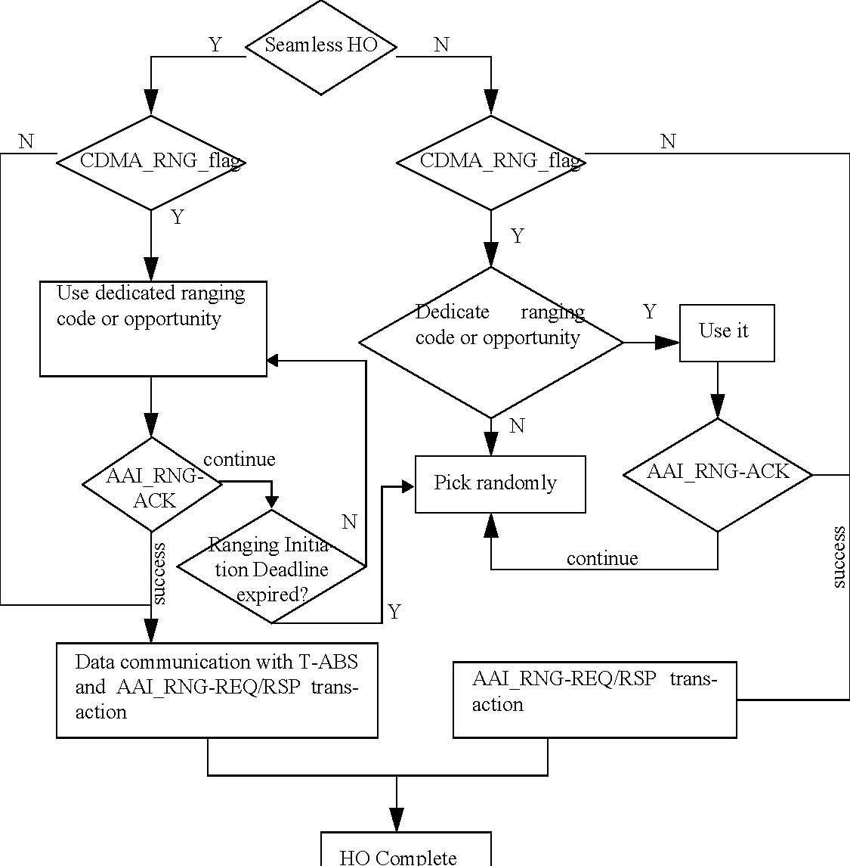

Figure 411—MS State machine during HO network reentry

--------------End of Proposed Text ---------------------------------------------------------------------

References
- IEEE P802.16m/D4, “DRAFT Amendment to IEEE Standard for Local and metropolitan area networks; Part 16: Air Interface for Broadband Wireless Access systems; Advanced Air Interface,” February 2009

