Project | IEEE 802.16 Broadband Wireless Access Working Group <http://ieee802.org/16>
Title | Proposed Change for Handling Concurrent Sleep Cycle Configuration Change Initiation in IEEE 802.16m (16.2.16.2.4)
Date Submitted | 2010-03-05
Source(s) | Ritesh Kumar Kalle, Debabrata Das  International Institute of Information Technology –Bangalore (IIIT-Bangalore)  Shantidev Mohanty  Intel Corporation | E-mail: riteshkumar.k@iiitb.ac.in  ddas@iiitb.ac.in  E-mail: shantidev.mohanty@intel.com
Re:
Abstract | This contribution proposes methods to handle concurrent sleep cycle configuration change initiation in IEEE 802.16m.
Purpose | To be discussed and adopted by TGm for 802.16m Letter Ballot 31
Notice | This document does not represent the agreed views of the IEEE 802.16 Working Group or any of its subgroups. It represents only the views of the participants listed in the “Source(s)” field above. It is offered as a basis for discussion. It is not binding on the contributor(s), who reserve(s) the right to add, amend or withdraw material contained herein.
Release | The contributor grants a free, irrevocable license to the IEEE to incorporate material contained in this contribution, and any modifications thereof, in the creation of an IEEE Standards publication; to copyright in the IEEE’s name any IEEE Standards publication even though it may include portions of this contribution; and at the IEEE’s sole discretion to permit others to reproduce in whole or in part the resulting IEEE Standards publication. The contributor also acknowledges and accepts that this contribution may be made public by IEEE 802.16.
Patent Policy | The contributor is familiar with the IEEE-SA Patent Policy and Procedures:  <http://standards.ieee.org/guides/bylaws/sect6-7.html#6> and <http://standards.ieee.org/guides/opman/sect6.html#6.3>.  Further information is located at <http://standards.ieee.org/board/pat/pat-material.html> and <http://standards.ieee.org/board/pat>.

Proposed Change for Handling Concurrent Sleep Cycle Configuration Change Initiation in IEEE 802.16m (16.2.16.2.4)
Ritesh Kumar Kalle, Debabrata Das

International Institute of Information Technology –Bangalore
Shantidev Mohanty

Intel Corporation

Introduction
This contribution proposes amendments in the manner IEEE 802.16m ABS and AMS behave when there are concurrent requests for Sleep Cycle Setting Change or Switch handled at AMS and ABS.

- The SCH/SCEH header has both the option of being a Request or a Response message (Used for acknowledgement) as per section “16.2.2.2.5 Sleep Control extended header (SCEH)”. This introduces an ambiguity when a sleep mode AMS and its serving ABS simultaneously send each other an SCEH to change the sleep cycle configuration.
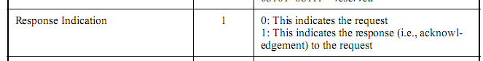
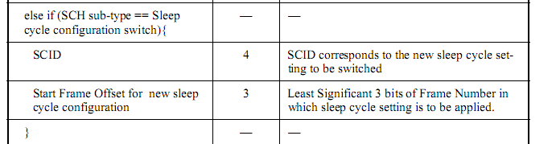

Text proposal for inclusion in the P802.16m/D4
========================== Start of Proposed Text ==============================
[Note to Editor: Modify the text in section 16.2.16.2.4, starting from line 49, page 304 as follows]

In the event that an ABS-initiated request (i.e., Unsolicited Sleep response AAI_SLP-RSP, SCH/SCEH) and an AMS-initiated request for Sleep Cycle setting change or switch (i.e., AAI_SLP-REQ, SCH/SCEH, Service Specific BR without STID Header Format) are being handled concurrently, the ABS-initiated request shall take precedence over the AMS-initiated Request. Therefore, if the AMS receives the ABS-initiated request while it is waiting for AAI_SLP-RSP message in response to AAI_SLP-REQ, the AMS shall stop the remaining procedure of the AMS-initiated request and continue with the ABS-initiated request. The ABS shall ignore an AMS-initiated request if it has initiated a change request.
========================== End of Proposed Text ==============================

