Project | IEEE 802.16 Broadband Wireless Access Working Group <http://ieee802.org/16>
Title | Proposed Change for Acknowledging the Sleep Cycle Configuration Change Initiated Using Service Specific BR without STID Header in IEEE 802.16m (16.2.16.2.4)
Date Submitted | 2010-03-05
Source(s) | Ritesh Kumar Kalle, Debabrata Das  International Institute of Information Technology –Bangalore (IIIT-Bangalore)  Shantidev Mohanty  Intel Corporation | E-mail: riteshkumar.k@iiitb.ac.in  ddas@iiitb.ac.in  E-mail: shantidev.mohanty@intel.com
Re:
Abstract | This contribution proposes methods to handle concurrent sleep cycle configuration change initiation in IEEE 802.16m.
Purpose | To be discussed and adopted by TGm for 802.16m Letter Ballot 31
Notice | This document does not represent the agreed views of the IEEE 802.16 Working Group or any of its subgroups. It represents only the views of the participants listed in the “Source(s)” field above. It is offered as a basis for discussion. It is not binding on the contributor(s), who reserve(s) the right to add, amend or withdraw material contained herein.
Release | The contributor grants a free, irrevocable license to the IEEE to incorporate material contained in this contribution, and any modifications thereof, in the creation of an IEEE Standards publication; to copyright in the IEEE’s name any IEEE Standards publication even though it may include portions of this contribution; and at the IEEE’s sole discretion to permit others to reproduce in whole or in part the resulting IEEE Standards publication. The contributor also acknowledges and accepts that this contribution may be made public by IEEE 802.16.
Patent Policy | The contributor is familiar with the IEEE-SA Patent Policy and Procedures:  <http://standards.ieee.org/guides/bylaws/sect6-7.html#6> and <http://standards.ieee.org/guides/opman/sect6.html#6.3>.  Further information is located at <http://standards.ieee.org/board/pat/pat-material.html> and <http://standards.ieee.org/board/pat>.

Proposed Change for Acknowledging the Sleep Cycle Configuration Change Initiated Using Service Specific BR without STID Header in IEEE 802.16m (16.2.16.2.4)
Ritesh Kumar Kalle, Debabrata Das

International Institute of Information Technology –Bangalore
Shantidev Mohanty

Intel Corporation

1. Introduction
This contribution proposes methods for Acknowledging the Sleep Cycle Configuration Change Initiated Using Service Specific BR without STID Header in IEEE 802.16m.

IEEE 802.16m/D4 now have included the SCID switch parameters in the “Service Specific BR without STID Header Format” in section 16.2.2.1.3.3. In this message, however the D4 document does not propose any unique acknowledgement mechanism from the ABS. (As per D4: If SCID change indicator is set to 1, the ABS shall send an acknowledgement to confirm the change of sleep mode configuration.)There needs to be further clarification in the manner the SCID switch is handled at the AMS and ABS.
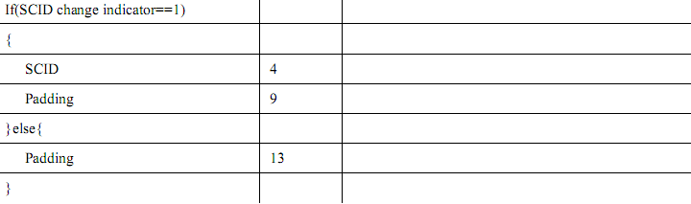

2. Proposed Text

Text proposal for inclusion in the P802.16m/D4
========================== Start of Proposed Text ==============================
[Note to Editor: Modify the text in section 16.2.2.1.3.3, starting from line 7, page 42 as follows]

If SCID change indicator is set to 1, the ABS shall send an acknowledgement using AAI_MSG-ACK message to confirm the change of sleep mode configuration.
========================== End of Proposed Text ==============================

