Project | IEEE 802.16 Broadband Wireless Access Working Group <http://ieee802.org/16>
Title | Change on capabiltiy index scheme(16.2.15.4)
Date Submitted | 2010-03-05
Source(s) | Youngkyo Baek  Hyeonjeong Kang  Rakesh Taori  Jungje Son  Samsung Electronics | E-mail: youngkyo.baek@samsung.com  Phone : +82-31-279-7321  *<http://standards.ieee.org/faqs/affiliationFAQ.html>
Re: | Call for LB #31 on “ P802.16m/D4”:  Target topic: “16.2.15.4”
Abstract | This contribution provides to clean up the capabiltiy index scheme
Purpose | To be discussed and adopted by WG LB
Notice | This document does not represent the agreed views of the IEEE 802.16 Working Group or any of its subgroups. It represents only the views of the participants listed in the “Source(s)” field above. It is offered as a basis for discussion. It is not binding on the contributor(s), who reserve(s) the right to add, amend or withdraw material contained herein.
Release | The contributor grants a free, irrevocable license to the IEEE to incorporate material contained in this contribution, and any modifications thereof, in the creation of an IEEE Standards publication; to copyright in the IEEE’s name any IEEE Standards publication even though it may include portions of this contribution; and at the IEEE’s sole discretion to permit others to reproduce in whole or in part the resulting IEEE Standards publication. The contributor also acknowledges and accepts that this contribution may be made public by IEEE 802.16.
Patent Policy | The contributor is familiar with the IEEE-SA Patent Policy and Procedures:  <http://standards.ieee.org/guides/bylaws/sect6-7.html#6> and <http://standards.ieee.org/guides/opman/sect6.html#6.3>.  Further information is located at <http://standards.ieee.org/board/pat/pat-material.html> and <http://standards.ieee.org/board/pat>.
Change on capabiltiy index scheme (16.2.15.4)
Youngkyo Baek, Hyeonjeong Kang, Rakesh Taori, Jungje Son
Samsung Electronics

Introduction
AMS’s basic capabilities are negotiated through basic capability negotiation procedure. The capabilities are negotiated through Capability Class(or CAPABILITY_INDEX).
Accroding to D4[1], the higher numeric values of CAPABILITY_INDEX, the more enhanced feature or higher protocol revisions. However, we defines different sorts of features in D4[1] so that it is impossible to say which one is more enhanced. For example, number of HARQ channel and PN window size should be negotiated respectively. But those two have to be decided exclusively. Hence, we may prioritize CAPABILITY_INDEX just for default value(i.e., 0) and maximum(i.e., N), but not for all CAPAVILITY_INDEX.
Meanwhile, Some SBC parameters belong not to capability to be negotiated but to indication/report.(e.g. auth type for EAP, current Tx power etc.) Those are not required to map to CAPABILITY_INDEX.
Besides, if new features are introduced in this specification D4[1] or later version, those can not be categorized to a Capability Class. Hence, we have to allow additional capability negotiation except for ‘through capability class’.

We suggest modification on the subclause16.2.15.4 based on the above.

1Proposed Text#1
Modify the sentences, line 1, page 296 and the figure 443 as follows.
----------------------------------------------------- Start of Proposed Text ---------------------------------------------------
16.2.15.4 Basic Capability Negotiation
Immediately after completion of ranging, the AMS informs the ABS of its basic capabilities by transmitting an AAI-SBC-REQ message. A "Capability Class" is defined as a unique set of functions, configuration parameters, air-interface protocol revision, and/or services that can uniquely describe a mobile station implementation or configuration while operating in the network. Each Capability Class is indicated by its corresponding CAPABILITY_INDEX. The AMS, by default, shall support the basic capabilities associated with "Capability Class 0" (i.e. CAPABILITY_INDEX = 0). If the AMS is capable of supporting higher revisions of physical layer or medium access control layer protocols or further wishes to use enhanced features, it shall send an AAI_SBC-REQ message to the ABS indicating the Capability Class highest "CAPABILITY_INDEX" that it can support. The CAPABILITY_INDEX = 0 indicates the default capability index and basic feature set or configuration parameters and may not need to be signaled.
Upon receipt of the AAI_SBC-REQ message containing the "CAPABILITY_INDEX" from the AMS, the ABS determines whether it could allow or could support the requested feature set or MAC and/or PHY protocol revisions. If the ABS does support or can allow the use of enhanced features, it shall respond with an AAI_SBC-RSP message to inform the AMS of its decision. The ABS shall only signal a "CAPABILITY_INDEX" which may be is numerically smaller than or equal to different than that requested by the AMS.
The higher numeric values of "CAPABILITY_INDEX", the more enhanced features or higher protocol revisions are used. The "CAPABILITY_INDEX" values range from 0 to N, where N denotes the maximum CAPABILITY_INDEX value. The CAPABILITY_INDEX = 0 indicates the default capability index and basic feature set or configuration parameters.
The features and configuration parameters included in the Capability Class 0 baseline capability class shall be sufficient to meet the minimum performance requirements of the standard. In case of failure in any stages of operation, the AMS and ABS shall fall back to "Capability Class 0" and restart negotiations for a new "Capability Class", if necessary.
Figure 438 shows the MAC management messages exchanged over the advanced air-interface and the relationship between the Capability Classes.

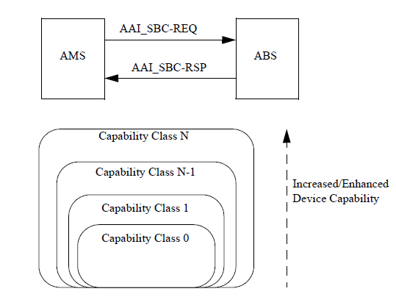

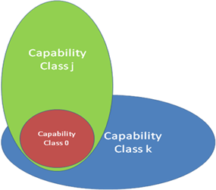

Figure 443—AAI_SBC-REQ/RSP messages over the air-interface and relationship between capability classes

----------------------------------------------------- End of Proposed Text ---------------------------------------------------

2Proposed Text#2
Modify the sentences, line 40, page 70 as follows.
----------------------------------------------------- Start of Proposed Text ---------------------------------------------------
In Table 679, the CAPABILITY_INDEX transmitted in the AAI_SBC-REQ message refers to the maximum "Capability Class" that the AMS can support. The maximum value of CAPABILITY_INDEX is denoted by [TBD] bits.
----------------------------------------------------- End of Proposed Text ---------------------------------------------------

3Proposed Text#3
Modify the sentences, line 22, page 71 as follows.
----------------------------------------------------- Start of Proposed Text ---------------------------------------------------
In Table 680, the CAPABILITY_INDEX transmitted in the AAI_SBC-RSP message refers to the "Capability Class" that the ABS has allowed the AMS to use during the session. The value of CAPABILITY_INDEX signaled in the AAI_SBC-RSP message is numerically smaller than or equal to the CAPABILITY_INDEX signaled in the AAI_SBC-REQ message by the AMS.
----------------------------------------------------- End of Proposed Text ---------------------------------------------------

References
- IEEE P802.16m/D4. DRAFT Amendment to IEEE Standard for Local and metropolitan area networks—Part 16: Air Interface for Broadband Wireless Access Systems—Advanced Air Interface, Feb 2010.
- IEEE 802.16m-08/003r9a. The Draft IEEE 802.16m System Description Document, May 2009.
- IEEE 802.16m-07/002r9. IEEE 802.16m System Requirements Document, Sep 2009.

