Project | IEEE 802.16 Broadband Wireless Access Working Group <http://ieee802.org/16>
Title | Proposed changes to the transmission of AAI_CM-IND message (16.2.8.2.11)
Date Submitted | 2010-03-05
Source(s) | Soojung Jung, Eunkyung Kim,  Jaesun Cha, Sungcheol Chang,  Hyun Lee, Chulsik Yoon  ETRI | E-mail: sjjung@etri.re.kr
Re: | IEEE 802.16 Working Group Letter Ballot Recirc #31:Announcement
Abstract | Proposed text to modify the description of AAI_CM-IND message
Purpose | To be discussed and adopted by TGm
Notice | This document does not represent the agreed views of the IEEE 802.16 Working Group or any of its subgroups. It represents only the views of the participants listed in the “Source(s)” field above. It is offered as a basis for discussion. It is not binding on the contributor(s), who reserve(s) the right to add, amend or withdraw material contained herein.
Release | The contributor grants a free, irrevocable license to the IEEE to incorporate material contained in this contribution, and any modifications thereof, in the creation of an IEEE Standards publication; to copyright in the IEEE’s name any IEEE Standards publication even though it may include portions of this contribution; and at the IEEE’s sole discretion to permit others to reproduce in whole or in part the resulting IEEE Standards publication. The contributor also acknowledges and accepts that this contribution may be made public by IEEE 802.16.
Patent Policy | The contributor is familiar with the IEEE-SA Patent Policy and Procedures:  <http://standards.ieee.org/guides/bylaws/sect6-7.html#6> and <http://standards.ieee.org/guides/opman/sect6.html#6.3>.  Further information is located at <http://standards.ieee.org/board/pat/pat-material.html> and <http://standards.ieee.org/board/pat>.

Proposed changes to the transmission of AAI_CM-IND message (16.2.8.11)

Soojung Jung, Eunkyung Kim, Jaesun Cha, Sungcheol Chang, Hyun Lee, Chulsik Yoon
ETRI

1. Introduction

According to the description of action time in Table 749, this value is used to provide the information about the time to switch to target carrier. And the AAI_CM-IND message shall be transmitted to the target carrier. Therefore, a time for transmission of AAI_CM-IND in the Figure 425 needs to be modified.
Next, according to the section 16.2.8.11.5.2, the AAI_CM-IND message shall not be transmitted in case of primary carrier change procedure when target carrier is one of active carrier. Although the target carrier is active, the ABS has to know when the transmission of any control signaling on the old primary carrier shall be stopped. Otherwise, transmission of a control message on the old primary carrier may not be completed until the transmission of AAI_CM-IND on the target carrier is completed. Therefore, the description for transmission of AAI_CM-IND needs to be modified.

2. Text Proposal
------------------------------------------------------------Start of the Text--------------------------------------------------------
[Modify the Figure 425 as follows]

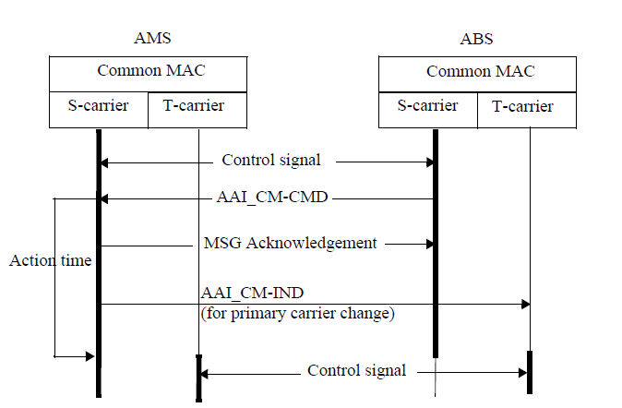

Figure 425. Primary Carrier Change procedure when target carrier is one of the active carriers

[Modify flowing text on line 7, page 247]

An AAI_CM-IND message shall be transmitted by an AMS to inform the ABS of the readiness of target carrier when the AMS is instructed to newly activate the target carrier(s) in an AAI_CM-CMD message with action code=0 or when the target carrier in an AAI_CM-CMD message with action code=1 has been transmitted by an ABS has not been an active carrier

-------------------------------------------------------------End of the Text--------------------------------------------------------

References
- IEEE P802.16m/D4, “Advanced Air Interface(Draft),” Feb. 2010.

