Project | IEEE 802.16 Broadband Wireless Access Working Group <http://ieee802.org/16>
Title | Proposed changes to the AMS initialization to support multicarrier operation(16.2.8.2.3)
Date Submitted | 2010-03-16
Source(s) | Soojung Jung, Eunkyung Kim,  Jaesun Cha, Sungcheol Chang,  Hyun Lee, Chulsik Yoon  ETRI  Daniel Cohn  Alvarion | E-mail: sjjung@etri.re.kr  E-mail: Daniel.cohn@alvarion.com
Re: | IEEE 802.16 Working Group Letter Ballot Recirc #31:Announcement
Abstract | modify the Figure 419
Purpose | To be discussed and adopted by TGm
Notice | This document does not represent the agreed views of the IEEE 802.16 Working Group or any of its subgroups. It represents only the views of the participants listed in the “Source(s)” field above. It is offered as a basis for discussion. It is not binding on the contributor(s), who reserve(s) the right to add, amend or withdraw material contained herein.
Release | The contributor grants a free, irrevocable license to the IEEE to incorporate material contained in this contribution, and any modifications thereof, in the creation of an IEEE Standards publication; to copyright in the IEEE’s name any IEEE Standards publication even though it may include portions of this contribution; and at the IEEE’s sole discretion to permit others to reproduce in whole or in part the resulting IEEE Standards publication. The contributor also acknowledges and accepts that this contribution may be made public by IEEE 802.16.
Patent Policy | The contributor is familiar with the IEEE-SA Patent Policy and Procedures:  <http://standards.ieee.org/guides/bylaws/sect6-7.html#6> and <http://standards.ieee.org/guides/opman/sect6.html#6.3>.  Further information is located at <http://standards.ieee.org/board/pat/pat-material.html> and <http://standards.ieee.org/board/pat>.

Proposed changes to the AMS initialization to support multicarrier operation (16.2.8.2.3)

Soojung Jung, Eunkyung Kim, Jaesun Cha, Sungcheol Chang, Hyun Lee, Chulsik Yoon
ETRI

Daniel Cohn
Alvarion

1. Introduction

According to the description of the AAI_Global-Config message, the AAI_Global-Config message provides the carrier information for all available carriers in the network. And the ABS Transmits the AAI_Global-Config message to an AMS right after network entry completes. But an interpretation of network entry completion may be ambiguous and the AAI_Global-Config message transmission is a prerequisite for the AAI_MC-REQ/RSP exchange. Therefore, the description of the AAI_Global-Config message should be clarified and the related step should be included in the Figure 419.

2. Text Proposal
------------------------------------------------------------Start of the Text--------------------------------------------------------
[Modify page 146, line 5 as follows]

The AMS transmits the AAI_Global-Config message to an AMS right after network entry completes after transmitting the AAI_REG-RSP message.

[Modify the Figure 419 as follows]
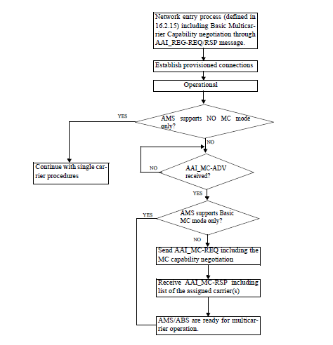

Figure 419 – AMS initialization overview to support multicarrier transmission
*Receiving AAI_Global_Config is independent of establishing provisioned connections. Therefore the order of AAI_Global-Config reception and provisioned connection establishment is not relevant..
** A single carrier AMS shall receive the multicarrier configuration information (AAI_MC-ADV message) during normal operation in the multicarrier ABS.

-------------------------------------------------------------End of the Text--------------------------------------------------------

References
- IEEE P802.16m/D4, “Advanced Air Interface(Draft),” Feb. 2010.

