Project | IEEE 802.16 Broadband Wireless Access Working Group <http://ieee802.org/16>
Title | PCINR averaging formula
Date Submitted | 2010-03-16
Source(s) | Jon Labs  Sylvain Labonte  Dov Andelman | 802.16 Maint TG
Re: | IEEE 802.16-10/0011: “IEEE 802.16 Working Group Letter Ballot #31: Announcement”
Abstract | Proposed resolution to comment A0033 in IEEE 802.16-10/0018r2
Purpose | To be discussed and adopted by WG LB
Notice | This document does not represent the agreed views of the IEEE 802.16 Working Group or any of its subgroups. It represents only the views of the participants listed in the “Source(s)” field above. It is offered as a basis for discussion. It is not binding on the contributor(s), who reserve(s) the right to add, amend or withdraw material contained herein.
Release | The contributor grants a free, irrevocable license to the IEEE to incorporate material contained in this contribution, and any modifications thereof, in the creation of an IEEE Standards publication; to copyright in the IEEE’s name any IEEE Standards publication even though it may include portions of this contribution; and at the IEEE’s sole discretion to permit others to reproduce in whole or in part the resulting IEEE Standards publication. The contributor also acknowledges and accepts that this contribution may be made public by IEEE 802.16.
Patent Policy | The contributor is familiar with the IEEE-SA Patent Policy and Procedures:  <http://standards.ieee.org/guides/bylaws/sect6-7.html#6> and <http://standards.ieee.org/guides/opman/sect6.html#6.3>.  Further information is located at <http://standards.ieee.org/board/pat/pat-material.html> and <http://standards.ieee.org/board/pat>.
- Introduction
This contribution is to provide a resolution to comment A0033 in IEEE 802.16-10/0018r2 LB#31 database.
In 16m/D4 the instruction to the editor leads to confusion because the new equation does not appear explicitly in the amendment. This should be clarified.

- Text change

Modify 802.16m/D4, page 30, section 8.4.12.3 as follows:

8.4.12.3 CINR mean and standard deviation
[Modify 8.4.12.3 as indicated:]
[Replace Equation 156 with an equation identical to Equation 158.]
[Replace Equation 156 by the following equation (same as 158)]

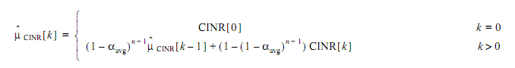
(156)

