Project | IEEE 802.16 Broadband Wireless Access Working Group <http://ieee802.org/16>
Title | Idle mode modification for the smooth evolution from 16e to 16m
Date Submitted | 2009-04-30
Source(s) | Lin Chen,  Feng Xie,  Yang Liu,  Yuqin Chen,  Zhaohua Lu  ZTE Corporation | E-mail:  {chen.lin23, xie.feng2, liu.yang8, chen.yuqin, lu.zhaohua}@zte.com.cn
Re: | Call for LB #31b on “ P802.16m/D5”:  Target topic: “16.2.18”
Abstract | This contribution proposes the texts for the idle mode modification for the smooth evolution from 16e to 16m (16.2.18)
Purpose | To be discussed and adopted
Notice | This document does not represent the agreed views of the IEEE 802.16 Working Group or any of its subgroups. It represents only the views of the participants listed in the “Source(s)” field above. It is offered as a basis for discussion. It is not binding on the contributor(s), who reserve(s) the right to add, amend or withdraw material contained herein.
Release | The contributor grants a free, irrevocable license to the IEEE to incorporate material contained in this contribution, and any modifications thereof, in the creation of an IEEE Standards publication; to copyright in the IEEE’s name any IEEE Standards publication even though it may include portions of this contribution; and at the IEEE’s sole discretion to permit others to reproduce in whole or in part the resulting IEEE Standards publication. The contributor also acknowledges and accepts that this contribution may be made public by IEEE 802.16.
Patent Policy | The contributor is familiar with the IEEE-SA Patent Policy and Procedures:  <http://standards.ieee.org/guides/bylaws/sect6-7.html#6> and <http://standards.ieee.org/guides/opman/sect6.html#6.3>.  Further information is located at <http://standards.ieee.org/board/pat/pat-material.html> and <http://standards.ieee.org/board/pat>.

Idle mode modification for the smooth evolution from 16e to 16m

Lin Chen, Feng Xie, Yang Liu, Yuqin Chen, Zhaohua Lu
ZTE Corporation

1. Introduction
Due to the deployment requirement, the smooth evolution from 16e to 16m network SHOULD be supported. However, the first release of Wimax profile supporting 16m will be lack of network support. That is, the Rel1.x ASN-GW is used for not only the 16e BS/MS but also the 16m ABS/AMS as shown in Figure 1.

Figure 1 The first phase deployment for WiMAX (from 16e to 16m)

In this deployment scenario, the idle mode is impacted and has to be modified. The ABS has to bridge the gap between the legacy ASN-GW and the 16m AMS/ABS. As shown in Table 1, the major differences include:
  - Identification
    - 16m use 10 bit DID together with paging cycle, paging offset to identify the AMS within the paging group,
    - 16e use the 24 bit MAC address hash to identify the AMS.
  - Paging groups:
    - 16m AMS could belong to multiple paging groups
    - 16e AMS could only belong to one paging groups
  - Paging listening interval:
    - 16m use the number of superframe to calculate the start of the paging listening interval
    - 16e use the number of frame to calculate the start of the paging listening interval
  - Emergency alert
    - 16m AMS support the paging for emergency indication
    - 16e does not support it.
  - DCR
    - 16m AMS may terminate the idle mode due to the entering of DCR mode
    - 16e AMS does not support it.

Table 1 Detailed Idle mode Comparison between 16e and 16m
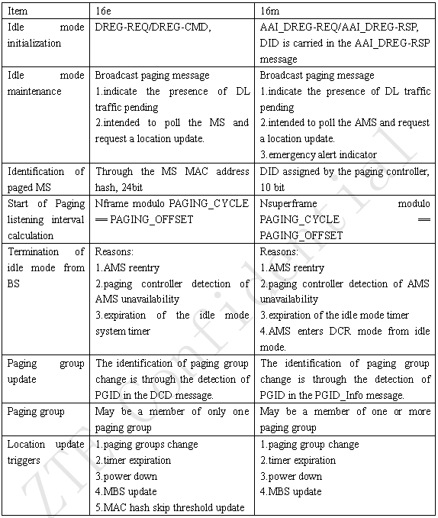

As we all know, the DID used to identify an AMS during paging in 16m is generally regarded as being assigned by the paging controller. Since the legacy ASN-GW does not support the updated paging controller, the DID could not be assigned by the paging controller any more. So the DID has to be removed.

Also the paging controller in the legacy ASN-GW regard all the paging groups as the same type, that is, it does not know which paging groups are for 16e BS and which paging groups are for 16m ABS. Since the numbering of frame and synchronization is different for 16e and 16m, for the ease of processing, when design the paging group,16e BS and mixed mode ABS may be in the same paging group, 16m only ABS and mixed mode ABS may be in the same paging group. The 16e BS and 16m only ABS should not be in the same paging group. So it is natural to consider that the idle initialization and the paging identification should happen within the same zone. That is, the AMS only listens to the same zone that it enters the idle mode until the paging group changes.

Except the identifier and paging zone, the emergency alert and DCR mode is not supported in the legacy ASN-GW. And the legacy ASN-GW only assigns one paging group to one AMS.

Based on the aforementioned analysis, the following solution is proposed.

2. Proposed Solution
For the Paging group, 16e BS and mixed mode ABS (LZone) could be in the same paging group, 16m only ABS and mixed mode ABS (MZone) could be in the same paging group. The 16e BS and 16m only ABS should not be in the same paging group. The PGID for the LZone BS or MZone ABS should be differentiated. For example, the first MSB of PGID could be used to distinguish the paging group from LZone or MZone.

For the ABS, according to the network configuration indication, the AAI_PAG-ADV message contains the DID or mac address hash info respectively. The ABS decides whether to page the AMS in LZone or MZone according to the PGID that the AMS belongs to. Since the paging offsets and paging cycles defined in paging controller of legacy ASN is in terms of frame whereas 16m specification is in terms of superframe, the ABS and AMS should do a mapping between these parameters for the paging groups of MZone.

For the AMS, if the network configuration indicates the advanced network is connected, it parse the DID from the AAI_DREG-RSP and the AAI_PAG-ADV message and use the DID to identify whether it is paged or not. Otherwise, it directly use the mac address hash to identify whether it is paged or not.

The advantage of this solution is that it works in each smooth evolution phase. Also the benefit of lower DID overhead (DID is 10 bit, MAC address hash is 24 bit) is maintained in 16m when advanced paging identifier is utilized. The paging identifier type indication could be further reused with the network entry identifier type indications.

3. Proposed text with change marks

Adopt the following modification in section 16.2.3.1 “AAI_RNG-REQ”, page 680, line 6:

Table 680—AAI_RNG-REQ message Field Descriptions
O | Paging Controller ID | 48 | The Paging Controller ID which the AMS currently maintains in idle mode. | To be included when the AMS is attempting to perform reentry from Idle Mode or location update. The DID is included only when the DID is assigned to the AMS.
O | Deregistration Identifier (DID) | 10 | The ID which the AMS is assigned for idle mode and currently maintains.
O | PGID | 16 | The identification of the paging group that the AMS is previously belonging to.
O | Paging Cycle | 4 | PAGING_CYCLE applied to the AMS
O | Paging Offset | 4 | PAGING_OFFSET applied to the AMS

Adopt the following modification in section 16.2.3.2 “AAI_RNG-RSP”, page 81, line 44:
Table 681—AAI_RNG-RSP message Field Descriptions
O | Paging Controller ID | 48 | The new Paging Controller ID which the AMS shall maintain in idle mode. | It shall be included only if the Location Update Response = 0x00 (Success of Idle Mode Location Update) and Paging Controller ID has changed. The DID is included only when the Network Configuration indicates ABS is attached to the advanced network.
O | Deregistration Identifier (DID) | 10 | The new DID which the AMS shall maintain in idle mode.

Adopt the following modification in section 16.2.3.21 “AAI_DREG-RSP”, page 81, line 44:
Table 708—AAI_DREG-RSP message
O | Paging offset | -4 | Used to indicate Paging offset for the AMS | Shall be present when Action code in AAI_DREG-RSP message is set to 0x05 or 0x07
O | Paging controller ID | 48 | Used to indicate Paging controller which manages and retains the MS's idle mode information  0..2481– | Shall be present when Action code in AAI_DREG-RSP message is set to 0x05 or 0x07
O | Paging group ID | 16 | Used to indicate Paging group which the MS is located in  0..2161– | Shall be present when Action code in AAI_DREG-RSP message is set to 0x05 or 0x07
O | Deregistration ID | 10 | Used to indicate Deregistration ID used to identify the MS in idle mode  0..2101– | Shall be present when Action code in AAI_DREG-RSP message is set to 0x05 or 0x07 and when the Network Configuration indicates ABS is attached to the advanced network.

Adopt the following modification in section 16.2.3.22 AAI_PAG-ADV (paging advertisement) Message, page 141, line 28:
Table 709 –AAI_PAG-ADV message
M | Paged MS Info[1..32] | Deregistration Identifier / MAC Address Hash | 10 / 24 | Used to indicate Deregistration ID for the MS to be paged (Deregistration Identifier and Paging Cycle are used to identify each paged AMS) 0..2¹⁰ – 1 / used to identify the MS to be paged. | Shall be present if the Network Configuration indicates ABS is attached to the advanced network and unless Num_AMSs is 0 / Shall be present if the Network Configuration indicates ABS is attached to the legacy network and unless Num_AMSs is 0
M | Paged MS Info[1..32] | Paging Cycle | 4 | Used to indicate Paging cycle for the AMS to be paged  0x00: 8 superframes  0x01: 16 superframes  0x02: 32 superframes  0x03-0x0F: reserved | Shall be present unless Num_AMSs is 0
M | Paged MS Info[1..32] | Action Code | 1 | Used to indicate the purpose of the AAI_PAG-ADV message  0b0: perform network reentry  0b1: perform ranging for location update | Shall be present unless Num_AMSs is 0

Adopt the following modification in section 16.2.18 “Idle mode”, page 379, line 46:

The LZone and MZone of ABS should be divided into different paging groups and could not be mixed into one paging group. Through the differentiated PGID of the paging groups that the AMS belongs to, the ABS decides where to page the AMS, in LZone or MZone. On the other hand, the paging offsets and paging cycles defined in paging controller of legacy ASN is in terms of frame whereas WirelessMAN-OFDMA Advanced system is in terms of superframe, the ABS and AMS should do a mapping between these parameters for the paging groups composed by the ABS’s MZone.

