Project | IEEE 802.16 Broadband Wireless Access Working Group <http://ieee802.org/16>
Title | Proposed Text on the E-MBS Operation in Idle State in IEEE P802.16m (16.9.2.3, 16.9.3.1, 16.3.6.2.3, 16.3.6.5.3, and 16.2.8.2.10.2)
Date Submitted | 2010-04-30
Source(s) | Eunkyung Kim, Soojung Jung, Jaesun Cha, Sungcheol Chang, Hyun Lee, Chulsik Yoon  ETRI  138 Gajeongno, Yusong-gu, Daejeon, 305-700, KOREA | Voice: +82-42-860-5415  E-mail: ekkim@etri.re.kr
Re: | “P802.16m/D5,” in response to the IEEE 802.16 Working Group Letter Ballot Recirc #31a: Announcement, IEEE 802.16-10/0032
Abstract | E-MBS Operation to support idle mode over multicarrier on IEEE 802.16m Amendment Draft Standard
Purpose | To discuss and adopt the proposed text in the next revision of 802.16m draft
Notice | This document does not represent the agreed views of the IEEE 802.16 Working Group or any of its subgroups. It represents only the views of the participants listed in the “Source(s)” field above. It is offered as a basis for discussion. It is not binding on the contributor(s), who reserve(s) the right to add, amend or withdraw material contained herein.
Release | The contributor grants a free, irrevocable license to the IEEE to incorporate material contained in this contribution, and any modifications thereof, in the creation of an IEEE Standards publication; to copyright in the IEEE’s name any IEEE Standards publication even though it may include portions of this contribution; and at the IEEE’s sole discretion to permit others to reproduce in whole or in part the resulting IEEE Standards publication. The contributor also acknowledges and accepts that this contribution may be made public by IEEE 802.16.
Patent Policy | The contributor is familiar with the IEEE-SA Patent Policy and Procedures:  <http://standards.ieee.org/guides/bylaws/sect6-7.html#6> and <http://standards.ieee.org/guides/opman/sect6.html#6.3>.  Further information is located at <http://standards.ieee.org/board/pat/pat-material.html> and <http://standards.ieee.org/board/pat>.

Proposed Text on the E-MBS Operation in Idle State in IEEE P802.16m (16.9.2.3, 16.9.3.1, 16.3.6.2.3, 16.3.6.5.3, and 16.2.8.2.10.2)
Eunkyung Kim, Soojung Jung, Jaesun Cha, Sungcheol Chang, Hyun Lee, Chulsik Yoon
ETRI

Instructions
IEEE 802.16m Amendment Draft Standard [1] describes the Enhanced Multicast Broadcast Service (E-MBS).
According to operation during idle mode in the single carrier mode in the IEEE 802.16m Amendment Draft Standard [1], the ABS shall transmit the PGID_Info at a predetermined location in the paging listening interval in order to advertise the paging group(s) that is supported by the ABS. The PGID_Info shall be transmitted by the ABS regardless of whether or not there any notifications for AMSs. The PGID_Info shall be present before any AAI_PAG-ADV message in the superframe.
If multicarrier feature is supported by the AMS and the ABS, following idle mode is defined regardless the AMS receives the E-MBS or not.
- PGID_Info message is transmitted in all fully configured carriers.
- AAI_PAG-ADV message for an AMS shall be transmitted in only one of the carriers with

Paging carrier index = DID modulo N (1)

,where N is the number of carriers per PGID in an ABS that are used for transmitting paging message for idle mode AMS(s).
- AAI_PAG-ADV message is transmitted in one or more of the frames starting from the second subframe in the super-frame
- For an E-MBS AMS, the AAI_PAG-ADV message may be transmitted in the same carrier as the dedicated carrier for E-MBS.

However, there is no rule in the dedicated carrier to transmit the AAI_PAG-ADV which may be transmitted in the unicast zone which is not existed in the dedicated carrier.
In order to support idle mode operated in the multicarrier, idle mode for multicarrier (16.2.8.2.10.2) and E-MBS operation in idle state (16.9.2.3) are modified.

E-MBS Operation in Idle State
In order to support idle state if multicarrier feature is supported by the AMS and ABS, following operation should be modified.
- PGID_Info message is transmitted in all carrier including fully and partially configured carrier.
- Dedicated carrier should support transmitting unicast traffic such as PGID_Info and PAG-ADV message.
- E-MBS AMS
- PGID_Info and PAG-ADV message should be transmitted via an corresponded carrier transmitting E-MBS, where the carrier is either mixed or dedicated carrier as described in Figure 1.
  - It can avoid unnecessary switching the carrier to receive the PGID_Info transmitted in a fully configured carrier
  - When the paging offset in a paging cycle is not the same frame as the frame of unicast, an AMS in idle mode should wait till the frame transmitting paging related message.
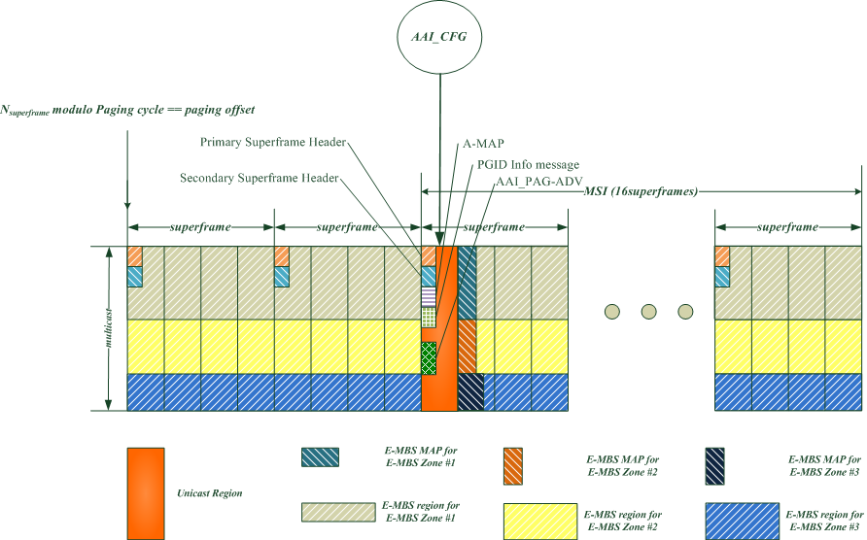
Figure 1 – Transmission of PGID_Info and AAI_PAG-ADV message via dedicated carrier

Text Proposal for the 802.16m Amendment Draft Standard
Note:
The text in BLACK color: the existing text in the 802.16m Amendment Draft Standard
The text in RED color: the removal of existing 802.16m Amendment Draft Standard Text
The text in BLUE color: the new text added to the 802.16m Amendment Draft Standard Text

[-------------------------------------------------Start of Text Proposal---------------------------------------------------]
[Remedy1: Modify the following text in 16.2.8.2.10.2 of 802.16m/D5]
16.2.8.2.10.2 Idle mode
A multicarrier supporting AMS in idle state follows the same procedures defined in 16.2.1718.
In a multi-carrier system the PGID_Info message is transmitted in all fully and partially configured carriers. The AAI_PAG-ADV message for an AMS shall be transmitted in only one of the carriers. An idle mode AMS determines the carrier index for monitoring the paging message within AMS's paging-listening interval where its paging message is transmitted using the following equations:
Paging carrier index = DID modulo N (2)
The value of N is the number of carriers per PGID in an ABS that are used for transmitting paging message for idle mode AMS(s). The Paging Carrier Index corresponds to the ascending order of physical carrier index of the carriers which are used for transmitting paging message in the ABS. Paging carrier indication bit is used to specify if a carrier is a paging carrier or not. When the Paging carrier indication =1, then the corresponding carrier is paging carrier. The Paging carrier indication of different carriers is included in the PGID_Info message and may be included in the AAI_NBR-ADV message or the AAI_MC-ADV message.
When an idle mode AMS moves to a new ABS and determines that the SFH change count of the new ABS is same as the information it received through the AAI_NBR-ADV message, then the AMS may use the paging carrier indication received through AAI_NBR-ADV message if this paging carrier indication is included in the AAI_NBR-ADV message.
The AAI_PAG-ADV message is transmitted in one or more of the frames starting from the second sub-frame in the super-frame.
For an E-MBS AMS the AAI_PAG-ADV message may be transmitted in the same carrier as the either mixed carrier or dedicated carrier for E-MBS. In this case, the AMS does not use (2) and idle mode supporting E-MBS is described in 16.9.2.3.
An AMS may perform Location Update process to acquire its preferred carrier for the idle mode support when AMS cannot find the paging carrier. If different carriers have different coverage area, then the preferred carrier is used for transmitting paging message. In this case, the AMS does not follow equation (2) to derive paging carrier index.

[Remedy2: Modify the following text in 16.3.6.2.3 of 802.16m/D5]
16.3.6.2.3 Enhanced Multicast Broadcast Service MAP (E-MBS MAP)
The E-MBS MAP carries configuration information for enhanced multicast broadcast service for one E-MBS Zone. The E-MBS MAP is transmitted in the first several RUs of the E-MBS region in the beginning of the MSI. In the case of transmitting the AAI_PAG-ADV message in the dedicated carrier, RUs for the frame of AAI_PAG-ADV or PGID_Info should be removed to calculate the RUs for E-MBS region. The parameters of the E-MBS region and the burst size of the E-MBS MAP is transmitted in the AAI_E-MBS-CFG MAC control message described in 16.9.3.1. AAI_E-MBS-CFG Change Indication indicates any change in the parameters of AAI_E-MBS-CFG MAC Control Message at its next transmission instance.

[Remedy3: Modify the Table 864 in 16.3.6.5.3 of 802.16m/D5]
Table 864—E-MBS DATA Information Elements
Syntax | Size (bit) | Description/Notes
E-MBS_DATA_IE () {
No. of E-MBS IDs+FIDs | 8 | Total number of E-MBS streams in the IE
For (i=0; i< No. of E-MBS IDs +FIDs,; i++){
E-MBS ID+FID | 16 | E-MBS ID + Flow ID of an E-MBS stream
I_{size-offset} | 5 | Depends on supported modes, 32modes assumed as baseline
MEF | 1 | E-MBS MIMO Encoding Format  0b0: SFBC  0b1: Vertical Encoding
If (MEF == 0b1){ |  | Parameters of Vertical Encoding
Mt | 1 | Number of streams for transmission for N_{t} =2, N_{t} =4, and N_{t} =8  (Mt <= N_{t})  0b0: 1 stream  0b1: 2 streams
}
E-MBS AAI subframe offset | Variable | Includes the location of the AAI subframe where the E-MBS data burst ends  MSI == 0b00: 6bits  MSI == 0b01: 7bits  MSI == 0b11: 9bits
E-MBS Resource Indexing | 7 | Includes the location of the SLRU index where the E-MBS data burst ends and frame to transmit unicast traffic such as AAI_E-MBS-CFG, PGID_Info, and/or AAI_PAG-ADV message should be excluded in the SLRU index.
} | - | -
}

[Remedy4: Modify the following text in 16.9.2.3 of 802.16m/D5]
16.9.2.3 E-MBS Operation in Idle State
When an AMS in Idle mode moves to an ABS which does not belongs to AMS' previous E-MBS Zone, the AMS is expected to update the E-MBS service flow management encodings at that ABS to provide continuous reception of E-MBS content. The AMS may obtain the E-MBS information in the target E-MBS zone through broadcast messages in the E-MBS-Zone of the serving ABS. If the idle AMS has not received such information from the serving E-MBS Zone, the AMS shall use location update procedure to acquire updated E-MBS service flow management encodings. In order to perform the MBS location update process, the AMS shall transmit AAI_RNG-REQ message with Ranging Purpose Indication Bit # 4 set to 1. In response to the request for MBS location update, the ABS shall transmit AAI_RNG-RSP message which may include the E-MBS zone identifier, E-MBS ID, FID, and E-MBS Zone Identifier Assignment parameter and etc. to provide update service flow management encodings for any affected E-MBS flow(s).
The AMS may also conduct re-entry from Idle mode if required by quality of service of corresponding E-MBS flow.
If the duration of paging listening interval based on the paging cycle and paging offset described in 16.2.18.2.3 is not the same frame of the predefined unicast region in the current carrier, the AMS in idle mode should wait till the frame including unicast region to receive AAI_PAG-ADV message.

[Remedy5: Modify the following text in line 51-52, page 830 in section 16.9.3.1 of 802.16m/D5]
E-MBS MAP Resource Index: Resource Index indicating the starting SLRUE-MBS_{E-MBS} index and size of a single allocation spanning contiguous SLRUE-MBS_{E-MBS}s of the E-MBS MAP, where frame to transmit unicast traffic such as AAI_E-MBS-CFG, PGID_Info, and/or AAI_PAG-ADV message should be excluded in the SLRU_{E-MBS} as shown figure XXX.

Figure XXX – Transmission of unicast message via dedicated carrier

[-------------------------------------------------End of Text Proposal----------------------------------------------------]

References
- IEEE P802.16m/D5, “DRAFT Amendment to IEEE Standard for Local and metropolitan area networks; Part 16: Air Interface for Broadband Wireless Access systems; Advanced Air Interface,” April 2010

