Project | IEEE 802.16 Broadband Wireless Access Working Group <http://ieee802.org/16>
Title | Proposed Changes to Ranging Channel for FDM-based UL PUSC Zone Support (16.3.9.1.4.3)
Date Submitted | 2010-05-07
Source(s) | Chiwoo Lim, Hwasun Yoo, Jaeweon Cho, Hokyu Choi, Heewon Kang  Samsung Electronics  HyunWoo Lee, Jin Sam Kwak  LG Electronics  Xinrong Wang, Yang-Seok Choi  Intel Corporation  Zheng Yan-Xiu, Chang-Lan Tsai, Chung-Lien Ho, Yu-Chuan Fang  ITRI  Pei-Kai Liao, Paul Cheng  MediaTek Inc | chiwoo.lim@samsung.com  {hyunwoolee.lee ; jinsam.kwak}@lge.com  {xinrong.wang; yang-seok.choi}@intel.com  zhengyanxiu@itri.org.tw  pk.liao@mediatek.com
Re: | IEEE 802.16-10/0032, “IEEE 802.16 Working Group Letter Ballot#31a”  Target topic: “IEEE P802.16m/D5, section 16.3.9.1.4.3”.
Abstract | The contribution proposes the text changes to Ranging Channel for FDM-based UL PUSC Zone Support of the 802.16m draft amendment, IEEE P802.16m/D5.
Purpose | To be discussed and adopted by TGm for the 802.16m amendment.
Notice | This document does not represent the agreed views of the IEEE 802.16 Working Group or any of its subgroups. It represents only the views of the participants listed in the “Source(s)” field above. It is offered as a basis for discussion. It is not binding on the contributor(s), who reserve(s) the right to add, amend or withdraw material contained herein.
Release | The contributor grants a free, irrevocable license to the IEEE to incorporate material contained in this contribution, and any modifications thereof, in the creation of an IEEE Standards publication; to copyright in the IEEE’s name any IEEE Standards publication even though it may include portions of this contribution; and at the IEEE’s sole discretion to permit others to reproduce in whole or in part the resulting IEEE Standards publication. The contributor also acknowledges and accepts that this contribution may be made public by IEEE 802.16.
Patent Policy | The contributor is familiar with the IEEE-SA Patent Policy and Procedures:  <http://standards.ieee.org/guides/bylaws/sect6-7.html#6> and <http://standards.ieee.org/guides/opman/sect6.html#6.3>.  Further information is located at <http://standards.ieee.org/board/pat/pat-material.html> and <http://standards.ieee.org/board/pat>.
Proposed Changes to Ranging Channel for FDM-based UL PUSC Zone Support (16.3.9.1.4.3)

Chiwoo Lim, Hwasun Yoo, Jaeweon Cho, Hokyu Choi, Heewon Kang
Samsung Electronics

HyunWoo Lee and Jin Sam Kwak
LG Electronics

Xinrong Wang and Yang-Seok Choi
Intel Corporation

Zheng Yan-Xiu, Chang-Lan Tsai, Chung-Lien Ho, Yu-Chuan Fang
ITRI

Pei-Kai Liao, Paul Cheng
MediaTek Inc

- Introduction
The contribution proposes the text changes of ranging channel for FDM-based UL PUSC Zone Support to be included in the 802.16m amendment. In the current draft amendment [1], a ranging transmission is performed during two consecutive symbols for the NS-RCH. And within the allocated ranging AAI subframe, first 4 symbols in a UL AAI subframe are occupied for the NS-RCH.
However, there is no description for opportunity of ranging transmission in a UL AAI subframe. It seems that permits two opportunities for the NS-RCH in a UL AAI subframe. However, it can cause the degradation of AGC operation. It’s allowed only one opportunity in case of green field with considering this aspect. It’s needed to keep the consistency.

- References
[1] IEEE P802.16m/D5, “P802.16m DRAFT Amendment to IEEE Standard for Local and metropolitan area networks Part 16: Air Interface for Broadband Wireless Access Systems”, April 2010

- Proposed changes for 802.16m draft amendment

--------------------------------------------------- Text Start ---------------------------------------------------
[Remedy-1: Modify the text on page 683 line 38-42 as following text]
A signal transmission of NS-RCH shall be performed during two four consecutive symbols with two basic units, in which the basic unit consists of 2 OFDMA symbols same as Figure 253 in 8.4.7.1. Within a basic unit, tThe same ranging code is transmitted on the ranging channel during each symbol, with no phase discontinuity between the two symbols. Onto two basic units, the AMS shall transmit the two consecutive RP codes (starting RP code shall always be a multiple of 2), as illustrated in Figure 254 in 8.4.7.1. A time-domain illustration of the NS-RCH is shown in Figure 563 (a).

[Remedy-2: Modify the figure 563(a) on page 684 as following]
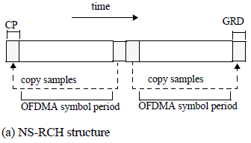
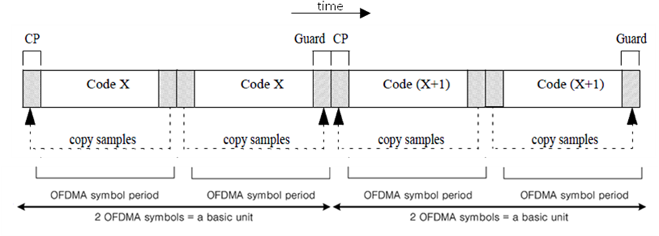
(a) NS-RCH structure

[Remedy-3: Modify the text on page 684 line 27-28 as following text]
Within the allocated ranging AAI subframe, first 4 symbols in a UL AAI subframe are occupied for the ranging structure for non-synchronized AMSs.
Within the allocated ranging AAI subframe, first 4 symbols in a UL AAI subframe are occupied for the NS-RCH.

[Remedy-4: Modify the figure 564 on page 684 as following]
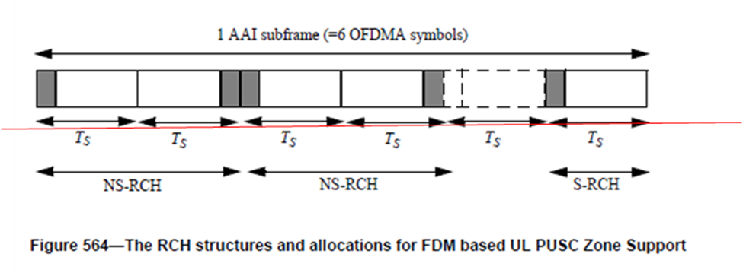

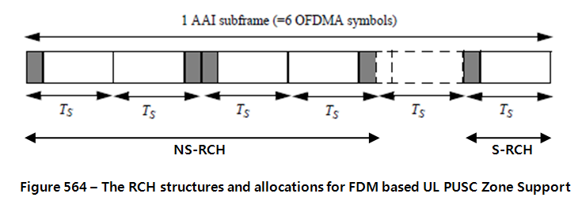

--------------------------------------------------- Text End ---------------------------------------------------

