Project | IEEE 802.16 Broadband Wireless Access Working Group <http://ieee802.org/16>
Title | Classification on generic HO procedure
Date Submitted | 2010-4-30
Source(s) | Guanghui Fan, Lei Jin，Bin Chen  Huawei Technologies | E-mail:  fanguanghui@huawei.com  jinlei60020191@huawei.com  binchen@huawei.com
Re: | Call for LB #31a on “ P802.16m/D5”:
Abstract | This contribution proposes about Classification on generic HO procedure
Purpose | To be discussed and adopted by TGm for 802.16m Letter Ballot 31a.
Notice | This document does not represent the agreed views of the IEEE 802.16 Working Group or any of its subgroups. It represents only the views of the participants listed in the “Source(s)” field above. It is offered as a basis for discussion. It is not binding on the contributor(s), who reserve(s) the right to add, amend or withdraw material contained herein.
Release | The contributor grants a free, irrevocable license to the IEEE to incorporate material contained in this contribution, and any modifications thereof, in the creation of an IEEE Standards publication; to copyright in the IEEE’s name any IEEE Standards publication even though it may include portions of this contribution; and at the IEEE’s sole discretion to permit others to reproduce in whole or in part the resulting IEEE Standards publication. The contributor also acknowledges and accepts that this contribution may be made public by IEEE 802.16.
Patent Policy | The contributor is familiar with the IEEE-SA Patent Policy and Procedures:  <http://standards.ieee.org/guides/bylaws/sect6-7.html#6> and <http://standards.ieee.org/guides/opman/sect6.html#6.3>.  Further information is located at <http://standards.ieee.org/board/pat/pat-material.html> and <http://standards.ieee.org/board/pat>.

Classification on generic HO procedure
Guanghui Fan, Lei Jin，Bin Chen
Huawei Technologies

Introduction
In Figure 410-Generic HO Procedure, the dash line of the messages between S-ABS and T-ABS may lead to confusion as the dash line in the specific means the messages is optional in the procedure. This contribution proposes to modify the dash line to real line if the message is mandated between S-ABS and T-ABS.

Text proposal for inclusion in the P802.16m/D5
========================== Start of Proposed Text ==============================
[Editor’s Note 1: modify the Figure 410-Generic HO Procedure as following in page 274]
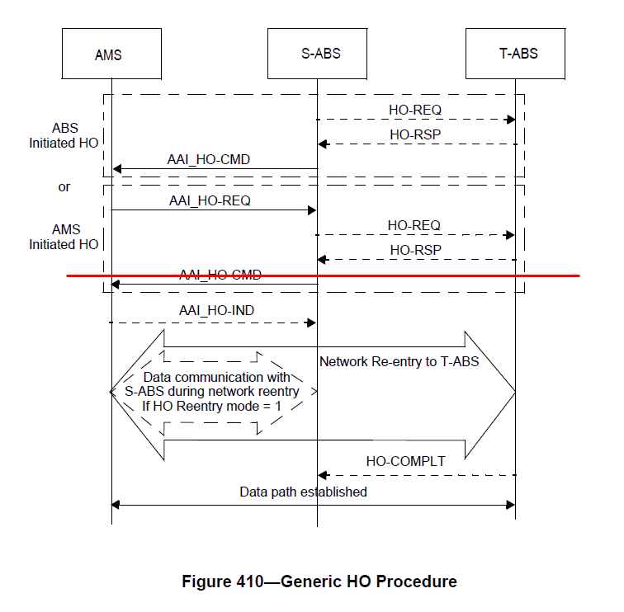
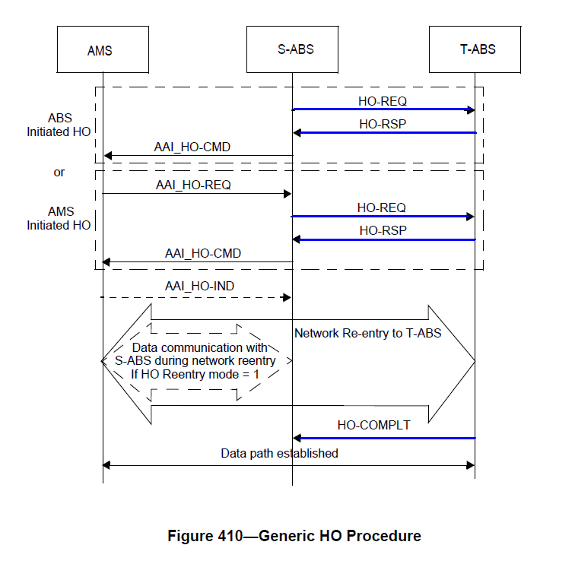
[Editor’s Note 2: modify the text as following in page 282 line 43]

After AMS finish network reentry with the target ABS, the target ABS becomes the serving ABS of the AMS and shall inform the former serving ABS the completion of HO procedure over backbone network.

========================== End of Proposed Text ==============================

