Project | IEEE 802.16 Broadband Wireless Access Working Group <http://ieee802.org/16>
Title | Modification on data path function blocks
Date Submitted | 2010-4-30
Source(s) | Bin Chen, Yunsong Yang, Ling Li, Guanghui Fan  Huawei Technologies | E-mail:  binchen@huawei.com  yunsongyang@huawei.com  ling_li@huawei.com  fanguanghui@huawei.com
Re: | Call for LB #31a on “ P802.16m/D5”:
Abstract | This contribution proposes to modify the data path function blocks
Purpose | To be discussed and adopted by TGm for 802.16m Letter Ballot 31a.
Notice | This document does not represent the agreed views of the IEEE 802.16 Working Group or any of its subgroups. It represents only the views of the participants listed in the “Source(s)” field above. It is offered as a basis for discussion. It is not binding on the contributor(s), who reserve(s) the right to add, amend or withdraw material contained herein.
Release | The contributor grants a free, irrevocable license to the IEEE to incorporate material contained in this contribution, and any modifications thereof, in the creation of an IEEE Standards publication; to copyright in the IEEE’s name any IEEE Standards publication even though it may include portions of this contribution; and at the IEEE’s sole discretion to permit others to reproduce in whole or in part the resulting IEEE Standards publication. The contributor also acknowledges and accepts that this contribution may be made public by IEEE 802.16.
Patent Policy | The contributor is familiar with the IEEE-SA Patent Policy and Procedures:  <http://standards.ieee.org/guides/bylaws/sect6-7.html#6> and <http://standards.ieee.org/guides/opman/sect6.html#6.3>.  Further information is located at <http://standards.ieee.org/board/pat/pat-material.html> and <http://standards.ieee.org/board/pat>.

Modification on data path function blocks
Bin Chen,Yunsong Yang, Ling Li, Guanghui Fan
Huawei Technologies

Introduction
In Figure 387 Data Path Functional Blocks involved in construction of MAC PDUs, the description of signaling header formation between MAC control modules and MAC PDU Formation module is not correct. The signaling header may also be transmitted from the MAC PDU Formation module to the MAC control modules.

Text proposal for inclusion in the P802.16m/D5
========================== Start of Proposed Text ==============================
[Editor’s Note 1: modify the Figure 387 Data Path Functional Blocks involved in construction of MAC PDUs as following in page 212]
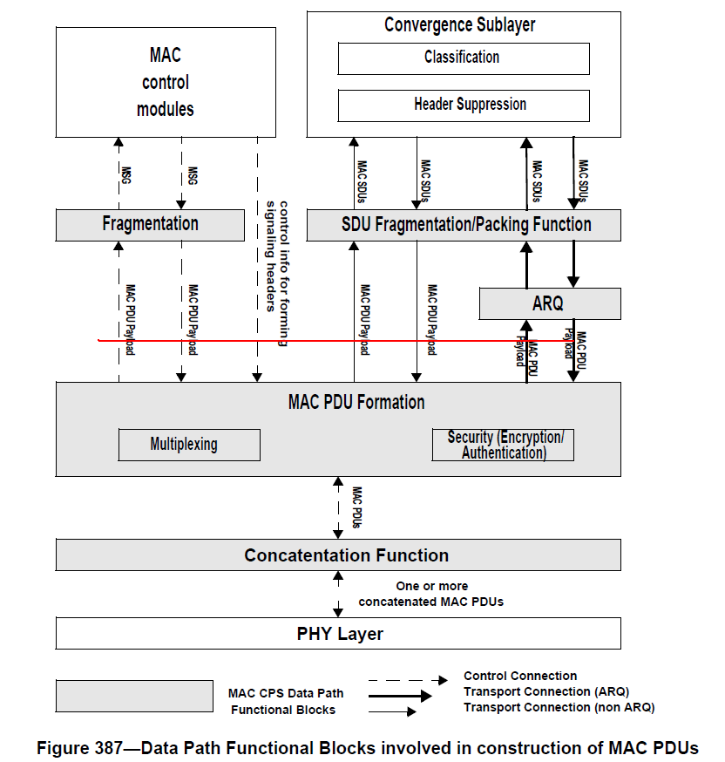
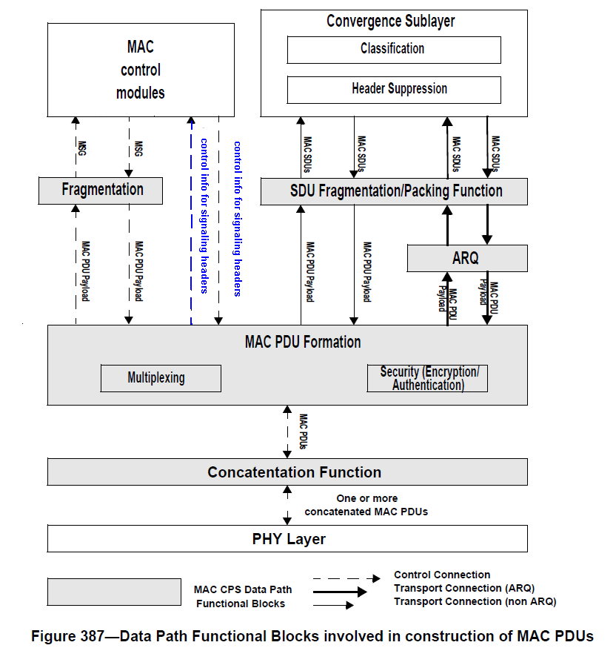

========================== End of Proposed Text ==============================

