Project | IEEE 802.16 Broadband Wireless Access Working Group <http://ieee802.org/16>
Title | Proposed Text on Enhanced LBS Support (16.8.3)
Date Submitted | 2010-05-13
Source(s) | Alexey Khoryaev, Kamran Etemad, Alexander Maltsev, Mikhail Shilov, Yang-seok Choi, Hujun Yin, Amir Rubin, Tom Harel  Intel Corporation  Sangheon Kim, Seonghyeon Chae, Jaeweon Cho, Hokyu Choi, Heewon Kang  Samsung Electronics Co., Ltd.  Lei Zhou, Fangmin Xu, Xufeng Zheng  Beijing Samsung Telecom R&D Center  Roman Maslennikov  University of Nizhny Novgorod | E-mails:  alexey.khoryaev@intel.com  alexander.maltsev@intel.com  kamran.etemad@intel.com  Sangheon.kim@samsung.com  l.zhou@samsung.com  roman.maslennikov@wcc.unn.ru
Re: | Comments on IEEE P802.16m/D5 for IEEE 802.16 Working Group Letter Ballot # 31a Topic: LBS (Section 16.8.3)
Abstract | This contribution proposes amendment text describing design of downlink LBS zone for enhanced LBS support
Purpose | To be discussed and adopted by TGm for theP802.16m/D6.
Notice | This document does not represent the agreed views of the IEEE 802.16 Working Group or any of its subgroups. It represents only the views of the participants listed in the “Source(s)” field above. It is offered as a basis for discussion. It is not binding on the contributor(s), who reserve(s) the right to add, amend or withdraw material contained herein.
Release | The contributor grants a free, irrevocable license to the IEEE to incorporate material contained in this contribution, and any modifications thereof, in the creation of an IEEE Standards publication; to copyright in the IEEE’s name any IEEE Standards publication even though it may include portions of this contribution; and at the IEEE’s sole discretion to permit others to reproduce in whole or in part the resulting IEEE Standards publication. The contributor also acknowledges and accepts that this contribution may be made public by IEEE 802.16.
Patent Policy | The contributor is familiar with the IEEE-SA Patent Policy and Procedures:  <http://standards.ieee.org/guides/bylaws/sect6-7.html#6> and <http://standards.ieee.org/guides/opman/sect6.html#6.3>.  Further information is located at <http://standards.ieee.org/board/pat/pat-material.html> and <http://standards.ieee.org/board/pat>.
Proposed Text on Enhanced LBS Support in Downlink
for the IEEE 802.16m AWD
Alexey Khoryaev, Kamran Etemad, Alexander Maltsev,
Mikhail Shilov, Yang-seok Choi
Intel Corporation

- Introduction
This contribution proposes amendment text describing the design of Downlink-LBS (D-LBS) zone for Enhanced LBS support in IEEE 802.16m systems and to be included in the IEEE 802.16m amendment draft [5]. The proposed text is developed so, that it is compliant to the IEEE 802.16m SRD [2] and the IEEE 802.16m SDD [3], and it follows the style and format guidelines in [4]. Current IEEE 802.16m SDD [3] is used as a basis for the text development.
The D-LBS zone is introduced to improve the performance characteristics of non-GPS-based location methods which rely on signal location parameters measured using reference signals transmitted by serving and neighboring ABSs/ARSs of the network [3]. The proposed D-LBS zone facilitates more accurate measurements of signal location parameters that are used for user positioning. The efficiency of proposed method was verified in severe multipath channel and strong interference environment using LBS evaluation assumptions defined in [6]. It was shown by link and system level simulations [7], that implementation of D-LBS zone substantially improves accuracy of user positioning and meet LBS requirements [2].
- System level evaluation of positioning error
This section provides brief overview of system level simulation results that were carried out to show performance of proposed D-LBS zone solution. Figure 1 shows cumulative distribution function of TOA estimation error for different TOA estimation algorithms. Two algorithms were evaluated: robust Max Peak TOA estimation algorithm and Adaptive threshold TOA estimation algorithm. In the Max peak TOA estimation algorithm the arrival time corresponds to the timing of the max power ray. In Adaptive threshold algorithm the threshold is calculated adaptively based on the measured SINR value and used to estimate arrival time of precursors that precede max power ray. As it can be seen from Figure 1 the Adaptive threshold TOA estimation algorithm significantly outperforms the Max Peak TOA estimation algorithm. Note that when the D-LBS zone is activated the TOA can be measured with almost equal quality for up to 5 BSs.
AMS positioning error was evaluated using the Taylor series expansion positioning algorithm based on TDOA location method. One receive antenna was used at the AMS receiver for TOA estimation. As it can be seen from positioning error cumulative distribution function shown in Figure 2 the strict handset based E911 requirements can be satisfied when 4 BSs and Adaptive threshold algorithm are applied. Note that performance of Max Peak TOA estimation significantly worse relative to Adaptive threshold algorithm. It can be explained by inaccurate TOA estimation of Max Peak TOA estimation algorithm which significantly depends on channel power delay profile.
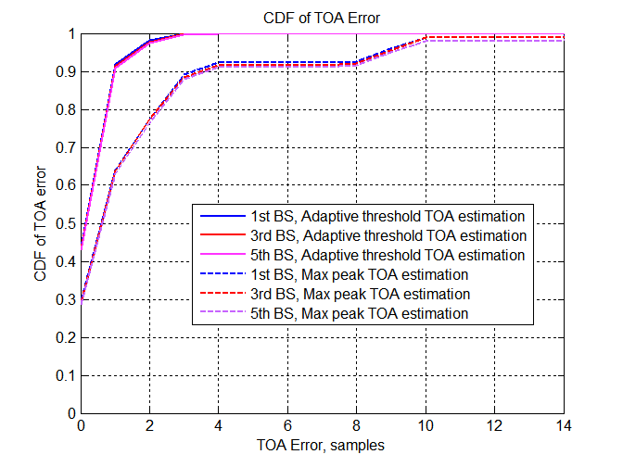
Figure 1: CDF of TOA estimation error

Figure 2 shows the system level simulation results of AMS positioning error when D-LBS zone is activated. In these simulations the Taylor series expansion algorithm was used for user positioning. As it can be seen from positioning error CDF presented in Figure 1 the strict handset based E911 requirements are satisfied when 4 BSs are used for location.
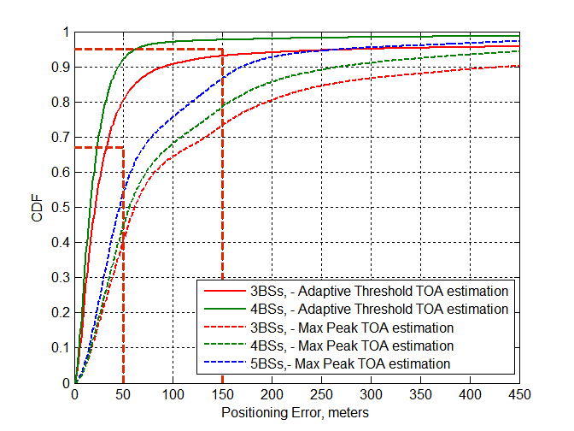
Figure 2: Positioning error CDF

- References
- IEEE P802.16Rev2/D9a, “Draft IEEE Standard for Local and Metropolitan Area Networks: Air Interface for Broadband Wireless Access,” March 2009.
- IEEE 802.16m-07/002r8, “802.16m System Requirements”
- IEEE 802.16m-08/0034r2, “The Draft IEEE 802.16m System Description Document”
- IEEE 802.16m-08/043, “Style guide for writing the IEEE 802.16m amendment”
- IEEE P802.16m/D3, “Part 16: Air Interface for Fixed and Mobile Broadband Wireless Access Systems – DRAFT Amendment to IEEE Standard for Local and metropolitan area networks”
- IEEE C802.16m-09/2202 “System Level Evaluation Assumptions for LBS Performance Analysis” (Alexey Khoryaev, Alexander Maltsev, Lei Zhou, Sangheon Kim, Fangmin Xu, Jinsoo Choi, Kanghee Kim, Kunmin Yeo; 2009-09-22)
- IEEE C802.16m-09/2201r1 “Evaluation of D-TDOA Positioning” (Alexey Khoryaev, Alexander Maltsev, Kamran Etemad et al; 2009-09-22)
- IEEE C802.16m-09/2314r2 “Proposed Text for Enhanced LBS Support (15.8.3)” (Lei Zhou, Fangmin Xu, Xufeng Zheng, Zheng Zhao; 2009-11-17)
=========================Start of Proposed Text ==============================
[Note to Editor: Add the following underlined blue text into 16.8.3 Enhanced LBS Support section on page 746]

16.8.3.1 Enhanced LBS support in downlink
The enhanced LBS support in downlink involves coordinated transmission of special location beacons across multiple ABSs in a designated Downlink LBS zone to facilitate measurements of parameters related to location determination at the AMS side.

16.8.3.1.1 Basic description of downlink LBS zone
To enable enhanced location determination, a dedicated Downlink LBS zone (D-LBS zone) may be defined to transmit location beacons to be received by AMSs and facilitate their measurement of location related parameters (RD, RTD, RSSI, etc.) with the higher accuracy.
Such dedicated D-LBS zone, when supported, shall be spread over four consecutive superframes. The location beacon shall be transmitted on the first symbol of the first subframe of the last frame of each D-LBS zone superframe.
The ABSs/ARSs configured to support D-LBS zone shall coordinate and transmit location beacons in accordance with the predefined D-LBS transmission plan.

16.8.3.1.2 Allocation of D-LBS zone in frame structure
The one D-LBS zone shall span four consecutive superframes. When the D-LBS zone is activated the first symbol of the first subframe of the last frame of superframe, that belong to D-LBS zone shall be replaced by location beacon. Figure 3 shows an example of the D-LBS zone allocation. In superframes where the D-LBS zone is allocated the first frame symbols shall be represented by the following pattern of synchronization signals S-P-S-L, where S – stands for SA-Preamble transmission in the first and the third frame of superframe, P – stands for PA-Preamble transmission in the second frame of superframe and L denotes location beacon transmission in the last frame of superframe.

Figure 3. D-LBS zone allocation

16.8.3.4 D-LBS zone location beacon signals
The SA-Preamble shall be used as a reference location beacon signal for transmission inside of D-LBS zone. The physical structure of the SA-Preamble signal transmitted by each ABS or ARS in the D-LBS zone shall be the same as defined in section 16.3.6.1.2 for given frame.
Each ABS/ARS shall transmit the corresponding SA-Preamble signal in the D-LBS zone in accordance with the predefined transmission plan that depends on the IDcell value assigned to the station. The location beacon transmission plan provides the time multiplexed transmission of these signals across neighboring ABSs/ARSs to simplify detection and measurements of the relevant signal location parameters from several ABSs/ARSs.
The D-LBS zone transmission plan spreads location beacon transmissions from different ABSs/ARSs over D-LBS zone OFDMA symbols.

16.8.3.4 Predefined D-LBS zone transmission plan
The predefined D-LBS zone transmission plan specifies on which orthogonal resource (symbol and carrier set) of D-LBS zone the location beacon shall be transmitted. To define transmission plan the existing set of SA-Preambles shall be partitioned into Q preamble location groups (PLGs). To determine PLG index the following equation shall be used:
$\text{PLG}=\text{mod}(\text{mod}(\text{IDcell}, \text{256}), Q)$ (1)
The number of preamble location/LBS groups Q shall be set to 12, that is equal to the number of orthogonal resources available in one D-LBS zone. The Table 1 determines the predefined D-LBS zone transmission plan that shall be used for transmission of location beacons.
Table 1. Predefined D-LBS zone transmission plan.
Allocated carrier set | D-LBS zone symbol index $s$ = 0  mod(Superframe number, 4) == 0 | D-LBS zone symbol index $s$ = 1  mod(Superframe number, 4) == 1 | D-LBS zone symbol index $s$ = 2  mod(Superframe number, 4) == 2 | D-LBS zone symbol index $s$ = 3  mod(Superframe number, 4) == 3
Carrier Set n = 0 | PLG = 0 | PLG = 1 | PLG = 2 | PLG = 3
Carrier Set n = 1 | PLG = 4 | PLG = 5 | PLG = 6 | PLG = 7
Carrier Set n = 2 | PLG = 8 | PLG = 9 | PLG = 10 | PLG = 11

In accordance with the predefined D-LBS zone transmission plan, each ABS and ARS shall determine PLG index using equation (1). The ABS and ARS shall transmit the location beacon signal on corresponding D-LBS zone symbol index $s$ and carrier set $n$ as it is defined in Table 1. The D-LBS symbol index and carrier set on which particular ABS and ARS transmit location beacons shall be determined from PLG index using the following equation (2)
$\begin{aligned}s=\text{mod}(\text{PLG},4); \\ n=\text{floor}({\text{PLG}}/4)\end{aligned}$ (2)
The D-LBS zone symbol index $s$ shall be associated with the superframe number using the following equation $s=\text{mod}(\text{Superframe} \text{number}, 4)$. When one station has multiple segments the all segments shall transmit the same SA-Preamble sequence. The SA-Preamble sequence for the purpose of location beacon transmission shall be determined by new IDcell value (IDcell_{PLG}) equal to ${\text{IDcell}}_{\text{PLG}}=\text{mod}(\text{IDcell}, \text{256})+\text{floor}({\text{PLG}}/4)⋅\text{256}$.
========================== End of Proposed Text =============================

