Project | IEEE 802.16 Broadband Wireless Access Working Group <http://ieee802.org/16>
Title | HARQ for UL Relay Assisted Joint MIMO
Date Submitted | 2010-07-08
Source(s) | Hsin-Piao Lin, Kun-Yi Lin  NTUT | Voice: +886-2-27712171#2248  E-mail: hplin@ntut.edu.tw
Re: | Comments on P802.16m/D6 for SB
Abstract | To propose text for the HARQ of Support for Relay to be included in P802.16m/D6.
Purpose | For TGm members’ discussion and approval
Notice | This document does not represent the agreed views of the IEEE 802.16 Working Group or any of its subgroups. It represents only the views of the participants listed in the “Source(s)” field above. It is offered as a basis for discussion. It is not binding on the contributor(s), who reserve(s) the right to add, amend or withdraw material contained herein.
Copyright Policy | The contributor is familiar with the IEEE-SA Copyright Policy <http://standards.ieee.org/IPR/copyrightpolicy.html>.
Patent Policy | The contributor is familiar with the IEEE-SA Patent Policy and Procedures:  <http://standards.ieee.org/guides/bylaws/sect6-7.html#6> and <http://standards.ieee.org/guides/opman/sect6.html#6.3>.  Further information is located at <http://standards.ieee.org/board/pat/pat-material.html> and <http://standards.ieee.org/board/pat>.
HARQ for UL Relay Assisted Joint MIMO

Kun-Yi Lin, Hsin-Piao Lin
NTUT

Abstract
This contribution provides amendment text for the HARQ of Support for Relay in the Advanced Air Interface to be included in Section 16.2.9 of the P802.16m/D6 [1].

Introduction
HARQ scheme is a combination of forward error correction (FEC) and ARQ scheme which provides higher reliability and throughput by combining the retransmission packet with the error decoded data that saved in the receiver buffer previously instead of discarding directly. Although HARQ can increase the throughput compare to the conventional ARQ, it is unavoidable that the AMS to be required to send some redundancy. This contribution proposes a cooperative HARQ scheme based on the relay assisted virtual multiple-input multiple-output (MIMO) architecture for uplink (UL) transmission. Figure 1 shows the structure of the relay assisted virtual MIMO for UL. In this proposed scheme, the ARS is dedicated to retransmit data packets for HARQ. In the same time, the AMS keep sending new data packets. The new data packets from MS and the retransmission data packets from ARS can be sent simultaneously by using virtual 2x2 MIMO structure, that is, there is a single antenna equipped at AMS and ARS respectively and two antennas are equipped at ABS. Instead of taking additional time slots for retransmission in conventional method, the relay is used for packet retransmission. The data packets are retransmitted with a time slot delay as illustrated in Fig. 2.

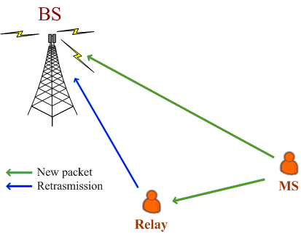
Figure 1 Structure of the proposed cooperative HARQ scheme for UL

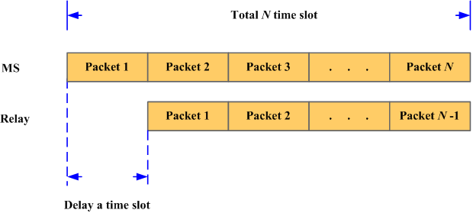
Figure 2 Framework of the proposed cooperative HARQ scheme

In the BS, the decoding procedure is according to the decoding results. When signals are decoded successfully, the BS will utilize the decoded signals to facilitate decoding the next data packets transmitted from MS by performing process the MIMO detection (ZF or MMSE equalizer based with OSIC). The former correct-decoded data stream can be used for detecting that improves the estimated accuracy. If the decoding is failure, the BS will store the error-decoded packet in the buffer. After receiving the retransmitted data packet, the error-decoded packet will be combined with the new packet by using partial-MRC to improve the data reliability. The MIMO signal detection is performed after partial-MRC. Procedures of the proposed cooperative HARQ scheme are briefly described in table I.

Table I Procedures of the proposed cooperative HARQ scheme
Station | The procedure of action
AMS | Broadcast the data packets to the Relay and the BS.
ARS | Delay a time slot regularly after receiving the packets transmitted from the MS.
ABS | Chose decoding schemes according to the decoding results of first transmitted packet:  If decoding successful:  The data packet is decoded by performing MIMO detection with the facilitation of previous correctly decoded data packet.  If decoding failure:  Detect the data packet using MIMO detection after performing Partial-MRC.

Figure 3 shows the simulated packet error rate performance of the proposed scheme. The retransmission times is set to 1, which means the maximum number of packet transmission times is 2. The notation, Direct-trans denotes the direct transmission from AMS with MRC combining. The notation, Coop-method denotes the proposed relay assisted cooperative HARQ scheme, where the data packets are retransmitted by the ARS regularly. The proposed method provides 2 dB gain at SNR of 8 dB for subcarriers=128 compared to the conventional retransmission method. The proposed relay assisted cooperative HARQ scheme can save the time slots for transmission, which utilizes the transmission resources efficiently, compared to the conventional HARQ method.

Figure 3 Packet error rate performance of the proposed cooperative HARQ scheme ($L=\text{128}$)

References
[1] IEEE P802.16m/D6, “DRAFT Amendment to IEEE Standard for Local and metropolitan area networks”

Proposed Text
------------------------------------------------------ Start of the proposed text ------------------------------------------------

16.6.2.9.X HARQ for UL Relay Assisted Joint MIMO

When ABS decodes packet failure, it should send negative acknowledgement to the ARS to request data retransmission than to AMS. While ARS sends HARQ data, the AMS continues sending new data packets. ABS can detect the HARQ data from ARS and the new data packets from AMS by using MIMO detection techniques.

Figure X shows an example of the UL timing relationships between an UL Basic Assignment A-MAP IE, a HARQ subpacket, corresponding HARQ feedback and retransmission.
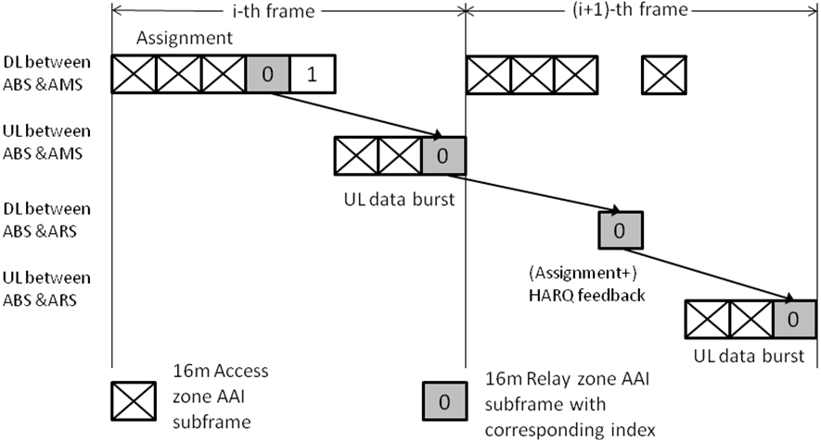
Figure X – Example of TDD UL HARQ timing for relay assisted joint MIMO

------------------------------------------------------- End of the proposed text ------------------------------------------------

