Project | IEEE 802.16 Broadband Wireless Access Working Group <http://ieee802.org/16>
Title | Clarification of Ranging Channels for FDM-based UL PUSC Zone Support (16.3.9.1.4.3)
Date Submitted | 2010-07-09
Source(s) | Chiwoo Lim, Hwasun Yoo, Jaeweon Cho, Hokyu Choi, Heewon Kang  Samsung Electronics  Xinrong Wang, Yang-Seok Choi  Intel Corporation  Pei-Kai Liao, Paul Cheng  MediaTek Inc.  HyunWoo Lee and Jin Sam Kwak  LG Electronics  Zheng Yan-Xiu, Chung-Lien Ho, Chang-Lan Tsai, Yu-Chuan Fang  ITRI | chiwoo.lim@samsung.com  xinrong.wang@intel.com  pk.liao@mediatek.com  {hyunwoolee.lee; jinsam.kwak}@lge.com  zhengyanxiu@irti.org.tw
Re: | Sponsor ballot comment on P802.16m/D6  Target topic: “IEEE P802.16m/D6, section 16.3.9.1.4.3”.
Abstract | The contribution proposes the clarification of Ranging Channel for FDM-based UL PUSC Zone Support of the 802.16m draft amendment, IEEE P802.16m/D6.
Purpose | To be discussed and adopted by TGm
Notice | This document does not represent the agreed views of the IEEE 802.16 Working Group or any of its subgroups. It represents only the views of the participants listed in the “Source(s)” field above. It is offered as a basis for discussion. It is not binding on the contributor(s), who reserve(s) the right to add, amend or withdraw material contained herein.
Release | The contributor grants a free, irrevocable license to the IEEE to incorporate material contained in this contribution, and any modifications thereof, in the creation of an IEEE Standards publication; to copyright in the IEEE’s name any IEEE Standards publication even though it may include portions of this contribution; and at the IEEE’s sole discretion to permit others to reproduce in whole or in part the resulting IEEE Standards publication. The contributor also acknowledges and accepts that this contribution may be made public by IEEE 802.16.
Patent Policy | The contributor is familiar with the IEEE-SA Patent Policy and Procedures:  <http://standards.ieee.org/guides/bylaws/sect6-7.html#6> and <http://standards.ieee.org/guides/opman/sect6.html#6.3>.  Further information is located at <http://standards.ieee.org/board/pat/pat-material.html> and <http://standards.ieee.org/board/pat>.
Clarification of Ranging Channel for FDM-based UL PUSC Zone Support (16.3.9.1.4.3)

Chiwoo Lim, Hwasun Yoo, Jaeweon Cho, Hokyu Choi, Heewon Kang
Samsung Electronics

Xinrong Wang, Yang-Seok Choi
Intel Corporation

Pei-Kai Liao, Paul Cheng
MediaTek Inc.

HyunWoo Lee and Jin Sam Kwak
LG Electronics

Zheng Yan-Xiu, Chung-Lien Ho, Chang-Lan Tsai, Yu-Chuan Fang
ITRI

- Introduction
The contribution proposes the clarification of ranging channel for FDM-based UL PUSC Zone Support to be included in the 802.16m amendment. In the current draft amendment [1], there is no clear description for the index of Code (X+1) in case that Code X has the last index in the code set. In general, each code set for initial and handover is distinguished. So, it’s proper that the index of Code (X+1) is the first index in the corresponding code set. (Cyclic mapping)
In addition, there is a wrong implemented comment. Figure 566 (a) has a problem for the direction of dotted arrow.

- References
[1] IEEE P802.16m/D6, “P802.16m DRAFT Amendment to IEEE Standard for Local and metropolitan area networks Part 16: Air Interface for Broadband Wireless Access Systems”, May 2010

- Proposed changes for 802.16m draft amendment

--------------------------------------------------- Text Start ---------------------------------------------------
[Remedy-1: Insert the following text on page 698 line 49]
The RP code index for random selection and its response is determined as the first RP code index between the two consecutive RP codes. If the first code (Code X) is selected as the last one in the code set, then Code (X+1) is the first one in the corresponding code set.

[Remedy-2: Modify the figure 566(a) on page 699 as following]
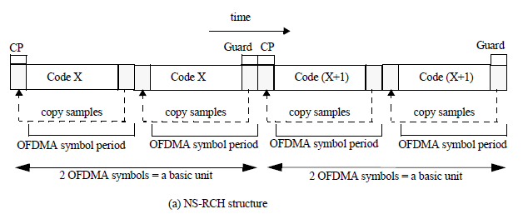
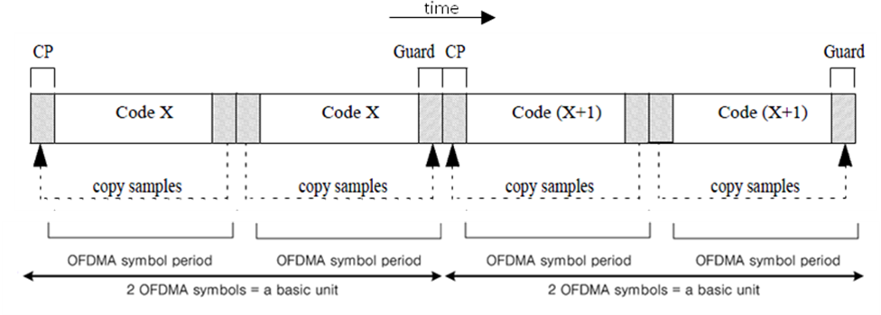
(a) NS-RCH structure

--------------------------------------------------- Text End ---------------------------------------------------

