Project | IEEE 802.16 Broadband Wireless Access Working Group <http://ieee802.org/16>
Title | Packet Loss-free handover over E-MBS networks
Date Submitted | 2010-07-09
Source(s) | Perumal Ramesh Babu, Youn Ok Park, Eunkyung Kim, Chulsik Yoon  ETRI  138 Gajeongno, Yusong-gu, Daejeon, 305-700, KOREA | Voice: +82-42-860-1755  E-mail:  {ramesh.babu, parkyo, ekkim, csyoon}@etri.re.kr
Re: | Proposed text changes to P802.16m/D6
Abstract | Using Phase-shifting principle to prevent packet loss
Purpose | To discuss and adopt the proposed text in the next revision of 802.16m draft
Notice | This document does not represent the agreed views of the IEEE 802.16 Working Group or any of its subgroups. It represents only the views of the participants listed in the “Source(s)” field above. It is offered as a basis for discussion. It is not binding on the contributor(s), who reserve(s) the right to add, amend or withdraw material contained herein.
Release | The contributor grants a free, irrevocable license to the IEEE to incorporate material contained in this contribution, and any modifications thereof, in the creation of an IEEE Standards publication; to copyright in the IEEE’s name any IEEE Standards publication even though it may include portions of this contribution; and at the IEEE’s sole discretion to permit others to reproduce in whole or in part the resulting IEEE Standards publication. The contributor also acknowledges and accepts that this contribution may be made public by IEEE 802.16.
Patent Policy | The contributor is familiar with the IEEE-SA Patent Policy and Procedures:  <http://standards.ieee.org/guides/bylaws/sect6-7.html#6> and <http://standards.ieee.org/guides/opman/sect6.html#6.3>.  Further information is located at <http://standards.ieee.org/board/pat/pat-material.html> and <http://standards.ieee.org/board/pat>.
Packet Loss-free handover over E-MBS networks
Perumal Ramesh Babu, Youn Ok Park, Eunkyung Kim, Chulsik Yoon
ETRI

Introduction

Cell

The term cell in this context is used for a subsystem that may consist of one or several transmitters sending entirely identical content on the same frequency (single frequency network, SFN). So a cell handover in this context is the change of frequency and data stream in order to receive the same service continued within another cell.

Packet loss

The number of packets lost while maintaining communication during a handover. Packet loss will most probably happen when the terminal tries to synchronize to the target frequency and transport stream in the handover process.

Handover in broadcast systems

Handover in broadcast systems are quite different from the ones e.g in cellular telecommunications networks, mainly due to the fact that no return channel exists. So the network’s infrastructure has no feedback about who is using the services and possibly moving from one cell to another. All the information for performing handovers has to be deployed to the terminals which will perform the handovers on their own.

Phase shifting principle

In the E-MBS case, the data is not transmitted every frame. The data is transmitted in Burst. So some frames are ON and some frames are OFF. When a mobile terminal changes from one cell to another, ideally it should be able to seamlessly continue receiving the current service in the new cell without any packet loss, assuming that the service is available in both cells. To achieve this, a static phase shift between the two cells may be applied such that when one cell is transmitting no other cells are transmitting. In other words, a cell transmits its E-MBS data during other cells OFF-time frames. If the phase shift is performed according to this, there should be overlapping of IP packets between two consecutive cells. This ensures, even with significant tolerance towards IP feeding stream delays, seamless loss-free handovers.

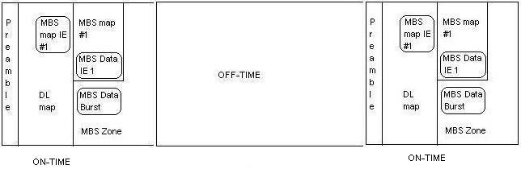

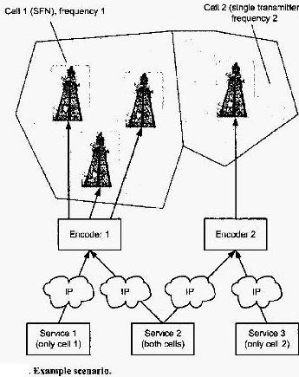

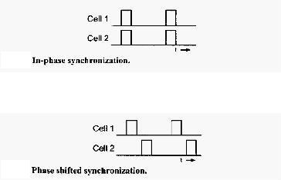

Here in the above and below figures two cells at the border are considered

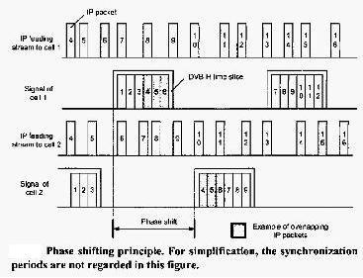

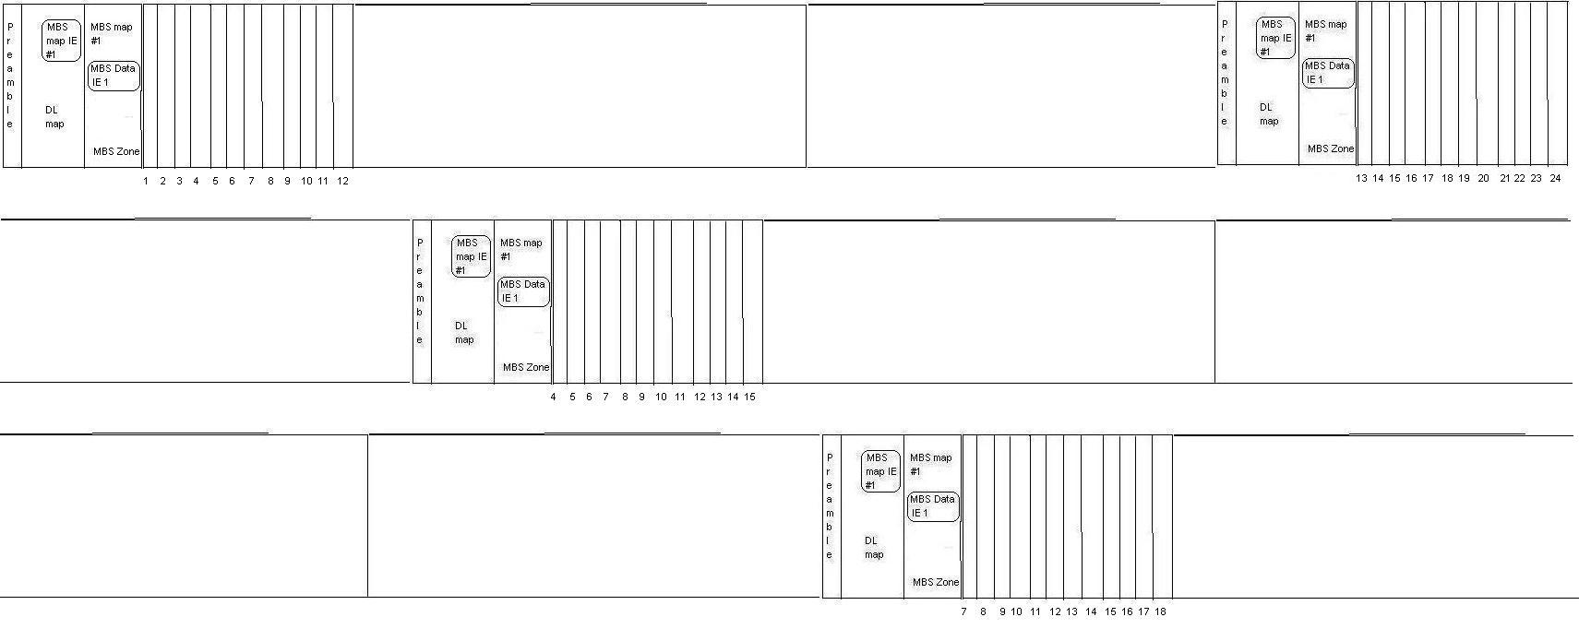

Here in the given example above, three cells are considered at the border.

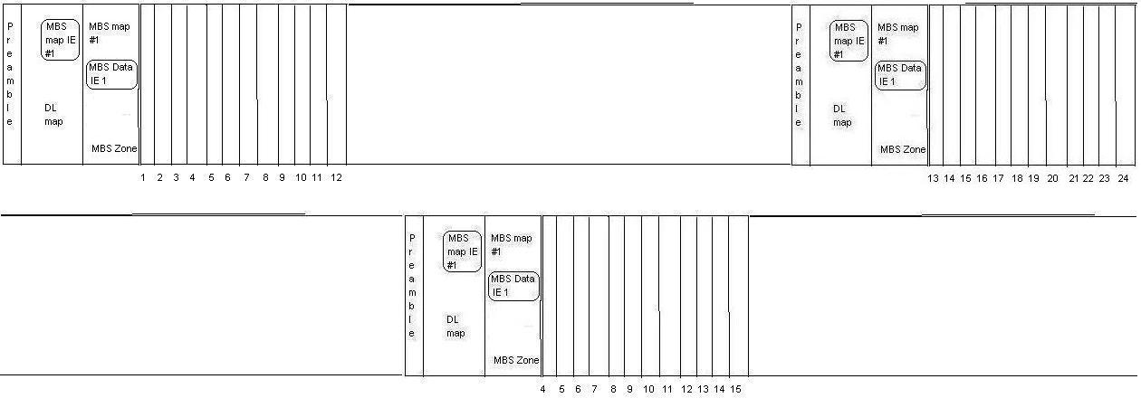

Here in the given example above, two cells are considered at the border.

Text Proposal for the 802.16m Amendment Draft Standard
Note:
The text in BLUE color: the new text added to the 802.16m Amendment Draft Standard Text

[-------------------------------------------------Start of Text Proposal---------------------------------------------------]
16.9.x. In the case of Broadcasting, to prevent packet loss during handover from one SFN cell to another, phase shifting principle should be used between the bordering cells.
[-------------------------------------------------End of Text Proposal----------------------------------------------------]

References
- Gunther May, “Loss-free handover for IP Datacast over DVB-H networks”.

