Project | IEEE 802.16 Broadband Wireless Access Working Group <http://ieee802.org/16>
Title | Relay Security cleanup considering PKMv3 (16.6.2.4)
Date Submitted | 2010-07-09
Source(s) | Youngkyo Baek  Hyunjeong Kang  Youngbin Chang  Samsung Electronics | E-mail: youngkyo.baek@samsung.com  Phone : +82-31-279-7321  *<http://standards.ieee.org/faqs/affiliationFAQ.html>
Re: | Call for SB on “ P802.16m/D6”:  Target topic: “16.6.2.4”
Abstract | This contribution proposes Relay Security considering PKMv3 to be included in the 802.16m amendment.
Purpose | To be discussed and adopted by WG SB
Notice | This document does not represent the agreed views of the IEEE 802.16 Working Group or any of its subgroups. It represents only the views of the participants listed in the “Source(s)” field above. It is offered as a basis for discussion. It is not binding on the contributor(s), who reserve(s) the right to add, amend or withdraw material contained herein.
Release | The contributor grants a free, irrevocable license to the IEEE to incorporate material contained in this contribution, and any modifications thereof, in the creation of an IEEE Standards publication; to copyright in the IEEE’s name any IEEE Standards publication even though it may include portions of this contribution; and at the IEEE’s sole discretion to permit others to reproduce in whole or in part the resulting IEEE Standards publication. The contributor also acknowledges and accepts that this contribution may be made public by IEEE 802.16.
Patent Policy | The contributor is familiar with the IEEE-SA Patent Policy and Procedures:  <http://standards.ieee.org/guides/bylaws/sect6-7.html#6> and <http://standards.ieee.org/guides/opman/sect6.html#6.3>.  Further information is located at <http://standards.ieee.org/board/pat/pat-material.html> and <http://standards.ieee.org/board/pat>.

Relay Security cleanup considering PKMv3 (16.6.2.4)
Youngkyo Baek, Hyunjeong Kang, Youngbin Chang
Samsung Electronics

1. Introduction
Current D6 relay security description does not match with the current PKM v3. Especially AK derivation and Key Agreement 3-way handshake procedure are described differently from macro’s PKM v3.
We suggest modifying the relay security in accordance with PKMv3 as text proposal.

2. Text Proposal
Modify the sentences at page 809, line 58 as follows
======================== Start of Proposed Text =====================
16.6.2.4 Security
An ARS uses the same security architecture and procedures as an AMS to provide privacy, authentication and confidentiality between itself and an ABS on the relay link.
An ARS is operating as distributed security mode. The AK established between an AMS and an authenticator is derived as follows and distributed to this ARS during key agreement.
AK = Dot16KDF(PMK, MS addressing MSID*|ARSID|AK_COUNT| "AK", 160) , where MS Addressing depends on the operation mode. If AMSID privacy is disabled, MS addressing shall be 48bit AMSID. Otherwise, it shall be AMSID*.
As shown in Figure 588—, after authorization for an AMS completes, the authenticator shall transfer the relevant Authorization Key (AK) context associated with the AMS to its ARS and the MSK for the AMS is established,the ARS starts key agreement with the AMS. During the key agreement, the authenticator shall transfer the relevant Authorization Key (AK) context associated with the AMS to its ARS. On obtaining AK context the ARS derives necessary security keys such as CMAC keys and TEK from the AK and the ARS shall start key agreement 3-way handshake with the AMS. Tthe ARS is responsible for key management of AK, CMAC keys and TEK, and interacts with the AMS as if it were an ABS in the AMS's perspectives. Especially AK is derived based on the ARSID in place of ABSID and NONCE_ABS in key agreement 3-way handshake is replaced with NONCE_ARS which the ARS generates randomly.
During the key agreement, similarly to macro ABS, the Security Association shall be established between an AMS and an ARS. The ARS uses the set of active keys shared with the AMS to perform encryption/decryption and integrity protection on the access link.
The ARS runs a secure encapsulation protocol with the ABS based on the primary SA, which is established between the ARS and the ABS. The access ARS uses the set of active keys shared with the ABS to perform encryption/decryption and integrity protection on the relay link.
MPDUs are encapsulated into one relay MAC PDU and en/decrypted at once by primary SA, which is established between the ARS and the ABS.
The security context used for relay link (between an ABS and an ARS) and access links (between an ARS and an AMS) are different and maintained independently. The key management follows as the same method as a macro ABS defined in 16.2.5.2.
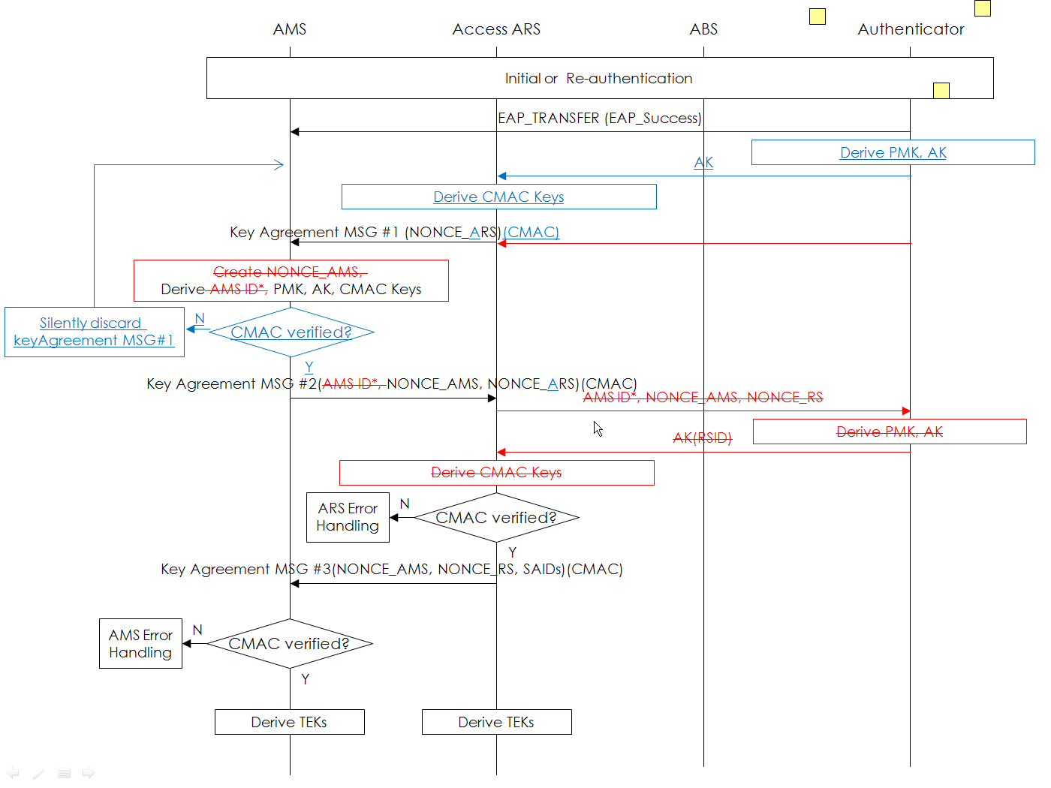 [to editor: in the figure remove the red-color boxes and arrows and add the blue-color boxes and arrows]
Figure 588—Key agreement procedure

============================== End of Proposed Text ===============

4. References
- IEEE P802.16m/D6. DRAFT Amendment to IEEE Standard for Local and metropolitan area networks—Part 16: Air Interface for Broadband Wireless Access Systems—Advanced Air Interface, MAY 2010.
- IEEE 802.16m-08/003r9a. The Draft IEEE 802.16m System Description Document, May 2009.
- IEEE 802.16m-07/002r9. IEEE 802.16m System Requirements Document, Sep 2009.

