Project | IEEE 802.16 Broadband Wireless Access Working Group <http://ieee802.org/16>
Title | Proposal to support MSID privacy disabled operation mode(16.2.5.3.1)
Date Submitted | 2010-07-09
Source(s) | Youngkyo Baek  Jungshin Park  Samsung Electronics | E-mail: youngkyo.baek@samsung.com  Phone : +82-31-279-7321  *<http://standards.ieee.org/faqs/affiliationFAQ.html>
Re: | Call for SB on “ P802.16m/D6”:  Target topic: “16.2.5.3.1”
Abstract | This contribution proposes mode of MSID privacy disabled operation to be included in the 802.16m amendment.
Purpose | To be discussed and adopted by WG SB
Notice | This document does not represent the agreed views of the IEEE 802.16 Working Group or any of its subgroups. It represents only the views of the participants listed in the “Source(s)” field above. It is offered as a basis for discussion. It is not binding on the contributor(s), who reserve(s) the right to add, amend or withdraw material contained herein.
Release | The contributor grants a free, irrevocable license to the IEEE to incorporate material contained in this contribution, and any modifications thereof, in the creation of an IEEE Standards publication; to copyright in the IEEE’s name any IEEE Standards publication even though it may include portions of this contribution; and at the IEEE’s sole discretion to permit others to reproduce in whole or in part the resulting IEEE Standards publication. The contributor also acknowledges and accepts that this contribution may be made public by IEEE 802.16.
Patent Policy | The contributor is familiar with the IEEE-SA Patent Policy and Procedures:  <http://standards.ieee.org/guides/bylaws/sect6-7.html#6> and <http://standards.ieee.org/guides/opman/sect6.html#6.3>.  Further information is located at <http://standards.ieee.org/board/pat/pat-material.html> and <http://standards.ieee.org/board/pat>.

Proposal to support MSID privacy disabled operation mode (16.2.5.3.1)
Youngkyo Baek, Jungshin Park
Samsung Electronics

1. Introduction
Currently a legacy Access networks are deployed together with a legacy core networks (e.g. AAA server).
Due to development of the new 16m technologies we expect the 16m Access network will be deployed in some time.
So we may expect that 16m Access network is deployed together with a legacy core network. For example, some service providers may want to deploy 16m Access network but maintain their legacy core network.
As another case, some users, who has 16m AMS but subscribes legacy-supporting NSP, may use Roaming service through the local NSP supporting the advanced technology.
In those situations, some 16m features may not be available to support.(e.g. MSID privacy etc.).
Hence, MS MAC address is transmitted as a plaintext in AAI_RNG-REQ/RSP during network entry, which is similar to wirelessMAN OFDMA reference system.

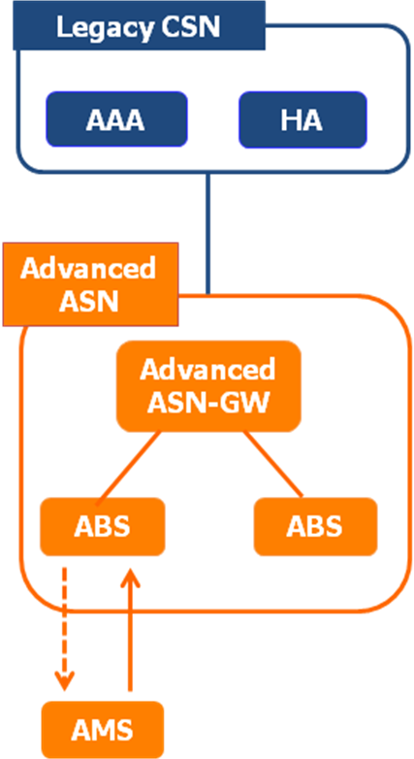
Figure 1. Deployment scenario of advanced ASN together with legacy CSN.
NWG agreed that it is considerable scenario that 16m Access network is deployed together with a legacy core network and made the following decision at July Tallinn meeting[4](see Figure 1) in order to support that scenario.
- MSID privacy is mandatory to support in advanced ABS, AMS, advanced ASNGW, advanced AAA, but optional to use.
- NAP shall advertise its capability to support MSID privacy when ASNGW is advanced.
- AMS (in accordance with HNSP) decides whether MSID privacy is used.
- There may be other 16m features impacting the legacy CSNs (FFS).
- Needs further discussion: Whether we need to hide the real MSID from ASN and VCSNs; over R3 and R5 (a bug?)
Considering their decision we suggest the following text proposal.

2. Text Proposal

Add some sentences at page 270, line 28 as follows
======================== Start of Proposed Text=====================
16.2.5.3.1 AMS identity privacy
AMS identity privacy support is the process of protecting the identity of AMS so that AMS MAC Address (ie., AMSID) is not revealed via air interface. While S-SFH Network Configuration bit = 0b1, AMS identity privacy is not possible due to the need to send the real AMSID as plain text in the AAI_RNG-REQ.
To protect AMSID a hash value of the real AMSID (i.e. AMSID*) is defined for the case of S-SFH Network Configuration bit = 0b0 as follows:
AMSID*=Dot16KDF(AMSID|80-bit zero padding, NONCE_AMS, 48)
•NONCE_AMS is a random 48-bit value generated by AMS before sending AAI_RNG-REQ message, and transmitted to ABS during the following Key Agreement 3-way handshake procedure. If the AMS doesn't receive a successful AAI_RNG-RSP from the ABS, the AMS should send another AAI_RNG-REQ with the AMSID* derived from the same NONCE_AMS to the ABS in the followed initial ranging procedure before retries are exhausted. If retries are exhausted, AMS should use another AMSID* derived from a newly generated NONCE_AMS.
When operating in S-SFH Network Configuration bit = 0b1:
AMSID is used in stead of AMSID* when sending AAI_RNG-REQ message and deriving AK.

AMSID privacy is applied as the following way;
- AMSID privacy is mandatory to support in ABS, AMS, advanced access network, advanced AAA, but optional to use.
- ABS shall advertise its capability to support AMSID privacy when access network is advanced.
- AMS (in accordance with Home NSP) decides whether AMSID privacy is used.

============================== End of Proposed Text===============

3. References
- IEEE P802.16m/D6. DRAFT Amendment to IEEE Standard for Local and metropolitan area networks—Part 16: Air Interface for Broadband Wireless Access Systems—Advanced Air Interface, MAY 2010.
- IEEE 802.16m-08/003r9a. The Draft IEEE 802.16m System Description Document, May 2009.
- IEEE 802.16m-07/002r9. IEEE 802.16m System Requirements Document, Sep 2009.
- nwg-tll-00012-r002_NWG_Security_Meeting_Tallinn.ppt , June 2010

