Project | IEEE 802.16 Broadband Wireless Access Working Group <http://ieee802.org/16>
Title | Proposal to support MSID privacy enable/disable operation (16.2.5.3.1)
Date Submitted | 2010-07-10
Source(s) | Youngkyo Baek,Jungshin Park  Jaejin Lim  Samsung Electronics  Suresh Nair,Dan Gal  Alcatel-Lucent  Duckey Lee  Korea Telecom  Young Jong Kim  SK telecom  Lee Joo Aun  YTL communications  Oleg Marinchenco, Vladimir Yanover  Alvarion | E-mail: youngkyo.baek@samsung.com  Phone : +82-31-279-7321  *<http://standards.ieee.org/faqs/affiliationFAQ.html>  suresh.p.nair@alcatel-lucent.com  dan.gal@alcatel-lucent.com
Re: | Call for SB on “ P802.16m/D6”:  Target topic: “16.2.5.3.1”
Abstract | This contribution proposes mode of MSID privacy disabled operation to be included in the 802.16m amendment.
Purpose | To be discussed and adopted by WG SB
Notice | This document does not represent the agreed views of the IEEE 802.16 Working Group or any of its subgroups. It represents only the views of the participants listed in the “Source(s)” field above. It is offered as a basis for discussion. It is not binding on the contributor(s), who reserve(s) the right to add, amend or withdraw material contained herein.
Release | The contributor grants a free, irrevocable license to the IEEE to incorporate material contained in this contribution, and any modifications thereof, in the creation of an IEEE Standards publication; to copyright in the IEEE’s name any IEEE Standards publication even though it may include portions of this contribution; and at the IEEE’s sole discretion to permit others to reproduce in whole or in part the resulting IEEE Standards publication. The contributor also acknowledges and accepts that this contribution may be made public by IEEE 802.16.
Patent Policy | The contributor is familiar with the IEEE-SA Patent Policy and Procedures:  <http://standards.ieee.org/guides/bylaws/sect6-7.html#6> and <http://standards.ieee.org/guides/opman/sect6.html#6.3>.  Further information is located at <http://standards.ieee.org/board/pat/pat-material.html> and <http://standards.ieee.org/board/pat>.

Proposal to support MSID privacy enable/disable operation (16.2.5.3.1)
Youngkyo Baek, Jungshin Park,Jaejin Lim
Samsung Electronics
Suresh Nair, Dan Gal
Alcatel-Lucent
Duckey Lee
Korea Telecom
Young Jong Kim
SK telecom
Lee Joo Aun
YTL communications
Oleg Marinchenco, Vladimir Yanover
Alvarion

1. Introduction
Current legacy Radio Access Networks are deployed together with a legacy ASN and CSN core networks.
It is, thus, expected that new 16m radio access networks (ABS and AMS) may be deployed and be required to operate with legacy ASN-GW or legacy CSN nodes, for quite some time.
In addition, 16m AMS subscribes may need to operate with legacy-supporting NSP, and require Roaming service through a local NSP that supports the 16m advanced technology.
In these and other scenarios, some 16m features may not be supported by the Network, such as MSID privacy.
Therefore, it is essential that the 16m air interface be able to disable or enable the AMSID privacy protection feature of the AMS.

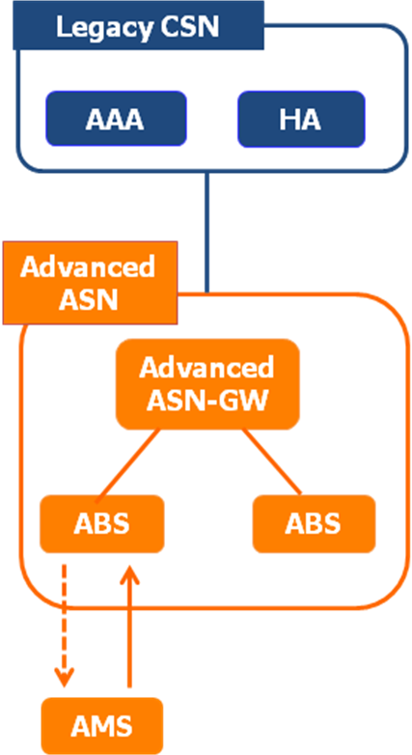
Figure 1. Deployment scenario of advanced ASN together with legacy CSN.
NWG agreed that it is considerable scenario that 16m Access network is deployed together with a legacy core network and made the following decision at the July 2010 Tallinn, Estonia meeting [4] (see Figure 1) in order to support that scenario.
- MSID privacy is mandatory to support in advanced ABS, AMS, advanced ASNGW, advanced AAA, but optional to use.
- NAP shall advertise its capability to support MSID privacy when ASNGW is advanced.
- AMS (in accordance with HNSP) decides whether MSID privacy is used.
- There may be other 16m features impacting the legacy CSNs (FFS).
- Needs further discussion: Whether we need to hide the real MSID from ASN and VCSNs; over R3 and R5 (a bug?)
Considering their decision, we suggest the following text proposal for P802.16m/D6.

2. Text Proposal

Add new text on page 270, at line 54 as follows
======================== Start of Proposed Text=====================
16.2.5.3.1 AMS identity privacy

AMS identity privacy support is the process of protecting the identity of AMS so that AMS MAC Address (ie., AMSID) is not revealed via air interface. While S-SFH Network Configuration bit = 0b1, AMS identity privacy is not possible due to the need to send the real AMSID as plain text in the AAI_RNG-REQ.
To protect AMSID a hash value of the real AMSID (i.e. AMSID*) is defined for the privacy of the AMSID case of S-SFH Network Configuration bit = 0b0 as follows:
AMSID*=Dot16KDF(AMSID|80-bit zero padding, NONCE_AMS, 48)
•NONCE_AMS is a random 48-bit value generated by AMS before sending AAI_RNG-REQ message, and transmitted to ABS during the following Key Agreement 3-way handshake procedure. If the AMS doesn't receive a successful AAI_RNG-RSP from the ABS, the AMS should send another AAI_RNG-REQ with the AMSID* derived from the same NONCE_AMS to the ABS in the followed initial ranging procedure before retries are exhausted. If retries are exhausted, AMS should use another AMSID* derived from a newly generated NONCE_AMS.
When operating in S-SFH Network Configuration bit = 0b1:
AMSID is used instead of AMSID* when sending AAI_RNG-REQ message and deriving AK.

Implementation of AMSID* is mandatory for all ABS, AMS, but usage shall be subject to the access and core network conditions.The ABS shall advertise its support of AMSID privacy (AMSID*) depending on the network conditions.
The AMS shall decide whether the AMSID privacy is turned on or off when AMSID privacy is supported by the network. Even if AMSID privacy is supported by the network, the netwok shall support that AMS uses AMSID privacy disabled operation.

============================== End of Proposed Text===============

3. References
- IEEE P802.16m/D6. DRAFT Amendment to IEEE Standard for Local and metropolitan area networks—Part 16: Air Interface for Broadband Wireless Access Systems—Advanced Air Interface, MAY 2010.
- IEEE 802.16m-08/003r9a. The Draft IEEE 802.16m System Description Document, May 2009.
- IEEE 802.16m-07/002r9. IEEE 802.16m System Requirements Document, Sep 2009.
- nwg-tll-00012-r002_NWG_Security_Meeting_Tallinn.ppt , June 2010

